**SR UNIVERSITY**

**AI assistant coding**

**ASSINGMENT NO:1**

* ***NAME : M.Saikumar***
* ***ENROLLMENT NO: 2403a54073***
* ***BATCH NO :03***
* ***SPECIALIZATION :DS***

**STEP1:**

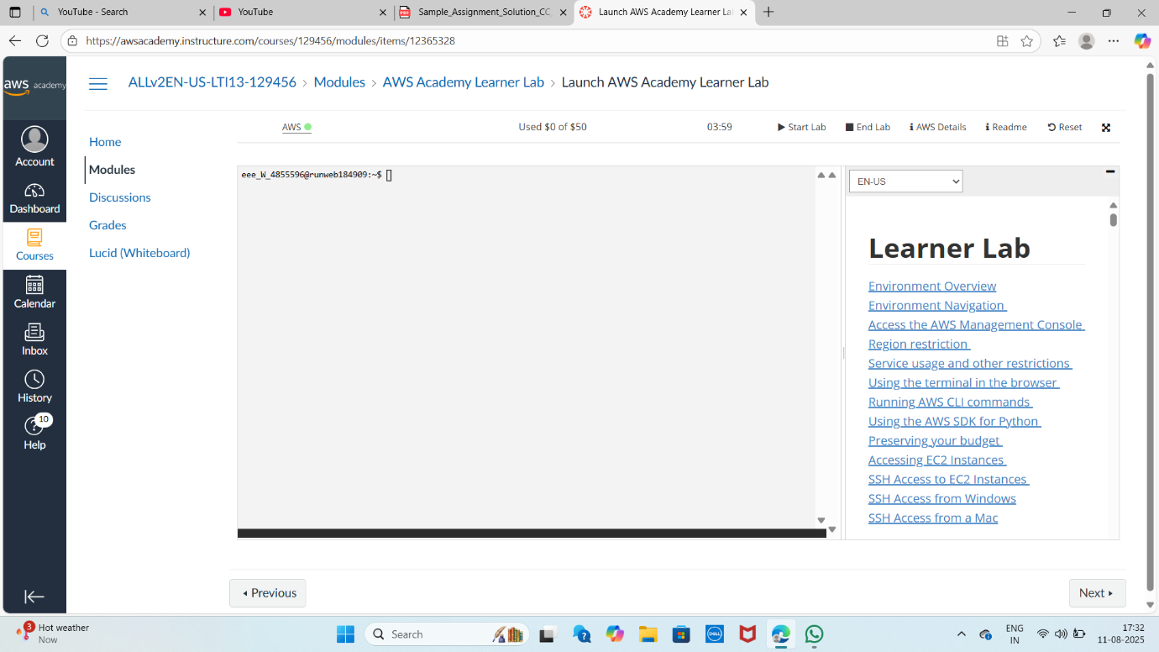

**STEP2:**

**STEP3:**

**STEP4:**

**STEP5:**

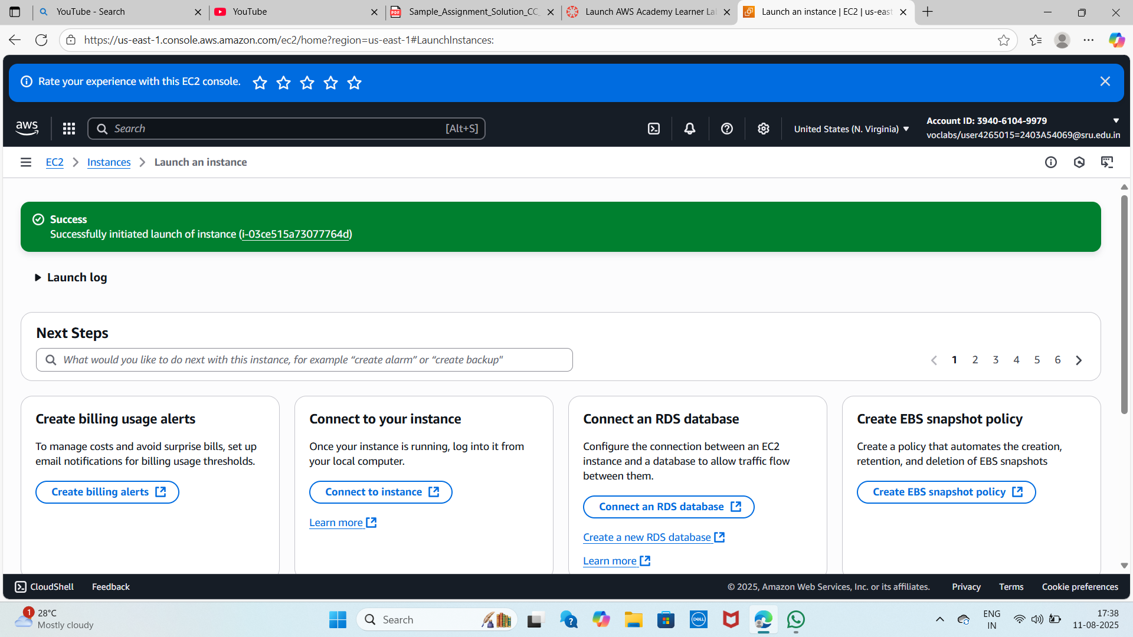

**STEP6:**

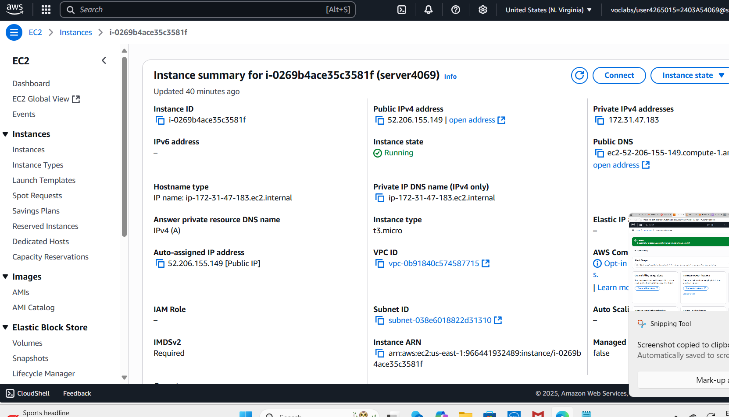

**STEP7:**

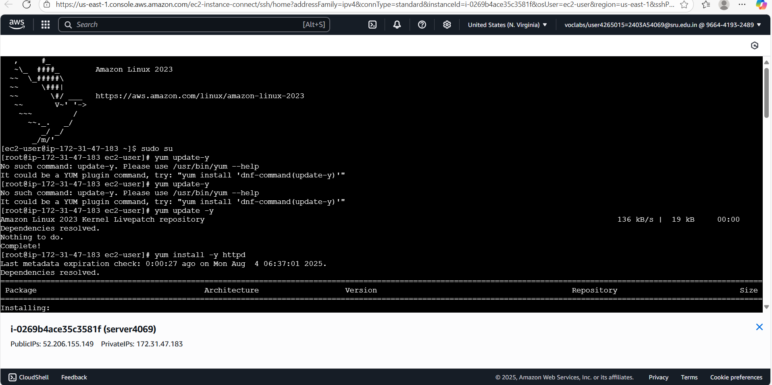

**STEP8:**

**STEP9:**

