**SR UNIVERSITY**

**AI assistant coding**

**ASSIGNMENT NO:02**

* *Name:*M.Saikumar
* **Roll no: 2403A54073**
* **Batch:03**

TASK:01

Write a function in python to display mean,minimum,maximum from the given list

CODE:

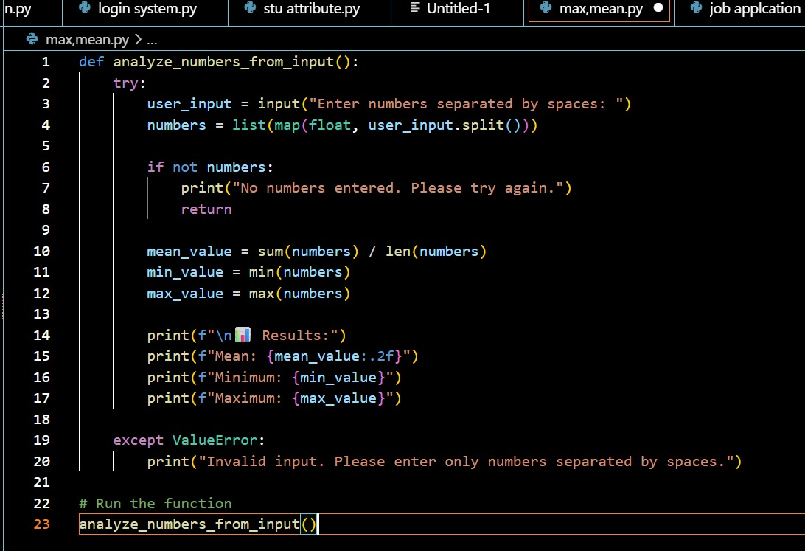

OUTPUT:

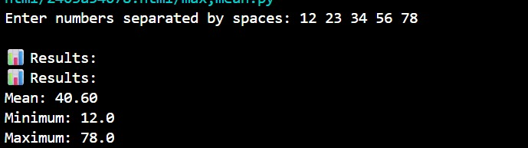

*EXPLANATION:*

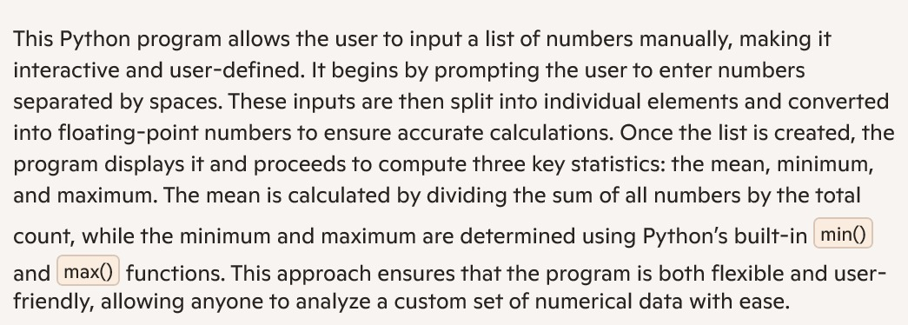

TASK:02

write a function in python which checks whether a number is an Armstrong number

CODE:

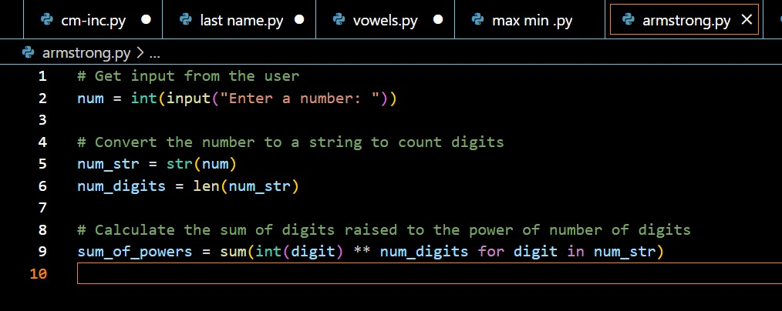

*OUTPUT*:

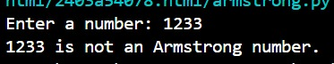

EXPLANATION:

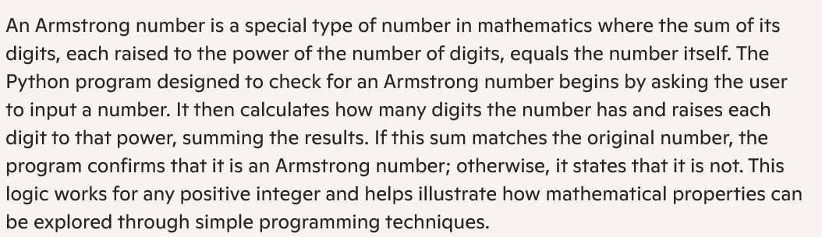

TASK:03

write a function in python which checks the number is prime or not using is_prime() and also checks if the number is palindrome or not using is_palindrome() and display the output

CODE:

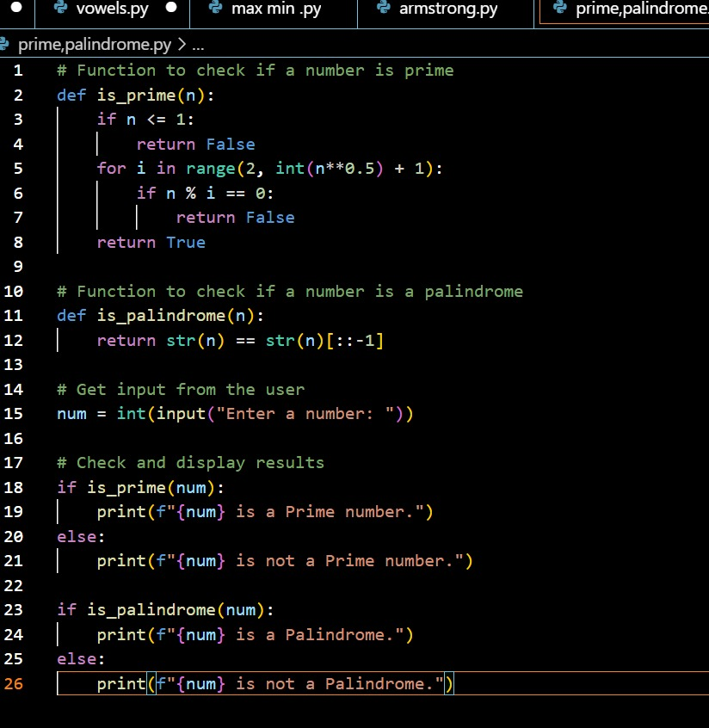

OUTPUT:

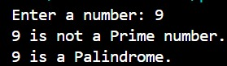

EXPLANATION:

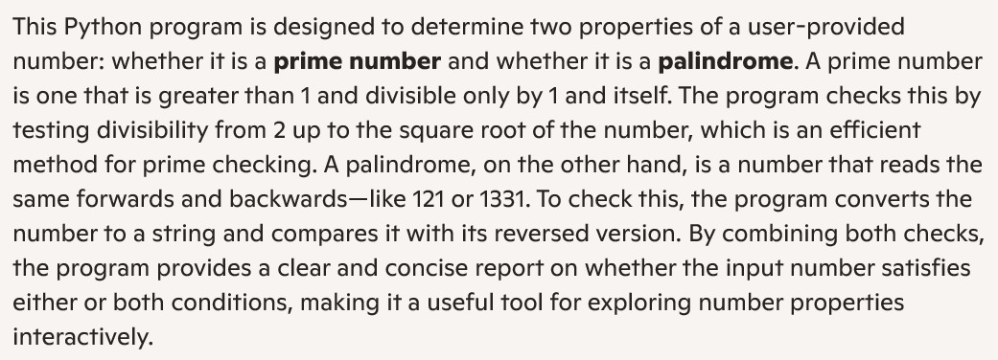

TASK:04

write a function python which takes input and prints the sum of first n natural numbers

CODE:

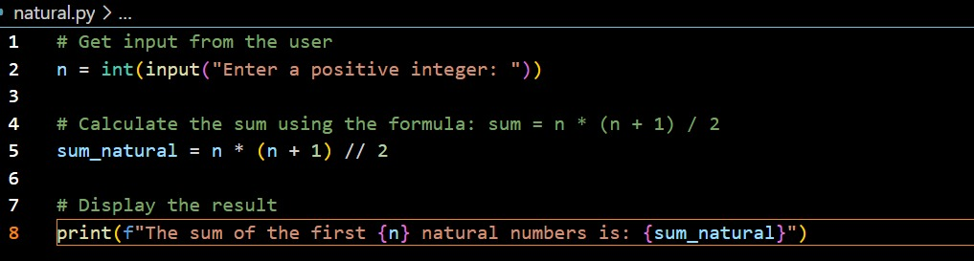

OUTPUT:



EXPLANATION:

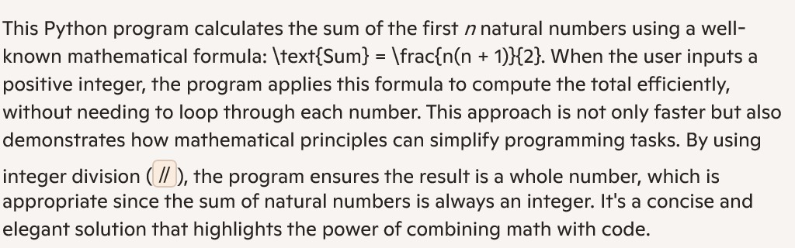

TASK:05

write a python program to calculate sum of odd and even numbers separated and display it

CODE:

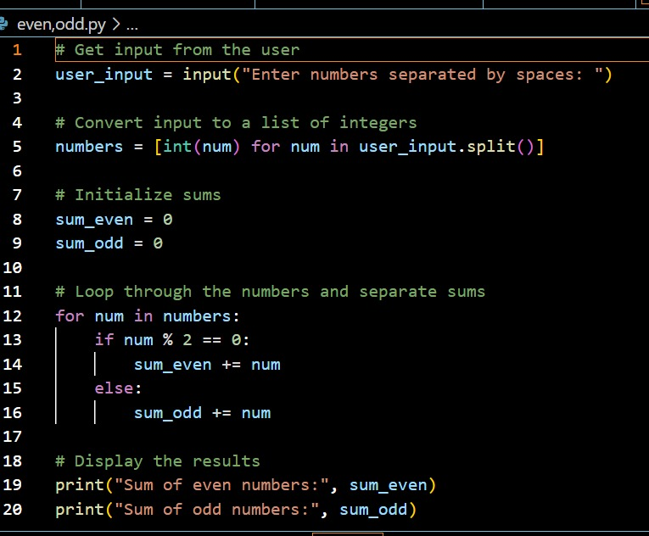

OUTPUT:

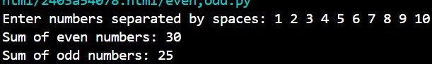

EXPLANATION:

