# Ai Assistant coding ASSIGNMENT NO:03

* ***NAME : M.Saikumar.***
* ***ENROLLMENT NO: 2403A54073***
* ***BATCH NO* : 03**
* **3.1:**

PROMPT*: Write program to calculate compound interest using functions*

Code:

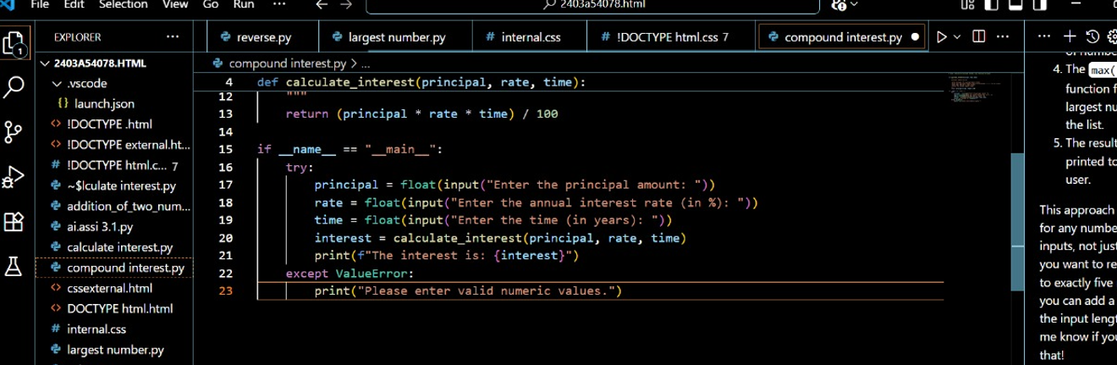

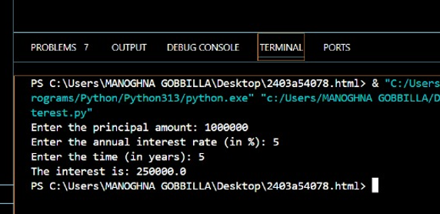

EXPLANATION:

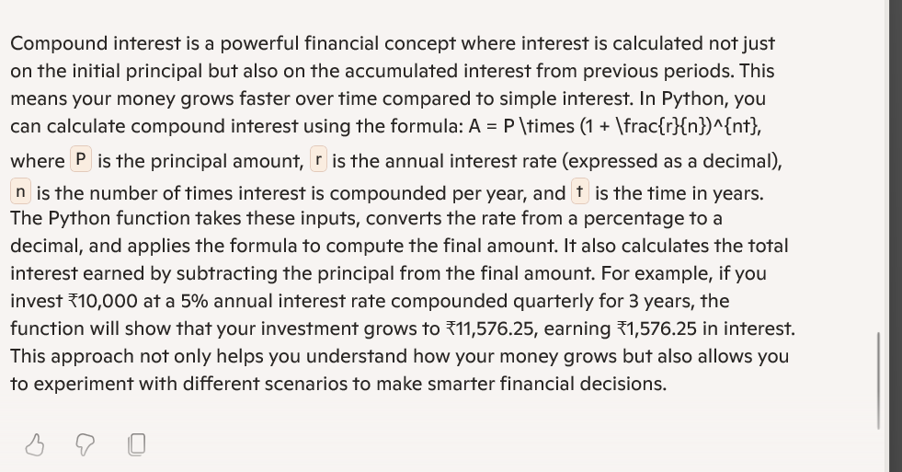

**3.2:**

PROMPT:**Write a python code to calculate average ,median,and mode of a given list of numbers**

CODE:

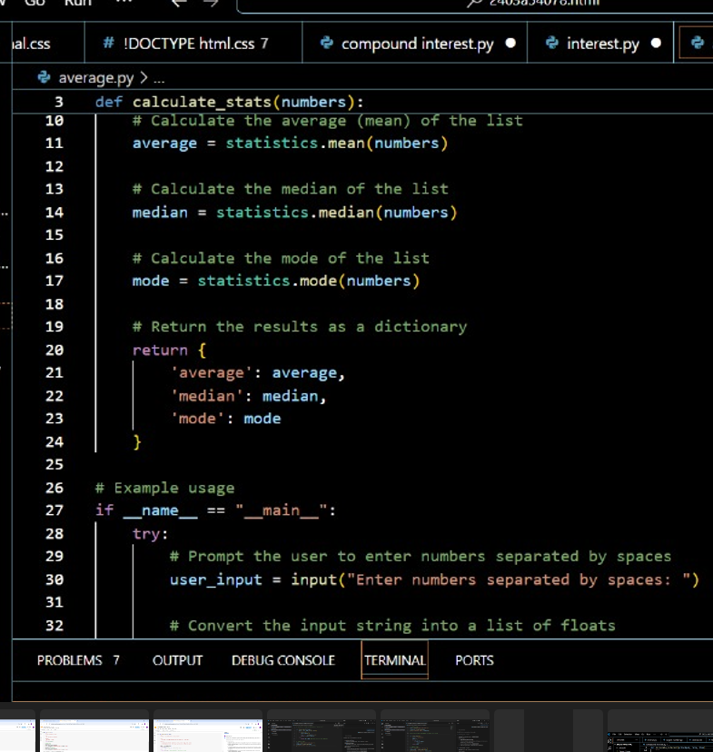

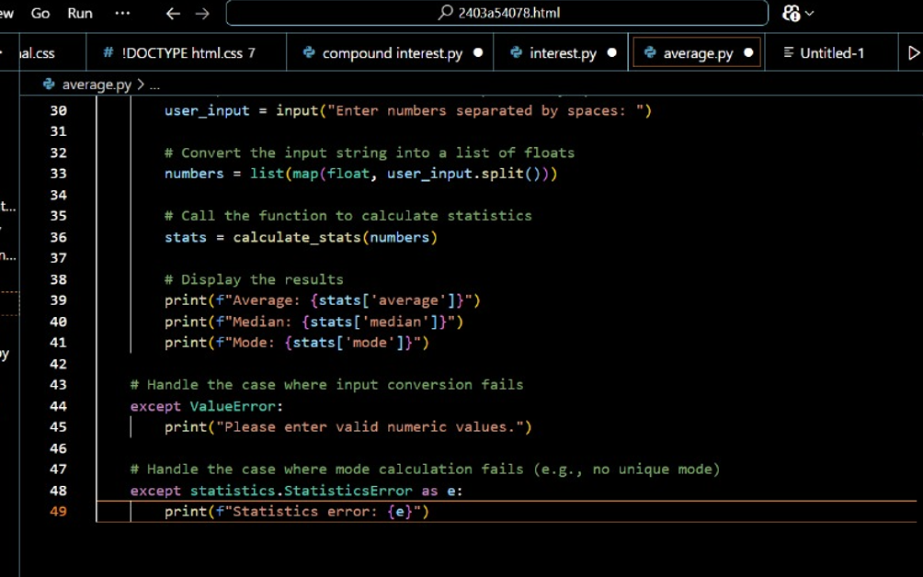

*Output:*



EXPLANATION**:**

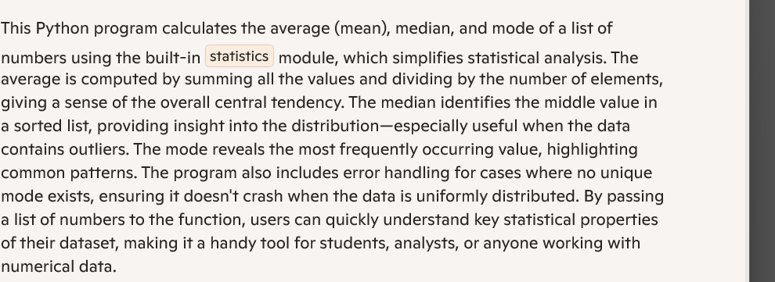

**3.3:**

*PROMPT***:Write a python code to convert given number into binary format**

*CODE:*

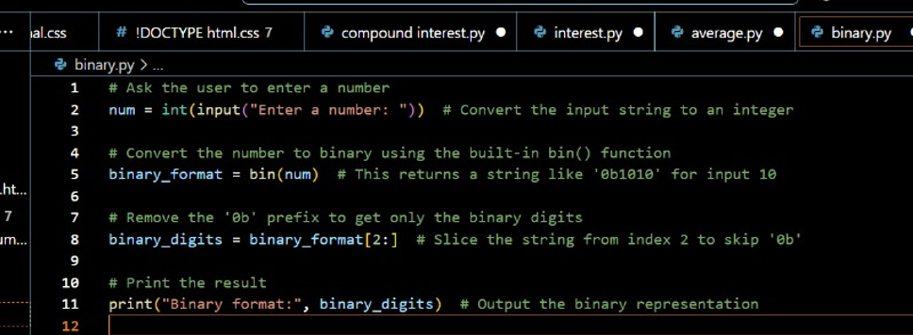

OUTPUT:

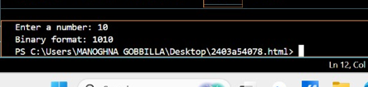

***EXPLANATION:***

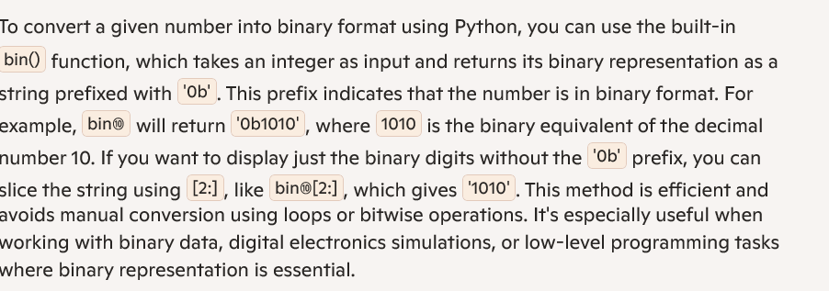

3.4:

*PROMPT*:Generate global user interface for an hotel based on customer requirements

CODE:

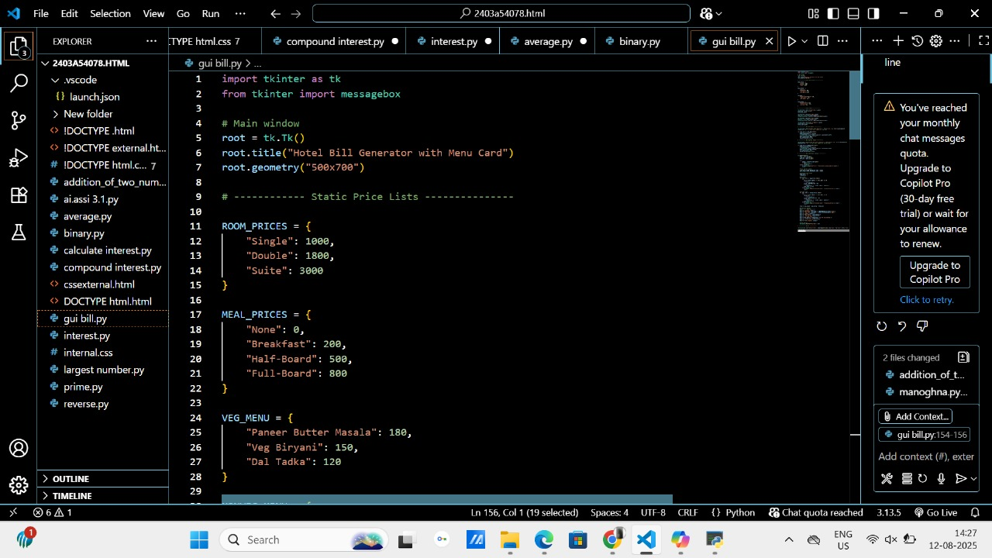

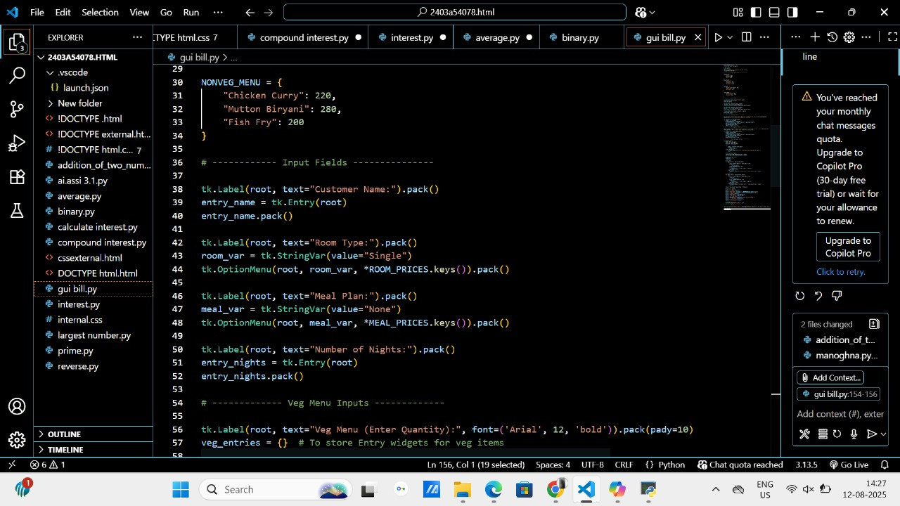

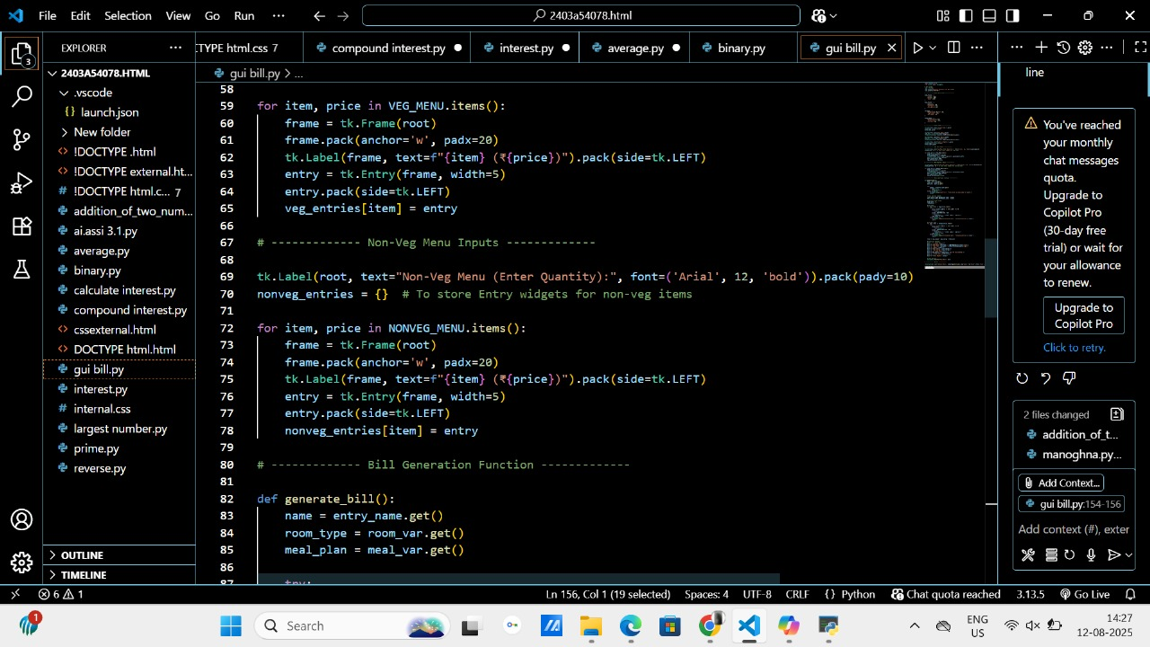

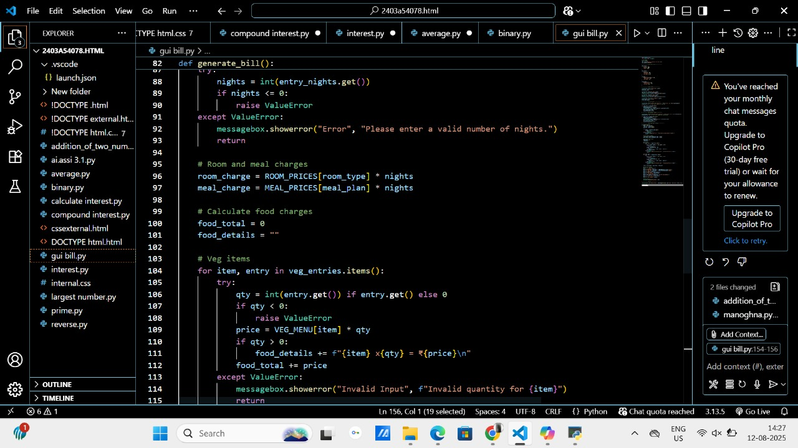

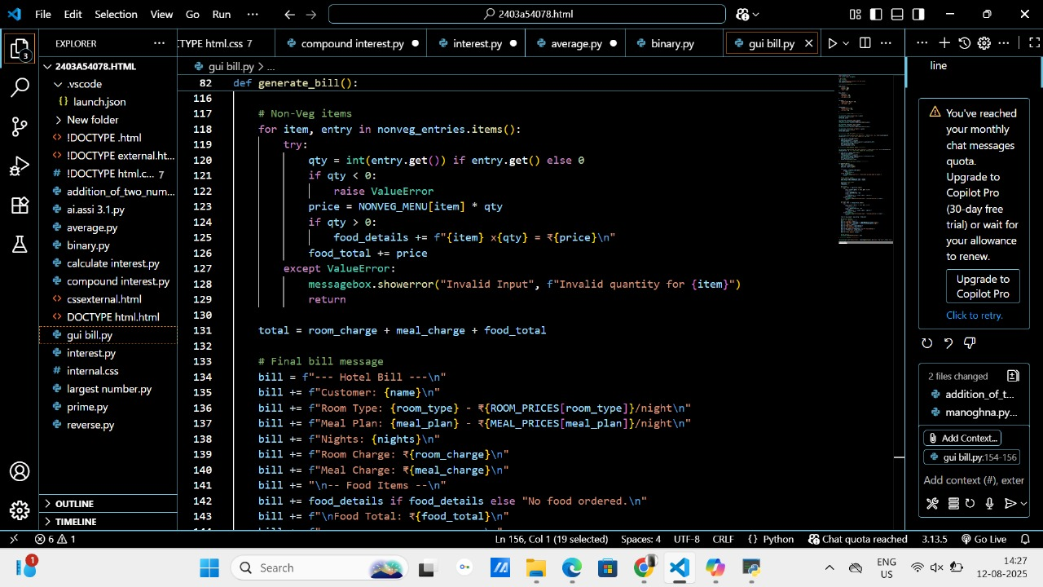

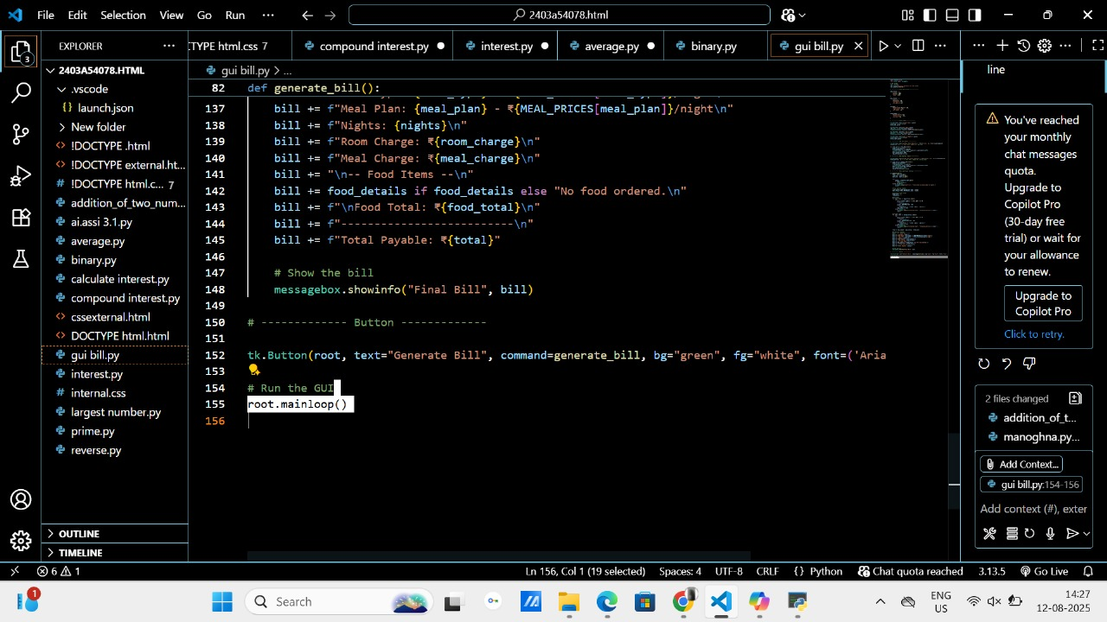

OUTPUT:

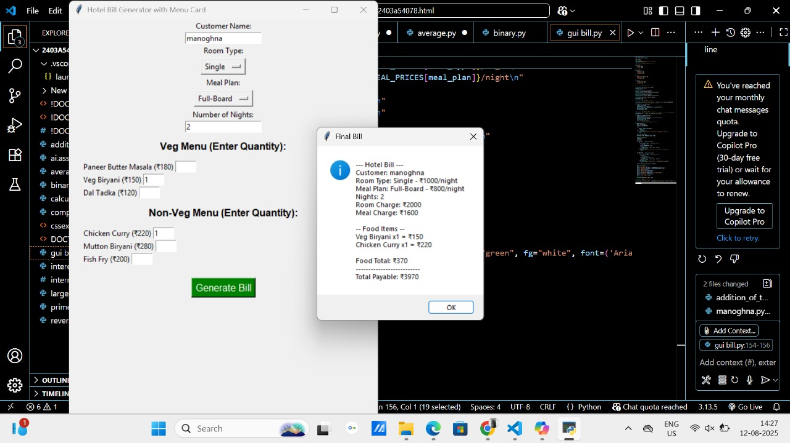

*EXPLANATION:*

