SR UNIVERSITY

**Ai assistant coding**

**ASSIGNMENT NO:04**

* **NAME : M.Sai kumar.**
* **ENROLLMENT NO: 2403A54073**
* **BATCH NO : 03**

***TASK:01***

***Zero-shot: Prompt AI to write a function that checks whether a given year is a leap year.***

***CODE:***

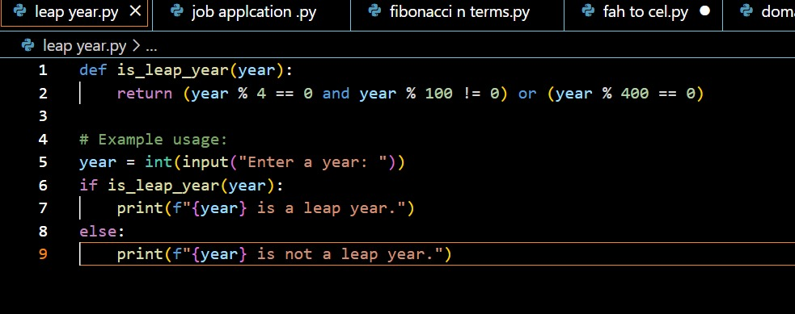

**OUTPUT:**

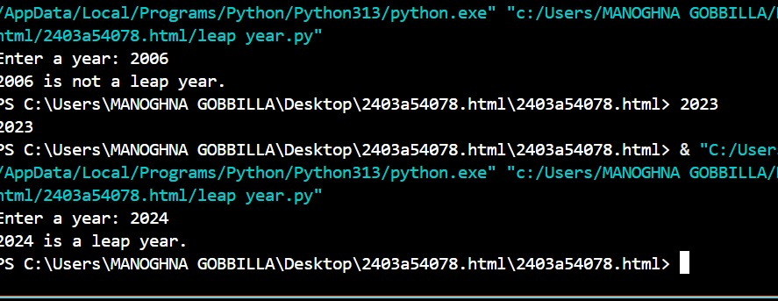

EXPLANATION:

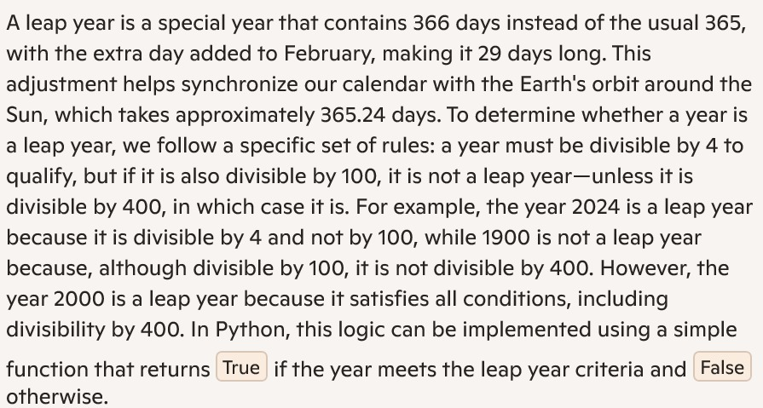

*TASK:02*

*One-shot: Give one input-output example to guide AI in writing a function that converts centimeters to inches.*

*CODE:*

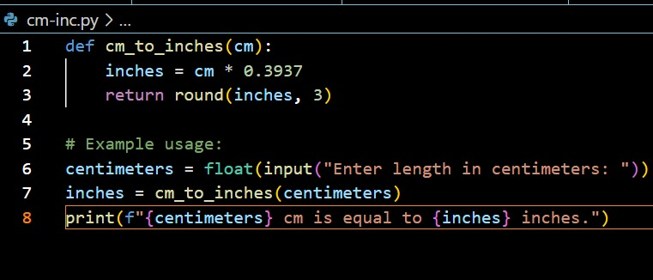

OUTPUT: 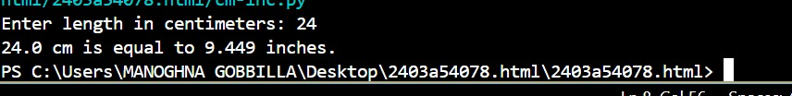

EXPLANATION:

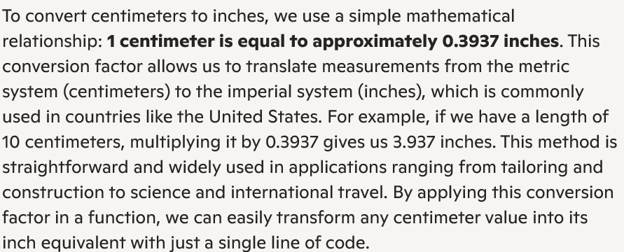

TASK:03

Few-shot: Provide 2–3 examples to generate a function that formats full names as “Last, First”

CODE:

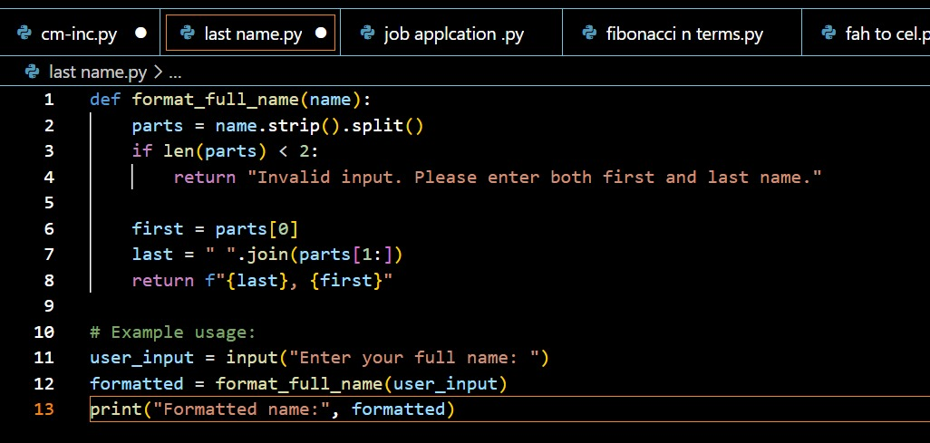

OUTPUT:

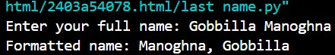

EXPLANATION:

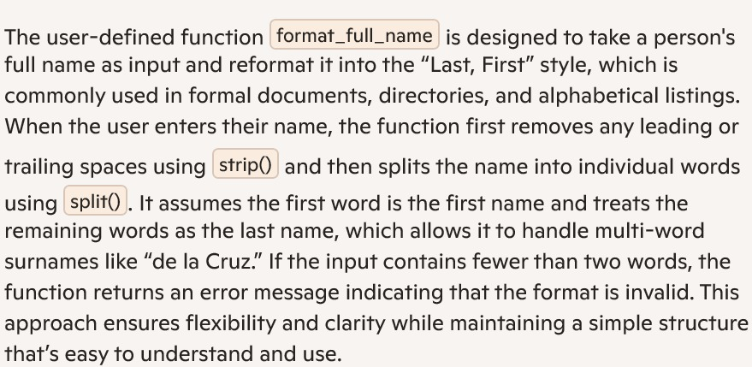

*TASK:04*

*Compare zero-shot and few-shot prompts for writing a function that counts the number of vowels in a string.*

*CODE:*

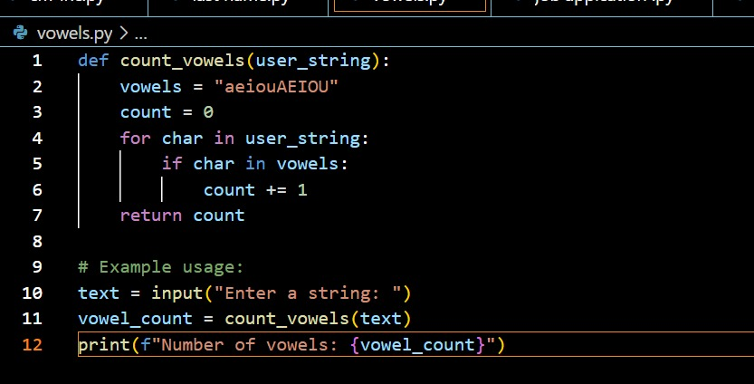

OUTPUT:

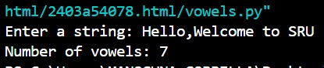

EXPLANATION:



TASK:05

Use few-shot prompting to generate a function that reads a .txt file and returns the number of lines

CODE:

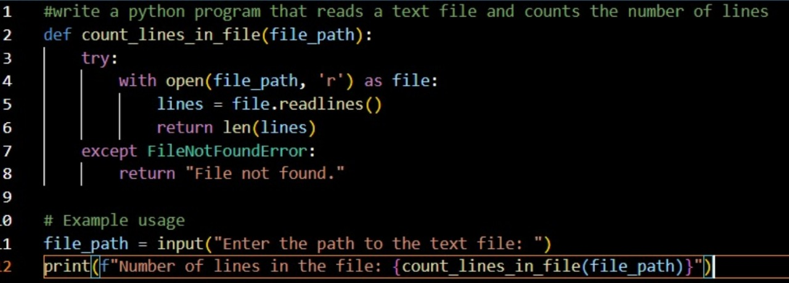

OUTPUT:

EXPLANATION:

