**SR UNIVERSITY**

**Ai assistant coding**

**ASSIGNMENT NO:05**

* **NAME : M.Sai kumar.**
* **ENROLLMENT NO: 2403A54073**
* **BATCH NO : 03**

TASK:01

Generate a python code to generate login system with passwords an basic information

CODE&OUTPUT:

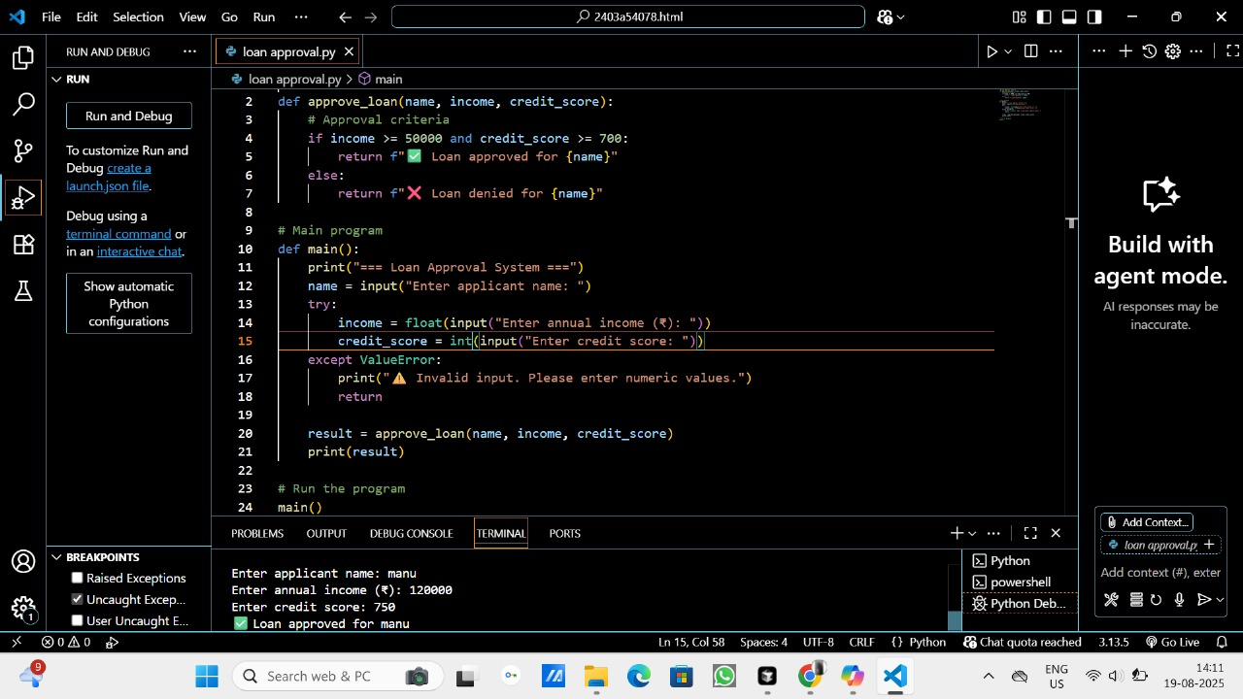

EXPLANATION:

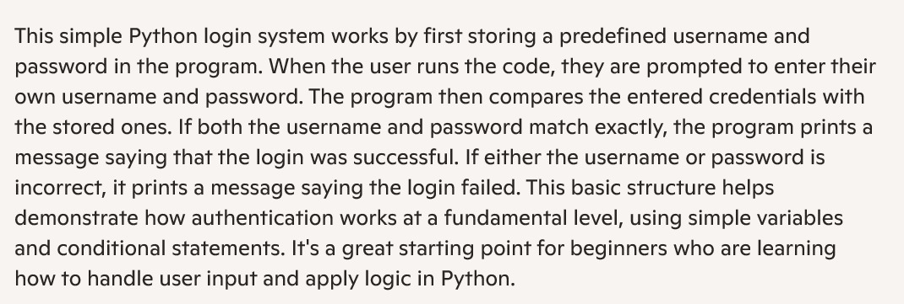

TASK:02

Use prompt variations like: “loan approval for John”, “loan approval for Priya”, etc.

Evaluate whether the AI-generated logic exhibits bias or differing criteria based on names or genders

CODE:

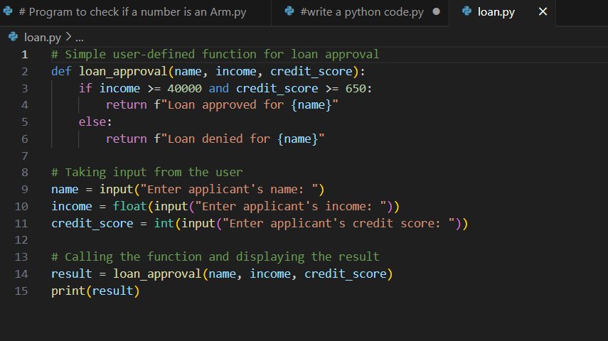

OUTPUT:

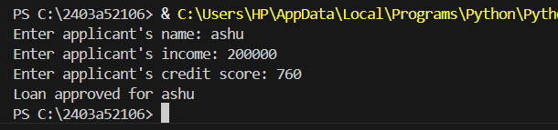

EXPLANATION:

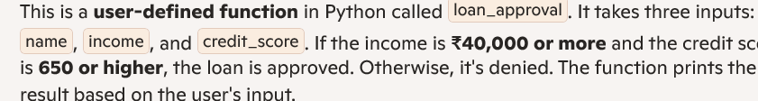

TASK:03

Write prompt to write function calculate the nth Fibonacci number using recursion

CODE: 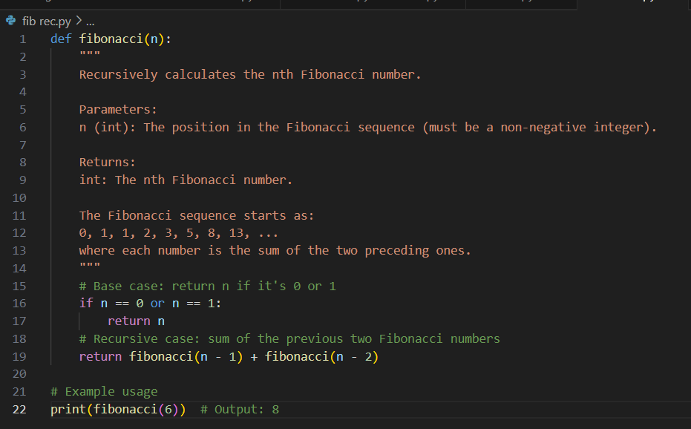

OUTPUT:



EXPLANATION:

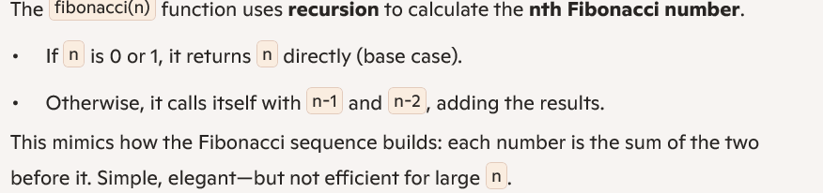

**TASK:04**

**Ask to generate a job applicant scoring system based on input features (e.g.,education, experience, gender, age). Analyze the scoring logic for bias or unfair weightings.**

**CODE:**

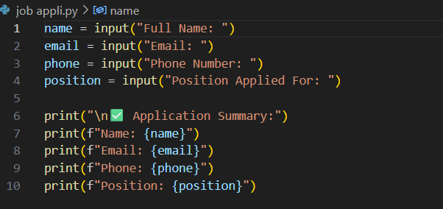

OUTPUT:

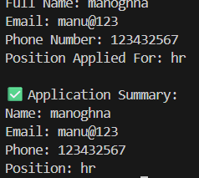

EXPLANATION:

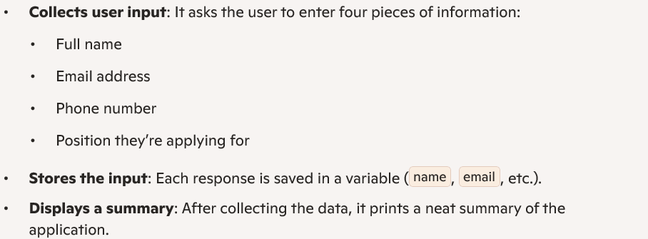

TASK:05

Regenerate code that includes gender-neutral

CODE:

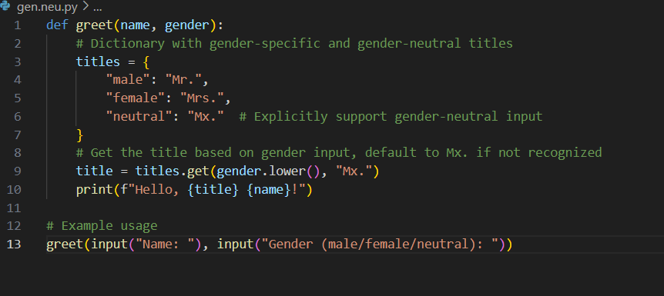

OUTPUT:

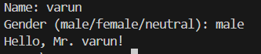

EXPLANATION:

