**SR UNIVERSITY**

**Ai assistant coding**

**ASSIGNMENT NO:06**

* NAME : M.Saikumar
* ENROLLMENT NO: 2403A54073
* BATCH NO : 03

**TASK:01**

**Start a Python class named Student with attributes name, roll_number, and marks. PromptGitHub Copilot to complete methods for displaying details and checking if marks are aboveaverage**

**CODE:**

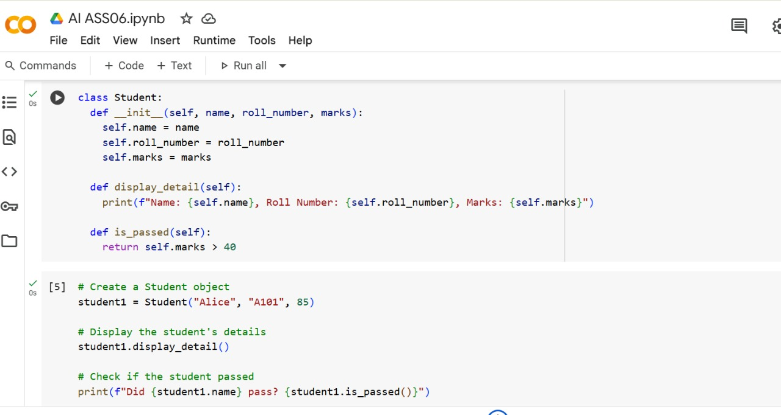

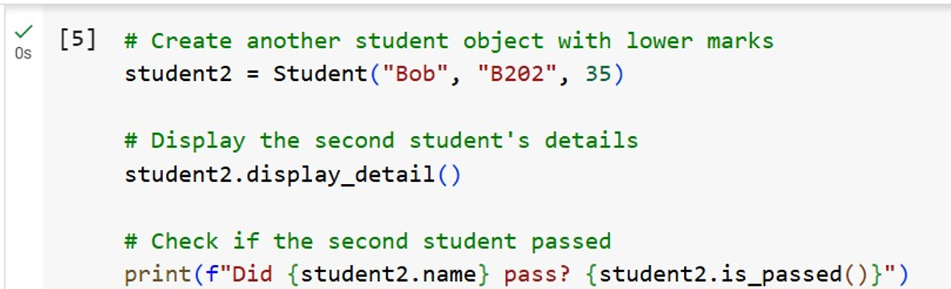

OUTPUT:

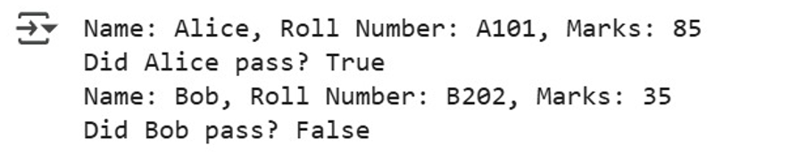

EXPLANATION:

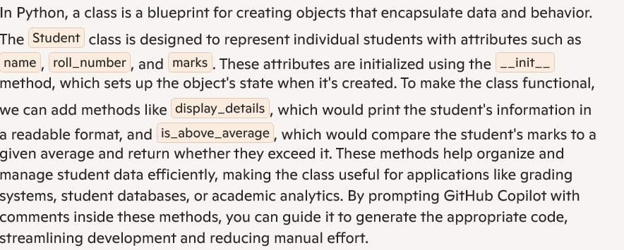

TASK:02

Write the first two lines of a for loop to iterate through a list of numbers. Use a comment prompt to let Copilot suggest how to calculate and print the square of even numbers only

CODE&OUTPUT:

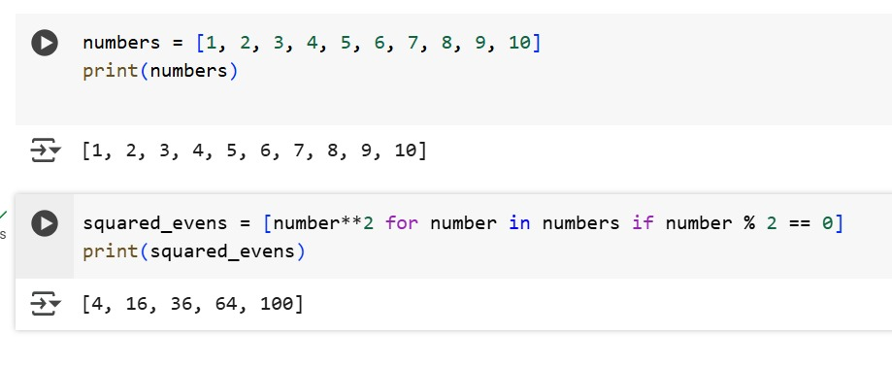

EXPLANATION:

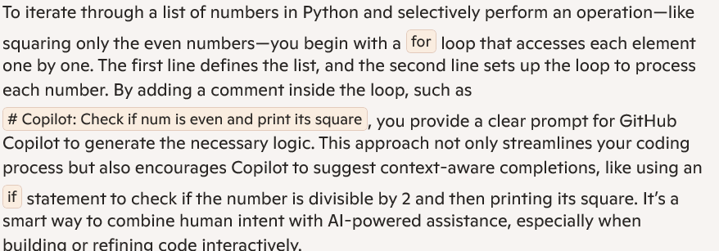

TASK:03

Create a class called BankAccount with attributes account_holder and balance. Use Copilot to complete methods for deposit(), withdraw(), and check for insufficient balance

CODE:

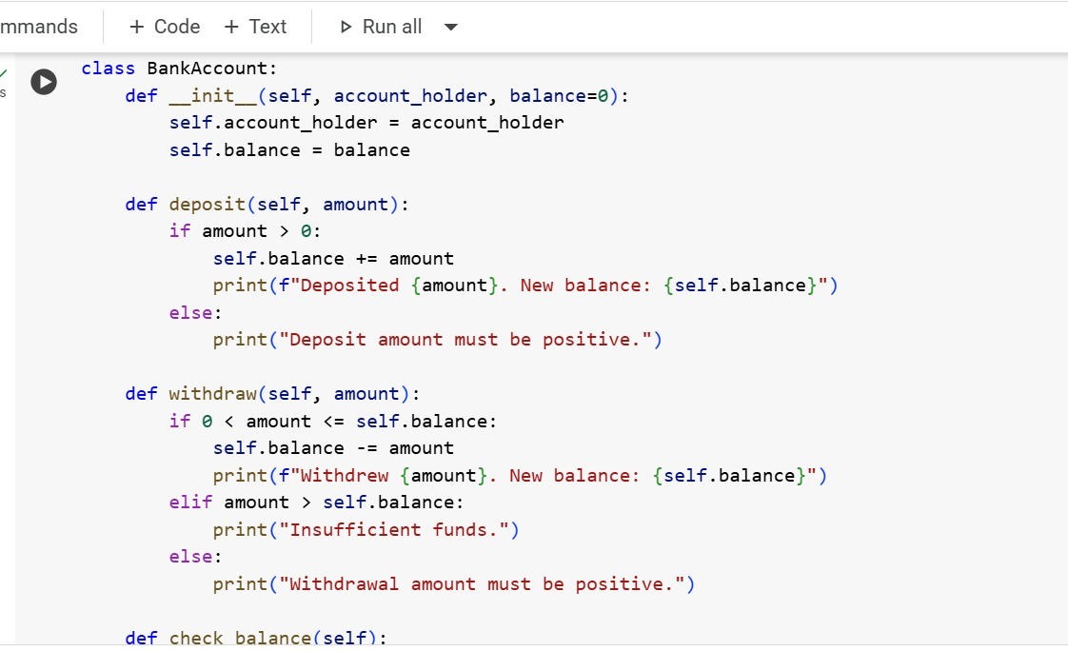

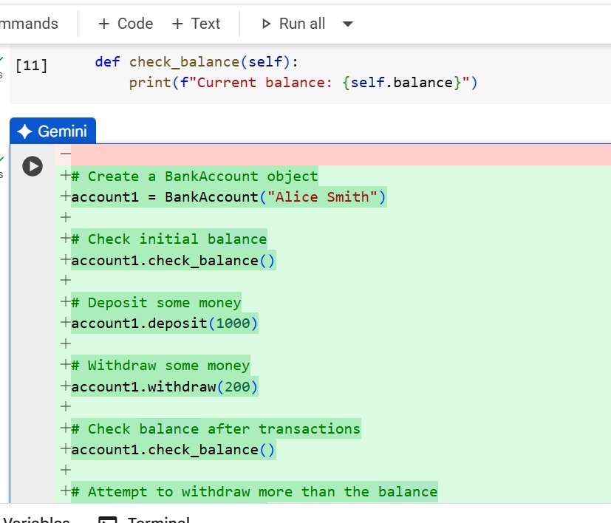

OUTPUT:

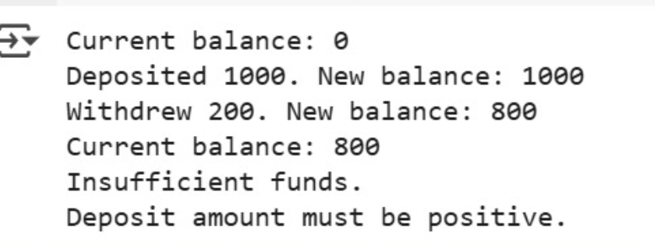

EXPLANATION:

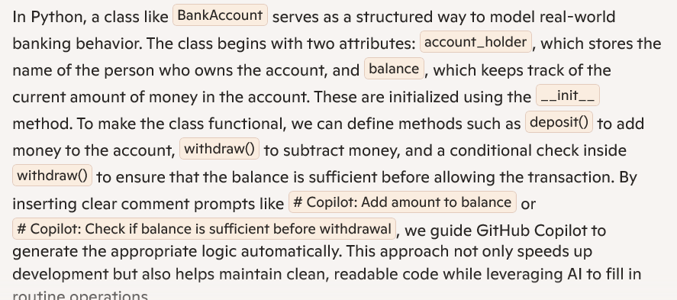

**TASK:04**

**Define a list of student dictionaries with keys name and score. Ask Copilot to write a while loop to print the names of students who scored more than 75.**

**CODE:**

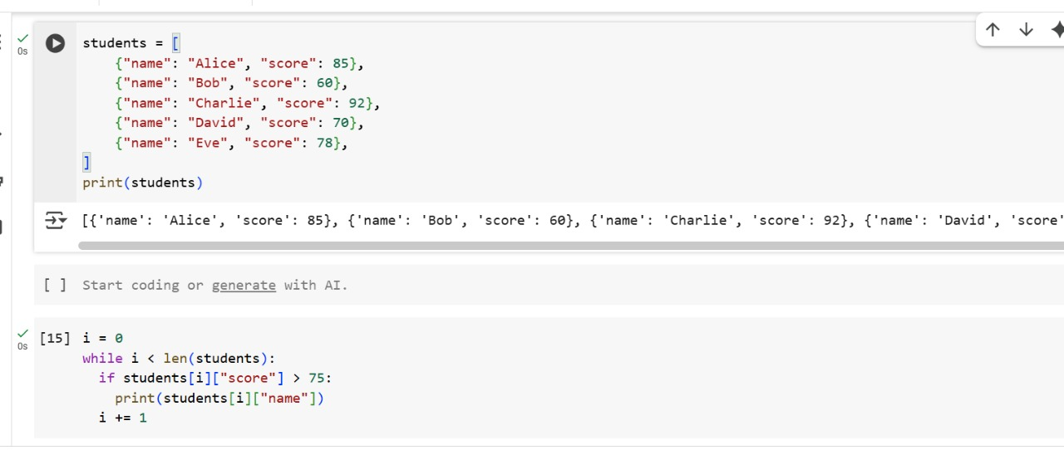

OUTPUT:

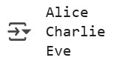

EXPLANATION:

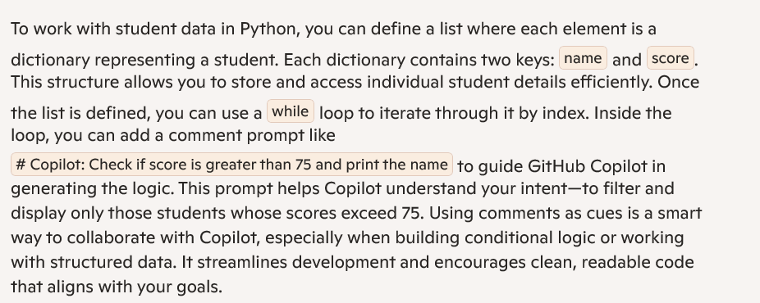

TASK:05

Begin writing a class ShoppingCart with an empty items list. Prompt Copilot to generate methods to add_item, remove_item, and use a loop to calculate the total bill using conditional discounts

CODE:

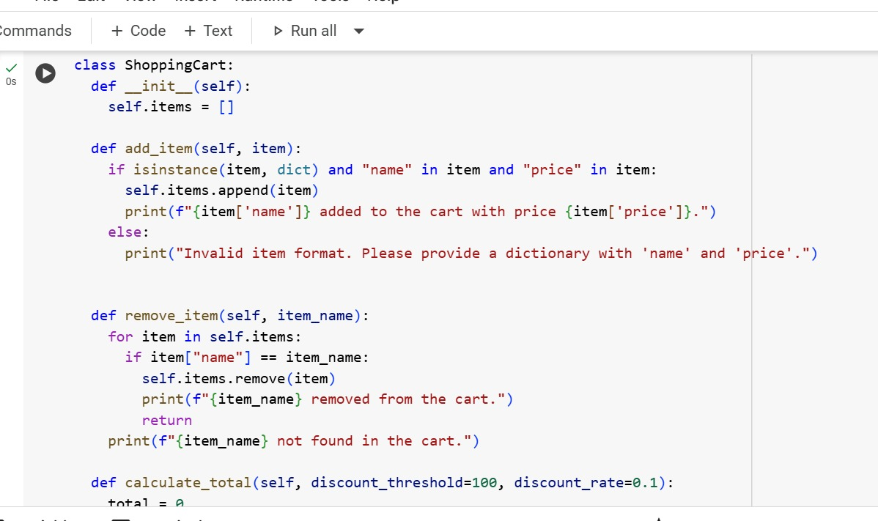

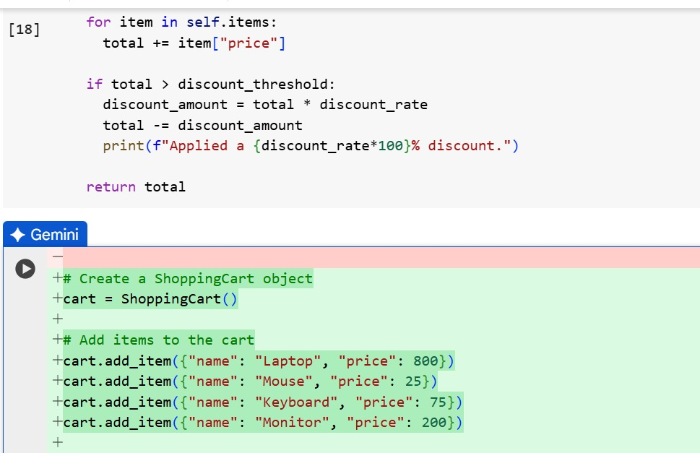

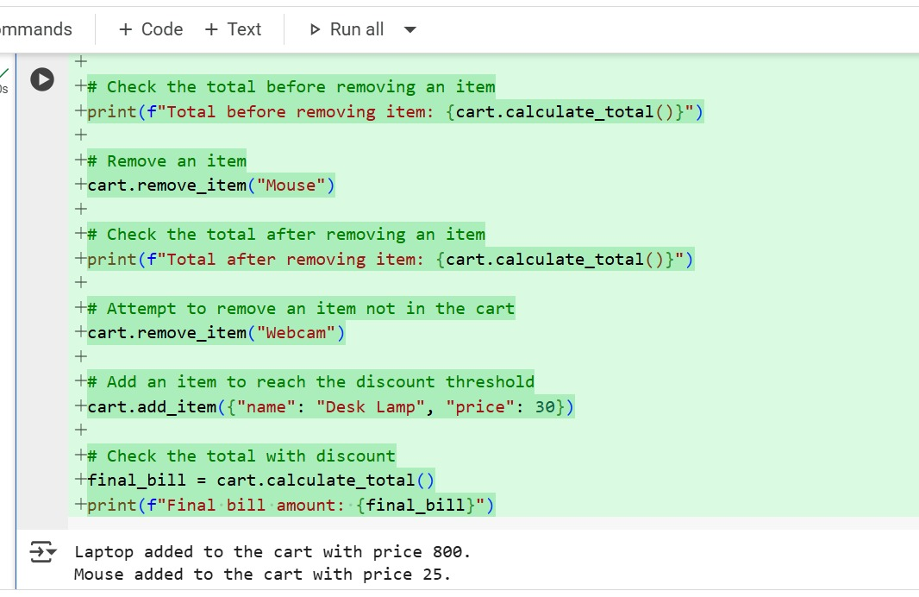

OUTPUT:

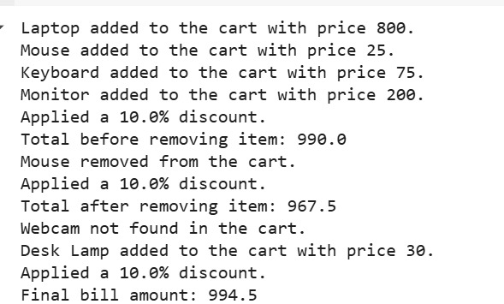

EXPLANATION:

