Assignment-6.4
Name:P.Sathwik
Roll No:2403A54075
Batch:03

Task Description #1:
• Start a Python class named Student with attributes name, roll_number, and marks. Prompt
GitHub Copilot to complete methods for displaying details and checking if marks are above
average.
Code:
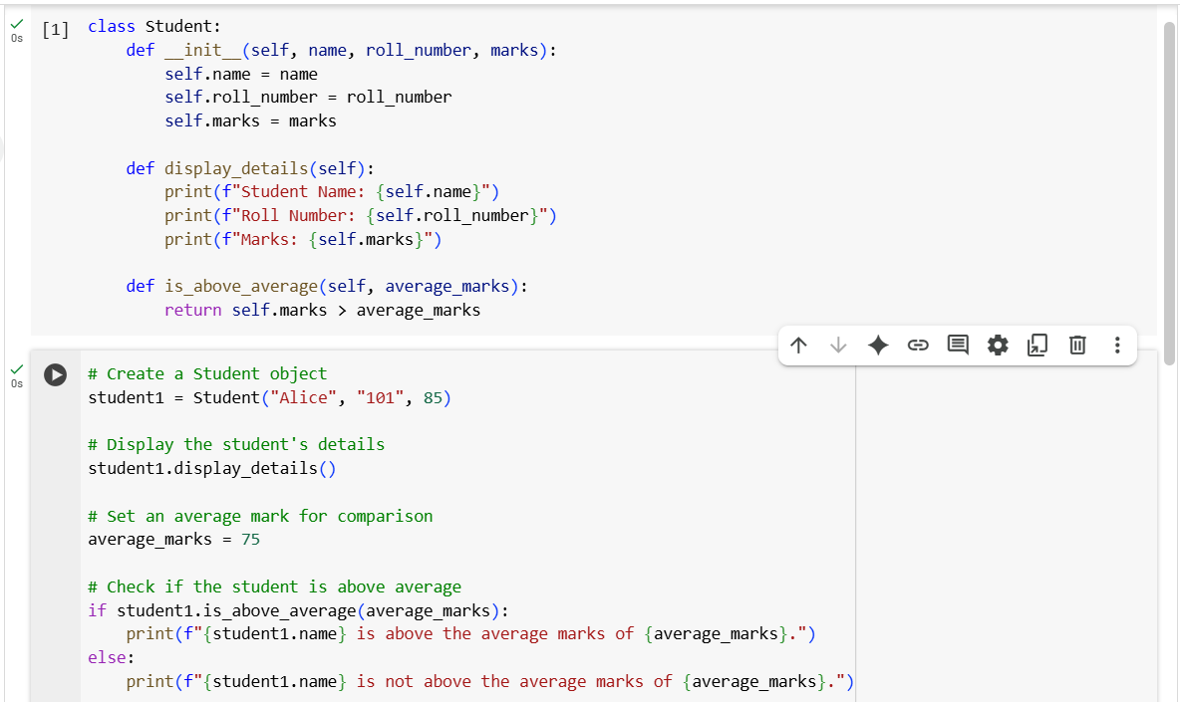
Explanation:
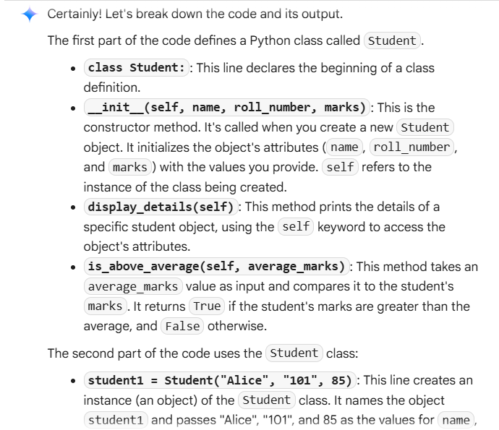
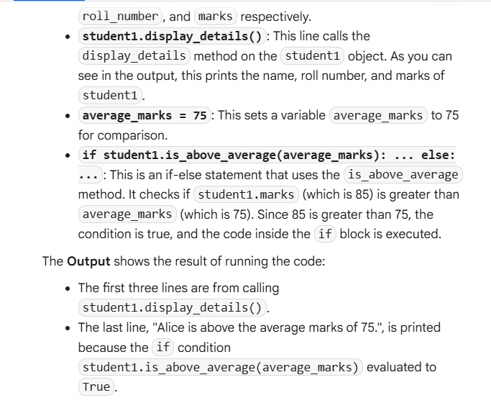
Task Description #2:
• Write the first two lines of a for loop to iterate through a list of numbers. Use a comment
prompt to let Copilot suggest how to calculate and print the square of even numbers only.
Code: 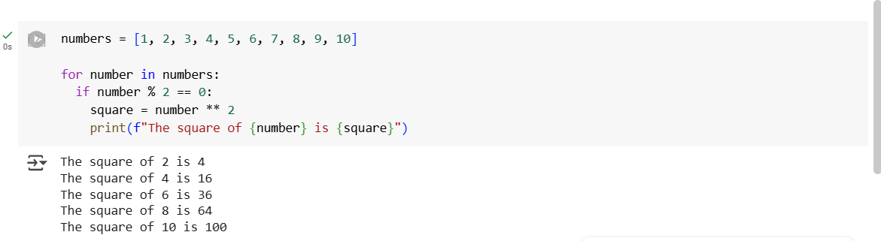
Explanation: 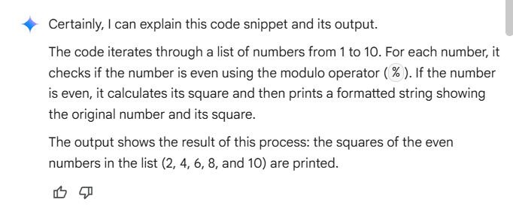

Task Description #3:
• Create a class called Bank Account with attributes account_holder and balance. Use Copilot to complete methods for deposit( ), withdraw( ), and check for insufficient balance.
Code:
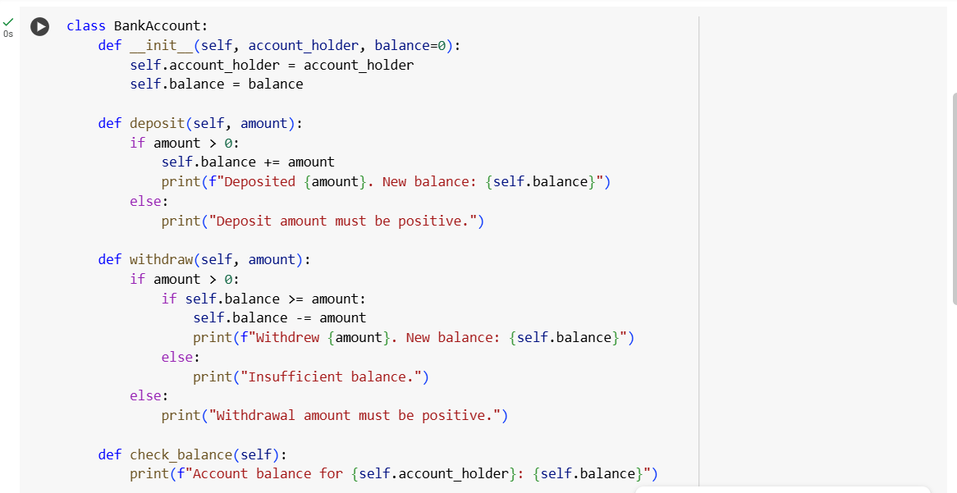
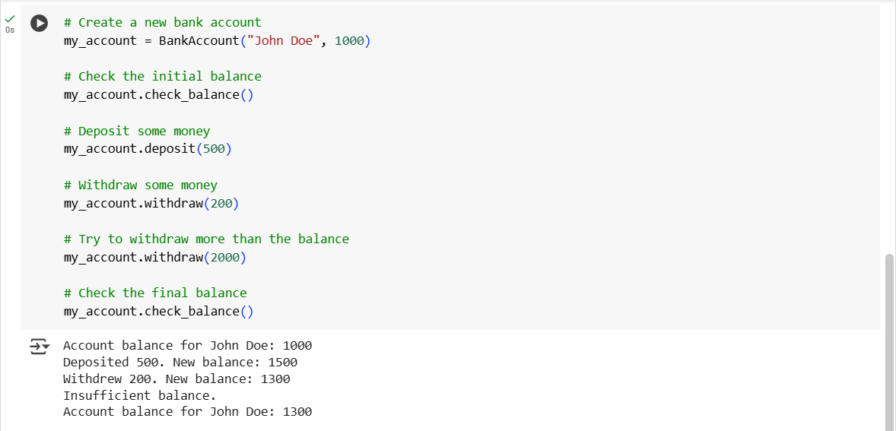
Explanation:
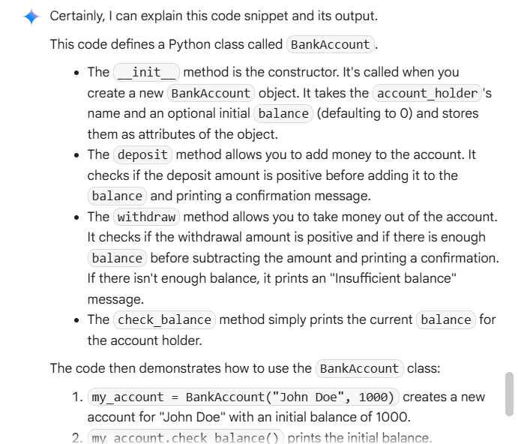
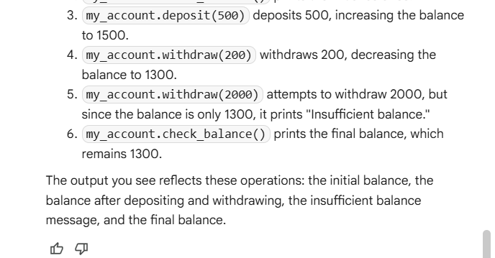

Task Description #4:
• Define a list of student dictionaries with keys name and score. Ask Copilot to write a while
loop to print the names of students who scored more than 75.
Code:
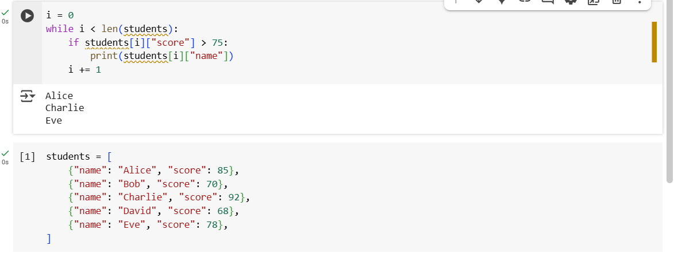
Explanation:
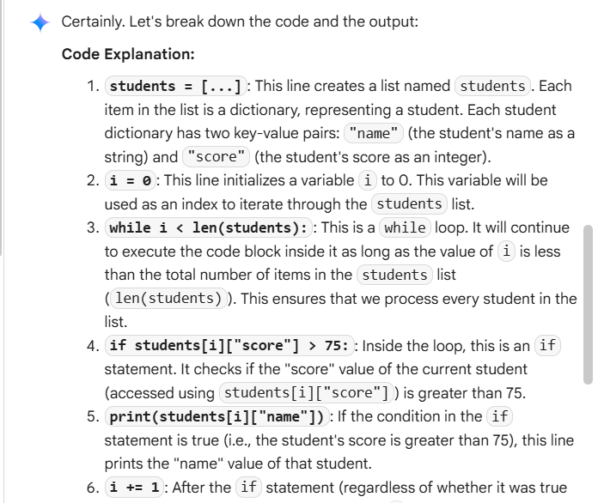
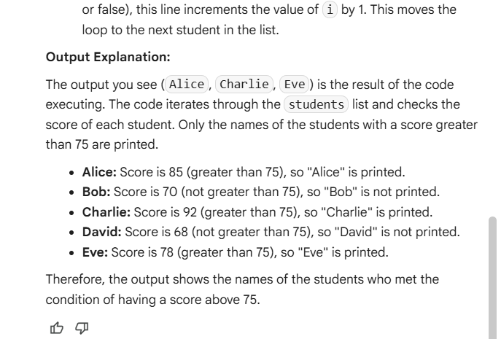

Task Description #5:
Begin writing a class ShoppingCart with an empty items list. Prompt Copilot to generate
methods to add_item, remove_item, and use a loop to calculate the total bill using conditional discounts.
Code:
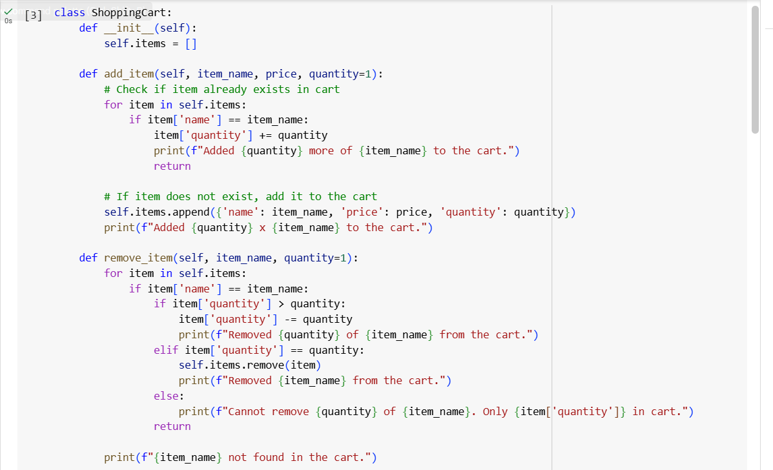
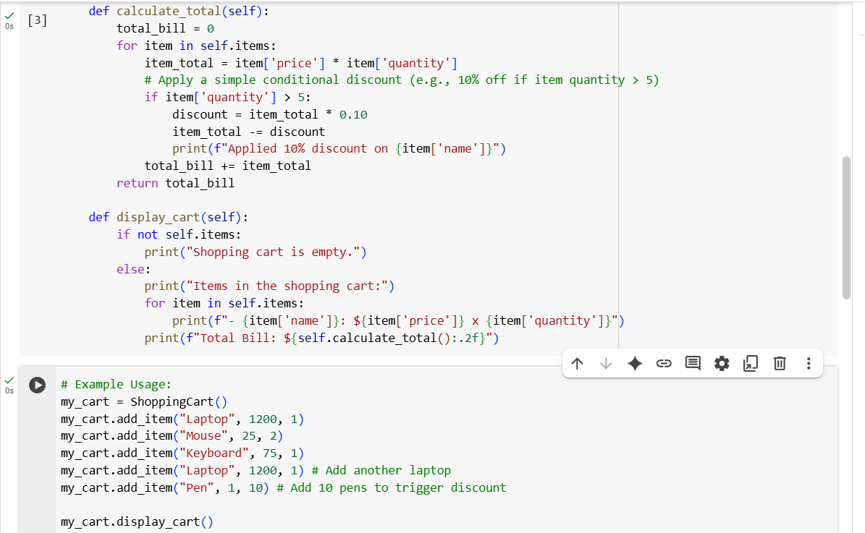
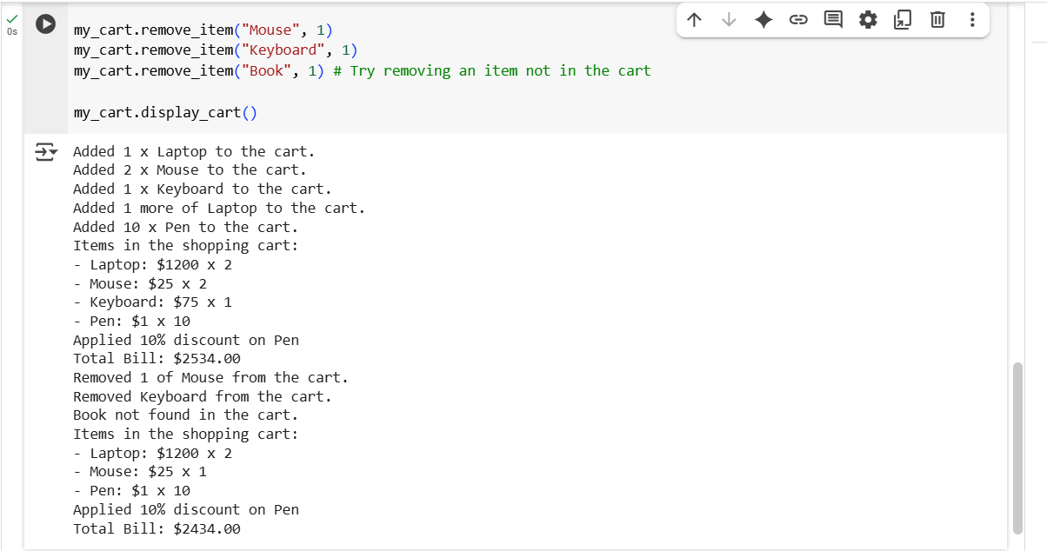
Explanation:
