AI ASSISTED CODING TEST-1

Set - B

QUESTION 2:

Write a Python program to extract all email addresses from a block of text using regular expressions. GitHub Copilot along with VS Code. Use zero shot prompting

PROMPT:

Write a Python program to extract all email addresses from a block of text using regular expressions.

CODE:

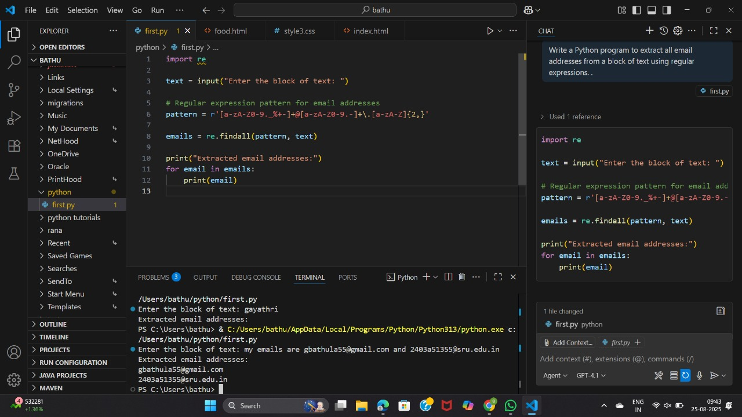

QUESTION 3:

given a list of movies with their genres, Write a Python function that recommends movies based on a user’s preferred genre. Use the Cursor AI tool. Use few shot prompting,

PROMPT:

given a list of movies with their genres, Write a Python function that recommends movies based on a user’s preferred genre

