Assignment 1

1. Install Anaconda
Anaconda is a distribution that makes it easy to manage Python environments and packages.
Steps:
- Go to the Anaconda official website.
- Download the installer for your operating system (Windows/Mac/Linux).
- Run the installer:
  - On Windows, check “Add Anaconda to PATH” if asked (recommended).
  - Choose Just Me unless you want it for all users.
- After installation, open Anaconda Navigator or Anaconda Prompt to verify.
conda --version
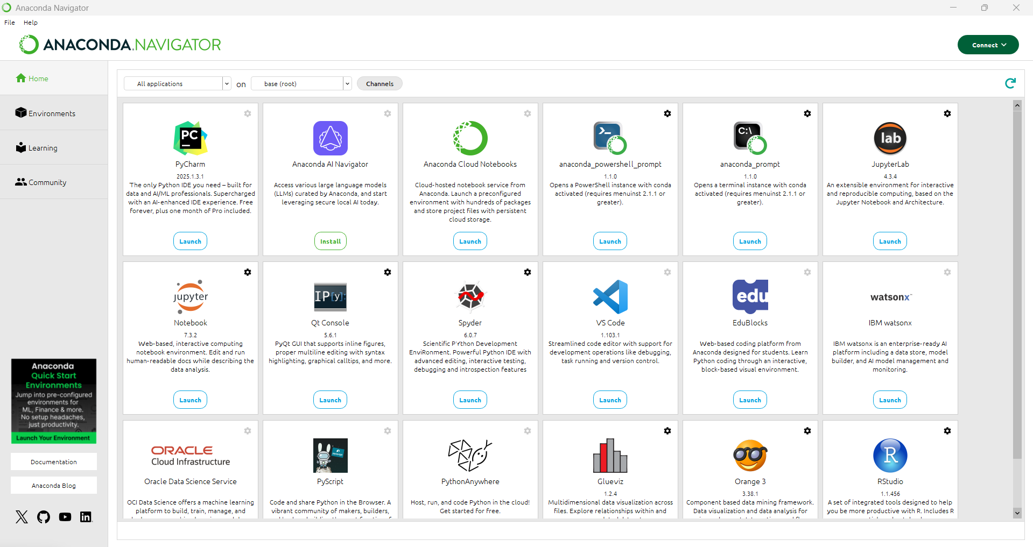

2. Install Visual Studio Code (VS Code)
- Download from VS Code official site.
- Run the installer:
  - Select Add to PATH and Register Code as an editor during setup.
- After installation, open VS Code.
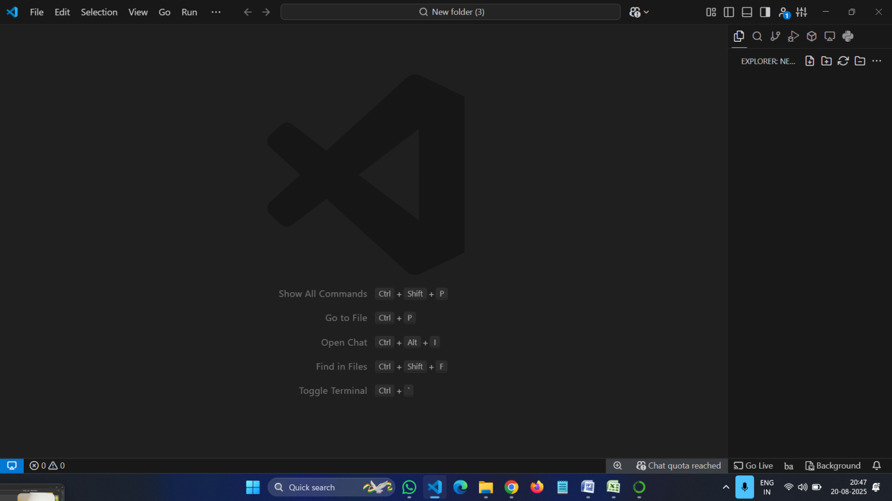

3. Create a GitHub Account
- Go to GitHub Sign Up.
- Click Sign up.
- Enter:
  - Email
  - Username
  - Password
- Verify your account (GitHub might ask for CAPTCHA or email confirmation).
- Once done, you have your GitHub profile ready.
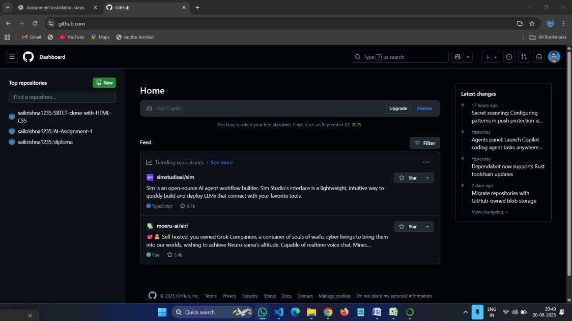

4. Install GitHub Copilot in VS Code
GitHub Copilot is an AI coding assistant.
Steps:
- Open VS Code.
- Go to Extensions Marketplace (left sidebar or press Ctrl+Shift+X).
- Search for GitHub Copilot.
- Click Install.
- After installation:
  - Sign in with your GitHub account.
  - Grant permission for Copilot to access VS Code.
- Restart VS Code.
- Now, when you type code, Copilot will suggest completions.
