Assignment-2

1. Install PyCharm
PyCharm is an IDE by JetBrains for Python development.
Steps:
- Go to PyCharm Download page.
- Choose Community Edition (Free) or Professional (Paid).
- Download the installer for your OS (Windows/Mac/Linux).
- Run the installer and follow the setup wizard.
  - On Windows: Check Add “bin” folder to the PATH and Create Desktop Shortcut if asked.
- After installation, open PyCharm.
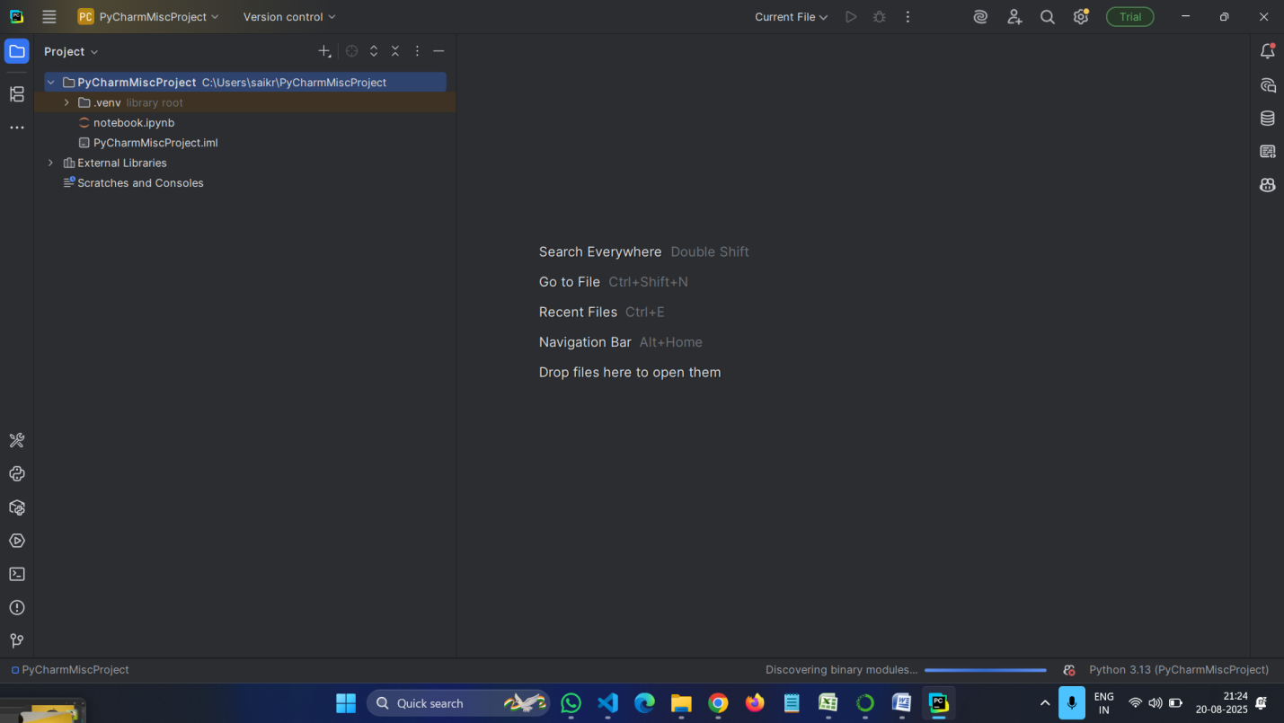

2. Install JetBrains Plugins in PyCharm
PyCharm allows you to add plugins for extra features.
Steps:
- Open PyCharm.
- Go to File > Settings > Plugins (or Preferences > Plugins on Mac).
- In the Marketplace tab:
  - Search and install useful plugins (example: Python packages, Markdown, Database Tools, etc.).
- Restart PyCharm after installing plugins.

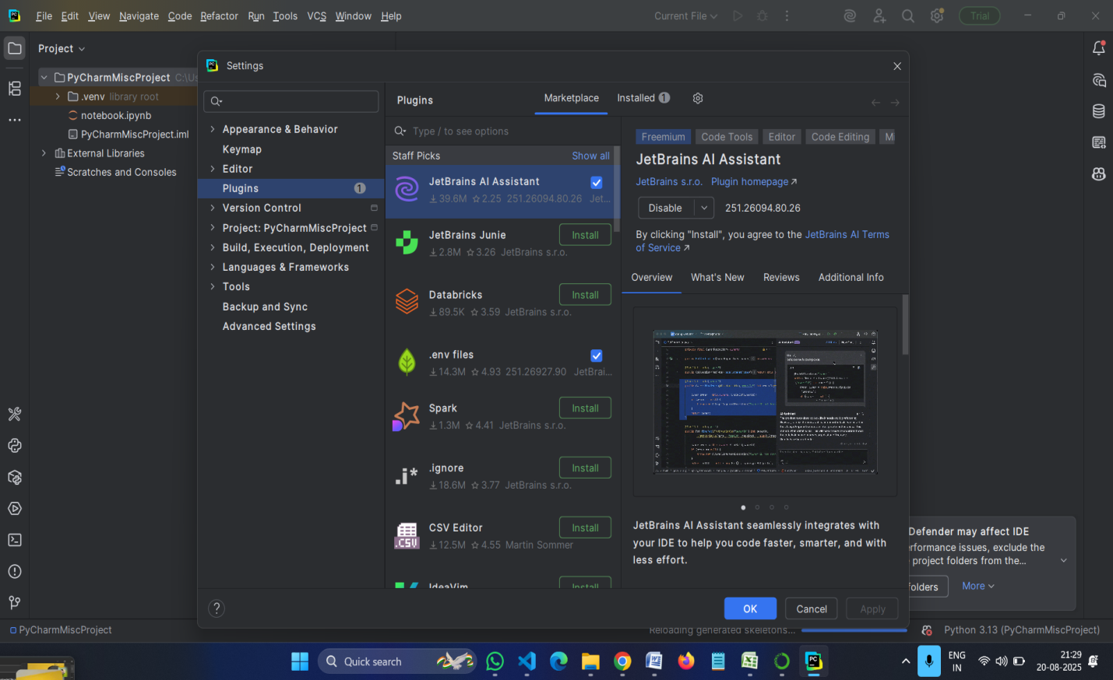

3. Install GitHub Copilot in PyCharm
GitHub Copilot also works in JetBrains IDEs like PyCharm.
Steps:
- Open PyCharm.
- Go to File > Settings > Plugins.
- In the Marketplace tab, search for GitHub Copilot.
- Click Install.
- After installation, restart PyCharm.
- Sign in with your GitHub account when prompted.
  - A browser window will open → authorize PyCharm to use GitHub Copilot.
- After successful login, GitHub Copilot will start suggesting code completions in PyCharm.

