 | SR UNIVERSITY  Campus Warangal
 | Program: II - B. Tech (CS& AI)
 | Faculty: Dr. Brij Kishor Tiwari
 | Department: Computer Science and AI Semester: I
 | AI Assisted Coding - Lab Test 1
Instructions:
- Use AI Tools like VScode+Github Copilot and Cursor AI for code generation
- This Assignment will be evaluated for 15 Marks (10 Marks for Tasks and 5 Marks for viva based on regular lab activities)
- Students need to submit assignment through canvas before due date
- Students who are absent for lab will receive 0 Marks

NAME:V.Varshini
HALL TICKET: 2403A54106
Q1. Context-Aware Prompt Design [5 M]
- Task: Write two different prompts to get a summarized news report from an AI model.
  - One with poor context.
  - One with detailed context (e.g., specify tone, target audience, and summary length).
- Compare the outputs and explain which is more effective and why.

- 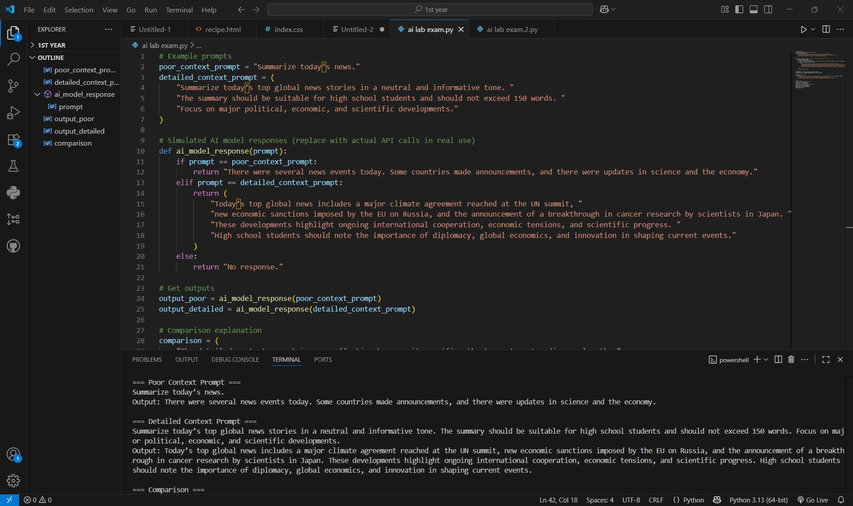
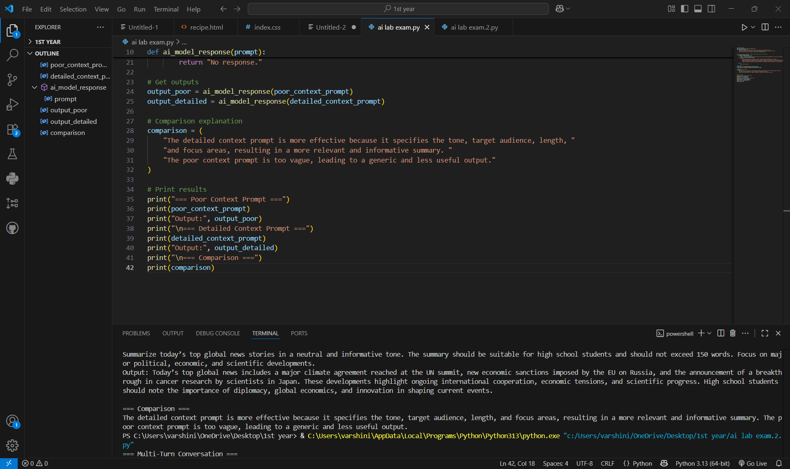

Q2. Multi-Turn Prompting Design [5 M]
- Scenario: You are designing a chatbot for customer support.
- Task: Write a sequence of 3 prompts where each uses the previous response as context (conversation continuity).
- Evaluate how context improves the AI’s accuracy.

- 
 