**Assignment-6**

**Name:** **Manchikatla Deekshitha**

**Hall Ticket No**: **2403A54125**

**Batch** :**04(Ds)**

**Task Description #1:**  
• Start a Python class named Student with attributes name, roll_number, and marks. Prompt  
GitHub Copilot to complete methods for displaying details and checking if marks are above  
average.

**CODE:**

Prompt1: create a new python cell and type the class skeleton

Prompt2: write methods display_details() to print details and is_passed() to check if marks are above 40

prompt3: test the class by creating objects

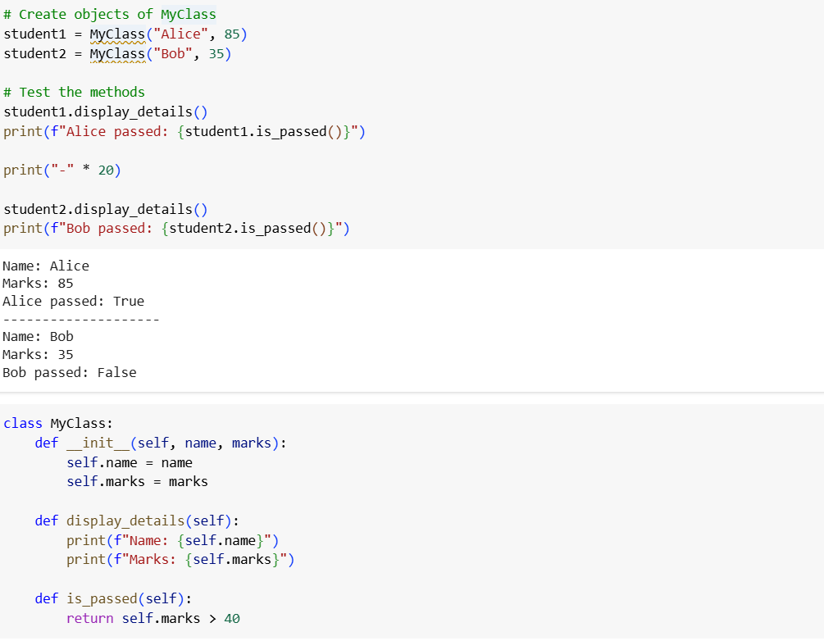

**Task Description #2:  
• Write the first two lines of a for loop to iterate through a list of numbers. Use a comment  
prompt to let Copilot suggest how to calculate and print the square of even numbers only**

**CODE:**

prompt1:start by creating a python list of numbers

prompt2:calculate and print the square of even numbers only 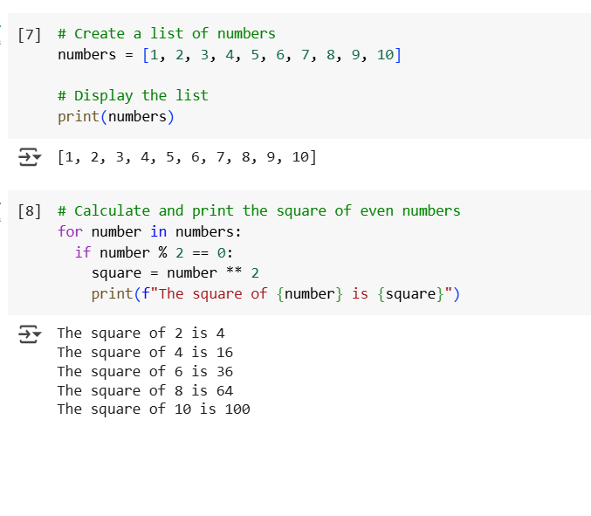

**Task Description #3:  
• Create a class called Bank Account with attributes account_holder and balance. Use Copilot to  
complete methods for deposit(), withdraw(), and check for insufficient balance.**

**CODE:**

Prompt 1: write the class skeleton with attributes

Prompt 2: generate methods def deposit(self,amount)

Prompt 3: add a method to check balance

Prompt 4:test the class by creating objects

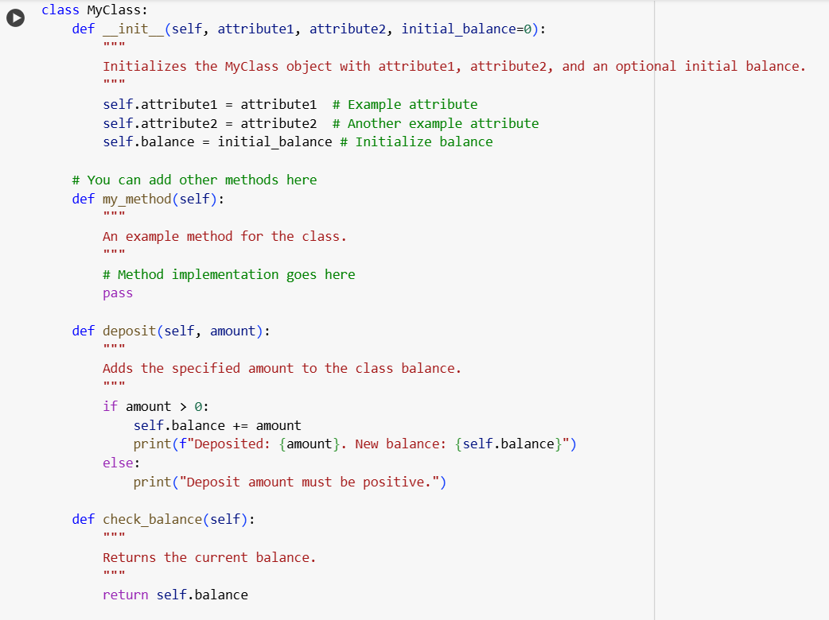

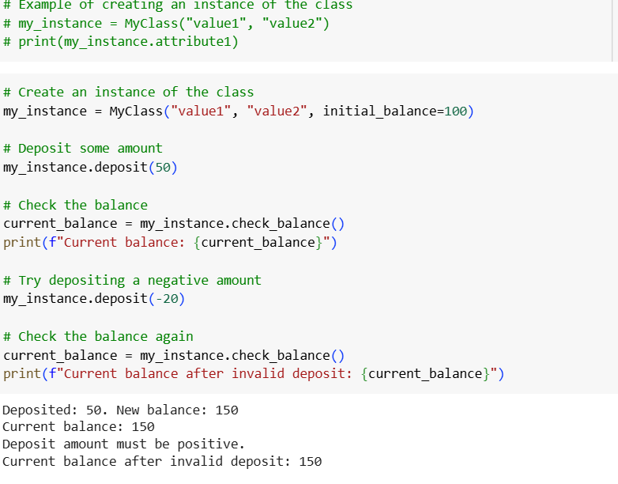

**Task Description #4:  
• Define a list of student dictionaries with keys name and score. Ask Copilot to write a while  
loop to print the names of students who scored more than 75.**

**CODE:**

**Promt1:**start by defining a list of students dictionaries with NAME ans score

**Prompt2 :**set up a while loop skeleton

**Prompt3:** complete the logic for flitering and printing the names of students who scored more than 75. 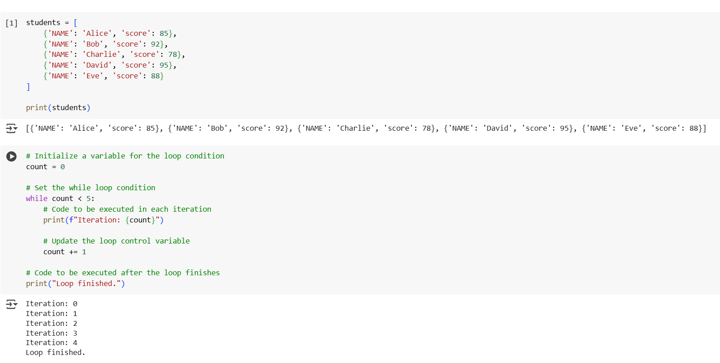

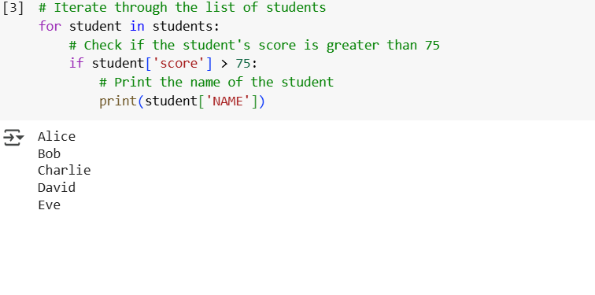

**Task Description #5:**

**• Begin writing a class ShoppingCart with an empty items list. Prompt Copilot to generate methods to add_item, remove_item, and use a loop to calculate the total bill using conditional discounts.**

**CODE:**

Prompt 1: Write a class ShoppingCart with an empty items list

Prompt 2: Generate methods to add_item, remove_item in the list

Prompt 3: use a loop to calculate the total bill using conditional discounts. 