SCHOOL OF COMPUTER SCIENCE AND ARTIFICIAL INTELLIGENCE |  |  |  |  | DEPARTMENT OF COMPUTER SCIENCE ENGINEERING
Program Name: B. Tech |  |  |  | Assignment Type: Lab |  |  | Academic Year:2025-2026
Course Coordinator Name |  |  |  | Venkataramana Veeramsetty
Instructor(s) Name |  |  |  | Dr. V. Venkataramana (Co-ordinator)  Dr. T. Sampath Kumar  Dr. Pramoda Patro  Dr. Brij Kishor Tiwari  Dr.J.Ravichander  Dr. Mohammand Ali Shaik  Dr. Anirodh Kumar  Mr. S.Naresh Kumar  Dr. RAJESH VELPULA  Mr. Kundhan Kumar  Ms. Ch.Rajitha  Mr. M Prakash  Mr. B.Raju  Intern 1 (Dharma teja)  Intern 2 (Sai Prasad)  Intern 3 (Sowmya)  NS_2 ( Mounika)
Course Code |  |  | 24CS002PC215 | Course Title |  | AI Assisted Coding
Year/Sem |  |  | II/I | Regulation |  | R24
Date and Day  of Assignment |  |  | Week4 - Monday | Time(s)
Duration |  |  | 2 Hours | Applicable to  Batches
AssignmentNumber:8.1(Present assignment number)/24(Total number of assignments)
 | Q.No. | Question |  |  |  |  |  | Expected Time  to complete
 | 1 | Lab 8: Test-Driven Development with AI – Generating and Working with Test Cases  Lab Objectives:  - To introduce students to test-driven development (TDD) using AI code generation tools.  - To enable the generation of test cases before writing code implementations.  - To reinforce the importance of testing, validation, and error handling.  - To encourage writing clean and reliable code based on AI-generated test expectations.  Lab Outcomes (LOs):  After completing this lab, students will be able to:  - Use AI tools to write test cases for Python functions and classes.  - Implement functions based on test cases in a test-first development style.  - Use unittest or pytest to validate code correctness.  - Analyze the completeness and coverage of AI-generated tests.  - Compare AI-generated and manually written test cases for quality and logic  Task Description #1 (Password Strength Validator – Apply AI in Security Context)  - Task: Apply AI to generate at least 3 assert test cases for is_strong_password(password) and implement the validator function.  - Requirements:  - Password must have at least 8 characters.  - Must include uppercase, lowercase, digit, and special character.  - Must not contain spaces.  Example Assert Test Cases:  assert is_strong_password("Abcd@123") == True  assert is_strong_password("abcd123") == False  assert is_strong_password("ABCD@1234") == True  Expected Output #1:  - Password validation logic passing all AI-generated test cases.  PROMPT:  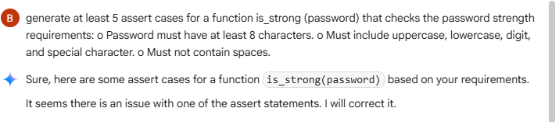  CODE:  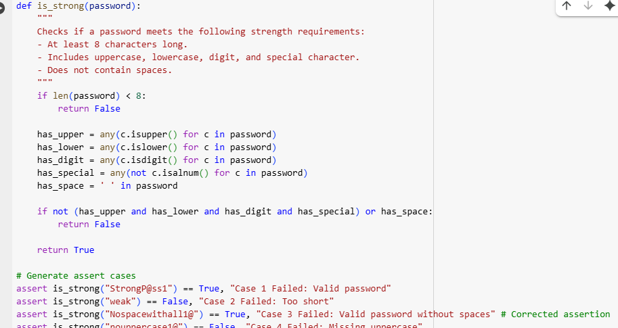  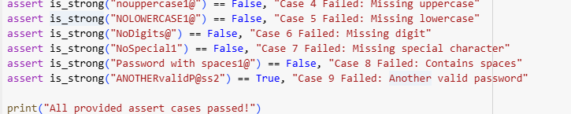  OUTPUT:  EXLPANATION:  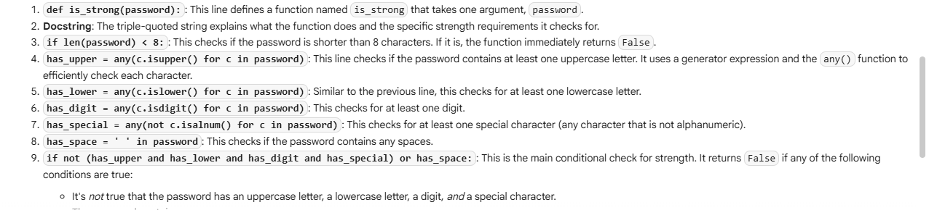  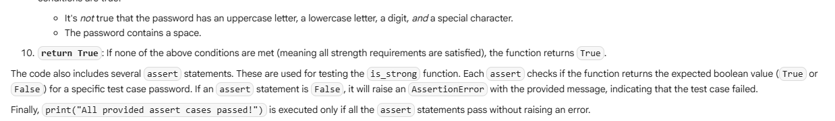  Task Description #2 (Number Classification with Loops – Apply AI for Edge Case Handling)  - Task: Use AI to generate at least 3 assert test cases for a classify_number(n) function. Implement using loops.  - Requirements:  - Classify numbers as Positive, Negative, or Zero.  - Handle invalid inputs like strings and None.  - Include boundary conditions (-1, 0, 1).  Example Assert Test Cases:  assert classify_number(10) == "Positive"  assert classify_number(-5) == "Negative"  assert classify_number(0) == "Zero"  Expected Output #2:  - Classification logic passing all assert tests.  PROMPT:  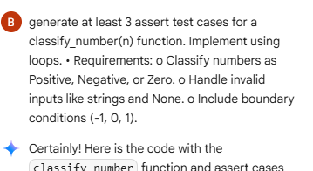  CODE:  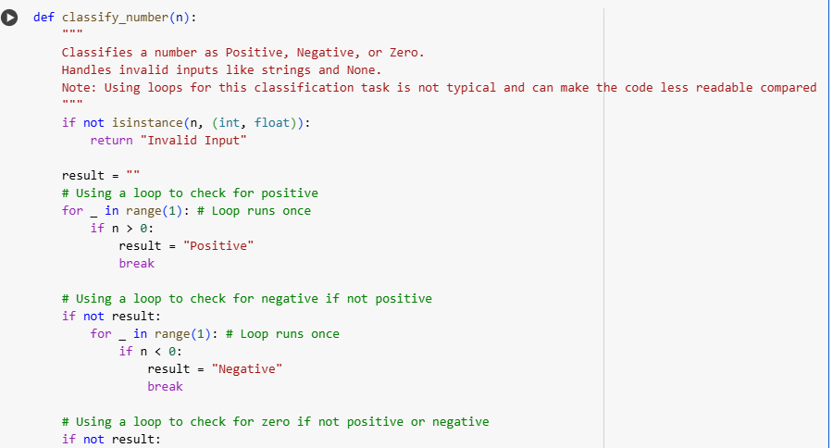  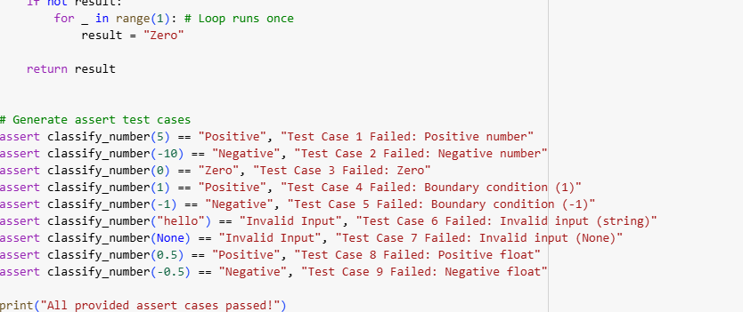  OUTPUT:    EXPLANATION:  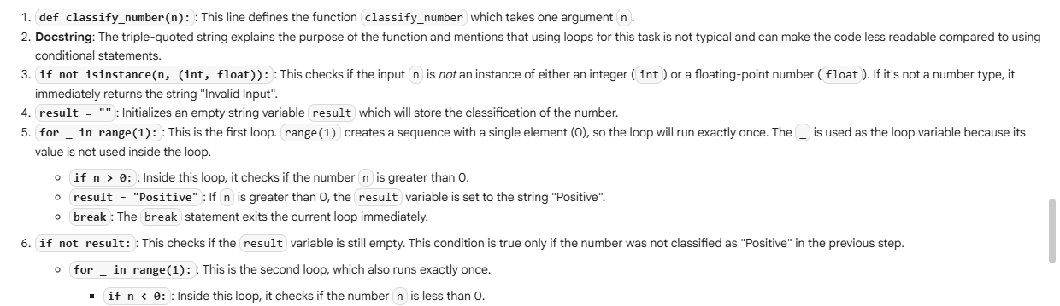  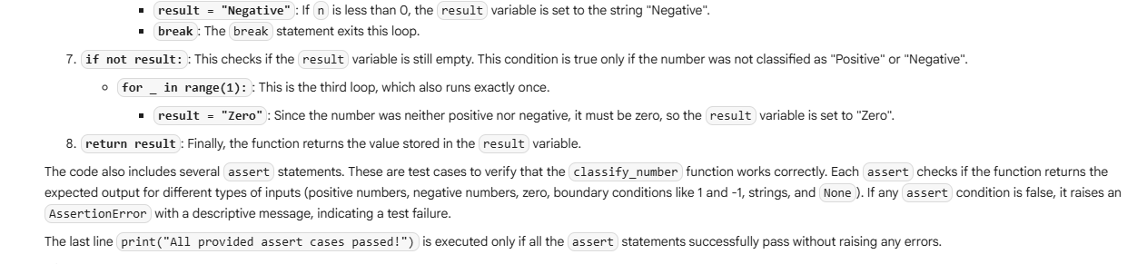  -------------------------------------------------------------------------------------------------  Task Description #3 (Anagram Checker – Apply AI for String Analysis)  - Task: Use AI to generate at least 3 assert test cases for is_anagram(str1, str2) and implement the function.  - Requirements:  - Ignore case, spaces, and punctuation.  - Handle edge cases (empty strings, identical words).  Example Assert Test Cases:  assert is_anagram("listen", "silent") == True  assert is_anagram("hello", "world") == False  assert is_anagram("Dormitory", "Dirty Room") == True  Expected Output #3:  - Function correctly identifying anagrams and passing all AI-generated tests.  PROMPT:  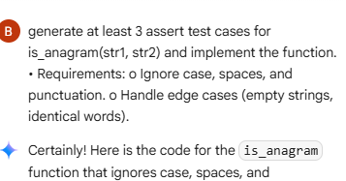  CODE:  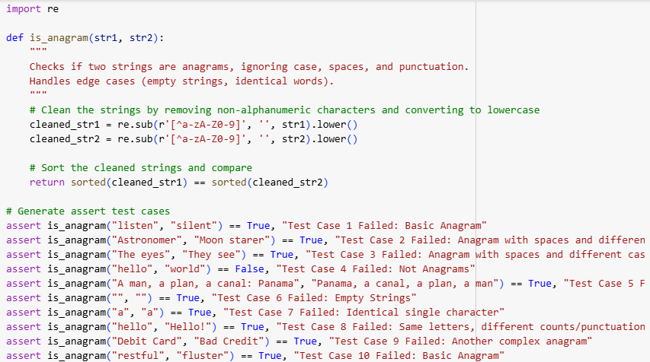  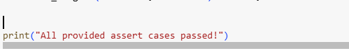  OUTPUT:  EXPLANATION:  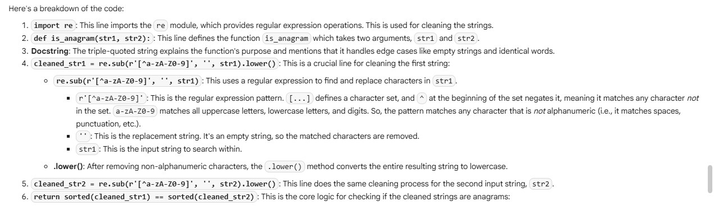  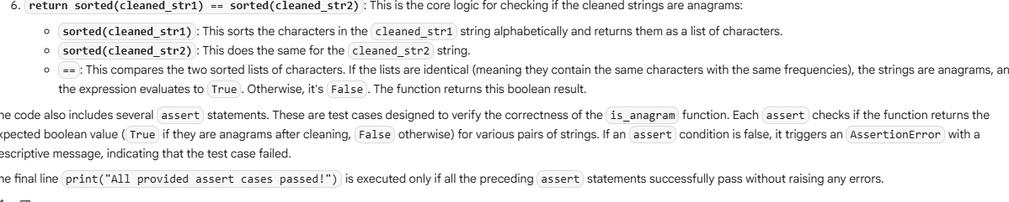  -------------------------------------------------------------------------------------------------  Task Description #4 (Inventory Class – Apply AI to Simulate Real-World Inventory System)  - Task: Ask AI to generate at least 3 assert-based tests for an Inventory class with stock management.  - Methods:  - add_item(name, quantity)  - remove_item(name, quantity)  - get_stock(name)  Example Assert Test Cases:  inv = Inventory()  inv.add_item("Pen", 10)  assert inv.get_stock("Pen") == 10  inv.remove_item("Pen", 5)  assert inv.get_stock("Pen") == 5  inv.add_item("Book", 3)  assert inv.get_stock("Book") == 3  Expected Output #4:  - Fully functional class passing all assertions.  PROMPT:  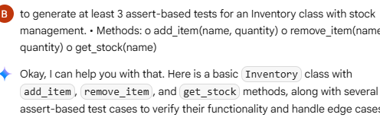  CODE:  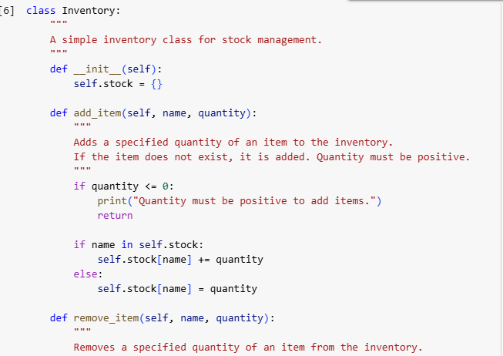  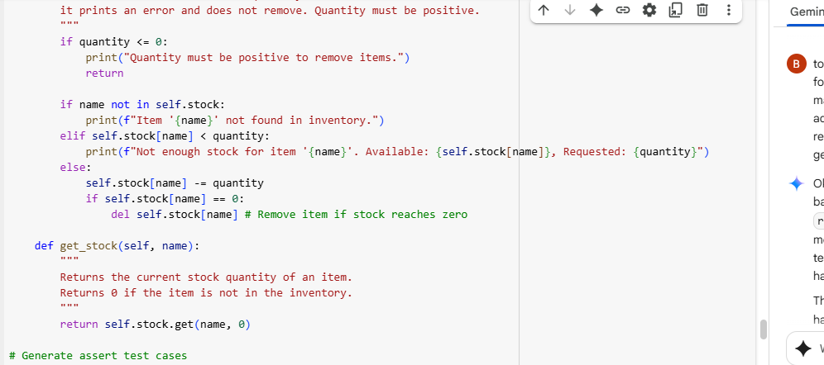  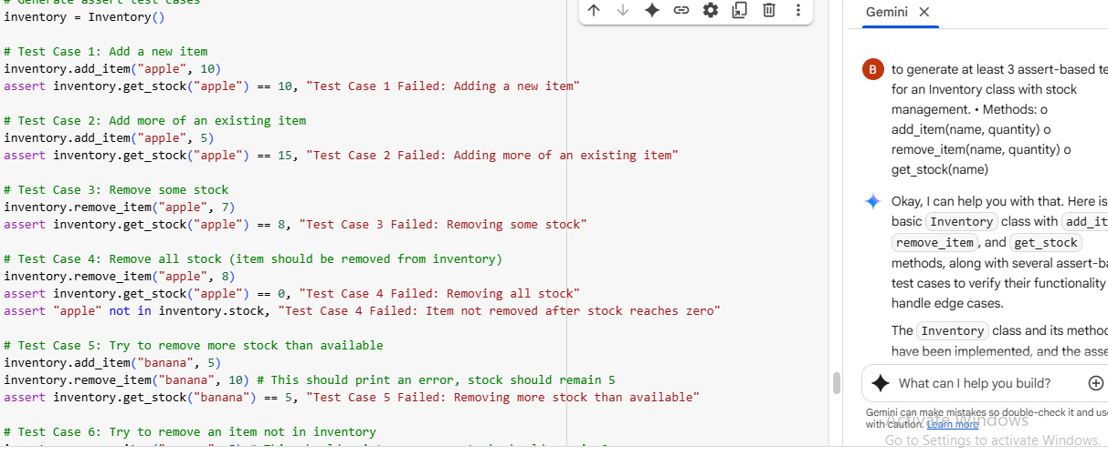  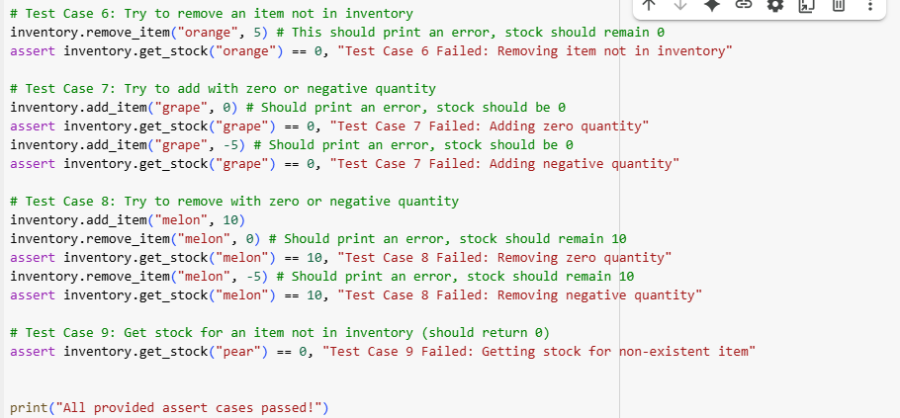  OUTPUT:  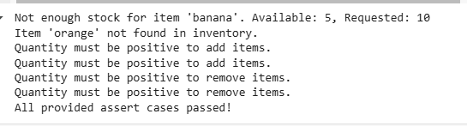  EXPLANNTION:  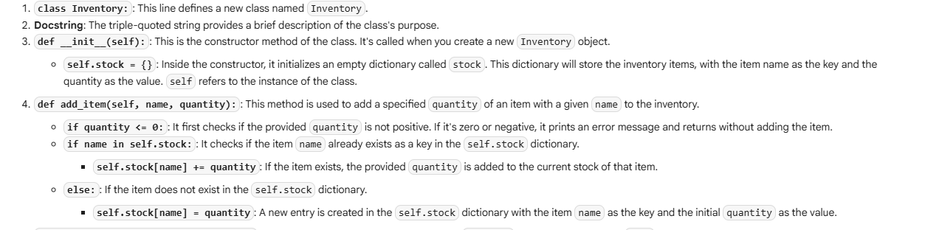  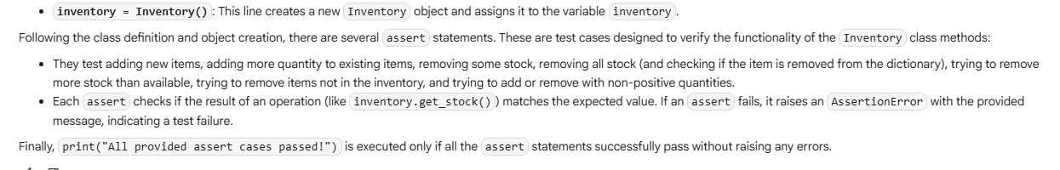  -------------------------------------------------------------------------------------------------  Task Description #5 (Date Validation & Formatting – Apply AI for Data Validation)  - Task: Use AI to generate at least 3 assert test cases for validate_and_format_date(date_str) to check and convert dates.  - Requirements:  - Validate "MM/DD/YYYY" format.  - Handle invalid dates.  - Convert valid dates to "YYYY-MM-DD".  Example Assert Test Cases:  assert validate_and_format_date("10/15/2023") == "2023-10-15"  assert validate_and_format_date("02/30/2023") == "Invalid Date"  assert validate_and_format_date("01/01/2024") == "2024-01-01"  Expected Output #5:  - Function passes all AI-generated assertions and handles edge cases.  PROMPT:  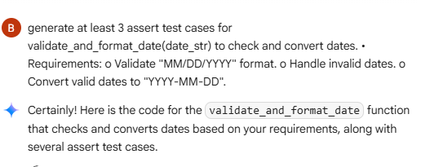  CODE:  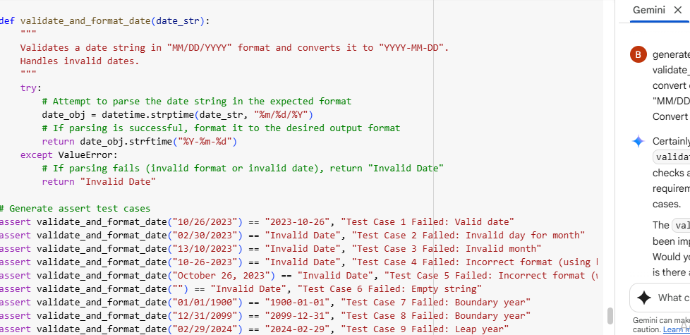  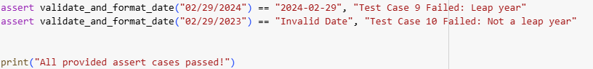  OUTPUT  EXPLAIN:  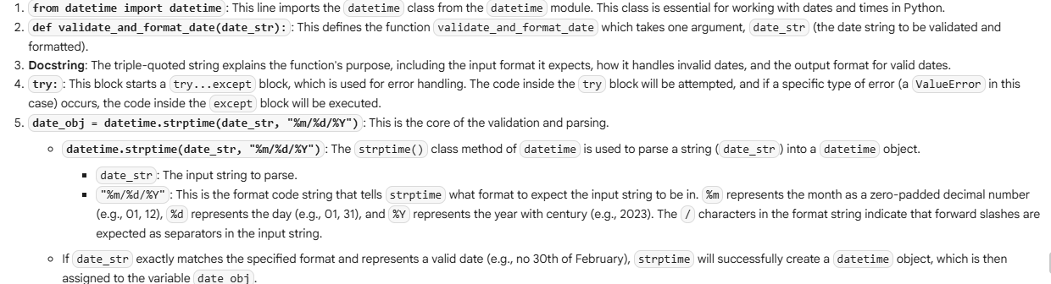  -------------------------------------------------------------------------------------------------  ✅ Deliverables (For All Tasks)  - AI-generated prompts for code and test case generation.  - At least 3 assert test cases for each task.  - AI-generated initial code and execution screenshots.  - Analysis of whether code passes all tests.  - Improved final version with inline comments and explanation.  - Compiled report (Word/PDF) with prompts, test cases, assertions, code, and output.  Evaluation Criteria:  Criteria Max Marks  Task #1 0.5  Task #2 0.5  Task #3 0.5  Task #4 0.5  Task #5 0.5  Total 2.5 Marks |  |  |  |  |  | Week4 - Monday

