Assignment-17

Name:Manchikatla Deekshitha
Rollno:2403a54125
Batch:04

Task 1 – Employee Data Preprocessing
Prompt:Generate a Python script that cleans an employee dataset: handle missing values (salary, department, joining_date), convert joining_date to datetime, standardize department names, and encode department/job_role
Code:
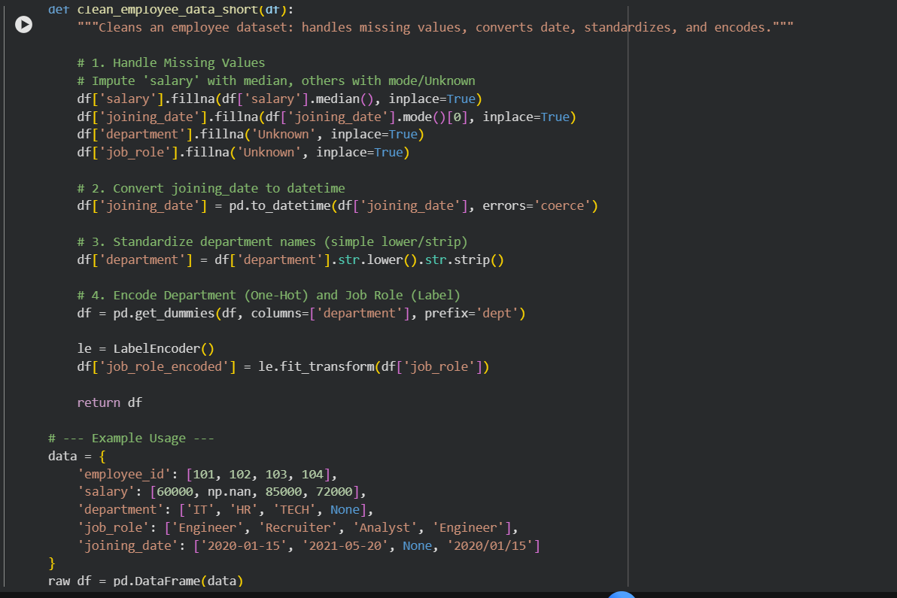

Output:
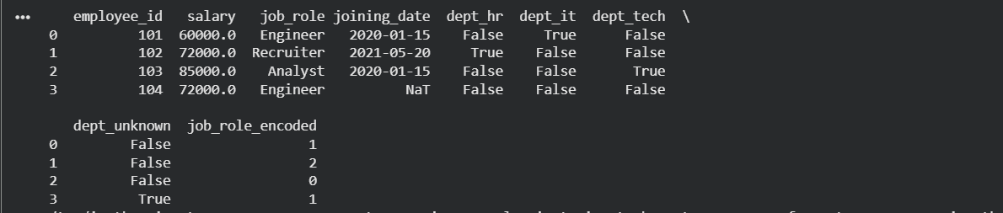
Explanation:

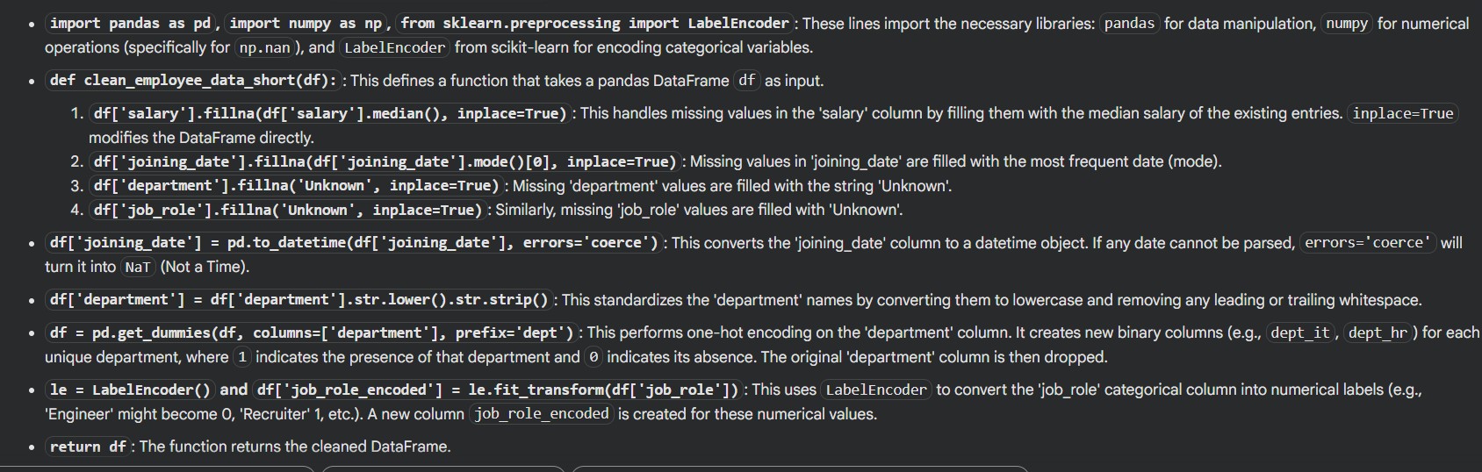

Task 2 – Sales Transaction Data Preprocessing
Prompt:Create a Python script to preprocess sales transaction data: handle missing values, fix date formats, standardize product/category names, remove duplicates, and encode categorical features.” “Assume the DataFrame is df and return a fully cleaned Pandas DataFrame.
Code:
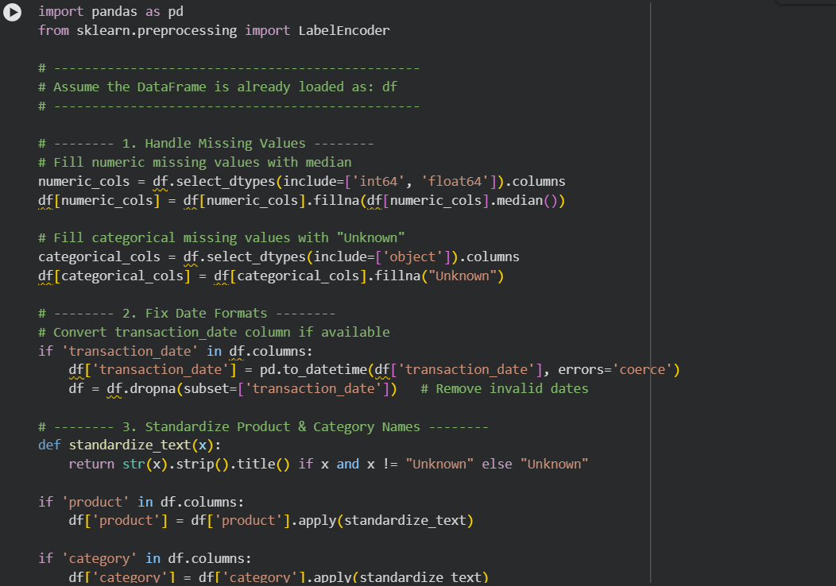
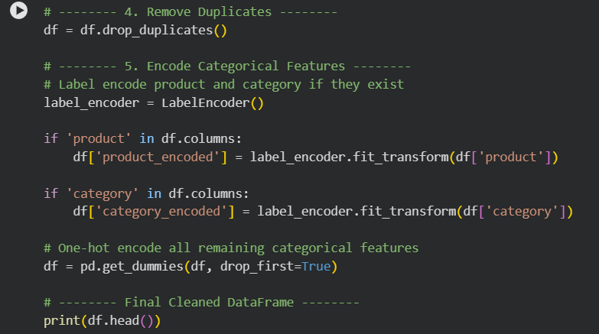
Output:
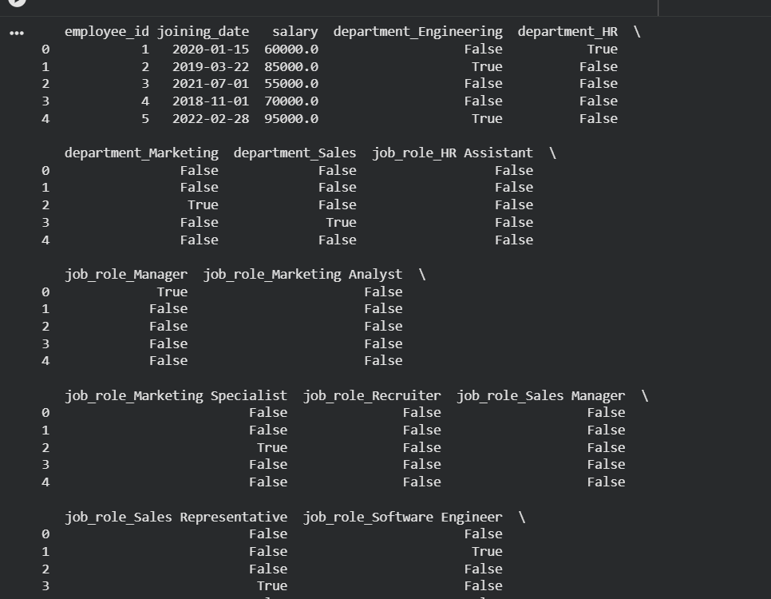
Explanation:
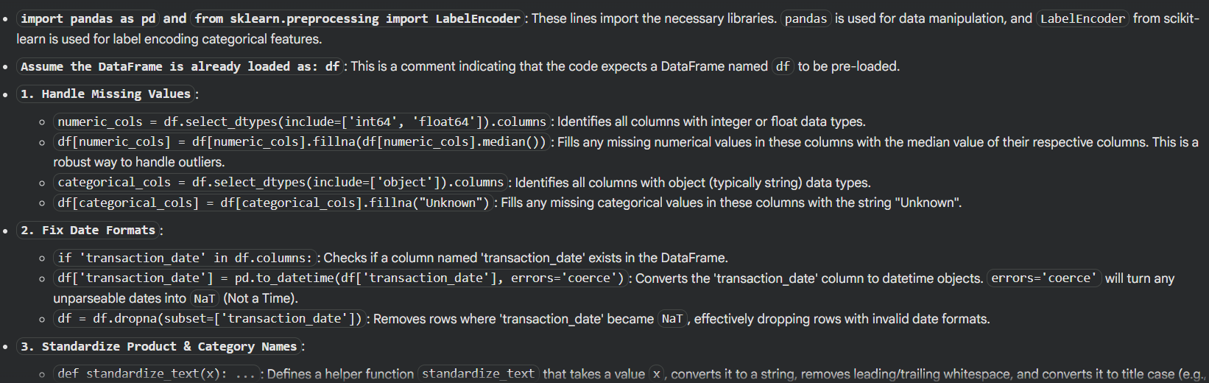
Task 3 – Healthcare Patient Records Cleaning
Prompt:Generate a Python script to clean healthcare patient records: fill missing numeric values with column mean, convert height from cm to meters, standardize categorical labels (e.g., 'M', 'Male', 'male' → 'Male'), and drop irrelevant columns like patient_id.
Code:
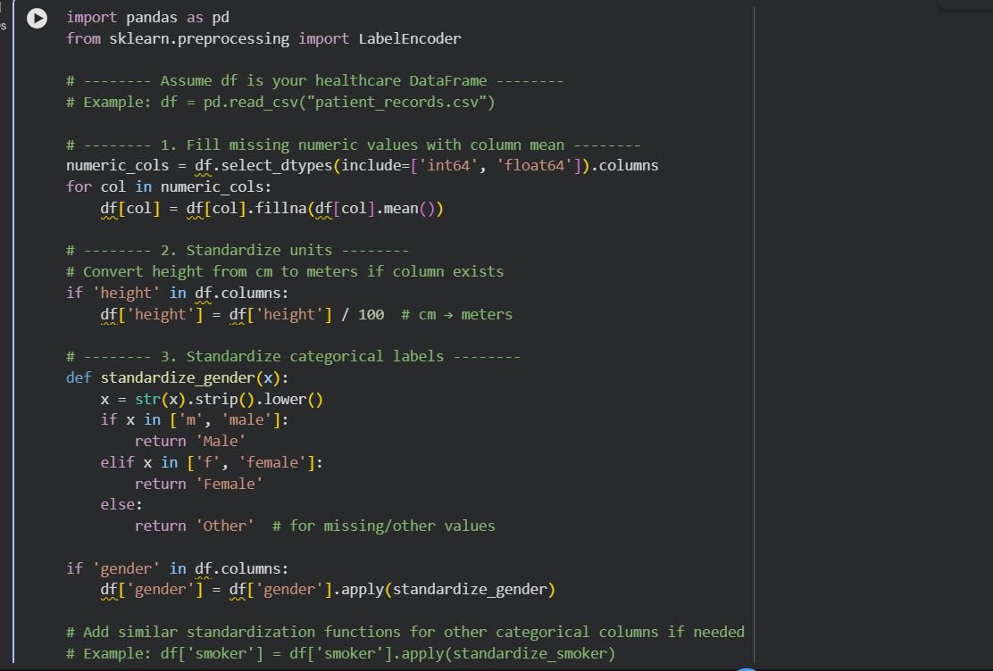
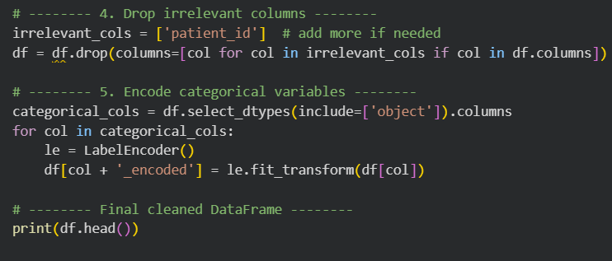 Output:
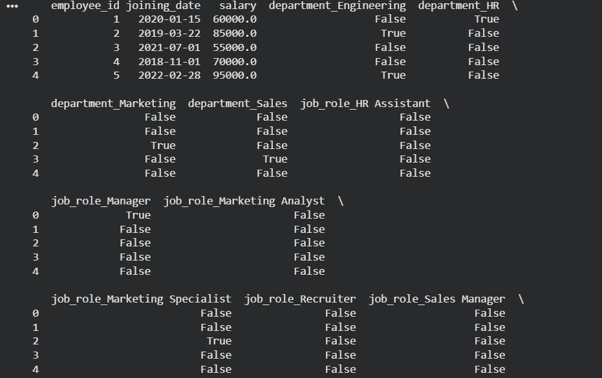
Explanation:
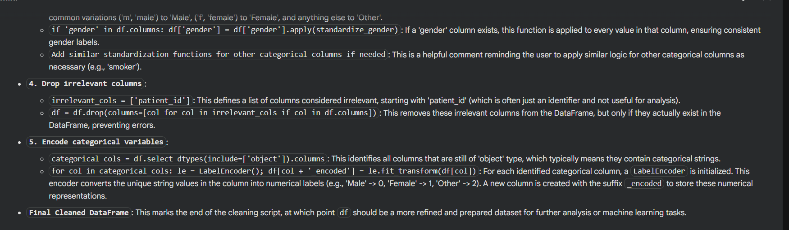
Task 4 – Social Media Sentiment Dataset Preparation
Prompt:Generate a Python script to preprocess a social media text dataset: remove special characters, URLs, and emojis, convert text to lowercase, tokenize, remove stop words, and apply lemmatization.”
“Assume the DataFrame is df with a column text, and output a processed dataset ready for NLP sentiment analysis.
Code:
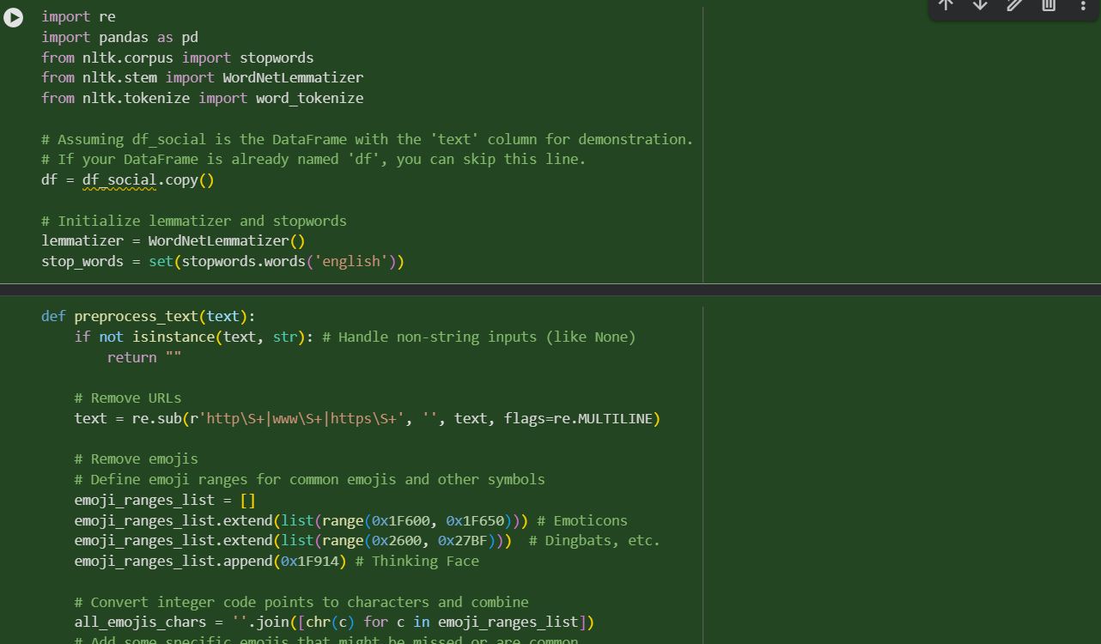
Explanation:
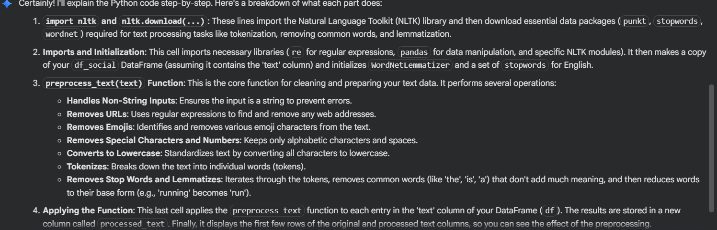

Task 5 – Financial Dataset Feature Engineering
Prompt:“Generate a Python script to perform feature engineering on a financial dataset: create new features like profit margin, return on investment (ROI), and categorize transactions, handle missing values, and scale numeric features.”
“Assume the DataFrame is df and output a processed dataset ready for machine learning models”
Code:
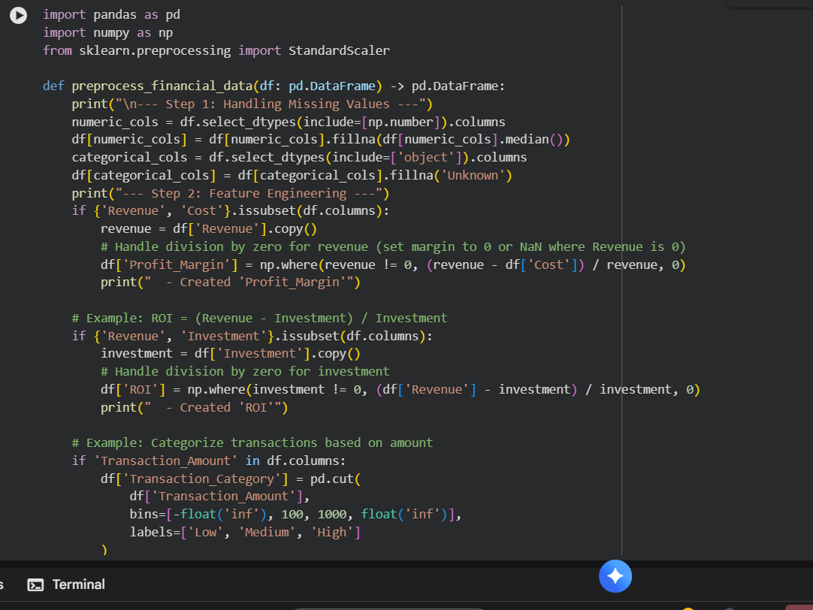

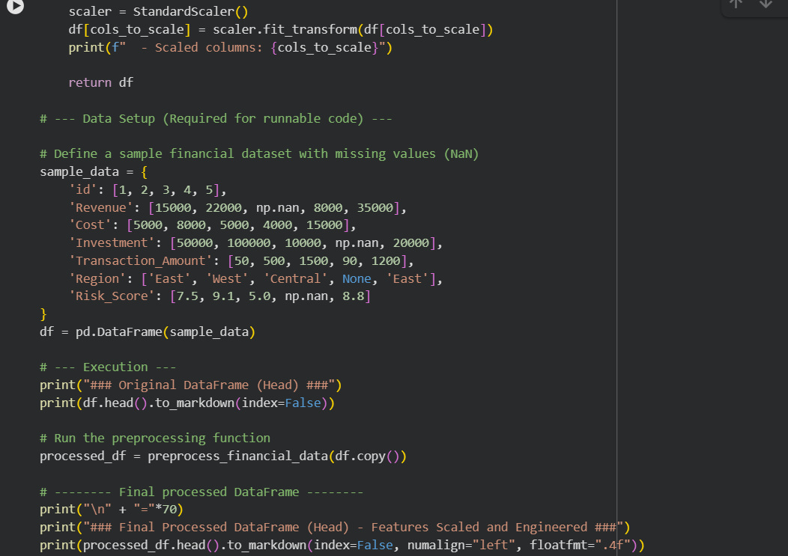
Output:
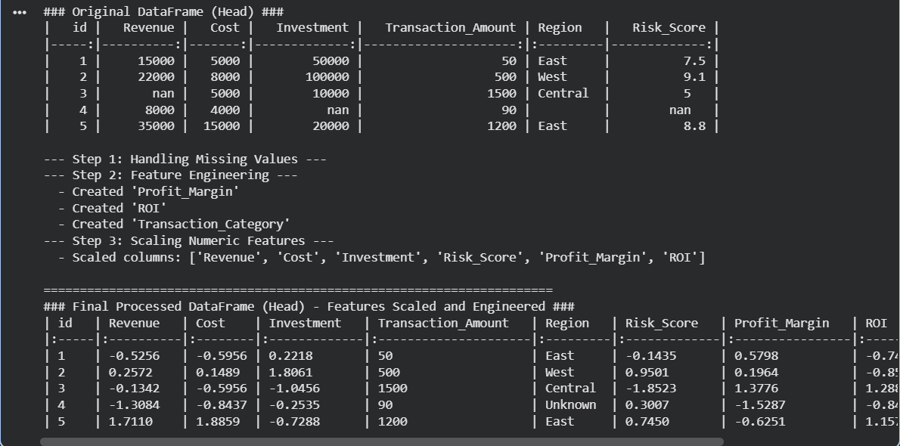
Explanation:
