SR UNIVERSITY

AI CODING

NAME:VASANTA

ENROLLMENT NO:2403A54127

BATCH NO:04

ASSIGNMENT NO:4.4

Task 1: Auto-Complete a Python Class for Bank Account  
Task Description #1  
• Write a class definition comment and start the constructor for a class called BankAccount with  
account_holder and balance attributes. Use GitHub Copilot to auto-complete the rest of the  
class, including methods to deposit, withdraw, and display balance.

PROMPT

CODE

Output

Explanation

Task 2: Auto-Complete a For Loop to Sum Even Numbers in a List  
Task Description #2  
• Write a comment and the initial line of a loop to iterate over a list. Allow GitHub Copilot to  
complete the logic to sum all even numbers in the list

Prompt

Code

Output

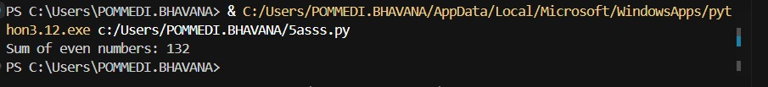

Explanation

Task 3: Auto-Complete Conditional Logic to Check Age Group  
Task Description #3  
• Start a function that takes age as input and returns whether the person is a child, teenager,  
adult, or senior using if-elif-else. Use Copilot to complete the conditionals.

Prompt



Code

Output

Explanation

Task 4: Auto-Complete a While Loop to Reverse Digits of a Number  
Task Description #4  
• Write a comment and start a while loop to reverse the digits of a number. Let Copilot  
complete the loop logic.

Prompt



Code

Output

Explanation

Task 5: Auto-Complete Class with Inheritance (Employee → Manager)  
Task Description #5  
• Begin a class Employee with attributes name and salary. Then, start a derived class Manager  
that inherits from Employee and adds department. Let GitHub Copilot complete the methods  
and constructor chaining

Prompt



Code

Output

Explanation

