SR UNIVAERSITY

AI CODING

NAME:VASANTA

HALL TICKET NO:2403A54127

ASSIGNMENT:06

BATCH NO:04

**Task Description #1:**

**•** Start a Python class named Student with attributes name, roll_number, and marks. Prompt GitHub Copilot to complete methods for displaying details and checking if marks are above average.

Prompt

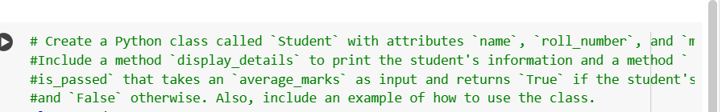

**Code**

**Output**

**Explanation**

**Task Description #2:**

**• Write the first two lines of a for loop to iterate through a list of numbers. Use a comment prompt to let Copilot suggest how to calculate and print the square of even numbers only**

**Prompt**

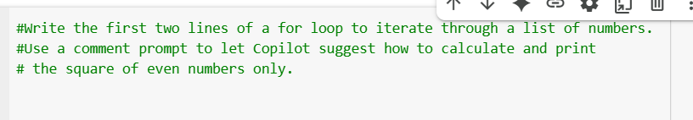

**Code**

**Output**

**Explanation**

**Task Description #3:**

**• Create a class called BankAccount with attributes account_holder and balance. Use Copilot to complete methods for deposit(), withdraw(), and check for insufficient balance.**

**Prompt**

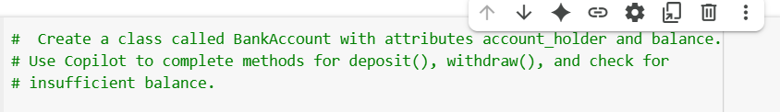

**Code**

**Output**

**Explanation**

**Task Description #4:**

**• Define a list of student dictionaries with keys name and score. Ask Copilot to write a while loop to print the names of students who scored more than 75.**

**Prompt**

**Code**

**Output**

**Explanation**

**Task Description #5:**

**• Begin writing a class ShoppingCart with an empty items list. Prompt Copilot to generate methods to add_item, remove_item, and use a loop to calculate the total bill using conditional discounts.**

**Prompt**

**Code**

**Output**

**Explanation**

