SR UNIVERSITY

**LAB ASSIGNMENT-09**

NAME:VASANTA

HALL TICKET NUMBER:2403A54127

BATCH NO:04(DS)

**Task Description#1 Basic Docstring Generation**

Prompt:

Write a Python function that takes a list of integers and returns the sum of even and odd numbers separately as a tuple.

First, add a **manual docstring** using **Google Style** that clearly describes the function, its arguments, and return values.  
Then, include a **second version of the same function** with a **docstring generated by an AI tool**.

I want to compare the manual docstring and the AI-generated one in terms of clarity and completeness.

Code:

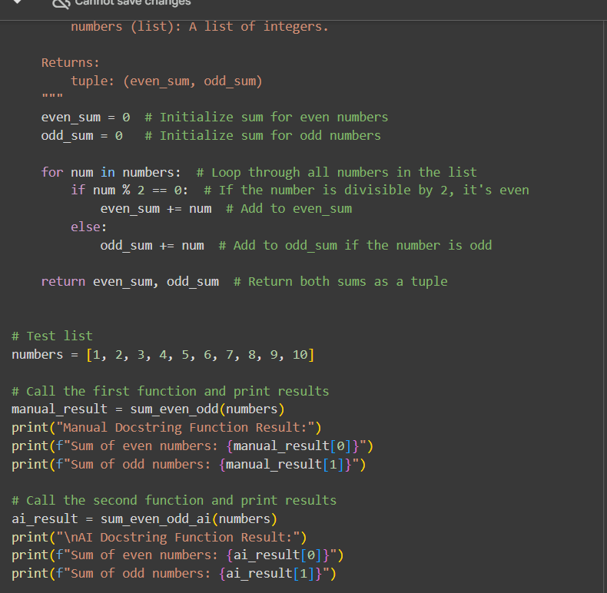

Output:

Explanation:

**Expected Output#2:** Students critically analyze AI-generated code comments.

Prompt:

Create a Python class called SRU_Student with attributes: name, roll_no, and hostel_status.  
Add two methods:

* fee_update() to update or show fee status
* display_details() to show all student details

First, write **manual inline comments** for each line.  
Then, use an **AI tool to generate automatic inline comments**.

Code:

Output:

Explanation

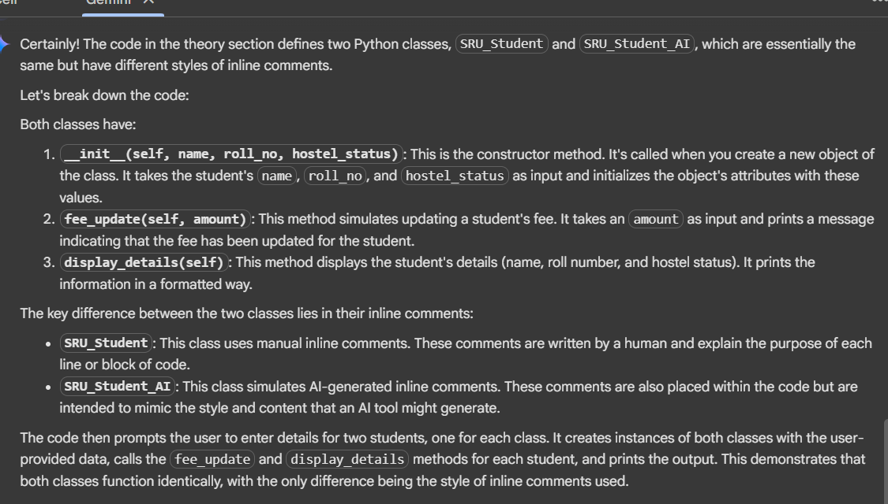

**Task Description#3**

Prompt:

Write a Python script with four functions: add, subtract, multiply, and divide.  
Write manual docstrings for each function using NumPy style.  
Then, use an AI tool to generate a module docstring and function docstrings.  
Compare your manual docstrings with the AI-generated ones.

Code

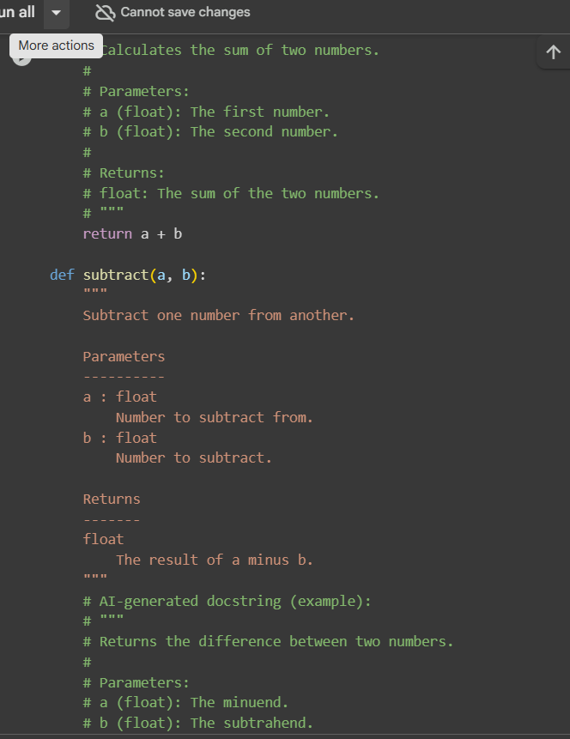

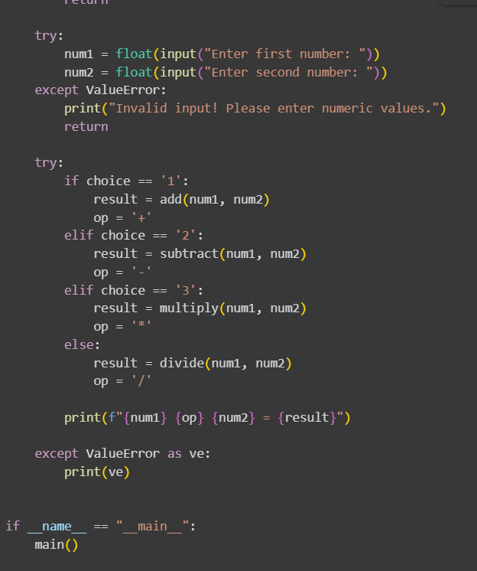

Output

