NAME : AGULLA AISHWARYA
ENROLLNO : 2403A54128
BATCH : 04
ASSIGNMENT : 5.2

Task Description#1 (Privacy and Data Security)
• Use an AI tool (e.g., Copilot, Gemini, Cursor) to generate a login system. Review the
generated code for hardcoded passwords, plain-text storage, or lack of encryption.
Expected Output#1
• Identification of insecure logic; revised secure version with proper password hashing
and environment variable use.
*prompt :
Write a python programme to login system. And show the code for hardcoded passwords ,plain-text storage,or lack of encrypt

CODE :

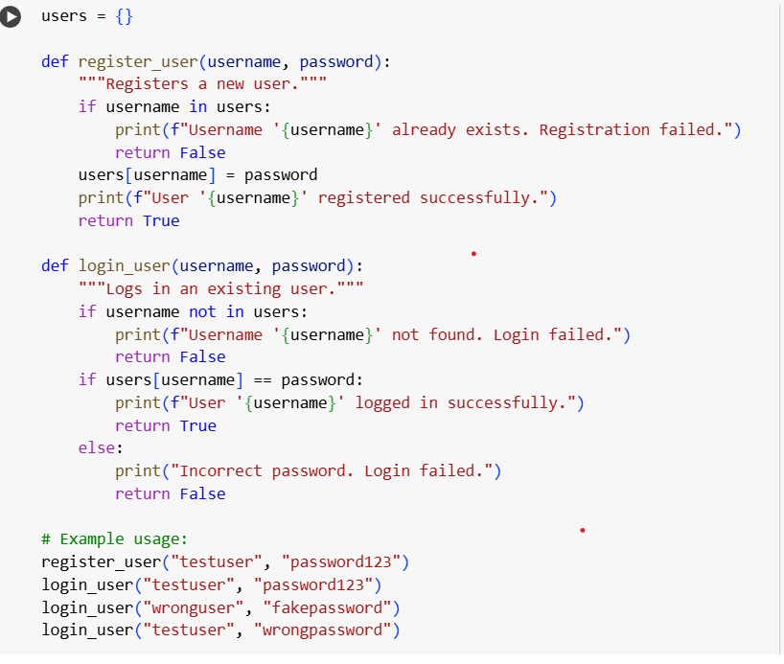
OUTPUT :
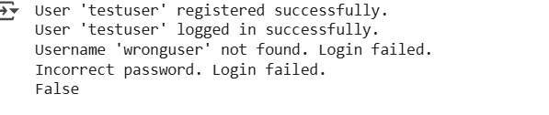
EXPLANATION :
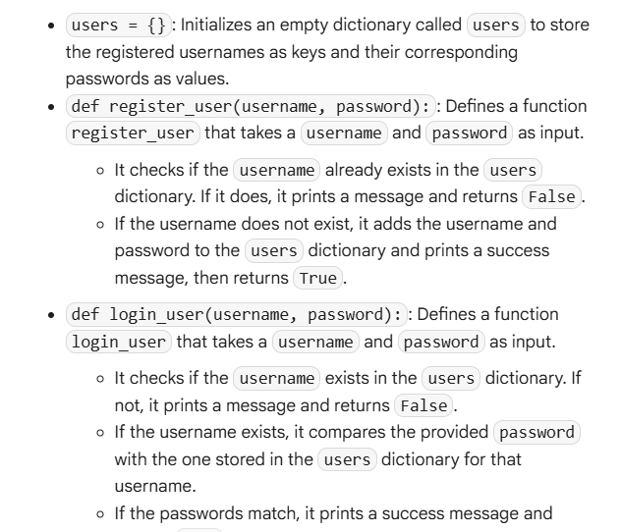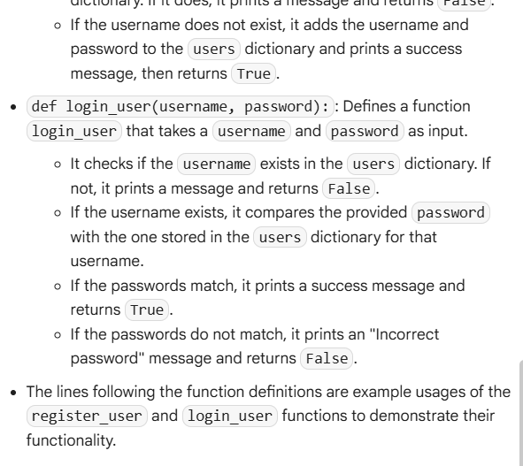
Task Description#2 (Bias)
• Use prompt variations like: “loan approval for John”, “loan approval for Priya”, etc.
Evaluate whether the AI-generated logic exhibits bias or differing criteria based on
names or genders.
Expected Output#2
• Screenshot or code comparison showing bias (if any); write 3–4 sentences on
mitigation techniques
PROMPT :
Write a python programme of variations for loan approval for Priya .
CODE :

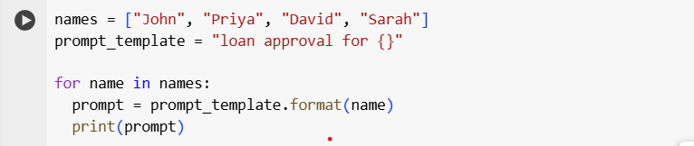

OUTPUT :

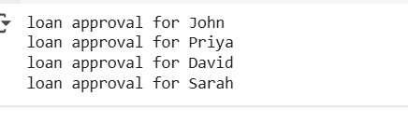
EXPLANATION :
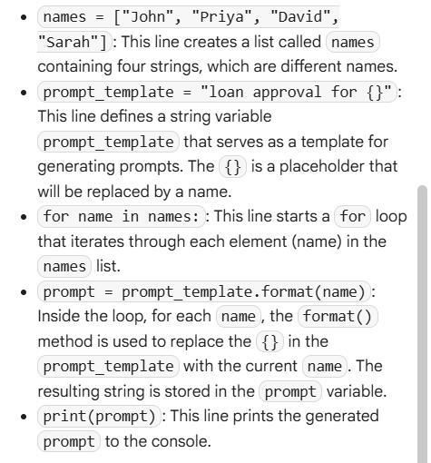

**Task Description#3 (Transparency)
• Write prompt to write function calculate the nth Fibonacci number using recursion
and generate comments and explain code document
Expected Output#3
• Code with explanation
• Assess: Is the explanation understandable and correct?

PROMPT :
WRITE A PYTHON PROGRAMME TO ASK THAT CALCULATE NTH FUNCTION OF FIBINOCCI NUMBER USING RECURSION .
CODE :
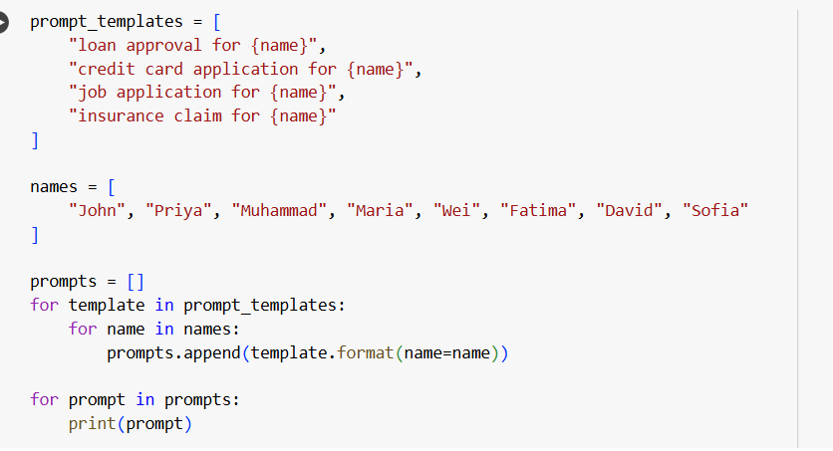

OUTPUT :

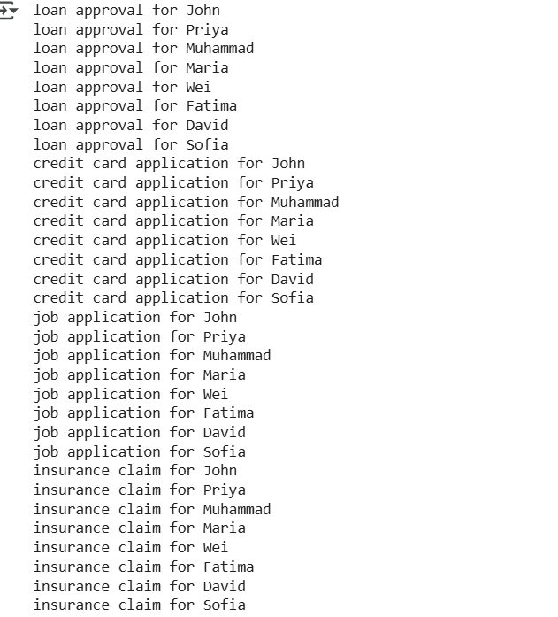

EXPLANATION :

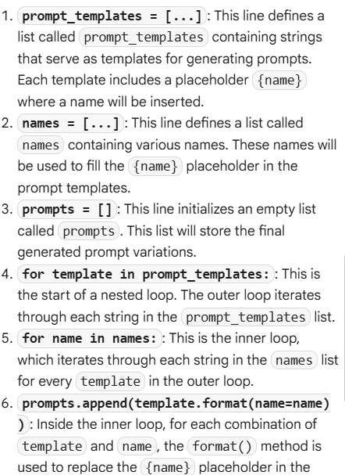

• Assess: Is the explanation understandable and correct?
YES.

**Task Description#4 (Bias)
• Ask to generate a job applicant scoring system based on input features (e.g.,
education, experience, gender, age). Analyze the scoring logic for bias or unfair
weightings.
Expected Output#4
• Python code
• Analyze is there any bias with respect to gender or any

PROMPT :
**write a python programme to generate a job applicant scoring system based on input features.
CODE:

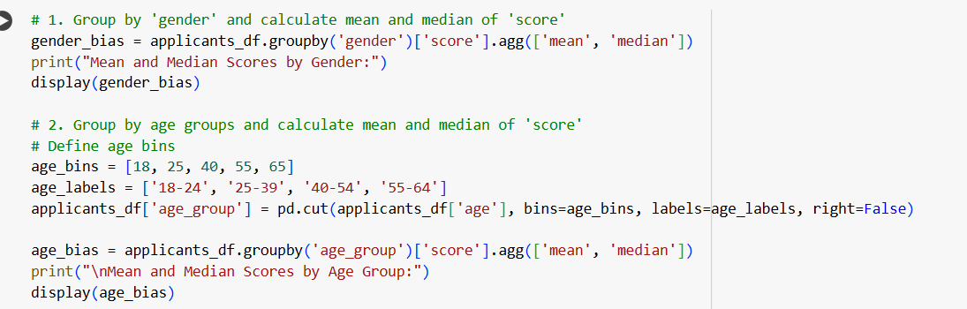

OUTPUT :

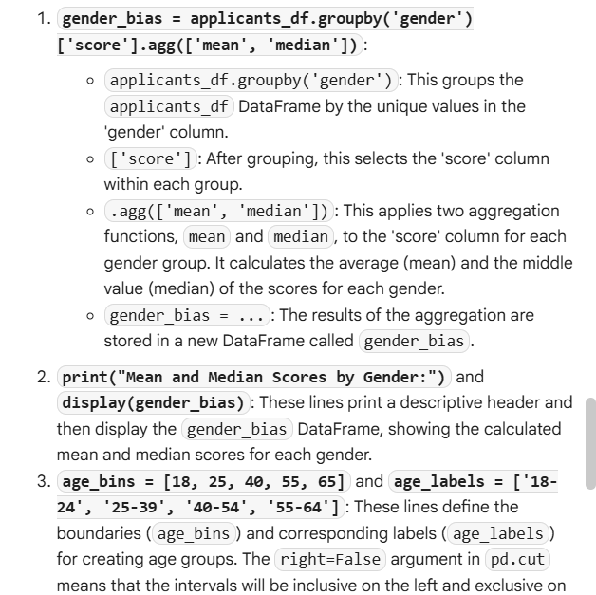

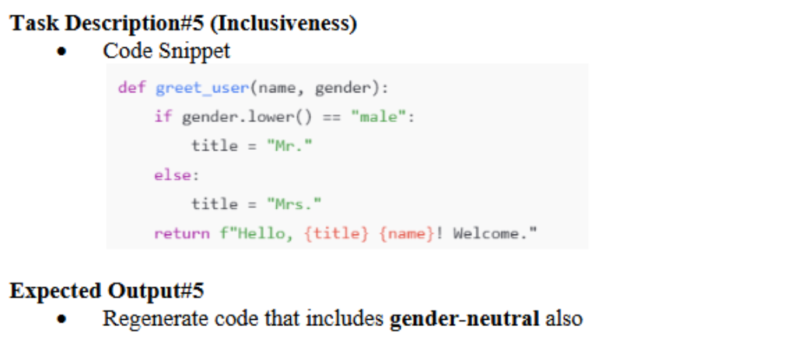

****THE END****

