Windows Security Log Analysis Report
Week 4 Lab: Windows Log Analysis with PowerShell
Field | Details
Analyst | [Your Name]
Date | 02 November 2026
System | [Computer Name], Windows 11, Windows PowerShell 5.1 (build 26100.9818)
Analysis Period | Last 1 hour / 24 hours / 7 days (as specified per exercise)
Scenario | SOC analyst at FinanceCorp investigating suspicious activity on Windows servers

Executive Summary
This lab used PowerShell (Get-WinEvent) to query the Windows Security Event Log for failed logons (4625), successful logons (4624), explicit credential use (4648), network share access (5140), group membership changes (4732) and special privilege assignments (4672).
Every filtered query returned "No events were found that match the specified selection criteria", and the only unfiltered query (Get-WinEvent -LogName Security -MaxEvents 10) returned an UnauthorizedAccessException. As a result, no brute-force, lateral-movement or privilege-escalation activity could be confirmed or ruled out. The evidence points to a permissions (non-elevated session) or audit-policy problem rather than a clean system, and the queries should be re-run from an elevated PowerShell (see Troubleshooting section).

1. Environment and Prerequisites
Command:
$PSVersionTable.PSVersion

Result: Windows PowerShell 5.1 (build 26100) meets the lab requirement of 5.1 or higher.
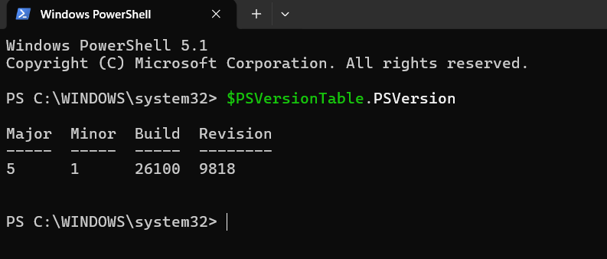
Figure 1: PowerShell version check

2. Basic PowerShell Event Log Queries

Exercise 1: View recent Security events
Get-WinEvent -LogName Security -MaxEvents 10

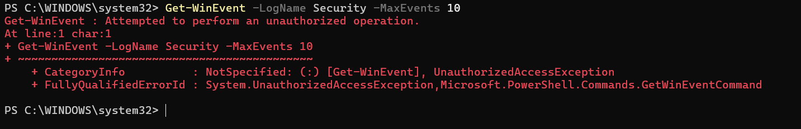
Figure 2: Get-WinEvent returns UnauthorizedAccessException
Observation: Reading the Security log requires Administrator rights (or membership in the *Event Log Readers* group). This error shows the session was not elevated, which is the root cause of the empty results in the later exercises.

Exercise 2: Filter by Event ID (4624 successful logons)
Get-WinEvent -FilterHashtable @{LogName='Security'; ID=4624} -MaxEvents 20 |
Select-Object TimeCreated, Id, Message |
Format-Table -AutoSize

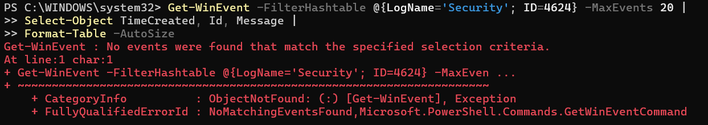
Figure 3: Event ID 4624 query: no events found
Observation: A normal Windows machine always has successful logon events, so an empty result indicates the log could not be read, not that no logons happened.

Exercise 3: Filter by time range
Last 24 hours:
$StartTime = (Get-Date).AddDays(-1)
Get-WinEvent -FilterHashtable @{
LogName='Security'
StartTime=$StartTime
} -MaxEvents 100

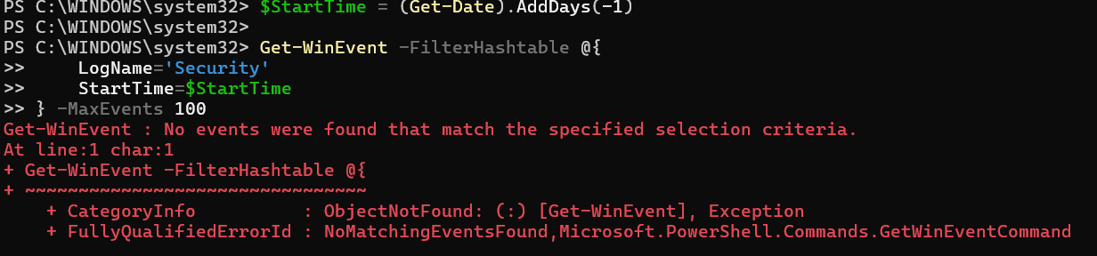
Figure 4: All Security events, last 24 hours: no events found
Last hour:
$StartTime = (Get-Date).AddHours(-1)
Get-WinEvent -FilterHashtable @{
LogName='Security'
StartTime=$StartTime
}

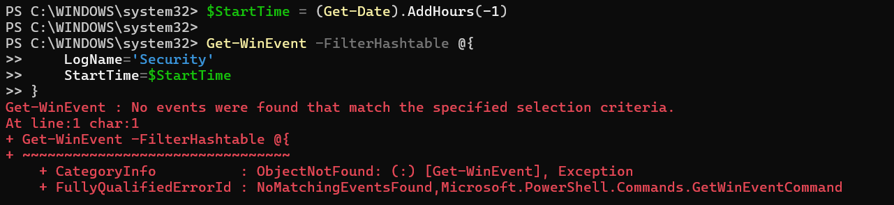
Figure 5: All Security events, last hour: no events found
Observation: Even queries with no Event ID filter returned nothing. This confirms the problem is access to the log, not the specific event IDs.

Exercise 4: Count failed logons (4625), last 24 hours
$StartTime = (Get-Date).AddDays(-1)
$FailedLogons = Get-WinEvent -FilterHashtable @{
LogName='Security'
ID=4625
StartTime=$StartTime
}
$FailedLogons.Count

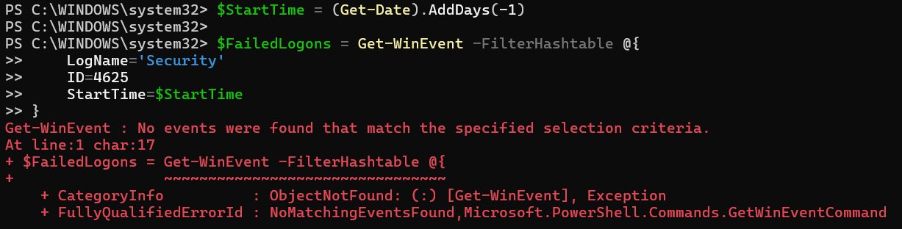
Figure 6: Failed logon count query: no events found
Result: The count could not be determined because no events were returned.

3. Extracting Event Properties

Exercise 5: Understanding event structure
$Event = Get-WinEvent -FilterHashtable @{LogName='Security'; ID=4625} -MaxEvents 1
$Event | Format-List *

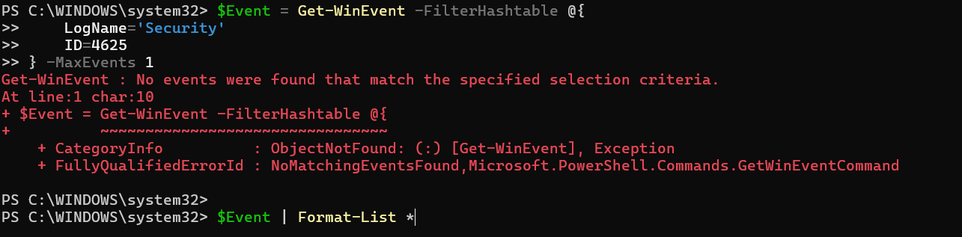
Figure 7: Retrieving one 4625 event: no events found
Result: $Event was empty, so Format-List * displayed nothing.

Exercise 6: Extract fields from failed logons
Get-WinEvent -FilterHashtable @{LogName='Security'; ID=4625} -MaxEvents 10 |
ForEach-Object {
[PSCustomObject]@{
TimeCreated = $_.TimeCreated
TargetUser = $_.Properties[5].Value
SourceIP = $_.Properties[19].Value
LogonType = $_.Properties[8].Value
FailureReason = $_.Properties[13].Value
}
} | Format-Table -AutoSize

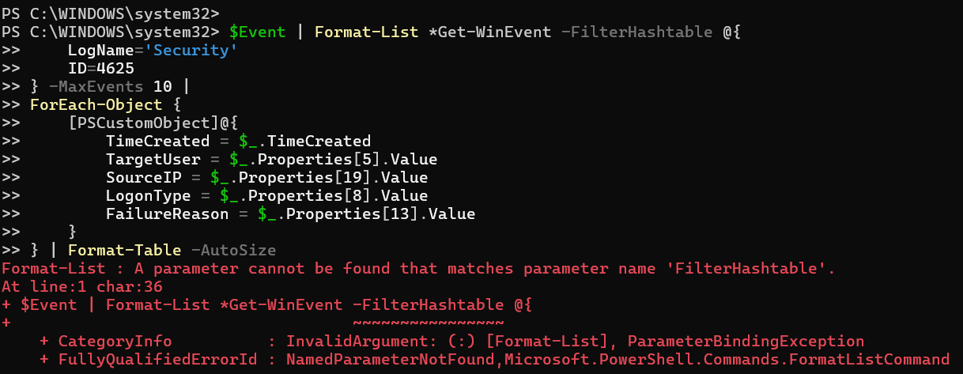
Figure 8: Command error caused by two commands joined on one line
Observation: In this attempt two commands were joined on one line ($Event | Format-List *Get-WinEvent ...), which caused a ParameterBindingException for FilterHashtable. Lesson learned: each command must be entered on its own line. The correct command is shown above.

Exercise 7: Top 5 source IP addresses
Get-WinEvent -FilterHashtable @{
LogName='Security'
ID=4625
StartTime=(Get-Date).AddDays(-1)
} | ForEach-Object {
$_.Properties[19].Value
} | Where-Object { $_ -ne '-' -and $_ -ne '' } |
Group-Object |
Sort-Object Count -Descending |
Select-Object -First 5 Name, Count

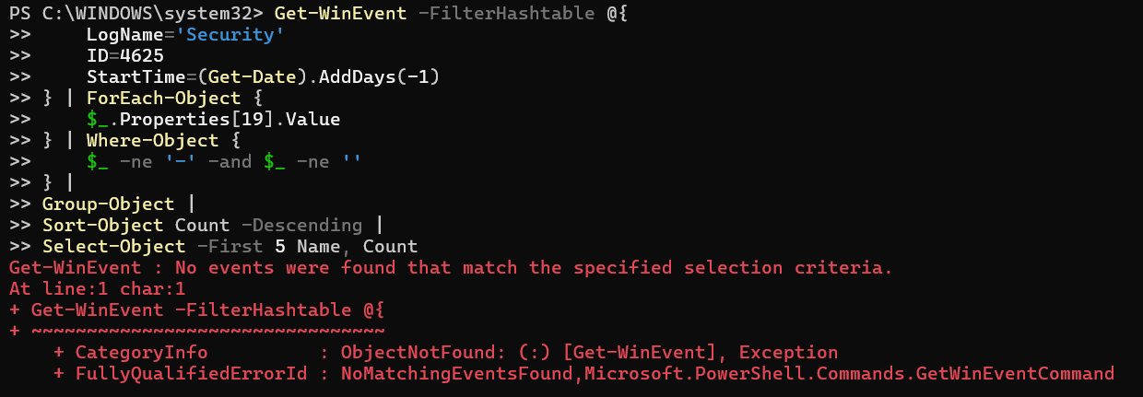
Figure 9: Top 5 source IPs: no events found

Exercise 8: Top 5 targeted usernames
Get-WinEvent -FilterHashtable @{
LogName='Security'
ID=4625
StartTime=(Get-Date).AddDays(-1)
} | ForEach-Object {
$_.Properties[5].Value
} | Where-Object { $_ -ne '-' -and $_ -ne '' } |
Group-Object |
Sort-Object Count -Descending |
Select-Object -First 5 @{Name='Username';Expression={$_.Name}}, @{Name='Failed Attempts';Expression={$_.Count}} |
Format-Table -AutoSize

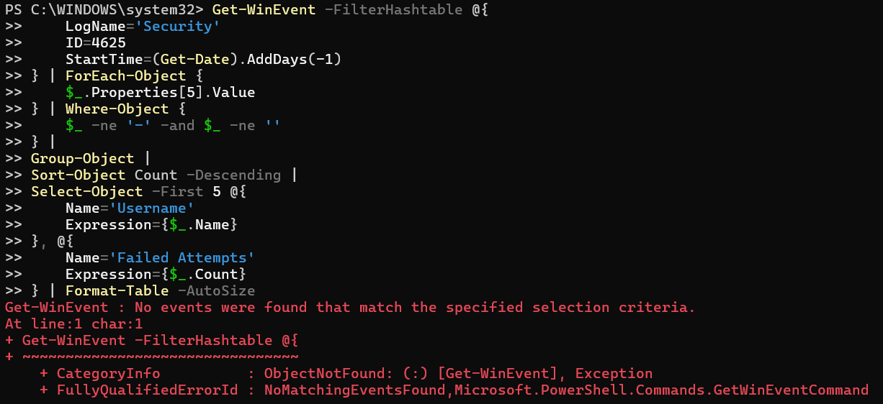
Figure 10: Top 5 targeted usernames: no events found

Exercise 9: Logon type distribution (failed attempts)
Get-WinEvent -FilterHashtable @{
LogName='Security'
ID=4625
StartTime=(Get-Date).AddDays(-1)
} | ForEach-Object {
$LogonType = $_.Properties[8].Value
switch ($LogonType) {
2 { 'Interactive' }
3 { 'Network' }
4 { 'Batch' }
5 { 'Service' }
7 { 'Unlock' }
8 { 'NetworkCleartext' }
9 { 'NewCredentials' }
10 { 'RemoteInteractive' }
11 { 'CachedInteractive' }
default { "Unknown ($LogonType)" }
}
} | Group-Object |
Sort-Object Count -Descending |
Select-Object @{Name='Logon Type';Expression={$_.Name}}, @{Name='Count';Expression={$_.Count}} |
Format-Table -AutoSize

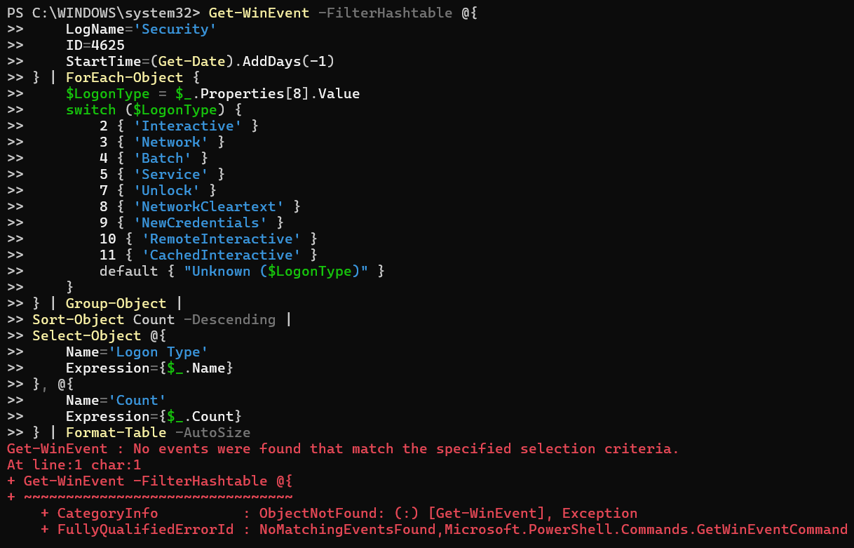
Figure 11: Logon type distribution: no events found

4. Brute-Force Attack Detection

Detection criteria
- Threshold: 5 failed attempts from the same source IP
- Time window: 1 hour
- Indicators: repeated failures from one IP, multiple usernames targeted, short time window

Exercise 10: Detection script (Detect-BruteForce.ps1)
The script was entered in the console. -ErrorAction SilentlyContinue was added so an empty log does not stop the script. The full script is in Appendix A.
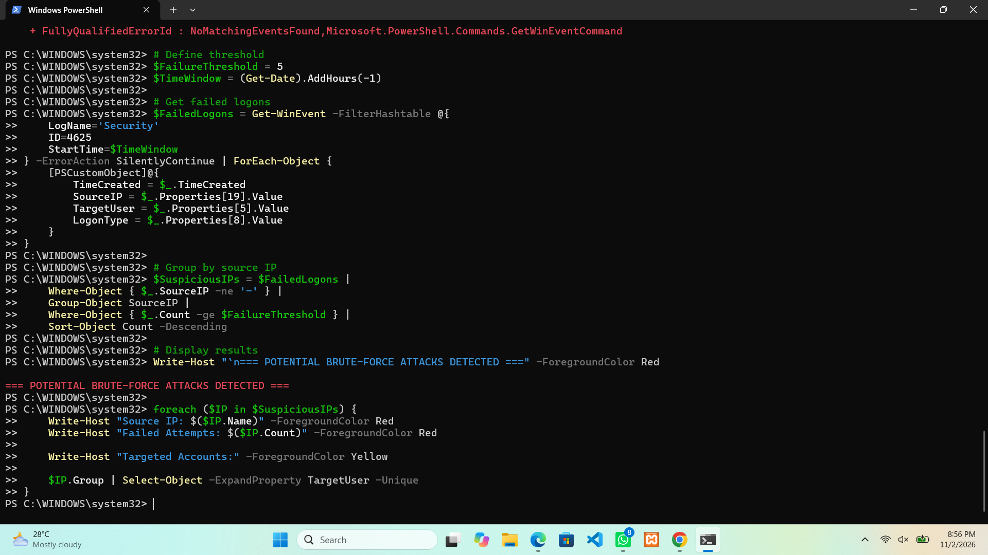
Figure 12: Brute-force detection script and output
Output: Only the heading "POTENTIAL BRUTE-FORCE ATTACKS DETECTED" was printed, with no source IPs listed.
Suspicious IPs identified: None (no data available). This must not be read as "no attack": $FailedLogons was empty because the Security log could not be read, so $SuspiciousIPs was also empty. The heading prints unconditionally; a production version should only print it when $SuspiciousIPs contains results.

Exercise 11: Generating test failed logons
To validate the detection logic, failed logons should be generated and verified from an elevated session:
1..10 | ForEach-Object {
net use \\localhost\C$ /user:FakeUser WrongPassword 2>$null
Start-Sleep -Seconds 2
}

Get-WinEvent -FilterHashtable @{
LogName='Security'
ID=4625
StartTime=(Get-Date).AddMinutes(-5)
} | Select-Object TimeCreated, Message | Format-List

Screenshot to be added after re-running as Administrator.

5. Lateral Movement Indicators

Explicit credential usage (Event ID 4648)
Get-WinEvent -FilterHashtable @{
LogName='Security'
ID=4648
StartTime=(Get-Date).AddDays(-1)
} | ForEach-Object {
$xml = [xml]$_.ToXml()
[PSCustomObject]@{
TimeCreated = $_.TimeCreated
SourceUser = $xml.Event.EventData.Data[1].'#text'
TargetUser = $xml.Event.EventData.Data[5].'#text'
TargetServer = $xml.Event.EventData.Data[8].'#text'
Process = $xml.Event.EventData.Data[11].'#text'
}
} | Format-Table -AutoSize

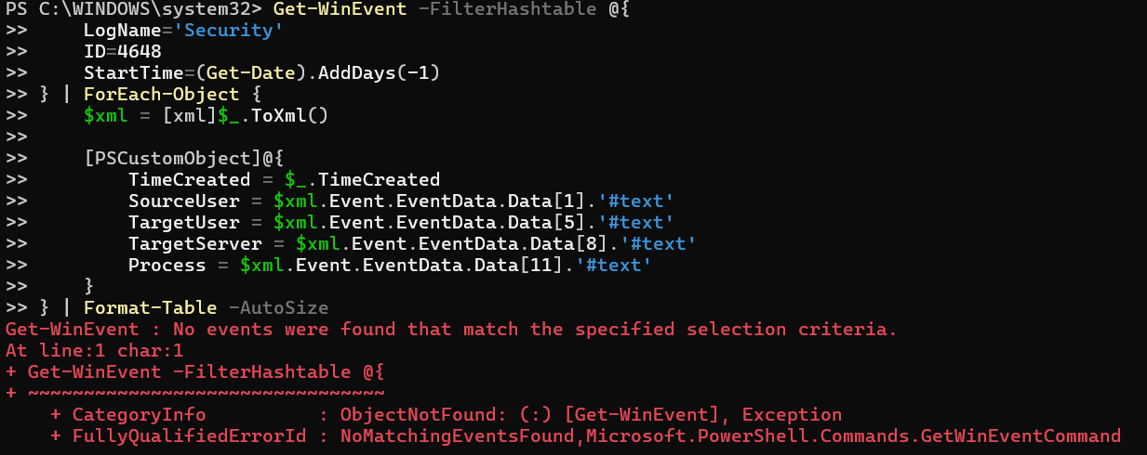
Figure 13: Event ID 4648 query: no events found
Finding: No explicit-credential usage could be confirmed.

Network share access (Event ID 5140)
Get-WinEvent -FilterHashtable @{
LogName='Security'
ID=5140
StartTime=(Get-Date).AddHours(-1)
} | ForEach-Object {
$xml = [xml]$_.ToXml()
[PSCustomObject]@{
TimeCreated = $_.TimeCreated
Account = $xml.Event.EventData.Data[1].'#text'
SourceIP = $xml.Event.EventData.Data[3].'#text'
ShareName = $xml.Event.EventData.Data[4].'#text'
}
} | Format-Table -AutoSize

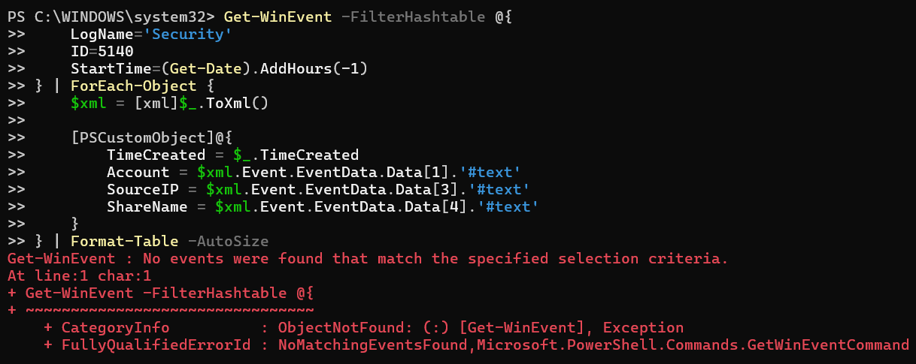
Figure 14: Event ID 5140 query: no events found
Finding: No share access events returned. Event 5140 is only generated if *Audit File Share* is enabled.

6. Privilege Escalation Indicators

Admin group changes (Event ID 4732, last 7 days)
Get-WinEvent -FilterHashtable @{
LogName='Security'
ID=4732
StartTime=(Get-Date).AddDays(-7)
} | ForEach-Object {
$xml = [xml]$_.ToXml()
[PSCustomObject]@{
TimeCreated = $_.TimeCreated
AddedUser = $xml.Event.EventData.Data[0].'#text'
GroupName = $xml.Event.EventData.Data[2].'#text'
AddedBy = $xml.Event.EventData.Data[6].'#text'
}
} | Format-Table -AutoSize

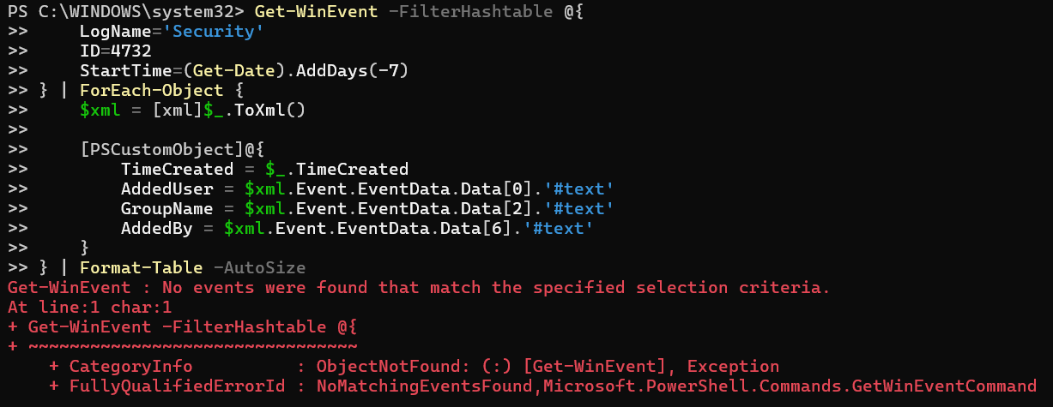
Figure 15: Event ID 4732 query: no events found
Finding: No group membership changes could be confirmed.

Special privilege assignments (Event ID 4672)
Get-WinEvent -FilterHashtable @{
LogName='Security'
ID=4672
StartTime=(Get-Date).AddHours(-1)
} | ForEach-Object {
$xml = [xml]$_.ToXml()
[PSCustomObject]@{
TimeCreated = $_.TimeCreated
Account = $xml.Event.EventData.Data[1].'#text'
LogonID = $xml.Event.EventData.Data[3].'#text'
}
} | Where-Object { $_.Account -notlike '*$' } |
Format-Table -AutoSize

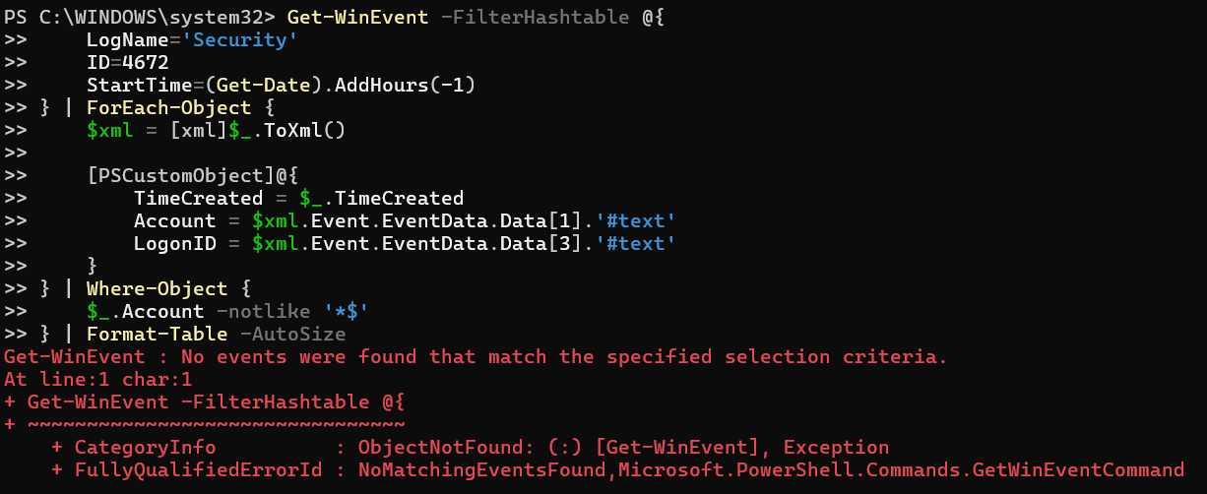
Figure 16: Event ID 4672 query: no events found
Finding: No results. Event 4672 is normally very frequent on any Windows system (every admin or SYSTEM logon), which again indicates the log was not readable.

7. Troubleshooting and Analysis of Results
Observation | Evidence | Interpretation
Unfiltered Get-WinEvent -LogName Security failed with UnauthorizedAccessException | Exercise 1 | Session lacks permission to read the Security log
All -FilterHashtable queries returned NoMatchingEventsFound | Exercises 2 to 15 | With -FilterHashtable, an access-denied condition can surface as "no events found"
Queries with no Event ID filter also returned nothing | Exercise 3 | Points to access or log availability, not absence of specific events
Very common events (4624, 4672) missing | Exercises 2, 15 | Unusual for an active Windows system

Most likely cause: PowerShell was not running as Administrator. Other possible causes: logon auditing disabled in local policy, or the Security log having been cleared (Event ID 1102).
Verification steps to run as Administrator:
# Confirm elevation (should return True)
([Security.Principal.WindowsPrincipal][Security.Principal.WindowsIdentity]::GetCurrent()).IsInRole([Security.Principal.WindowsBuiltInRole]::Administrator)

# Confirm the log is readable
Get-WinEvent -LogName Security -MaxEvents 10

# Check and enable logon auditing
auditpol /get /category:"Logon/Logoff"
auditpol /set /subcategory:"Logon" /success:enable /failure:enable

8. Exporting Results

Exercise 17: Export to CSV
Get-WinEvent -FilterHashtable @{
LogName='Security'
ID=4625
StartTime=(Get-Date).AddDays(-1)
} | ForEach-Object {
[PSCustomObject]@{
TimeCreated = $_.TimeCreated
SourceIP = $_.Properties[19].Value
TargetUser = $_.Properties[5].Value
LogonType = $_.Properties[8].Value
FailureReason = $_.Properties[13].Value
}
} | Export-Csv -Path "$env:USERPROFILE\Desktop\FailedLogons.csv" -NoTypeInformation

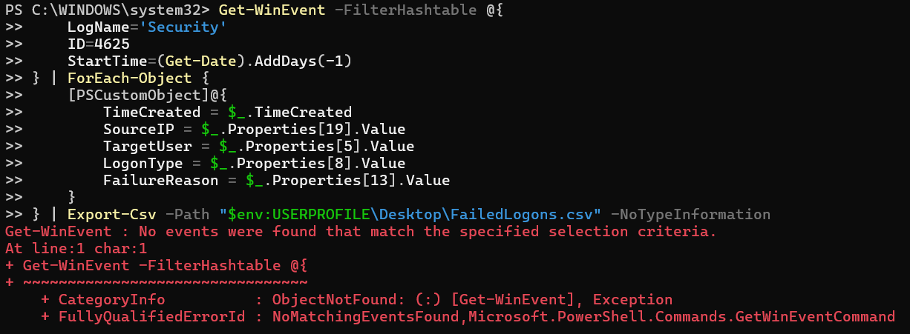
Figure 17: CSV export: no events found, so no CSV was written
Result: The pipeline stopped at Get-WinEvent, so no FailedLogons.csv was created.

Exercise 18: Export to HTML
$HTML = $FailedLogons |
Select-Object TimeCreated, Id, Message |
ConvertTo-Html -Title "Failed Logon Report"
$HTML | Out-File "$env:USERPROFILE\Desktop\FailedLogons.html"

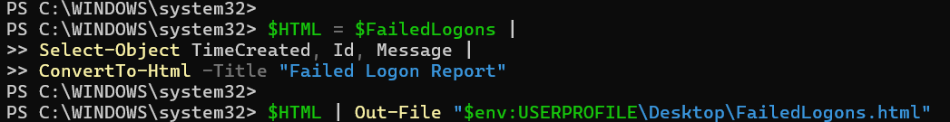
Figure 18: HTML report export commands
Result: No error was displayed, but because $FailedLogons was empty the HTML file contains only an empty table with no event rows.

9. Recommendations

Immediate actions
- Re-run all exercises from an elevated PowerShell (Win + X, then Terminal (Admin)) and refresh screenshots and exports.
- Verify that *Audit Logon* (success and failure) and *Audit File Share* are enabled so events 4624, 4625 and 5140 are generated.
- Generate test failed logons (Exercise 11) to confirm the detection script flags the source IP.
- Check for Event ID 1102 (audit log cleared) to rule out log tampering.

Long-term improvements
- Add a pre-check to every script that confirms elevation and fails loudly if the Security log cannot be read, so "no access" is never confused with "no attacks".
- Only print the brute-force alert when suspicious IPs actually exist.
- Forward Security events to a SIEM (e.g. Splunk) and alert on repeated 4625 events, 4648 from unusual processes, and 4732 changes to Administrators.
- Enable account lockout policy, enforce MFA, restrict RDP exposure, and increase Security log size and retention.
- Schedule Analyze-SecurityLogs.ps1 to run daily with Task Scheduler.

Appendix A: Detect-BruteForce.ps1
# Define threshold
$FailureThreshold = 5
$TimeWindow = (Get-Date).AddHours(-1)

# Get failed logons
$FailedLogons = Get-WinEvent -FilterHashtable @{
LogName='Security'
ID=4625
StartTime=$TimeWindow
} -ErrorAction SilentlyContinue | ForEach-Object {
[PSCustomObject]@{
TimeCreated = $_.TimeCreated
SourceIP = $_.Properties[19].Value
TargetUser = $_.Properties[5].Value
LogonType = $_.Properties[8].Value
}
}

# Group by source IP
$SuspiciousIPs = $FailedLogons |
Where-Object { $_.SourceIP -ne '-' } |
Group-Object SourceIP |
Where-Object { $_.Count -ge $FailureThreshold } |
Sort-Object Count -Descending

# Display results
Write-Host "`n=== POTENTIAL BRUTE-FORCE ATTACKS DETECTED ===" -ForegroundColor Red
Write-Host "Time Window: Last 1 hour" -ForegroundColor Yellow
Write-Host "Threshold: $FailureThreshold failed attempts`n" -ForegroundColor Yellow

foreach ($IP in $SuspiciousIPs) {
Write-Host "Source IP: $($IP.Name)" -ForegroundColor Red
Write-Host "Failed Attempts: $($IP.Count)" -ForegroundColor Red
Write-Host "Targeted Accounts:" -ForegroundColor Yellow
$IP.Group | Select-Object -ExpandProperty TargetUser -Unique | ForEach-Object {
Write-Host " $_"
}
Write-Host ""
}

Appendix B: Analyze-SecurityLogs.ps1
<#
.SYNOPSIS
Comprehensive Windows Security Log Analysis Script.
.DESCRIPTION
Analyzes Windows Security Event Logs for suspicious activity.
.PARAMETER Hours
Number of hours to analyze (default: 24).
.EXAMPLE
.\Analyze-SecurityLogs.ps1 -Hours 24
#>
param(
[int]$Hours = 24
)

$StartTime = (Get-Date).AddHours(-$Hours)

Write-Host "`n========================================" -ForegroundColor Cyan
Write-Host "Windows Security Log Analysis Report" -ForegroundColor Cyan
Write-Host "========================================" -ForegroundColor Cyan
Write-Host "Analysis Period: Last $Hours hours" -ForegroundColor Yellow
Write-Host "Start Time: $StartTime" -ForegroundColor Yellow
Write-Host "========================================`n" -ForegroundColor Cyan

# 1. Failed Logon Analysis
Write-Host "[1] FAILED LOGON ANALYSIS" -ForegroundColor Green
Write-Host "-----------------------------------" -ForegroundColor Green

$FailedLogons = Get-WinEvent -FilterHashtable @{
LogName='Security'
ID=4625
StartTime=$StartTime
} -ErrorAction SilentlyContinue

if ($FailedLogons) {
Write-Host "Total Failed Logons: $($FailedLogons.Count)" -ForegroundColor Yellow

Write-Host "`nTop 5 Source IPs:" -ForegroundColor Cyan
$FailedLogons | ForEach-Object { $_.Properties[19].Value } |
Where-Object { $_ -ne '-' } |
Group-Object | Sort-Object Count -Descending | Select-Object -First 5 |
Format-Table @{Name='IP Address';Expression={$_.Name}}, @{Name='Attempts';Expression={$_.Count}} -AutoSize

Write-Host "Top 5 Targeted Accounts:" -ForegroundColor Cyan
$FailedLogons | ForEach-Object { $_.Properties[5].Value } |
Where-Object { $_ -ne '-' } |
Group-Object | Sort-Object Count -Descending | Select-Object -First 5 |
Format-Table @{Name='Username';Expression={$_.Name}}, @{Name='Attempts';Expression={$_.Count}} -AutoSize
} else {
Write-Host "No failed logons found." -ForegroundColor Green
}

# 2. Successful Logon Analysis
Write-Host "`n[2] SUCCESSFUL LOGON ANALYSIS" -ForegroundColor Green
Write-Host "-----------------------------------" -ForegroundColor Green

$SuccessfulLogons = Get-WinEvent -FilterHashtable @{
LogName='Security'
ID=4624
StartTime=$StartTime
} -ErrorAction SilentlyContinue

if ($SuccessfulLogons) {
Write-Host "Total Successful Logons: $($SuccessfulLogons.Count)" -ForegroundColor Yellow

Write-Host "`nLogon Type Distribution:" -ForegroundColor Cyan
$SuccessfulLogons | ForEach-Object {
$LogonType = $_.Properties[8].Value
switch ($LogonType) {
2 { 'Interactive' }
3 { 'Network' }
10 { 'RemoteInteractive' }
default { "Type $LogonType" }
}
} | Group-Object | Sort-Object Count -Descending |
Format-Table @{Name='Logon Type';Expression={$_.Name}}, @{Name='Count';Expression={$_.Count}} -AutoSize
}

# 3. Account Management
Write-Host "`n[3] ACCOUNT MANAGEMENT EVENTS" -ForegroundColor Green
Write-Host "-----------------------------------" -ForegroundColor Green

$AccountEvents = Get-WinEvent -FilterHashtable @{
LogName='Security'
ID=4720,4722,4724,4732
StartTime=$StartTime
} -ErrorAction SilentlyContinue

if ($AccountEvents) {
Write-Host "Account Management Events: $($AccountEvents.Count)" -ForegroundColor Yellow
$AccountEvents | Group-Object Id |
Format-Table @{Name='Event ID';Expression={$_.Name}}, @{Name='Count';Expression={$_.Count}} -AutoSize
} else {
Write-Host "No account management events found." -ForegroundColor Green
}

# 4. Privilege Escalation
Write-Host "`n[4] PRIVILEGE ESCALATION INDICATORS" -ForegroundColor Green
Write-Host "-----------------------------------" -ForegroundColor Green

$PrivEsc = Get-WinEvent -FilterHashtable @{
LogName='Security'
ID=4672,4648
StartTime=$StartTime
} -ErrorAction SilentlyContinue

if ($PrivEsc) {
Write-Host "Privilege-Related Events: $($PrivEsc.Count)" -ForegroundColor Yellow
$PrivEsc | Group-Object Id |
Format-Table @{Name='Event ID';Expression={$_.Name}}, @{Name='Count';Expression={$_.Count}} -AutoSize
}

Write-Host "`n========================================" -ForegroundColor Cyan
Write-Host "Analysis Complete" -ForegroundColor Cyan
Write-Host "========================================`n" -ForegroundColor Cyan

Lab Completion Time: [Record your time]
Difficulty Level: Intermediate

