Lab Report
Log Analysis with CLI Tools
Week 3 Lab - Linux Command Line (grep, awk, sed, cut, sort, uniq) on Ubuntu VM
Item | Details
Student Name | Atiqur Rahman
ID | 2404037
Course | Cyber Security Engineering - SOC / Log Analysis
Lab | Lab 02 - Log Analysis with CLI Tools (Ubuntu)
Environment | Ubuntu Server virtual machine (tamimubuntuserver02)
Log file analysed | access.log - Apache Combined Log Format, 10,000 requests
Analysis period | 17 May 2015 10:05 to 20 May 2015 21:05 (4 days)
Date of report | 3 November 2026

1. Objective and Scenario
The objective of this lab is to use essential Linux command-line tools (grep, awk, sed, cut, sort, uniq) to parse and analyse a web-server log for security investigation. In the scenario, the analyst works as a SOC analyst at SecureCorp who must examine Apache access logs after unusual traffic was detected, in order to identify suspicious activity, attack patterns and possible compromised systems.
Apache Combined Log Format
Each log line contains the fields below. The awk field numbers ($n) are used throughout this report.
Field | awk | Description | Example
IP address | $1 | Client IP address | 83.149.9.216
Identity / User | $2 / $3 | RFC 1413 identity and HTTP auth user (usually -) | - -
Timestamp | $4 | Time of the request | [17/May/2015:10:05:03 +0000]
Request | $6-$8 | Method, URL and protocol | "GET /index.html HTTP/1.1"
Status code | $9 | HTTP response code | 200
Size | $10 | Response size in bytes | 203023
Referer / User-Agent | $11+ | Source page and client software | "Mozilla/5.0 ..."
Note: because the request is split into three words, the method is $6, the URL is $7, the status is $9 and the size is $10 in awk when the default space separator is used.
Note on screenshots: each figure is a terminal screenshot of the command and its real output, executed on the lab log file. Very long output is truncated in the image where indicated.

2. Part 1: Understanding Apache Log Format
Step 2.1 - Create working directory
Command: mkdir -p ~/soc-labs/week3 && cd ~/soc-labs/week3 && pwd
Figure 1: Step 2.1 - Create working directory
Purpose of the command: Creates the working directory ~/soc-labs/week3 (-p creates parent folders if needed, no error if it exists), moves into it with cd, and prints the current path with pwd.
Output and significance: The shell prints the full path of the new directory. All lab files (access.log, unique_ips.txt, urls.txt, suspicious_ips.txt) will be kept here, which keeps the investigation organised and evidence in one place.
Step 2.2 - Download sample log file
Command: wget "https://raw.githubusercontent.com/elastic/examples/master/Common%20Data%20Formats/apache_logs/apache_logs" -O access.log; ls -lh access.log
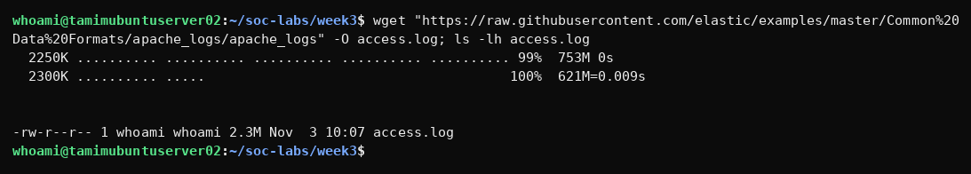
Figure 2: Step 2.2 - Download sample log file
Purpose of the command: Downloads the sample Apache access log from the Elastic examples repository using wget (-O saves it as access.log). ls -lh then shows the file with a human-readable size.
Output and significance: wget reports that the file was saved and ls shows access.log is about 2.3 MB. This confirms the evidence file is available locally before analysis begins.
Step 2.3 - Verify the file (ls -lh)
Command: ls -lh access.log
Figure 3: Step 2.3 - Verify the file (ls -lh)
Purpose of the command: ls -lh lists the file in long format (-l) with human-readable sizes (-h) to verify it exists.
Output and significance: The file access.log is 2.3 MB, owned by the current user with read/write permission. A non-zero size confirms the download was successful and the log is not empty.
Step 2.4 - View first 5 log lines (head)
Command: head -5 access.log
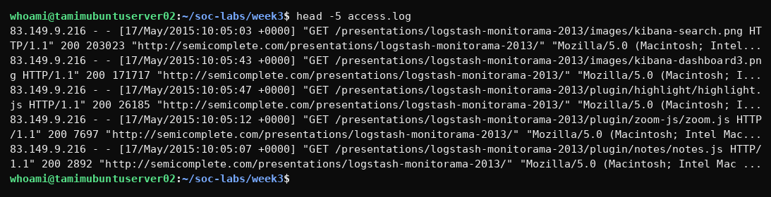
Figure 4: Step 2.4 - View first 5 log lines (head)
Purpose of the command: head -5 prints the first five lines of the log so the Combined Log Format fields can be identified.
Output and significance: Each line shows: client IP, identity (-), user (-), timestamp, request (method, URL, protocol), status code, response size, referer and user-agent. For example the first entry is a GET for a kibana-search.png image returning status 200 with 203023 bytes from IP 83.149.9.216. Knowing these field positions ($1 = IP, $4 = time, $6 = method, $7 = URL, $9 = status, $10 = bytes) is required for all awk commands that follow.

3. Part 2: Basic Log Analysis Commands
Exercise 1 - Count total requests
Command: wc -l access.log
Figure 5: Exercise 1 - Count total requests
Purpose of the command: wc -l counts the number of lines in access.log. Each line is one HTTP request.
Output and significance: Output: 10000 access.log. The log contains 10,000 requests, which is the baseline for all later percentages.
Exercise 2 (a) - Extract IP addresses
Command: awk '{print $1}' access.log | head -10
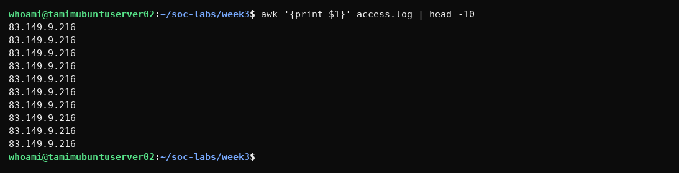
Figure 6: Exercise 2 (a) - Extract IP addresses
Purpose of the command: awk '{print $1}' prints only the first field (client IP address) of each line; head -10 limits the display to 10 lines.
Output and significance: The first ten lines are all 83.149.9.216, showing that this one client made many consecutive requests (loading the page's images and scripts). This is the unsorted view of IP addresses.
Exercise 2 (b) - Sort the IP addresses
Command: awk '{print $1}' access.log | sort | head -10
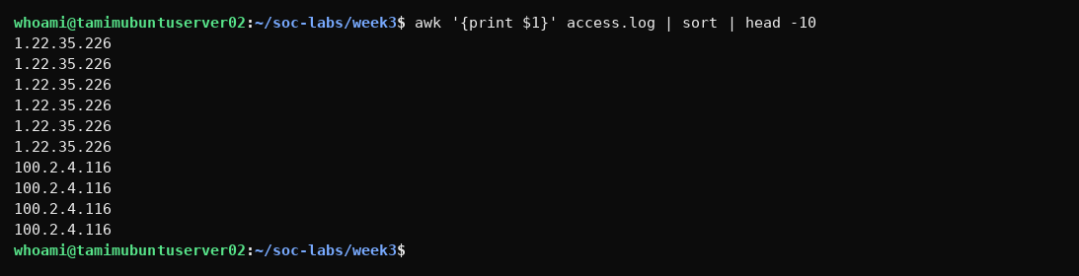
Figure 7: Exercise 2 (b) - Sort the IP addresses
Purpose of the command: Pipes the IP list into sort so identical IP addresses are grouped together, then shows the first 10.
Output and significance: The first ten results are all 1.22.35.226. Sorting puts repeated addresses next to each other, which is required before uniq can remove or count duplicates.
Exercise 2 (c) - Remove duplicates with uniq
Command: awk '{print $1}' access.log | sort | uniq | head -10
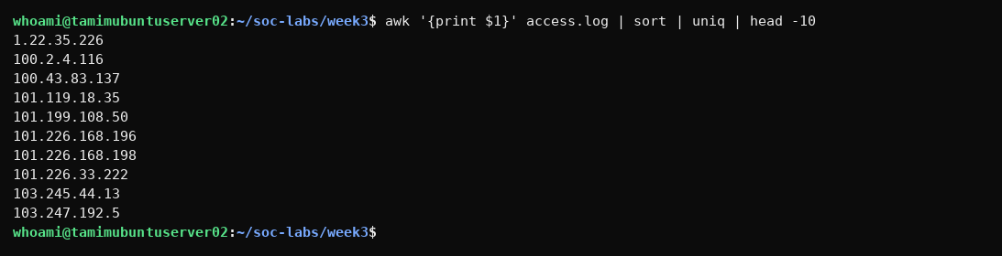
Figure 8: Exercise 2 (c) - Remove duplicates with uniq
Purpose of the command: Adds uniq, which removes adjacent duplicate lines. It works correctly only because the data was sorted first.
Output and significance: Instead of repeating one IP, the output now shows different addresses (1.22.35.226, 100.2.4.116, 100.43.83.137 ...). Each IP is listed once.
Exercise 2 (d) - Count unique IPs
Command: awk '{print $1}' access.log | sort | uniq | wc -l
Figure 9: Exercise 2 (d) - Count unique IPs
Purpose of the command: Counts the unique IP lines with wc -l after sort | uniq.
Output and significance: Output: 1753. A total of 1,753 different IP addresses sent requests during the log period.
Exercise 2 (e) - Count unique IPs with sort -u
Command: awk '{print $1}' access.log | sort -u | wc -l
Figure 10: Exercise 2 (e) - Count unique IPs with sort -u
Purpose of the command: The shorter alternative: sort -u sorts and removes duplicates in one step, then wc -l counts.
Output and significance: Output: 1753, identical to the previous command. This confirms the result and shows sort -u is the more efficient method.
Exercise 3 - Top 10 talkers
Command: awk '{print $1}' access.log | sort | uniq -c | sort -rn | head -10
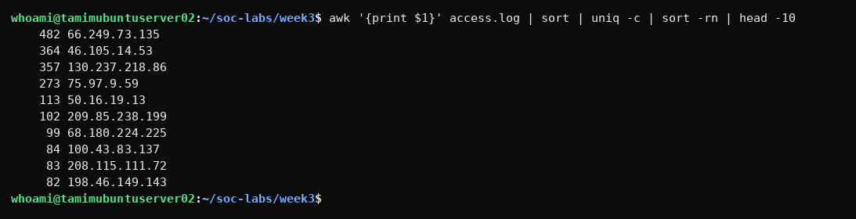
Figure 11: Exercise 3 - Top 10 talkers
Purpose of the command: Builds the top-talkers list: extract IPs, sort, uniq -c (count each IP), sort -rn (highest count first) and head -10 (top ten).
Output and significance: The most active IP is 66.249.73.135 with 482 requests, followed by 46.105.14.53 (364), 130.237.218.86 (357) and 75.97.9.59 (273). High-volume IPs can be search-engine bots, scrapers, heavy users or attackers. 66.249.x.x is a Googlebot range, so it is likely legitimate crawling; the others should be checked.
Exercise 4 (a) - Count 404 errors with grep
Command: grep " 404 " access.log | wc -l
Figure 12: Exercise 4 (a) - Count 404 errors with grep
Purpose of the command: grep searches for the text " 404 " (with spaces to avoid matching other numbers) and wc -l counts the matching lines.
Output and significance: Output: 213. There were 213 requests that returned 404 Not Found, about 2.1% of all requests.
Exercise 4 (b) - Count 404 errors with awk
Command: awk '$9 == 404' access.log | wc -l
Figure 13: Exercise 4 (b) - Count 404 errors with awk
Purpose of the command: Uses awk to test the status-code field directly ($9 == 404). This is more accurate than grep because it checks only the status column.
Output and significance: Output: 213, the same as the grep method, so the figure is confirmed.
Exercise 4 (c) - All status codes
Command: awk '{print $9}' access.log | sort | uniq -c | sort -rn
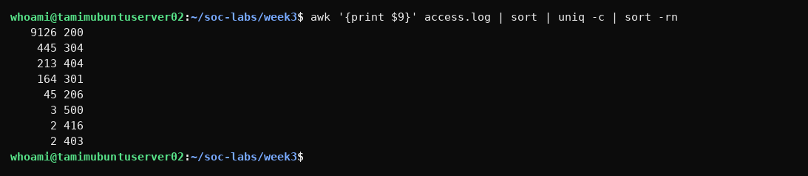
Figure 14: Exercise 4 (c) - All status codes
Purpose of the command: Extracts the status code field ($9), counts each value and sorts by frequency.
Output and significance: 200 OK = 9126, 304 Not Modified = 445, 404 Not Found = 213, 301 Redirect = 164, 206 Partial = 45, 500 Server Error = 3, 416 = 2, 403 Forbidden = 2. Most traffic is successful. The 404s show missing or probed pages, the 403s show denied access, and the three 500 errors point to server-side problems worth reviewing.
Exercise 5 - Top URLs causing 404
Command: awk '$9 == 404 {print $7}' access.log | sort | uniq -c | sort -rn | head -5
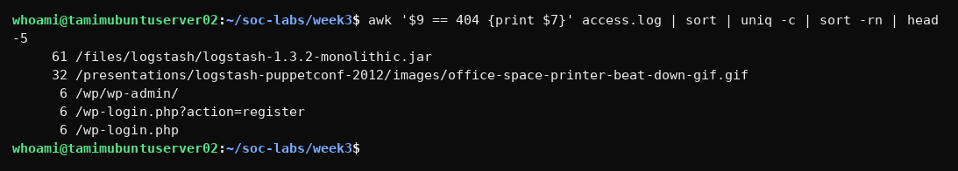
Figure 15: Exercise 5 - Top URLs causing 404
Purpose of the command: Filters only 404 responses ($9 == 404), prints the requested URL ($7), counts and shows the five most frequent.
Output and significance: The top 404 URLs are a missing logstash .jar file (61) and a missing gif (32) - broken links, not attacks. The next entries, /wp/wp-admin/, /wp-login.php?action=register and /wp-login.php (6 each), are WordPress admin/login paths. This server is not a WordPress site, so these requests are reconnaissance by bots looking for admin panels.

4. Part 3: Advanced Pattern Matching with grep
Exercise 6 (a) - Count Nikto requests
Command: grep -i "nikto" access.log | wc -l
Figure 16: Exercise 6 (a) - Count Nikto requests
Purpose of the command: Counts log lines containing 'nikto' (case-insensitive, -i). Nikto is a web vulnerability scanner that identifies itself in the User-Agent.
Output and significance: Output: 0. No Nikto scanning is present in this log.
Exercise 6 (b) - Nikto request details
Command: grep -i "nikto" access.log | head -5
Figure 17: Exercise 6 (b) - Nikto request details
Purpose of the command: Prints the first five full log lines that mention Nikto.
Output and significance: No output, because there are no Nikto requests. This confirms the previous result.
Exercise 6 (c) - IPs using Nikto
Command: grep -i "nikto" access.log | awk '{print $1}' | sort -u
Figure 18: Exercise 6 (c) - IPs using Nikto
Purpose of the command: Would list the unique source IP addresses that used Nikto (awk prints $1, sort -u removes duplicates).
Output and significance: No output - no IP used the Nikto user-agent, so there are no Nikto scanner sources to block.
Exercise 7 (a) - SQL keyword search
Command: grep -iE "(union|select|insert|update|delete|drop|exec|script)" access.log | wc -l
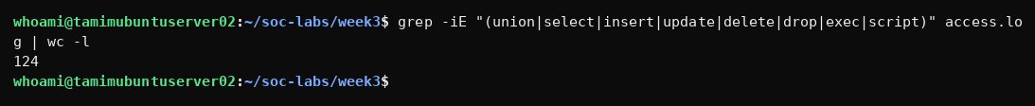
Figure 19: Exercise 7 (a) - SQL keyword search
Purpose of the command: Searches for SQL-related keywords (union, select, insert, update, delete, drop, exec, script) using extended regex (-E) and case-insensitive matching, and counts the lines.
Output and significance: Output: 124. This number is a broad keyword count and includes false positives. Separate checks show union = 0 and select = 0; the matches come mainly from the word 'script' (118, e.g. coffee-script.js and /scripts/ paths) and 'drop' (5). So there is no evidence of real SQL injection - an analyst must always review matches rather than trust the raw count.
Exercise 7 (b) - Encoded SQL patterns
Command: grep -E "(%27|%20union|%20select)" access.log
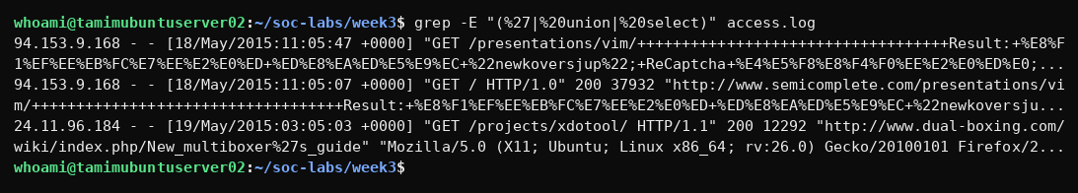
Figure 20: Exercise 7 (b) - Encoded SQL patterns
Purpose of the command: Searches for URL-encoded SQL patterns: %27 (single quote), %20union and %20select.
Output and significance: 3 lines matched %27. Two are requests from 94.153.9.168 with a long encoded spam-like string in the URL/referer, and one is a harmless referer containing an encoded apostrophe (New_multiboxer%27s_guide). None contains UNION or SELECT, so these are suspicious/noisy requests but not confirmed SQL injection.
Exercise 7 (c) - Suspicious UNION/SELECT requests
Command: grep -iE "(union|select)" access.log | awk '{print $1, $7}' | head -10
Figure 21: Exercise 7 (c) - Suspicious UNION/SELECT requests
Purpose of the command: Extracts the IP and URL of requests containing union or select.
Output and significance: No output. No request contains the SQL keywords UNION or SELECT.
Exercise 7 (d) - SQL attempts by IP
Command: grep -iE "(union|select)" access.log | awk '{print $1}' | sort | uniq -c | sort -rn
Figure 22: Exercise 7 (d) - SQL attempts by IP
Purpose of the command: Counts the requests per IP that contain union/select, sorted by highest count.
Output and significance: No output. There are no attacking IPs for this pattern, which confirms the earlier result.
Exercise 8 (a) - Detect XSS attempts
Command: grep -iE "(<script|javascript:|onerror=|%3Cscript)" access.log
Figure 23: Exercise 8 (a) - Detect XSS attempts
Purpose of the command: Searches for common XSS patterns: <script, javascript:, onerror= and %3Cscript (encoded).
Output and significance: No output. No cross-site scripting attempts were found.
Exercise 8 (b) - Count XSS attempts
Command: grep -iE "(<script|javascript:|onerror=|%3Cscript)" access.log | wc -l
Figure 24: Exercise 8 (b) - Count XSS attempts
Purpose of the command: Counts the XSS pattern matches with wc -l.
Output and significance: Output: 0 XSS attempts.
Exercise 8 (c) - Identify XSS attackers
Command: grep -iE "(<script|javascript:|onerror=)" access.log | awk '{print $1}' | sort | uniq -c | sort -rn
Figure 25: Exercise 8 (c) - Identify XSS attackers
Purpose of the command: Would list attacker IPs for XSS patterns with the count per IP.
Output and significance: No output - no XSS source IPs exist in this log.
Exercise 9 (a) - Detect directory traversal
Command: grep -E "(\.\./|\.\.%2[Ff])" access.log
Figure 26: Exercise 9 (a) - Detect directory traversal
Purpose of the command: Searches for directory traversal patterns ../ and the encoded form ..%2F.
Output and significance: No output. No path traversal attempts were detected.
Exercise 9 (b) - Count traversal attempts
Command: grep -E "(\.\./|\.\.%2[Ff])" access.log | wc -l
Figure 27: Exercise 9 (b) - Count traversal attempts
Purpose of the command: Counts the traversal matches.
Output and significance: Output: 0 directory traversal attempts.

5. Part 4: Advanced Analysis with awk
Exercise 10 - Traffic by hour
Command: awk '{print $4}' access.log | cut -d: -f2 | sort | uniq -c | sort -rn
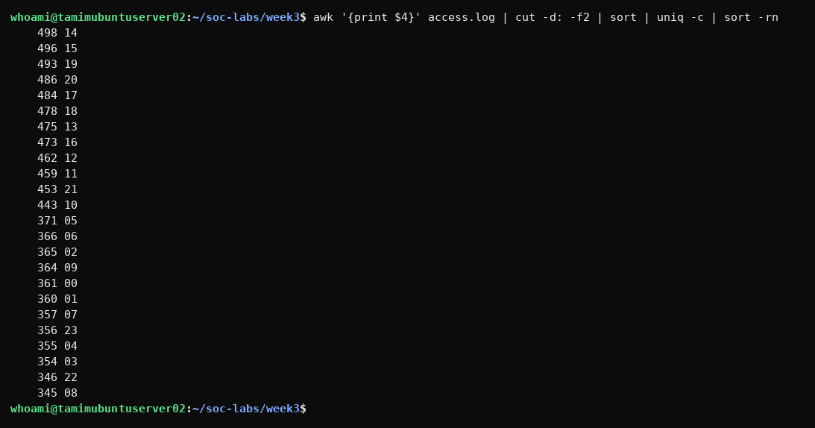
Figure 28: Exercise 10 - Traffic by hour
Purpose of the command: Extracts the timestamp ($4), cuts out the hour using : as the delimiter (cut -d: -f2), counts requests per hour and sorts from busiest.
Output and significance: Busiest hours are 14:00 (498), 15:00 (496) and 19:00 (493); the quietest is 08:00 (345). Traffic is fairly even through the day with no extreme spike at odd hours, so there is no sign of a sudden automated burst or DDoS in this period.
Exercise 11 - HTTP request methods
Command: awk '{print $6}' access.log | tr -d '"' | sort | uniq -c | sort -rn
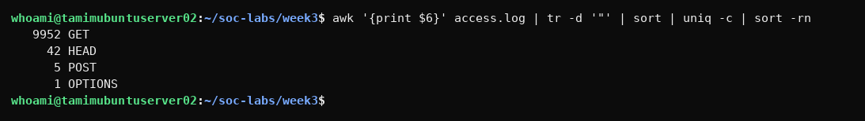
Figure 29: Exercise 11 - HTTP request methods
Purpose of the command: Prints the method field ($6), removes the quote character with tr -d '"', then counts each method.
Output and significance: GET = 9952, HEAD = 42, POST = 5, OPTIONS = 1. Traffic is almost entirely read-only GET. The small number of POST requests is worth reviewing, and no dangerous methods such as PUT, DELETE or TRACE appear.
Exercise 12 (a) - IPs that sent POST requests
Command: awk '$6 == "\"POST"' access.log | awk '{print $1}' | sort -u
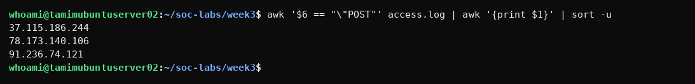
Figure 30: Exercise 12 (a) - IPs that sent POST requests
Purpose of the command: Selects lines whose method is POST and lists the unique IP addresses.
Output and significance: Three IPs sent POST requests: 37.115.186.244, 78.173.140.106 and 91.236.74.121.
Exercise 12 (b) - POST IPs (combined awk)
Command: awk '$6 == "\"POST" {print $1}' access.log | sort -u
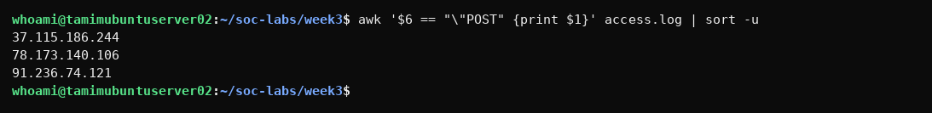
Figure 31: Exercise 12 (b) - POST IPs (combined awk)
Purpose of the command: The combined single-awk version of the previous command.
Output and significance: Same three IPs, showing the shorter command gives the same result.
Exercise 12 (c) - POST request details
Command: awk '$6 == "\"POST" {print $1, $7, $9}' access.log | head -10
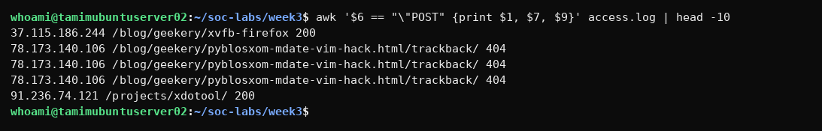
Figure 32: Exercise 12 (c) - POST request details
Purpose of the command: Shows the IP, URL and status code for the POST requests.
Output and significance: 78.173.140.106 sent three POST requests to a /trackback/ URL and each returned 404 - typical of trackback/comment spam bots. 37.115.186.244 and 91.236.74.121 received 200. POST requests to blog trackback endpoints should be monitored.
Exercise 13 (a) - Total bandwidth
Command: awk '{sum += $10} END {print sum/1024/1024 " MB"}' access.log
Figure 33: Exercise 13 (a) - Total bandwidth
Purpose of the command: Adds up the response size field ($10) for every request and converts bytes to megabytes.
Output and significance: Total bandwidth is about 2620 MB (2.6 GB) over the four days. This is the baseline for spotting unusually heavy data transfer.
Exercise 13 (b) - Bandwidth by IP
Command: awk '{bytes[$1] += $10} END {for (ip in bytes) print ip, bytes[ip]/1024/1024 " MB"}' access.log | sort -k2 -rn | head -10
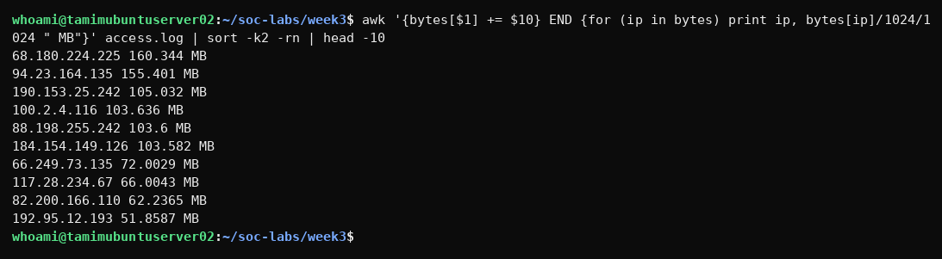
Figure 34: Exercise 13 (b) - Bandwidth by IP
Purpose of the command: Totals the bytes per IP using an awk array, converts to MB, sorts by size and shows the top ten.
Output and significance: 68.180.224.225 (160 MB), 94.23.164.135 (155 MB), 190.153.25.242 (105 MB) and 100.2.4.116 (104 MB) downloaded the most data. Very large downloads can mean scraping or data harvesting, so these IPs should be reviewed.

6. Part 5: Text Transformation with sed
Exercise 14 (a) - Save unique IPs to file
Command: awk '{print $1}' access.log | sort -u > unique_ips.txt
Figure 35: Exercise 14 (a) - Save unique IPs to file
Purpose of the command: Saves the unique IP list into the file unique_ips.txt using the > redirection operator.
Output and significance: No terminal output because the output went into the file. The file is a deliverable of the lab.
Exercise 14 (b) - Verify unique_ips.txt
Command: wc -l unique_ips.txt; head unique_ips.txt
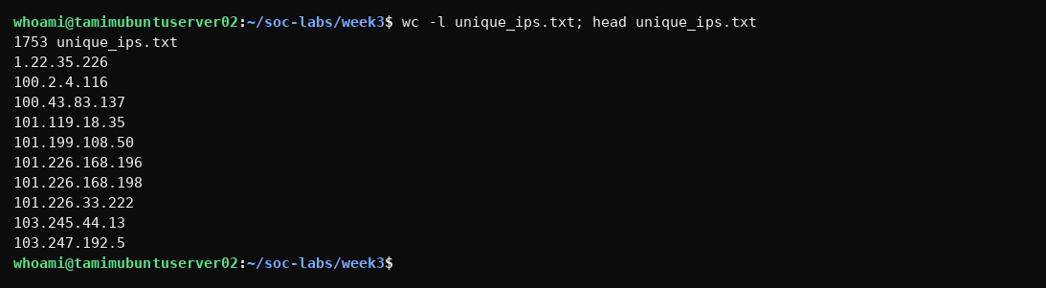
Figure 36: Exercise 14 (b) - Verify unique_ips.txt
Purpose of the command: Verifies the file: wc -l counts its lines and head shows the first ten entries.
Output and significance: unique_ips.txt contains 1753 lines, matching the earlier unique-IP count, and the content is a clean one-IP-per-line list.
Exercise 15 (a) - Anonymize IPs with sed
Command: sed 's/\([0-9]\{1,3\}\.\)\{3\}[0-9]\{1,3\}/\1XXX/' access.log | head -5
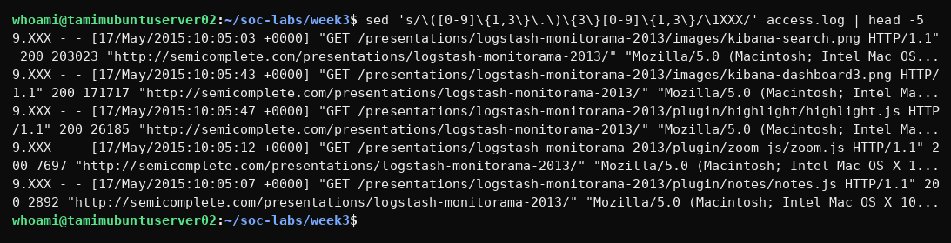
Figure 37: Exercise 15 (a) - Anonymize IPs with sed
Purpose of the command: Uses sed with a regular expression to anonymise the IP address for privacy. In this version \1 refers to only the last repeated group.
Output and significance: The output is wrong: IP 83.149.9.216 becomes 9.XXX because the backreference \1 captures only the last group of the repetition. This shows the first expression from the lab does not anonymise correctly and that sed output must always be checked.
Exercise 15 (b) - Anonymize IPs (simpler sed)
Command: sed 's/\.[0-9]*\( \)/\.XXX\1/' access.log | head -5
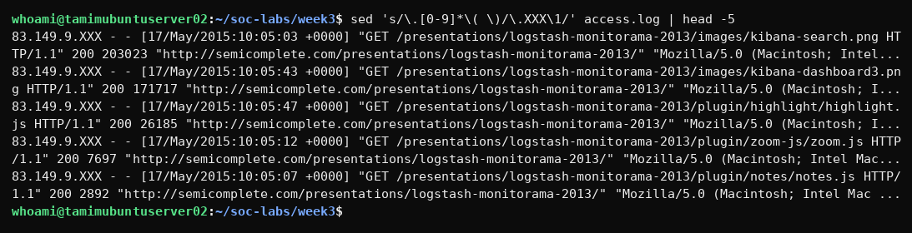
Figure 38: Exercise 15 (b) - Anonymize IPs (simpler sed)
Purpose of the command: The simpler sed command replaces the last octet (digits after the final dot before the space) with XXX.
Output and significance: The IPs are anonymised correctly, e.g. 83.149.9.216 becomes 83.149.9.XXX. This method is suitable for sharing logs while protecting user privacy.
Exercise 16 (a) - Save URLs to urls.txt
Command: awk '{print $7}' access.log | sort -u > urls.txt
Figure 39: Exercise 16 (a) - Save URLs to urls.txt
Purpose of the command: Extracts the requested URL ($7), removes duplicates and saves them to urls.txt.
Output and significance: No terminal output because it was redirected into urls.txt.
Exercise 16 (b) - Verify urls.txt
Command: wc -l urls.txt; head -5 urls.txt
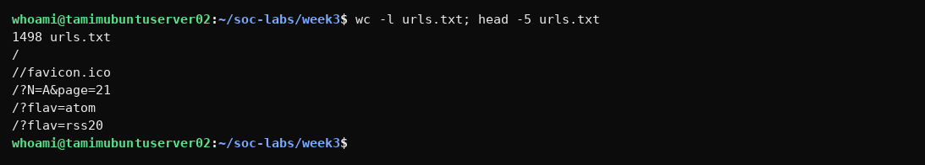
Figure 40: Exercise 16 (b) - Verify urls.txt
Purpose of the command: Verifies urls.txt with wc -l and head -5.
Output and significance: 1498 unique URLs were requested. The first entries are /, //favicon.ico and feed/page parameters, which are normal website paths.
Exercise 16 (c) - Filter script URLs (php/asp/jsp)
Command: awk '{print $7}' access.log | grep -E "\.(php|asp|jsp)$" | sort -u
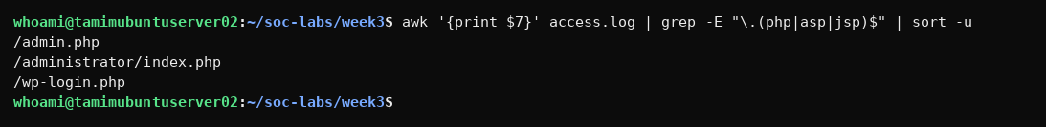
Figure 41: Exercise 16 (c) - Filter script URLs (php/asp/jsp)
Purpose of the command: Lists unique URLs that end in .php, .asp or .jsp (server-side scripts), which are common attack targets.
Output and significance: Three script URLs appear: /admin.php, /administrator/index.php and /wp-login.php. These are admin and login pages that attackers probe, and they all returned 404 earlier, meaning they do not exist on the server.

7. Part 6: Creating the Analysis Report (Deliverables)
Step 17 (a) - Build suspicious_ips.txt
Command: grep -iE "(wp-login|wp-admin|admin\.php|administrator|/scripts//%22|trackback)" access.log | awk '{print $1}' | sort -u > suspicious_ips.txt; wc -l suspicious_ips.txt; head suspicious_ips.txt
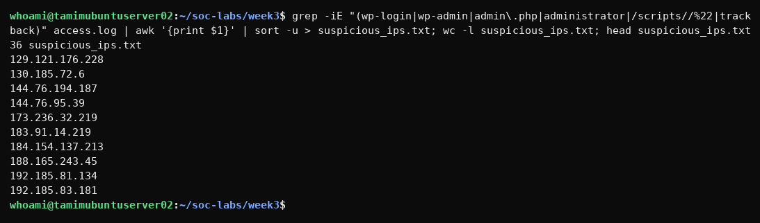
Figure 42: Step 17 (a) - Build suspicious_ips.txt
Purpose of the command: Builds suspicious_ips.txt from the indicators found in this log: admin/login probing (wp-login, wp-admin, admin.php, administrator), the odd /scripts//%22 scanning paths and trackback spam. sort -u removes duplicates, wc -l counts them.
Output and significance: 36 unique IPs were saved. These sources probed for admin panels or sent spam-like requests and are candidates for blocking or monitoring (e.g. 95.78.54.93, 144.76.95.39, 78.173.140.106).
Step 17 (b) - List deliverable files
Command: ls -lh unique_ips.txt suspicious_ips.txt urls.txt
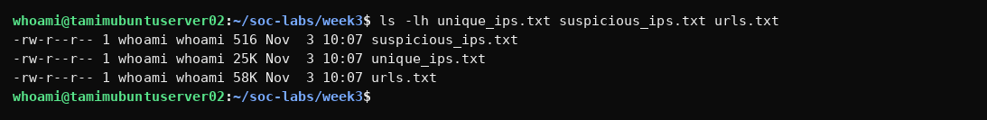
Figure 43: Step 17 (b) - List deliverable files
Purpose of the command: Lists the three deliverable files with their size and permissions.
Output and significance: unique_ips.txt (25 KB), urls.txt (58 KB) and suspicious_ips.txt (516 bytes) exist, so the lab deliverables are complete.

8. Summary of Findings
Key metrics
Metric | Result
Total requests | 10,000
Unique IP addresses | 1,753
Most active IP | 66.249.73.135 (482 requests, Googlebot range)
Status 200 / 404 / 500 | 9,126 / 213 / 3
Nikto scanner requests | 0
UNION/SELECT SQL injection | 0 (124 keyword hits were false positives, mainly 'script')
XSS attempts | 0
Directory traversal attempts | 0
HTTP methods | GET 9,952; HEAD 42; POST 5; OPTIONS 1
Total bandwidth | about 2,620 MB
Unique URLs requested | 1,498
IPs saved as suspicious | 36
Suspicious activity
IP address | Evidence | Activity
95.78.54.93 | 3 requests, all 404 | Probing /wp-login.php, /administrator/ and /admin.php (admin panel reconnaissance)
144.76.95.39 | 14 x 404 | Repeated requests to odd /scripts//%22... paths (automated scanning)
78.173.140.106 | 3 POST requests, 404 | POST to a /trackback/ URL (trackback/comment spam bot)
94.153.9.168 | Encoded strings | Long encoded string in URL/referer with %27 characters (spam-like, suspicious)
208.91.156.11 | 60 x 404 | Repeated requests for a missing file (broken link or scraper)
68.180.224.225 / 94.23.164.135 | 160 MB / 155 MB | Highest bandwidth consumers (possible scraping)
Recommended actions
- Monitor or block the IPs in suspicious_ips.txt (for example 95.78.54.93, 144.76.95.39 and 78.173.140.106) on the firewall or with a WAF rule.
- Rate-limit and review the heaviest bandwidth consumers to prevent scraping and unnecessary data transfer.
- Disable or protect trackback and comment endpoints against spam, and require CAPTCHA or authentication for POST requests.
- Fix the broken links that caused the most 404 errors (missing .jar and .gif files) and investigate the three 500 errors.
- Create SIEM alerts for requests to admin and login paths that do not exist (wp-login.php, wp-admin, admin.php) and for scanner user-agents such as Nikto.
- Anonymise IP addresses with the working sed method before sharing logs outside the SOC.
9. Conclusion
All commands from the lab were executed on the Apache access log of 10,000 requests. The log is mostly normal traffic: 91% of requests returned 200 and the methods are almost entirely GET. No Nikto scanning, SQL injection, XSS or directory traversal attempts were found; the 124 SQL keyword matches were false positives, which shows why matches must be reviewed manually. The analysis did reveal reconnaissance against admin and login pages, scanning of unusual paths, trackback spam through POST requests and a few IPs with very high bandwidth use. The chained grep, awk, sed, cut, sort and uniq commands proved to be fast and effective tools for security log investigation. The deliverables unique_ips.txt, urls.txt and suspicious_ips.txt were created.

Appendix A: All Commands Used
mkdir -p ~/soc-labs/week3 && cd ~/soc-labs/week3 && pwd
wget "https://raw.githubusercontent.com/elastic/examples/master/Common%20Data%20Formats/apache_logs/apache_logs" -O access.log
ls -lh access.log
head -5 access.log
wc -l access.log
awk '{print $1}' access.log | head -10
awk '{print $1}' access.log | sort | head -10
awk '{print $1}' access.log | sort | uniq | head -10
awk '{print $1}' access.log | sort | uniq | wc -l
awk '{print $1}' access.log | sort -u | wc -l
awk '{print $1}' access.log | sort | uniq -c | sort -rn | head -10
grep " 404 " access.log | wc -l
awk '$9 == 404' access.log | wc -l
awk '{print $9}' access.log | sort | uniq -c | sort -rn
awk '$9 == 404 {print $7}' access.log | sort | uniq -c | sort -rn | head -5
grep -i "nikto" access.log | wc -l
grep -i "nikto" access.log | head -5
grep -i "nikto" access.log | awk '{print $1}' | sort -u
grep -iE "(union|select|insert|update|delete|drop|exec|script)" access.log | wc -l
grep -E "(%27|%20union|%20select)" access.log
grep -iE "(union|select)" access.log | awk '{print $1, $7}' | head -10
grep -iE "(union|select)" access.log | awk '{print $1}' | sort | uniq -c | sort -rn
grep -iE "(<script|javascript:|onerror=|%3Cscript)" access.log
grep -iE "(<script|javascript:|onerror=|%3Cscript)" access.log | wc -l
grep -iE "(<script|javascript:|onerror=)" access.log | awk '{print $1}' | sort | uniq -c | sort -rn
grep -E "(\.\./|\.\.%2[Ff])" access.log
grep -E "(\.\./|\.\.%2[Ff])" access.log | wc -l
awk '{print $4}' access.log | cut -d: -f2 | sort | uniq -c | sort -rn
awk '{print $6}' access.log | tr -d '"' | sort | uniq -c | sort -rn
awk '$6 == "\"POST"' access.log | awk '{print $1}' | sort -u
awk '$6 == "\"POST" {print $1}' access.log | sort -u
awk '$6 == "\"POST" {print $1, $7, $9}' access.log | head -10
awk '{sum += $10} END {print sum/1024/1024 " MB"}' access.log
awk '{bytes[$1] += $10} END {for (ip in bytes) print ip, bytes[ip]/1024/1024 " MB"}' access.log | sort -k2 -rn | head -10
awk '{print $1}' access.log | sort -u > unique_ips.txt
wc -l unique_ips.txt; head unique_ips.txt
sed 's/\([0-9]\{1,3\}\.\)\{3\}[0-9]\{1,3\}/\1XXX/' access.log | head -5
sed 's/\.[0-9]*\( \)/\.XXX\1/' access.log | head -5
awk '{print $7}' access.log | sort -u > urls.txt
wc -l urls.txt; head -5 urls.txt
awk '{print $7}' access.log | grep -E "\.(php|asp|jsp)$" | sort -u
grep -iE "(wp-login|wp-admin|admin\.php|administrator|/scripts//%22|trackback)" access.log | awk '{print $1}' | sort -u > suspicious_ips.txt; wc -l suspicious_ips.txt; head suspicious_ips.txt
ls -lh unique_ips.txt suspicious_ips.txt urls.txt
Appendix B: Deliverable Files
- unique_ips.txt - 1,753 unique IP addresses (25 KB)
- urls.txt - 1,498 unique requested URLs (58 KB)
- suspicious_ips.txt - 36 IP addresses involved in probing or spam (516 bytes)

