MPC-MAP Assignment No. 1 - Report

Author: Sebastian Šimanský

Date: 30/3/2026

Task 1

This task will recieve only small debrief since it requieres no output and is only a mean to understand future excersises.
After scrolling through different types of variables I’ve picked a map in setup file to try the first ever simulation of given robot.
This led to discovery that the simulation does not work in matlab 2025.
Program crashes in closed function which led me to believe I was setting up something wrong or I was missing something (that was not the case).

Task 2/3
In this section I’ve prepared new script called calc_unc.m in uncertainties folder.
This script is responsible for collecting N amount of data (N>100) and calculating stds, covariances (task 3) and plotting required histograms.
Covariances are indeed square matricies where number of rows/columns is given by number of measured variables for each sensor.

LiDAR histograms:
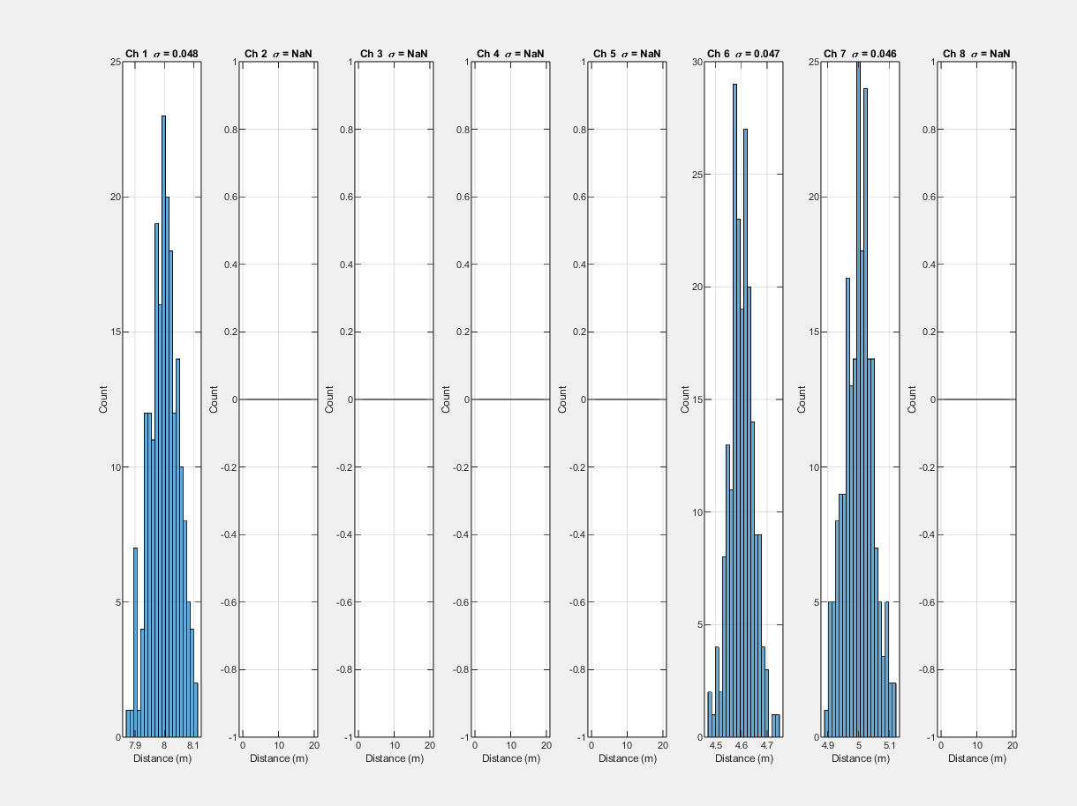

GNSS histograms:
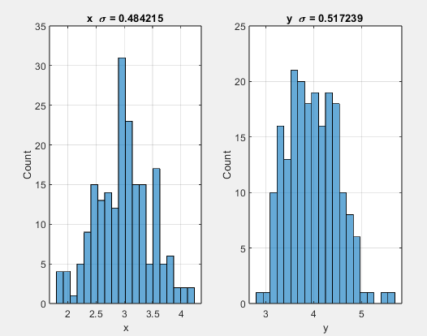

Task 4
Here norm_pdf function was created to calculate propability density function of normal distribution.
Resulting plot:
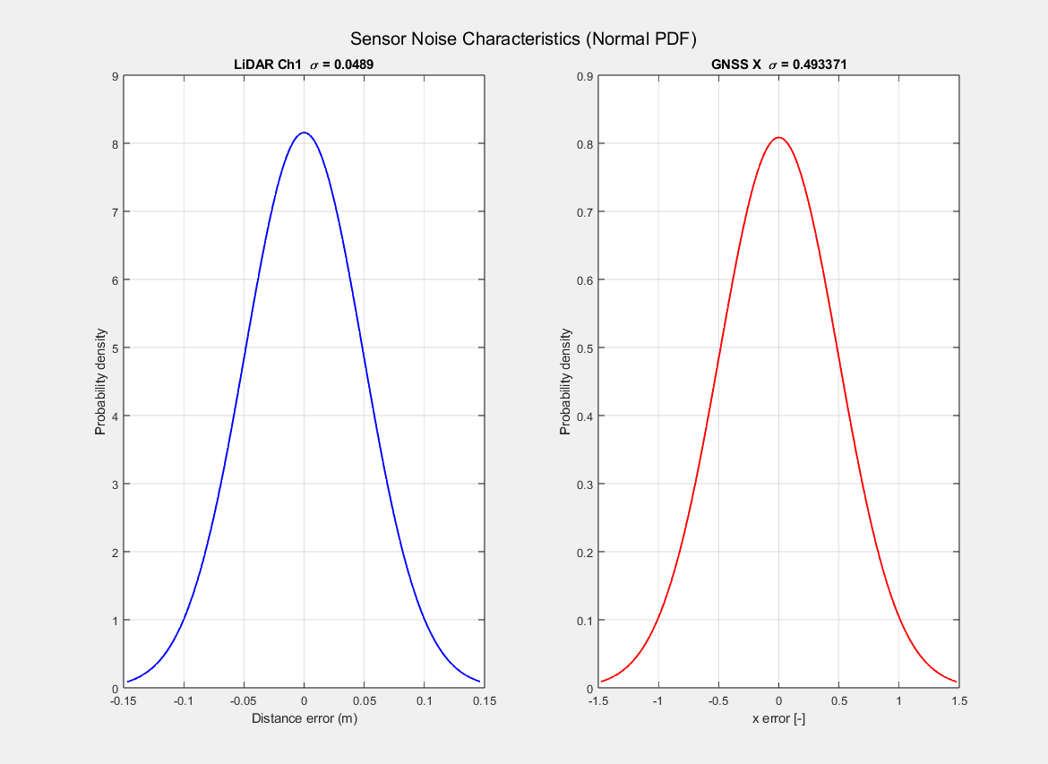

Task 5

Heuristic success!
