MPC-MAP Assignment No. 3 - Report

Author: Sebastian Šimanský

Date: 13/4/2026

The goal of this week assignement
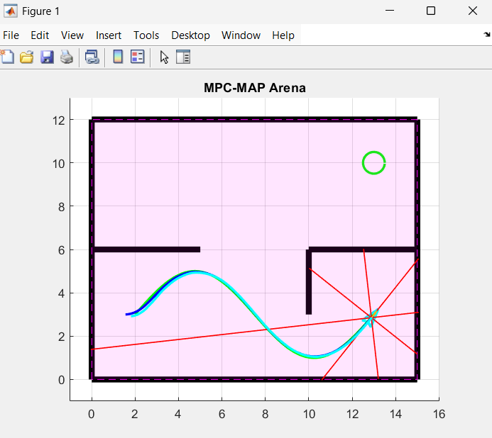
This was completed in several steps:
Predict pose
With information about previous estimated pose and wheel speed command we are able to estimate a cloud of points where the next pose could be
the dispersion is tunable with:
alpha_v = 0.1;
alpha_omega = 0.1;
base_noise = 0.1;

Correction
is the next step of particle filter, i tis done by ray casting simulated LIDAR readings from each particle's pose and comparing them to real sensor data using a Gaussian likelihood to assign weights

Then resampling
using systematic resampling to clone good particles and kill bad ones, encoding probability into population rather than weights.

Finally pose estimation
averaging particle positions with a circular mean for the angle.

The currect issue that I am facing is the initial estimate of the pose.
A wall was added so that the map is not symmetrical, even so .. initial pose is not correctly assumed on each run
Ideas how to tune if I was not supposed to do final commit within 30 minutes:
-Play with dispersion coefs (alpha) inside predict_pose.m alognisde with sigma coeficient
-Change sigma during runtime, maybe stop the car at the start get the initial pose correctly first

