MPC-MAP Assignment No. 1 - Report

Author: Sebastian Šimanský

Date: 20/4/2026

Task 1

This part uses calc_unc function, where i keep car stationary via counter for 200 tics. This way i can gather data for kalman init.

Task 2
Efk_predict – takes motion vector and via nonlinear kinematics of the vehicle g(u,x) it calculates estimate of postitiom (INCLUDING the theta)
after that kf_correct takes the measurement of [x,y] and does innovation to correct predicted state.

Task 3 and 4
I do not think I reached optimal performance yet but I did not want to spent too much time here. The idea is that my measurement covariance Q is given by my covariance estimation in stationary mode. So the way is to decrease R matrix values, since the GNSS measurement is quite noisy.
Kalman filter tuning is also about realtion of Q and R values.
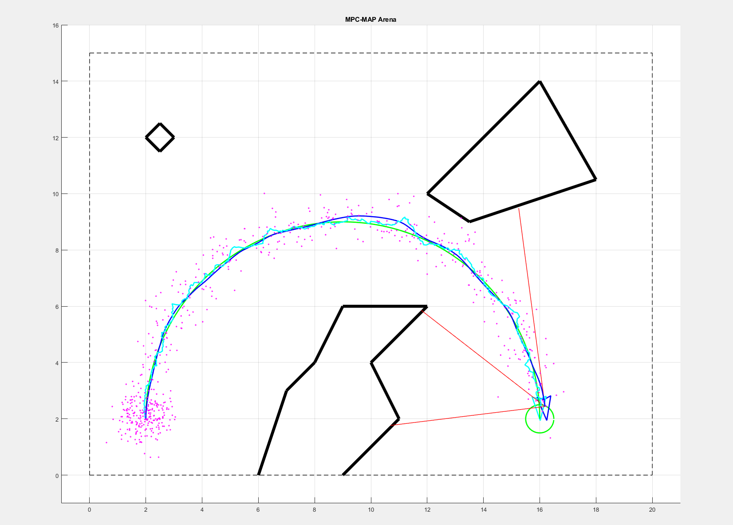
This is the final result of my kalman tuning with linear velocity target of 0.55 m/s

