1.What is server?

-server is the place where all the resources are present.

-It accepts all upcoming requests.

-Compare to normal computer it has higher configuration.

Ex- Google,Facebook,Amazone

2.What is protocol?

-Protocol is set of rules provided for communication.

-Browser understandnds only HTTP/HTTPS

-HTTP stand for hyper text transfer protocol.

-HTTPS stand for hyper text transfer protocol secure.

-HTTP protocol is used to share texual information.

3.What is actually HTTP?

-HTTP stands for HyperText Transfer Protocol.

-It is a protocol used to access the data on the World Wide Web (www).

-The HTTP protocol can be used to transfer the data in the form of plain

text,

hypertext, audio, video, and so on.

-HTTP is similar to the FTP as it also transfers the files from

one host to another host.

But, HTTP is simpler than FTP as HTTP uses only one connection,

i.e., no control connection to transfer the files.

4.What is actually HTTPS?

-HTTPS stand for Hypertext Transfer Protocol Secure.

-It is a secure extension or version of HTTP.

-This protocol is mainly used for providing security to the data sent

between a website and the web browser.

-It is widely used on the internet and used for secure communications.

-Those websites which need login credentials should use the HTTPS protocol

for sending the data.

5.What is Web-Browser?

-Browser is an application used to communicate with websites.

-Only browsers can understand web languages.

-Different browsers contains different compilers.

Ex- Chrom ,Mozila firefox , Microsoft edge etc.

6.What is meant by request?

-Request is a data-exchange from browser(client) to website(server).

-Request can be send in different ways

1.Typing Url

2.Clicking on Hyperlink.

3.Submitting responses.

-Request can share user data.

7.What is response?

-Response is data exchange from website(server) to browser (client).

-Response can be divided into two types.

1.static

2.Dynamic

8.What is URL?

-A URL(Universal Resourse Locator) is a type of uniform resource identifier

and is address of a resource

on the World Wide Web and the protocol used to access it.

-It is used to indicate the location of a web resource to access the web pages.

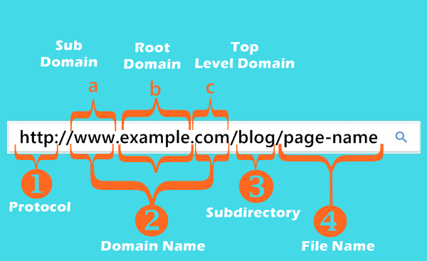

9.What is www?

-The World Wide Web is another way to describe the Internet,

which is a network of computers which are connected and that share

information and allow communication around the world

10.What is webpages?

-A document which can be display in a web browser or structure by any markup

language is nothing but the webpages.

11.What is Website?

-A collection of web-pages which are grouped together and usually connected

together in various ways.

12.What is Web-Server?

-A computer that hosts a website on the internet.

13.What is Search-Engine?

-A web service that helps you to find other webpages,such as Google,Bing,

Yahoo etc.

14.What is Internet?

-Internet is a global network that connects billions of computers across the world

with each other and to the World Wide Web.

-It uses standard internet protocol suite (IP) to connect billions of

computer users worldwide.

15.What is Intranet?

-An Intranet is a private network of computers designed for a certain

group of people and owned

by a particular firm or organization.

16.What is Extranet?

-Extranet is a part of an organization's intranet.

-It is a communication network that is based on internet protocols (IP).

-It provides controlled access to firm's intranet to its trading partners,

customers,

and other businesses.

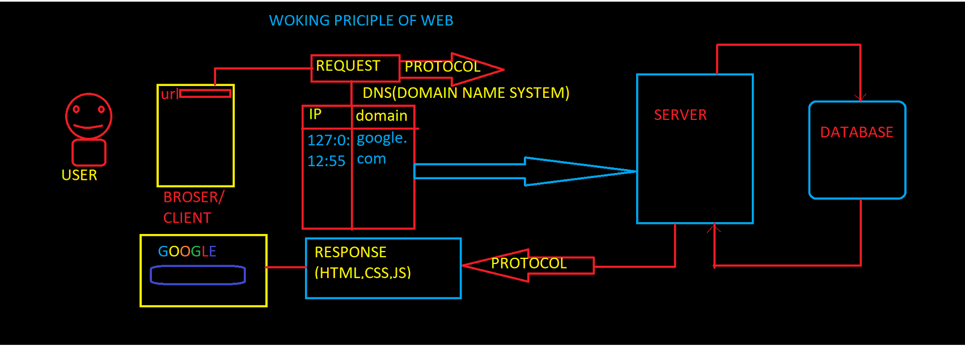

Brief History of HTML

**Tim Berners-Lee** is known as the father of HTML. The first available description of

HTML was a document called "HTML Tags" proposed by Tim in late 1991. The latest

version of HTML is HTML5, which we will learn later in this tutorial.

HTML Versions

**HTML 1.0:** The first version of HTML was 1.0, which was the barebones version of

HTML language, and it was released in 1995.

**HTML 2.0:** This was the next version which was released in 1996, and it was

standard language version for website design. HTML 2.0 was able to support extra

features such as form-based file upload, form elements such as text box, option

button, etc.

**HTML 3.2:** HTML 3.2 version was published by W3C in early 1998. This version was

capable of creating tables and providing support for extra options for form elements.

It can also support a web page with complex mathematical equations. It became an

official standard for any browser till January 1997. Today it is practically supported

by most of the browsers.

**HTML 4.01:** HTML 4.01 version was released on December 1999, and it is a very

stable version of HTML language. This version is the current official standard, and it

provides added support for stylesheets (CSS) and scripting ability for various

multimedia elements.

**HTML5 :** HTML5 is the newest version of HyperText Markup language. The first draft

of this version was announced in January 2010.

What is HTML

HTML is an acronym which stands for **Hyper Text Markup Language** which is used

for creating web pages and web applications. Let's see what is meant by Hypertext

Markup Language, and Web page.

**Hyper Text:** HyperText simply means "Text within Text." A text has a link within it, is

a hypertext. Whenever you click on a link which brings you to a new webpage, you

have clicked on a hypertext. HyperText is a way to link two or more web pages

(HTML documents) with each other.

**Markup language:** A markup language is a computer language that is used to apply

layout and formatting conventions to a text document. Markup language makes text

more interactive and dynamic. It can turn text into images, tables, links, etc.

**HTML**

HTML stands for Hyper Text Markup Language.

HTML is used for developing structure of webpage.

HTML file has extension .html/.htm .

HTML files can be created by using simple text editors

**HTML TAGS**

In HTML elements are

represented by using tags.

Anything which is surrounded

by ‘ < > ‘ is known as Tag.

Tags are used to define different types of elements.

Example : <h1> <br>

There are two types of tags :

1. Pair tags / container tag

2. Unpaired tag / Self closing tags / empty tag

Pair tags :

• HTML tags which contains closing tags along with opening

tags are known as Pair tags.

• Example : <h1>……</h1> , <div>….</div>

Self closing tags

• HTML tags which does not need closing tags are known as

Self closing tags.

• Example : <br> , <hr>

**HTML TYPOGRAPHY**

Typography contains tags which can be applied on text.

Example :

**Text is appearing bold**

*But sometimes it can be in italic*

It can have underline

**AND HEADINGS**

**HTML HEADINGS**

HTML heading tags are used to provide to use headings to

webpage.

Heading tags are <h1> , <h2> , <h3> , <h4> , <h5> , <h6>

Heading tags are paired type of tags.

<h1> tag displays heading in bigger font size whereas <h6> in

lower font size.

Moving from <h1> to <h6> font size of heading decreases.

Example : <h1>MySite</h1>

**Paragraph in HTML**

To provide paragraphs in web page we have to use paragraph

tag.

<p>……….</p>

We can use multiple paragraph tags to provide paragraphs in

web page.

Paragraph tag is paired type of tag.

Break Line Tag :

It is used to break line in web page.

<br> it is self closing tag.

**ATTRIBUTES**

Attributes are simply properties of tags.

We can change properties of tag like color , background color

, size vice versa.

Attributes must be provided into opening tag.

Attributes must be in the pattern of attribute = “value”

Example : < p title=“info”>

Some common Attributes :

Name , id , class , style

**Horizontal line :**

To provide horizontal line we have to use <hr> tag.

We can increase height by using height attribute.

**ELEMENT**

Opening and closing tag along with content are completely

known as **HTML ELEMENT**.

We can provide elements inside another element.

Example : <h1>My webpage </h1>

Elements which does not have content are known as empty

elements.

Example : <br>

**Hyperlinks in HTML**

Hyperlinks are used to join multiple webpages.

To provide Hyperlinks in web page we have to use <a>

anchor tag.

Syntax :

<a href=“address of webpage” >link</a>

Anchor tag contains attribute href and target.

1. href attribute : It is used to provide link of webpage

which you want to join.

2. target attribute : it is used to provide behavior for

opening of link. Like opening link in new tab , in current

tab.

**Images in HTML**

To make more interactive pages we can provide images in

HTML.

To provide image in HTML we have to use <img>

<img> tag is self closing tag

Example :

<img src=“source of image” height=“120” width=“120”

alt=“alt text”>

Src attribute is used to provide source of file.

Alt attribute is used to provide alternative text for image

If we do not provide height and width image will take its

original resolution.

**ADVANCED HYPERLINKS**

We can use any element as hyperlink in HTML.

We have to put that element inside <a>.

Example :

<a href=“https://www.google.com”>

<img src=“./images/first.jpg”>

</a>

Brief History of HTML

**Tim Berners-Lee** is known as the father of HTML. The first available description of HTML was a document called "HTML Tags" proposed by Tim in late 1991. The latest version of HTML is HTML5, which we will learn later in this tutorial.

HTML Versions

**HTML 1.0:** The first version of HTML was 1.0, which was the barebones version of HTML language, and it was released in 1991.

**HTML 2.0:** This was the next version which was released in 1995, and it was standard language version for website design. HTML 2.0 was able to support extra features such as form-based file upload, form elements such as text box, option button, etc.

**HTML 3.2:** HTML 3.2 version was published by W3C in early 1997. This version was capable of creating tables and providing support for extra options for form elements. It can also support a web page with complex mathematical equations. It became an official standard for any browser till January 1997. Today it is practically supported by most of the browsers.

**HTML 4.01:** HTML 4.01 version was released on December 1999, and it is a very stable version of HTML language. This version is the current official standard, and it provides added support for stylesheets (CSS) and scripting ability for various multimedia elements.

**HTML5 :** HTML5 is the newest version of HyperText Markup language. The first draft of this version was announced in January 2008.

**HTML**

HTML stands for Hyper Text Markup Language.

HTML is used for developing structure of webpage.

HTML file has extension .html/.htm .

HTML files can be created by using simple text editors

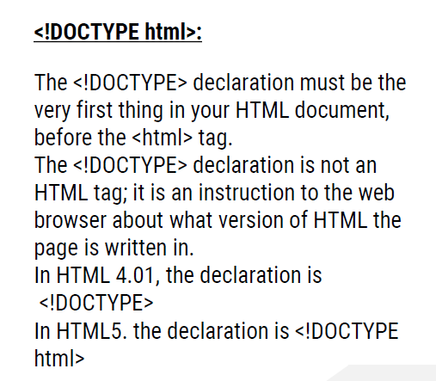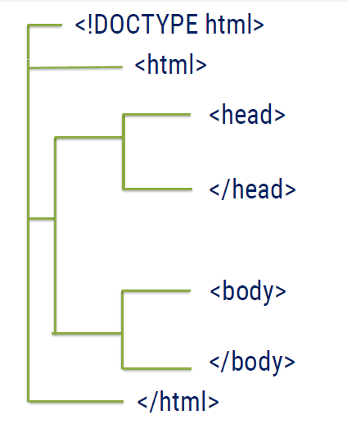

**HTML TAGS**

In HTML elements are represented by using tags.

Anything which is surrounded by ‘ <   > ‘ is known as Tag.

Tags are used to define different types of elements.

Example : <h1> <br>

There are two types of tags :

1. Pair tags / container tag
2. Unpaired tag / Self closing tags / empty tag

Pair tags :

* HTML tags which contains closing tags along with opening tags are known as Pair tags.
* Example : <h1>……</h1> ,  <div>….</div>

Self closing tags

* HTML tags which does not need closing tags are known as Self closing tags.
* Example : <br> , <hr>

**HTML TYPOGRAPHY**

Typography contains tags which can be applied on text.

Example :

**Text is appearing bold**

*But sometimes it can be in italic*

It can have underline

**AND HEADINGS**

**HTML HEADINGS**

HTML heading tags are used to provide to use headings to webpage.

Heading tags are <h1> , <h2> , <h3> , <h4> , <h5> , <h6>

Heading tags are paired type of tags.

<h1> tag displays heading in bigger font size whereas <h6> in lower font size.

Moving from <h1> to <h6> font size of heading decreases.

Example :        <h1>MySite</h1>

**Paragraph in HTML**

To provide paragraphs in web page we have to use paragraph tag.

<p>……….</p>

We can use multiple paragraph tags to provide paragraphs in web page.

Paragraph tag is paired type of tag.

Break Line Tag :

It is used to break line in web page.

<br> it is self closing tag.

**ATTRIBUTES**

Attributes are simply properties of tags.

We can change properties of tag like color , background color , size vice versa.

Attributes must be provided into opening tag.

Attributes must be in the pattern of   attribute = “value”

Example :            <  p title=“info”>

Some common Attributes :

Name , id , class , style

**Horizontal line :**

To provide horizontal line we have to use <hr> tag.

We can increase height by using height attribute.

**ELEMENT**

Opening and closing tag along with content are completely known as **HTML ELEMENT**.

We can provide elements inside another element.

Example :   <h1>My webpage </h1>

Elements which does not have content are known as empty elements.

Example : <br>

**Hyperlinks in HTML**

Hyperlinks are used to join multiple webpages.

To provide Hyperlinks in web page we have to use <a> anchor tag.

Syntax :

                <a href=“address of webpage” >link</a>

Anchor tag contains attribute href and target.

1. href attribute :  It is used to provide link of webpage which you want to join.
2. target attribute : it is used to provide behavior for opening of link. Like opening link in new tab , in current tab.

**Images in HTML**

To make more interactive pages we can provide images in HTML.

To provide image in HTML we have to use <img>

<img> tag is self closing tag

Example :

<img src=“source of image” height=“120” width=“120” alt=“alt text”>

Src attribute is used to provide source of file.

Alt attribute is used to provide alternative text for image

If we do not provide height and width image will take its original resolution.

**ADVANCED HYPERLINKS**

We can use any element as hyperlink in HTML.

We have to put  that element inside <a>.

Example :  
<a href=“https://www.google.com”>

<img src=“./images/first.jpg”>

</a>

**HTML LISTS**

HTML lists are used to list out items on webpage.

There are mainly 2 types of lists :

1. Ordered List
2. Unordered List

Ordered List :

Ordered Lists are used to provide ordered items.

Example :

1) Cold drinks

2) Soft drinks

3) Hard drinks

To provide ordered list we have to use <ol>

To list out items we have to <li> tag

Example:

<ol>

    <li>Cold Drinks</li>

    <li>Soft Drinks</li>

    <li>Hard Drinks</li>

</ol>

Type attribute is used to provide type marker to list items.

By default value of type attribute is 1.

We can provide values like : - 1 , A , a , I ,i

Reversed attribute is used to reversed the ordered list.

**Unordered Lists :**

Unordered Lists are used to provide list in unordered way.

Unordered list provided by using <ul>.

Example:

* Burger
* Pizza
* Pav Bhaji

HTML code :

<ul>

<li>Burger</li>

<li>Pizza</li>

<li>Pav Bhaji</li>

</ul>

We can provide list type

Square , circle , disc , none

**DESCRIPTIVE LIST**

There is rarely is used list which is descriptive list.

It is used to list out items with description.

Example:

Java

    - Backend Language

HTML

    - Frontend Language

<dl>

<dt>Java</dt>

<dd>Backend Language</dd>

<dt>HTML</dt>

<dd>Frontend Language</dd>

</dl>

**TYPES OF ELEMENTS**

There are two types of elements in HTML :

1. BLOCK LEVEL
2. INLINE LEVEL
3. INLINE BLOCK LEVEL

**1.BLOCK LEVEL ELEMENT :**

Elements which occupy width same as browser width are known as block level elements.

Block level elements width depends on browser width.

Height and width can be changed for Block Level Elements.

Example :

      <p>  , <h3> ( all headings ),div etc

**2.INLINE ELEMENTS :**

Inline elements are elements which takes width of content.

Width of inline elements depends on content.

We can not change height and width of inline elements.

Example:

<a> , <span> etc

**3.INLINE-BLOCK**

Inline-block level elements takes exact height and width of an element and along with that we can modify an element.

Ex- <img> etc

**FORMATING TAGS**

**BOLD , ITALIC , UNDERLINE**

To bold text we have to use **<b>** tag.

Bold tag is paired type of tag.

To make text in italic style use **<i>** tag

Italic tag is paired type of tag.

To make text underline use **<u>** tag

Underline tag is paired type of tag.

   <em>IT IS USED TO EMPHASIZE THE TEXT</em>

    <br>

    <small>IT IS USED TO DEFINE SMALL TEXT.</small>

    <br>

    <strong>IT IS USED TO DEFINE BOLD TEXT</strong>

    <br>

    IT IS USED TO<sub> DEFINE SUBSCRIPTED TEXT</sub>

    <br>

    IT IS USED TO <sup>DEFINE SUPERSCRIPTED TEXT</sup>

    <br>

    <ins>IT IS USED TO DEFINE INSERTED TEXT (UNDERLINE)</ins>

    <br>

    <del>IT IS USED TO DEFINE DELETED TEXT</del>

    <br>

    <mark>IT IS USED TO HIGHLIGHT THE TEXT</mark>

|  |  |
| --- | --- |
| <abbr> | Defines an abbreviation or acronym |
| <address> | Defines contact information for the author/owner of a document |
| <bdo> | Defines the text direction |
|  |  |
| <cite> | Defines the title of a work |
| <q> | Defines a short inline quotation |

**TYPES OF ELEMENTS**

There are two types of elements in HTML :

1. BLOCK LEVEL
2. INLINE LEVEL
3. INLINE BLOCK LEVEL

**1.BLOCK LEVEL ELEMENT :**

Elements which occupy width same as browser width are known as block level elements.

Block level elements width depends on browser width.

Height and width can be changed for Block Level Elements.

Example :

      <p>  , <h3> ( all headings ),div etc

**2.INLINE ELEMENTS :**

Inline elements are elements which takes width of content.

Width of inline elements depends on content.

We can not change height and width of inline elements.

Example:

<a> , <span> etc

**3.INLINE-BLOCK**

Inline-block level elements takes exact height and width of an element and along with that we can modify an element.

Ex- <img> etc

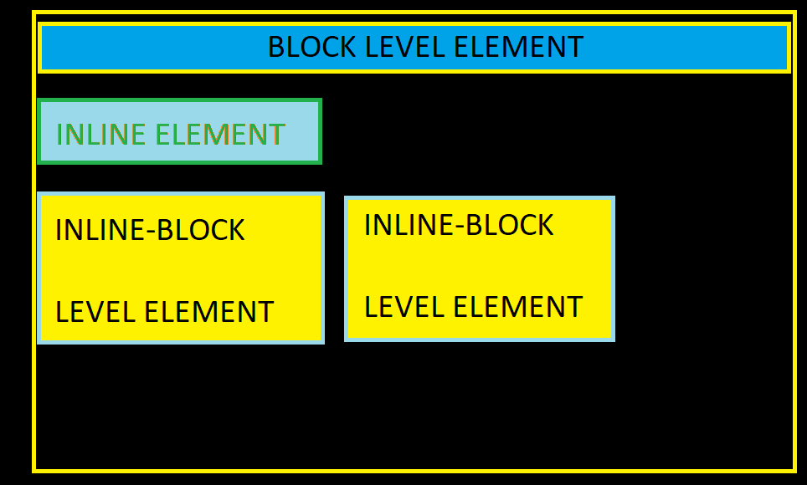

HTML TABLES

HTML Tables represent data in the form of tables.

Table consists of rows and columns.

To provide table in webpage we have to use <table> tag.

Each row of table is represented by using <tr> tag whereas each column is represented by using <td> tag.

Table contains heading which can be represented by using <th> tag.

Table title can be provided by using <caption> tag.

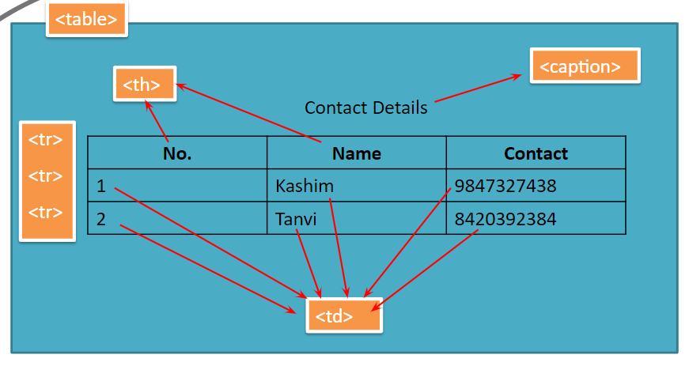

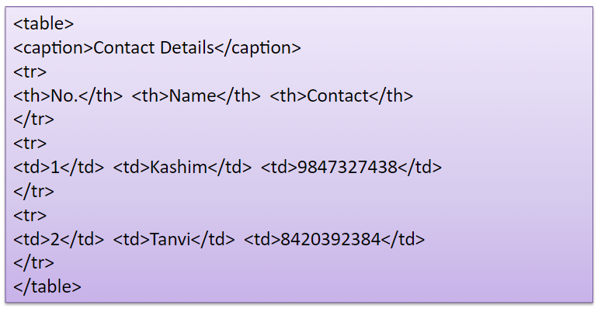

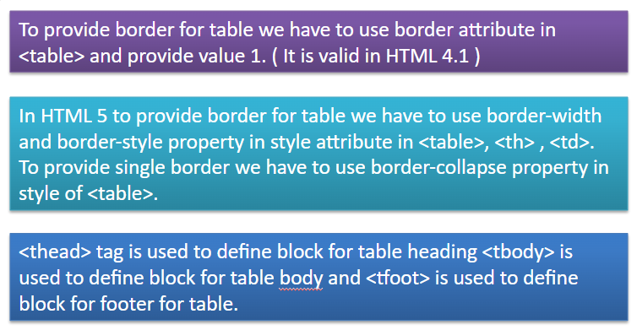

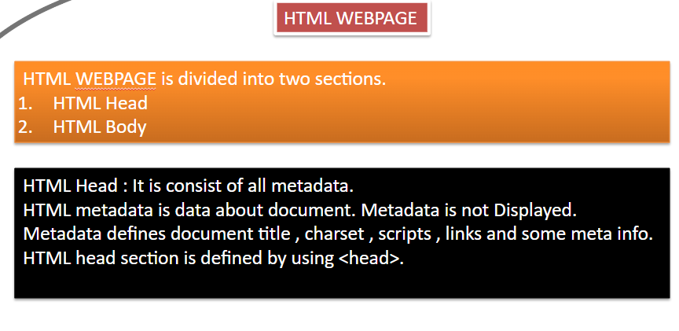

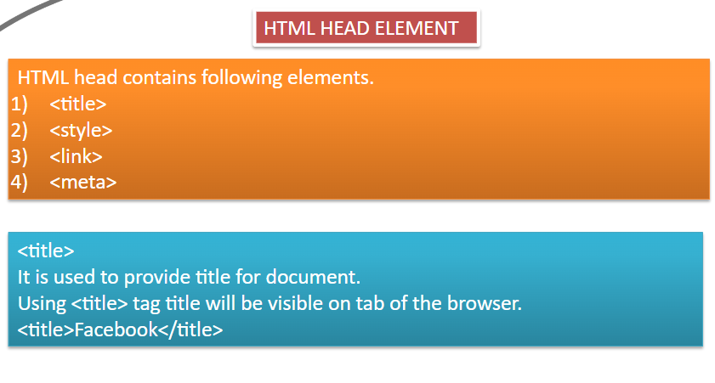

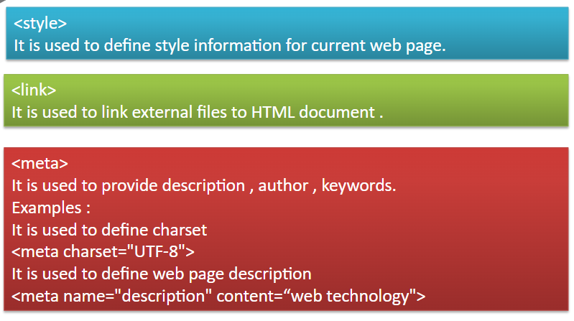

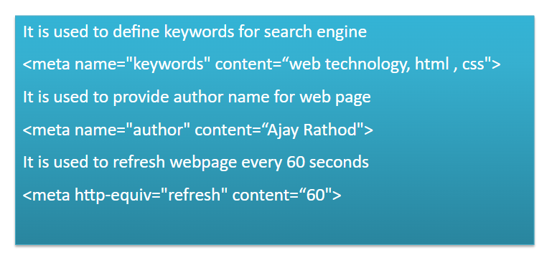

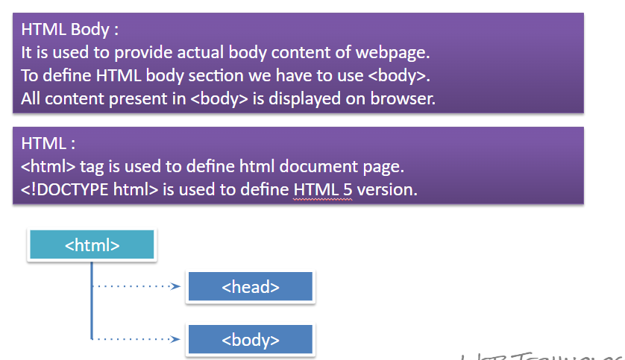

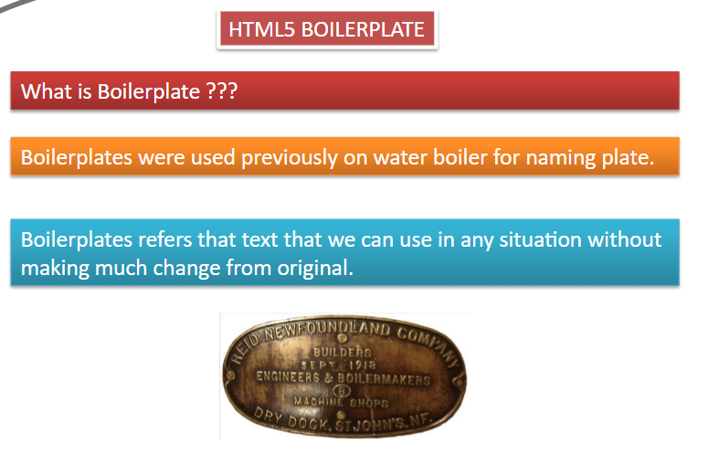

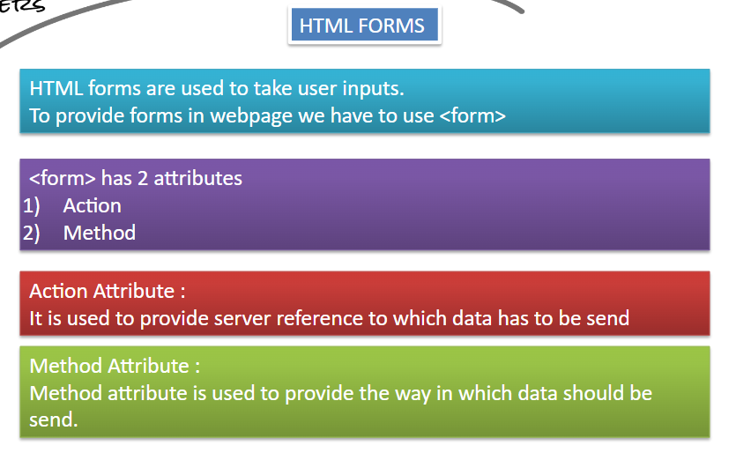

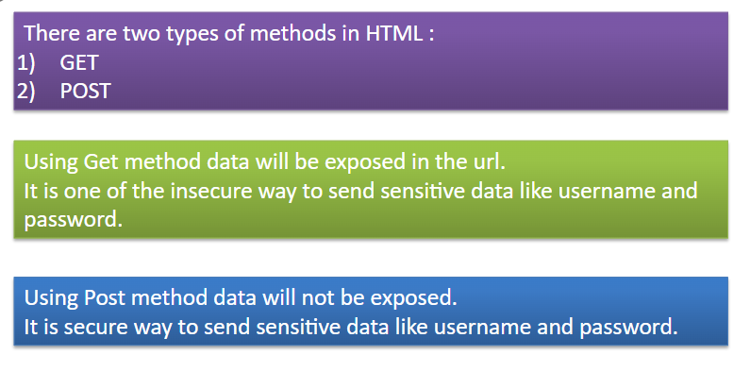

HTML TABLES

HTML Tables represent data in the form of tables.

Table consists of rows and columns.

To provide table in webpage we have to use <table> tag.

Each row of table is represented by using <tr> tag whereas each column is represented by using <td> tag.

Table contains heading which can be represented by using <th> tag.

Table title can be provided by using <caption> tag.







HTML Table Padding & Spacing

HTML tables can adjust the padding inside the cells, and also the space between the cells.

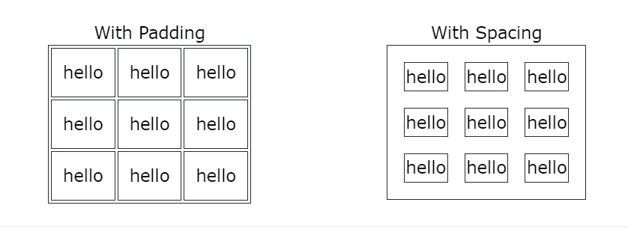

Cellspacing: this is an attribute which is used to increase the space between two cells.

Cellpadding: this is an attribute which is used to increase the surrounding area of cell.

HTML Table Colspan & Rowspan

Colspan :This is an attribute which is used to merge two or more than two colums.

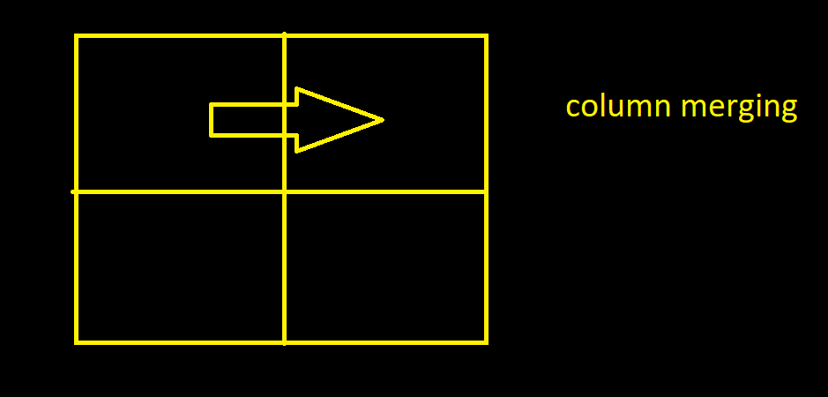

Rowspan :This is an attribute which is used to merge two or more than two rows.

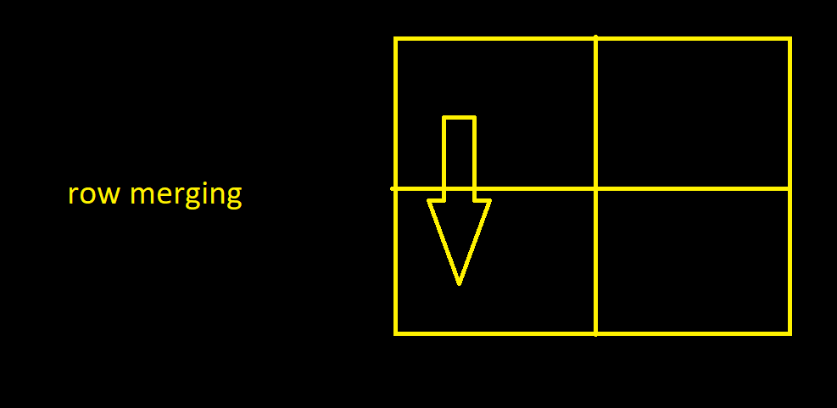

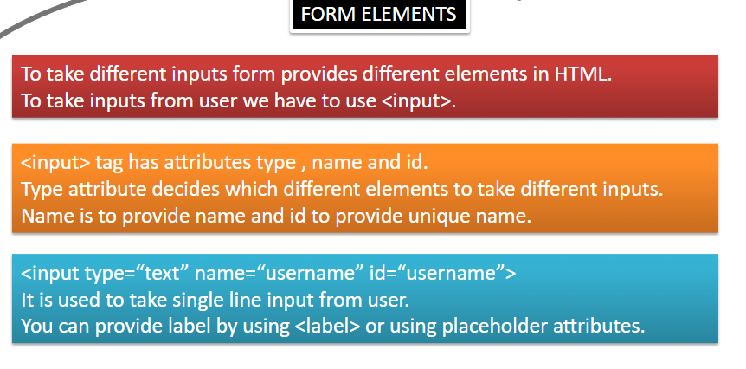

* <input>
* <label>
* <select>
* <textarea>
* <button>
* <fieldset>
* <legend>
* <datalist>
* <option>

The <input> Element

One of the most used form element is the <input> element.

The <input> element can be displayed in several ways, depending on the type attribute.

<form action="">

<label for="fname">First name:</label><br>

<input type="text" id="fname" name="fname"><br><br>

<input type="submit" value="Submit"></form>

## The <label> Element

The <label> element defines a label for several form elements.

The <label> element is useful for screen-reader users, because the screen-reader will read out loud the label when the user focus on the input element.

The <label> element also help users who have difficulty clicking on very small regions (such as radio buttons or checkboxes) - because when the user clicks the text within the <label> element, it toggles the radio button/checkbox.

The for attribute of the <label> tag should be equal to the id attribute of the <input> element to bind them together.

## The <select> Element

The <select> element defines a drop-down list:

<label for="cars">Choose a car:</label>  
<select id="cars" name="cars">  
  <option value="volvo">Volvo</option>  
  <option value="saab">Saab</option>  
  <option value="fiat">Fiat</option>  
  <option value="audi">Audi</option>  
</select>

The <option> elements defines an option that can be selected.

By default, the first item in the drop-down list is selected.

To define a pre-selected option, add the selected attribute to the option:

<select id="cars" name="cars">

<option value="volvo">Volvo</option>

<option value="saab">Saab</option>

<option value="fiat" selected>Fiat</option>

<option value="audi">Audi</option>

</select>

### **Visible Values:**

Use the size attribute to specify the number of visible values:

<label for="cars">Choose a car:</label>  
<select id="cars" name="cars" size="3">  
  <option value="volvo">Volvo</option>  
  <option value="saab">Saab</option>  
  <option value="fiat">Fiat</option>  
  <option value="audi">Audi</option>  
</select>

### **Allow Multiple Selections:**

Use the multiple attribute to allow the user to select more than one value:

<label for="cars">Choose a car:</label>  
<select id="cars" name="cars" size="4"multiple>  
  <option value="volvo">Volvo</option>  
  <option value="saab">Saab</option>  
  <option value="fiat">Fiat</option>  
  <option value="audi">Audi</option>  
</select>

## The <textarea> Element

The <textarea> element defines a multi-line input field (a text area):

<form action="">

<textarea name="message" rows="10" cols="30">The cat was playing in the garden.</textarea>

<br><br>

<input type="submit"></form>

The rows attribute specifies the visible number of lines in a text area.

The cols attribute specifies the visible width of a text area.

## The <button> Element

The <button> element defines a clickable button:

<button type="button" onclick="alert('Hello World!')">Click Me!</button>

## The <fieldset> and <legend> Elements

The <fieldset> element is used to group related data in a form.

The <legend> element defines a caption for the <fieldset> element.

<form action="">  
  <fieldset>  
    <legend>Personalia:</legend>  
    <label for="fname">First name:</label><br>  
    <input type="text" id="fname" name="fname" value="John"><br>  
    <label for="lname">Last name:</label><br>  
    <input type="text" id="lname" name="lname" value="Doe"><br><br>  
    <input type="submit" value="Submit">  
  </fieldset>  
</form>

## The <datalist> Element

The <datalist> element specifies a list of pre-defined options for an <input> element.

Users will see a drop-down list of the pre-defined options as they input data.

The list attribute of the <input> element, must refer to the id attribute of the <datalist> element.

<form action="">  
  <input list="browsers">  
  <datalist id="browsers">  
    <option value="Internet Explorer">  
    <option value="Firefox">  
    <option value="Chrome">  
    <option value="Opera">  
    <option value="Safari">  
  </datalist>  
</form>

HTML Input Types

Here are the different input types you can use in HTML:

* <input type="button">
* <input type="checkbox">
* <input type="color">
* <input type="date">
* <input type="datetime-local">
* <input type="email">
* <input type="file">
* <input type="hidden">
* <input type="image">
* <input type="month">
* <input type="number">
* <input type="password">
* <input type="radio">
* <input type="range">
* <input type="reset">
* <input type="search">
* <input type="submit">
* <input type="tel">
* <input type="text">
* <input type="time">
* <input type="url">
* <input type="week">

## Input Type Text

<input type="text"> defines a **single-line text input field**:

<form>  
  <label for="fname">First name:</label><br>  
  <input type="text" id="fname" name="fname"><br>  
    
</form>

## Input Type Password

<input type="password"> defines a **password field**:

<form>  
  <label for="username">Username:</label><br>  
  <input type="text" id="username" name="username"><br>  
  <label for="pwd">Password:</label><br>  
  <input type="password" id="pwd" name="pwd">  
</form>

## Input Type Submit

<input type="submit"> defines a button for **submitting** form data to a **form-handler**.

The form-handler is typically a server page with a script for processing input data.

The form-handler is specified in the form's action attribute:

<form action="">  
  <label for="fname">First name:</label><br>  
  <input type="text" id="fname" name="fname" value="John"><br>  
  <input type="submit" value="Submit">  
</form>

## Input Type Reset

<input type="reset"> defines a **reset button** that will reset all form values to their default values:

<form action="">  
  <label for="fname">First name:</label><br>  
  <input type="text" id="fname" name="fname" value="John"><br>  
 <input type="submit" value="Submit">  
  <input type="reset" value="RESET">  
</form>

## Input Type Radio

<input type="radio"> defines a **radio button**.

Radio buttons let a user select ONLY ONE of a limited number of choices:

<form>  
  <input type="radio" id="html" name="fav_language" value="HTML">  
  <label for="html">HTML</label><br>  
  <input type="radio" id="css" name="fav_language" value="CSS">  
  <label for="css">CSS</label><br>  
  <input type="radio" id="javascript" name="fav_language" value="JavaScript">  
  <label for="javascript">JavaScript</label>

<input type="submit" value="Submit">  
</form>

Input Type Checkbox

<input type="checkbox"> defines a **checkbox**.

Checkboxes let a user select ZERO or MORE options of a limited number of choices.

### **Example**

<form>  
  <input type="checkbox" id="vehicle1" name="vehicle1" value="Bike">  
  <label for="vehicle1"> I have a bike</label><br>  
  <input type="checkbox" id="vehicle2" name="vehicle2" value="Car">  
  <label for="vehicle2"> I have a car</label><br>  
  <input type="checkbox" id="vehicle3" name="vehicle3" value="Boat">  
  <label for="vehicle3"> I have a boat</label>  
</form>

## Input Type Color

The <input type="color"> is used for input fields that should contain a color.

Depending on browser support, a color picker can show up in the input field.

### **Example**

<form>  
  <label for="favcolor">Select your favorite color:</label>  
  <input type="color" id="favcolor" name="favcolor">  
</form>

## Input Type Date

The <input type="date"> is used for input fields that should contain a date.

Depending on browser support, a date picker can show up in the input field.

### **Example**

<form>  
  <label for="birthday">Birthday:</label>  
  <input type="date" id="birthday" name="birthday">  
</form>

You can also use the min and max attributes to add restrictions to dates:

### **Example**

<form>  
  <label for="datemax">Enter a date before 1980-01-01:</label>  
  <input type="date" id="datemax" name="datemax" max="1979-12-31"><br><br>  
  <label for="datemin">Enter a date after 2000-01-01:</label>  
  <input type="date" id="datemin" name="datemin" min="2000-01-02">  
</form>

## Input Type Datetime-local

The <input type="datetime-local"> specifies a date and time input field, with no time zone.

Depending on browser support, a date picker can show up in the input field.

### **Example**

<form>  
  <label for="birthdaytime">Birthday (date and time):</label>  
  <input type="datetime-local" id="birthdaytime" name="birthdaytime">  
</form>

## Input Type Email

The <input type="email"> is used for input fields that should contain an e-mail address.

Depending on browser support, the e-mail address can be automatically validated when submitted.

Some smartphones recognize the email type, and add ".com" to the keyboard to match email input.

### **Example**

<form>  
  <label for="email">Enter your email:</label>  
  <input type="email" id="email" name="email">  
</form>

## Input Type Image

The <input type="image"> defines an image as a submit button.

The path to the image is specified in the src attribute.

### **Example**

<form>  
<input type="image" src="img_submit.gif" alt="Submit" width="48" height="48">  
</form>

## Input Type File

The <input type="file"> defines a file-select field and a "Browse" button for file uploads.

### **Example**

<form>  
  <label for="myfile">Select a file:</label>  
  <input type="file" id="myfile" name="myfile">  
</form>

## Input Type Month

The <input type="month"> allows the user to select a month and year.

Depending on browser support, a date picker can show up in the input field.

### **Example**

<form>  
  <label for="bdaymonth">Birthday (month and year):</label>  
  <input type="month" id="bdaymonth" name="bdaymonth">  
</form>

## Input Type Number

The <input type="number"> defines a **numeric** input field.

You can also set restrictions on what numbers are accepted.

The following example displays a numeric input field, where you can enter a value from 1 to 5:

### **Example**

<form>  
  <label for="quantity">Quantity (between 1 and 5):</label>  
  <input type="number" id="quantity" name="quantity" min="1" max="5">  
</form>

## Input Type Month

The <input type="month"> allows the user to select a month and year.

Depending on browser support, a date picker can show up in the input field.

### **Example**

<form>  
  <label for="bdaymonth">Birthday (month and year):</label>  
  <input type="month" id="bdaymonth" name="bdaymonth">  
</form>

## Input Type Number

The <input type="number"> defines a **numeric** input field.

You can also set restrictions on what numbers are accepted.

The following example displays a numeric input field, where you can enter a value from 1 to 5:

|  |  |
| --- | --- |
| **Attribute** | **Description** |
| checked | Specifies that an input field should be pre-selected when the page loads (for type="checkbox" or type="radio") |
| disabled | Specifies that an input field should be disabled |
| max | Specifies the maximum value for an input field |
| maxlength | Specifies the maximum number of character for an input field |
| min | Specifies the minimum value for an input field |
| pattern | Specifies a regular expression to check the input value against |
| readonly | Specifies that an input field is read only (cannot be changed) |
| required | Specifies that an input field is required (must be filled out) |
| size | Specifies the width (in characters) of an input field |
| step | Specifies the legal number intervals for an input field |
| Value  Placeholder | Specifies the default value for an input field |

### **Example**

<form>  
  <label for="quantity">Quantity (between 1 and 5):</label>  
  <input type="number" id="quantity" name="quantity" min="1" max="5">  
</form>

## Input Type Range

The <input type="range"> defines a control for entering a number whose exact value is not important (like a slider control). Default range is 0 to 100. However, you can set restrictions on what numbers are accepted with the min, max, and step attributes:

### **Example**

<form>  
  <label for="vol">Volume (between 0 and 50):</label>  
  <input type="range" id="vol" name="vol" min="0" max="50">  
</form>

## Input Type Search

The <input type="search"> is used for search fields (a search field behaves like a regular text field).

### **Example**

<form>  
  <label for="gsearch">Search Google:</label>  
  <input type="search" id="gsearch" name="gsearch">  
</form>

## Input Type Tel

The <input type="tel"> is used for input fields that should contain a telephone number.

### **Example**

<form>  
  <label for="phone">Enter your phone number:</label>  
  <input type="tel" id="phone" name="phone" pattern="[0-9]{3}-[0-9]{2}-[0-9]{3}">  
</form>

## Input Type Time

The <input type="time"> allows the user to select a time (no time zone).

Depending on browser support, a time picker can show up in the input field.

### **Example**

<form>  
  <label for="appt">Select a time:</label>  
  <input type="time" id="appt" name="appt">  
</form>

## Input Type Url

The <input type="url"> is used for input fields that should contain a URL address.

Depending on browser support, the url field can be automatically validated when submitted.

Some smartphones recognize the url type, and adds ".com" to the keyboard to match url input.

### **Example**

<form>  
  <label for="homepage">Add your homepage:</label>  
  <input type="url" id="homepage" name="homepage">  
</form>

## Input Type Week

The <input type="week"> allows the user to select a week and year.

Depending on browser support, a date picker can show up in the input field.

### **Example**

<form>  
  <label for="week">Select a week:</label>  
  <input type="week" id="week" name="week">  
</form>

## The value Attribute

The input value attribute specifies an initial value for an input field:

## The readonly Attribute

The input readonly attribute specifies that an input field is read-only.

A read-only input field cannot be modified (however, a user can tab to it, highlight it, and copy the text from it).

## The disabled Attribute

The input disabled attribute specifies that an input field should be disabled.

A disabled input field is unusable and un-clickable.

The value of a disabled input field will not be sent when submitting the form!

## The size Attribute

The input size attribute specifies the visible width, in characters, of an input field.

The default value for size is 20.

**Note:** The size attribute works with the following input types: text, search, tel, url, email, and password.

## The maxlength Attribute

The input maxlength attribute specifies the maximum number of characters allowed in an input field.

**Note:** When a maxlength is set, the input field will not accept more than the specified number of characters.

## The min and max Attributes

The input min and max attributes specify the minimum and maximum values for an input field.

The min and max attributes work with the following input types: number, range, date, datetime-local, month, time and week.

**Tip:** Use the max and min attributes together to create a range of legal values.

## The multiple Attribute

The input multiple attribute specifies that the user is allowed to enter more than one value in an input field.

The multiple attribute works with the following input types: email, and file.

## The pattern Attribute

The input pattern attribute specifies a regular expression that the input field's value is checked against, when the form is submitted.

The pattern attribute works with the following input types: text, date, search, url, tel, email, and password.

## The placeholder Attribute

The input placeholder attribute specifies a short hint that describes the expected value of an input field (a sample value or a short description of the expected format).

The short hint is displayed in the input field before the user enters a value.

The placeholder attribute works with the following input types: text, search, url, tel, email, and password.

## The required Attribute

The input required attribute specifies that an input field must be filled out before submitting the form.

The required attribute works with the following input types: text, search, url, tel, email, password, date pickers, number, checkbox, radio, and file.

## The step Attribute

The input step attribute specifies the legal number intervals for an input field.

Example: if step="3", legal numbers could be -3, 0, 3, 6, etc.

**Tip:** This attribute can be used together with the max and min attributes to create a range of legal values.

The step attribute works with the following input types: number, range, date, datetime-local, month, time and week.

## The autofocus Attribute

The input autofocus attribute specifies that an input field should automatically get focus when the page loads.

## The list Attribute

The input list attribute refers to a <datalist> element that contains pre-defined options for an <input> element.

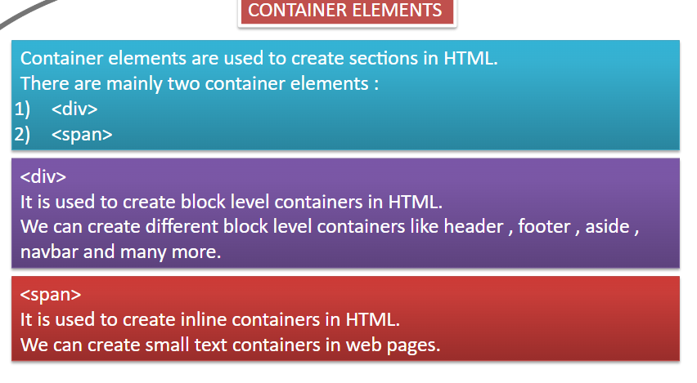

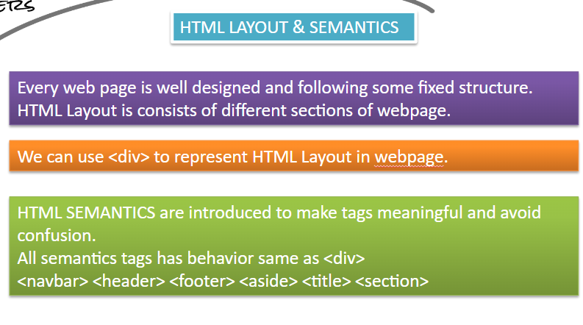

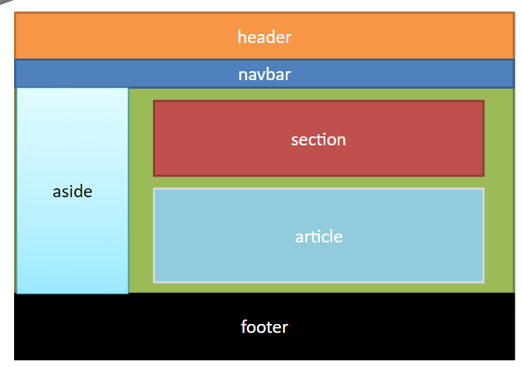

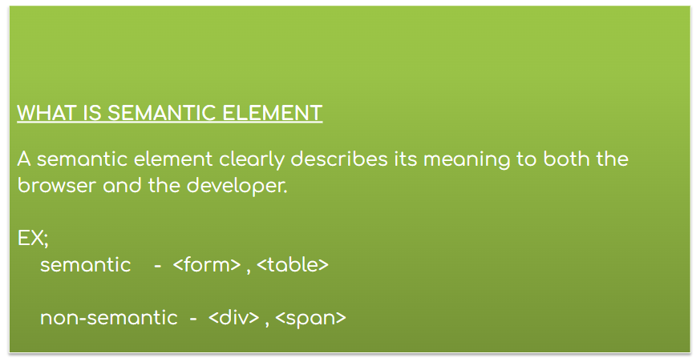

**HTML Interview Questions**

1. **What is HTML?**

HTML (HyperText Markup Language) is the standard markup language used to create web pages. It describes the structure of a web page using elements and tags.

1. **What are the differences between HTML and XHTML?**

XHTML (eXtensible HyperText Markup Language) is a stricter, XML-based version of HTML. It requires well-formed tags, proper nesting, and all tags to be closed, including empty tags.

1. **What is a doctype and why is it important?**

A doctype declaration defines the version of HTML being used and helps browsers render the content correctly. For example, <!DOCTYPE html> declares HTML5.

1. **Explain the structure of an HTML document.**

An HTML document typically consists of:

<!DOCTYPE html>

<html>

<head>

<title>Page Title</title>

<meta charset="UTF-8">

<meta name="viewport" content="width=device-width, initial-scale=1.0">

</head>

<body>

<!-- Content goes here -->

</body>

</html>

1. **What are semantic HTML elements?**

Semantic HTML elements clearly describe their meaning in a human- and machine-readable way. Examples include <header>, <footer>, <article>, and <section>.

1. **How do you create a hyperlink in HTML?**

Using the <a> tag:

<a href="https://www.example.com">Link Text</a>

1. **What is the purpose of the alt attribute in an <img> tag?**

The alt attribute provides alternative text for an image if it cannot be displayed. It is also used by screen readers to describe the image for visually impaired users.

1. **What is the difference between block-level and inline elements?**

Block-level elements (e.g., <div>, <p>, <h1>) start on a new line and take up the full width available. Inline elements (e.g., <span>, <a>, <img>) do not start on a new line and only take up as much width as necessary.

**How can you include CSS in an HTML document?**

Inline: <div style="color: red;">Text</div>

Internal:

<style> div { color: red; } </style>

External:

<link rel="stylesheet" href="styles.css">

1. **What is the difference between <div> and <span>?**

<div> is a block-level element used to group larger sections of content. <span> is an inline element used to group small pieces of content within a block.

1. **What are HTML5 APIs? Can you name a few?**

HTML5 introduced several new APIs for more complex web applications:

Geolocation API: for accessing geographical location.

Web Storage API: for local and session storage.

Canvas API: for drawing graphics and animations.

Web Workers: for running scripts in background threads.

1. **How do you embed a video in an HTML document?**

Using the <video> tag:

html

<video width="320" height="240" controls>

<source src="movie.mp4" type="video/mp4">

Your browser does not support the video tag. </video>

1. **What is the purpose of the data-* attributes in HTML5?**

The data-* attributes allow you to store custom data on HTML elements. These can be accessed via JavaScript for additional functionality.

1. **Explain the concept of HTML forms and form elements.**

HTML forms are used to collect user input. Form elements include <input>, <textarea>, <select>, <button>, and <form> itself, which groups them together.

1. **How can you improve the accessibility of a web page using HTML?**

Use semantic HTML elements.

Provide alt text for images.

Use aria-* attributes to enhance accessibility for screen readers.

Ensure keyboard navigability by using the tabindex attribute and proper focus management.