**WEBTECH**

1.What is server?

-server is the place where all the resources are present.

-It accepts all upcoming requests.

-Compare to normal computer it has higher configuration.

Ex- Google,Facebook,Amazone

2.What is protocol?

-Protocol is set of rules provided for communication.

-Browser understandnds only HTTP/HTTPS

-HTTP stand for hyper text transfer protocol.

-HTTPS stand for hyper text transfer protocol secure.

-HTTP protocol is used to share texual information.

3.What is actually HTTP?

-HTTP stands for HyperText Transfer Protocol.

-It is a protocol used to access the data on the World Wide Web (www).

-The HTTP protocol can be used to transfer the data in the form of plain

text,

hypertext, audio, video, and so on.

-HTTP is similar to the FTP as it also transfers the files from

one host to another host.

But, HTTP is simpler than FTP as HTTP uses only one connection,

i.e., no control connection to transfer the files.

4.What is actually HTTPS?

-HTTPS stand for Hypertext Transfer Protocol Secure.

-It is a secure extension or version of HTTP.

-This protocol is mainly used for providing security to the data sent

between a website and the web browser.

-It is widely used on the internet and used for secure communications.

-Those websites which need login credentials should use the HTTPS protocol

for sending the data.

5.What is Web-Browser?

-Browser is an application used to communicate with websites.

-Only browsers can understand web languages.

-Different browsers contains different compilers.

Ex- Chrom ,Mozila firefox , Microsoft edge etc.

6.What is meant by request?

-Request is a data-exchange from browser(client) to website(server).

-Request can be send in different ways

1.Typing Url

2.Clicking on Hyperlink.

3.Submitting responses.

-Request can share user data.

7.What is response?

-Response is data exchange from website(server) to browser (client).

-Response can be divided into two types.

1.static

2.Dynamic

8.What is URL?

-A URL(Universal Resourse Locator) is a type of uniform resource identifier

and is address of a resource

on the World Wide Web and the protocol used to access it.

-It is used to indicate the location of a web resource to access the web pages.

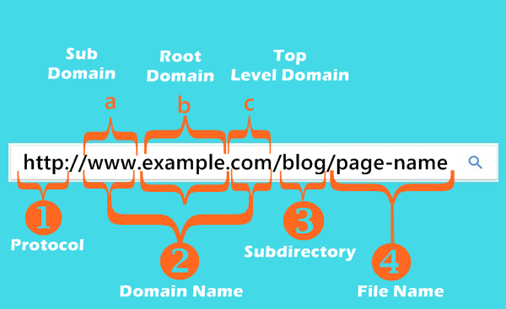

9.What is www?

-The World Wide Web is another way to describe the Internet,

which is a network of computers which are connected and that share

information and allow communication around the world

10.What is webpages?

-A document which can be display in a web browser or structure by any markup

language is nothing but the webpages.

11.What is Website?

-A collection of web-pages which are grouped together and usually connected

together in various ways.

12.What is Web-Server?

-A computer that hosts a website on the internet.

13.What is Search-Engine?

-A web service that helps you to find other webpages,such as Google,Bing,

Yahoo etc.

14.What is Internet?

-Internet is a global network that connects billions of computers across the world

with each other and to the World Wide Web.

-It uses standard internet protocol suite (IP) to connect billions of

computer users worldwide.

15.What is Intranet?

-An Intranet is a private network of computers designed for a certain

group of people and owned

by a particular firm or organization.

16.What is Extranet?

-Extranet is a part of an organization's intranet.

-It is a communication network that is based on internet protocols (IP).

-It provides controlled access to firm's intranet to its trading partners,

customers,

and other businesses.

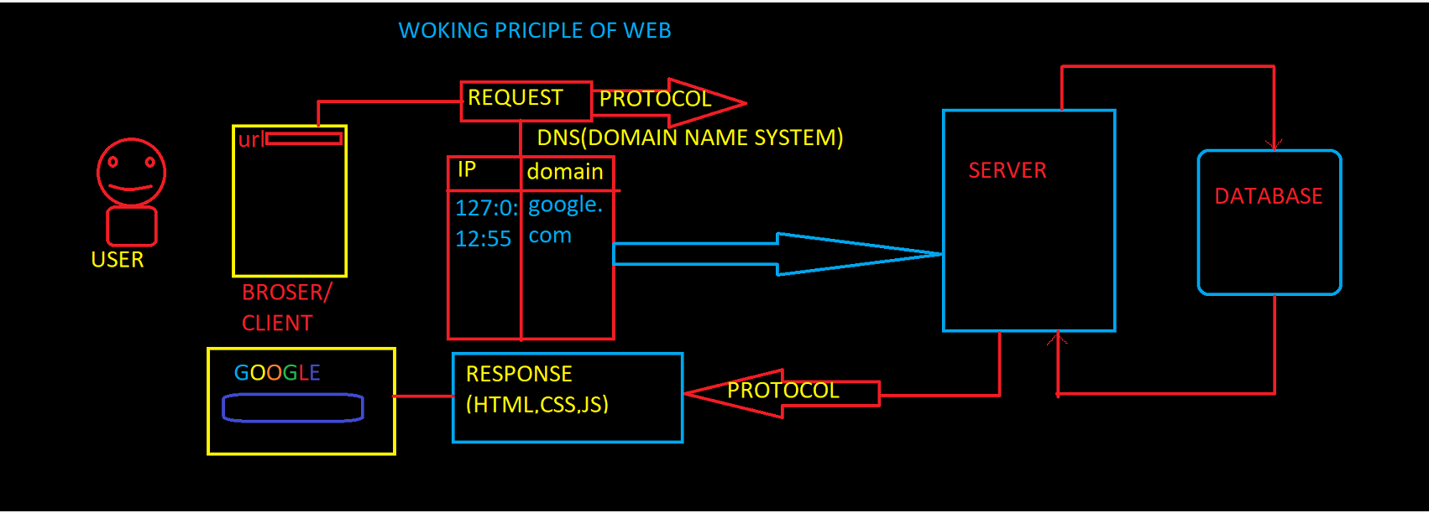

**HTML**

Brief History of HTML

**Tim Berners-Lee** is known as the father of HTML. The first available description of HTML was a document called "HTML Tags" proposed by Tim in late 1991. The latest version of HTML is HTML5, which we will learn later in this tutorial.

HTML Versions

**HTML 1.0:** The first version of HTML was 1.0, which was the barebones version of HTML language, and it was released in 1995.

**HTML 2.0:** This was the next version which was released in 1996, and it was standard language version for website design. HTML 2.0 was able to support extra features such as form-based file upload, form elements such as text box, option button, etc.

**HTML 3.2:** HTML 3.2 version was published by W3C in early 1998. This version was capable of creating tables and providing support for extra options for form elements. It can also support a web page with complex mathematical equations. It became an official standard for any browser till January 1997. Today it is practically supported by most of the browsers.

**HTML 4.01:** HTML 4.01 version was released on December 1999, and it is a very stable version of HTML language. This version is the current official standard, and it provides added support for stylesheets (CSS) and scripting ability for various multimedia elements.

**HTML5 :** HTML5 is the newest version of HyperText Markup language. The first draft of this version was announced in January 2010.

**HTML**

HTML stands for Hyper Text Markup Language.

HTML is used for developing structure of webpage.

HTML file has extension .html/.htm .

HTML files can be created by using simple text editors

**STRUCTURE OF HTML**

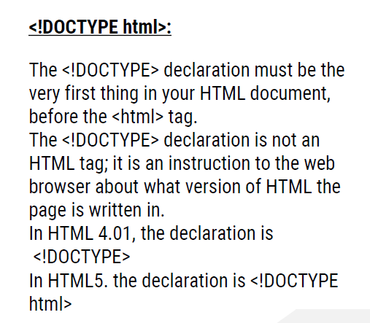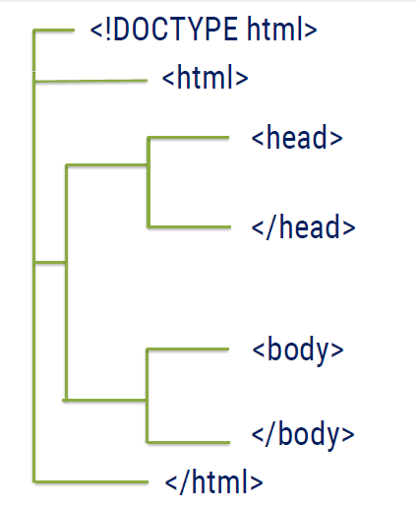

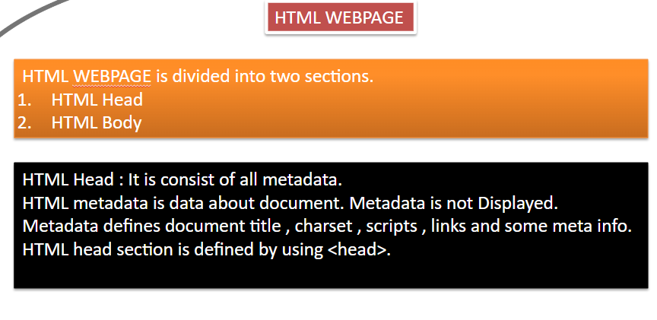

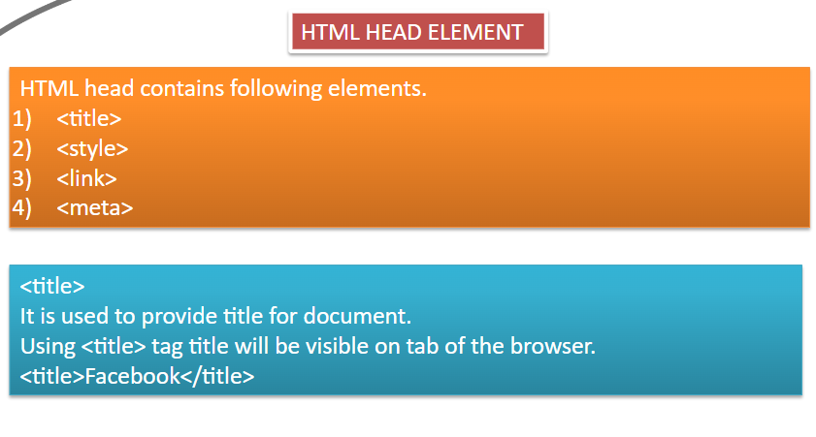

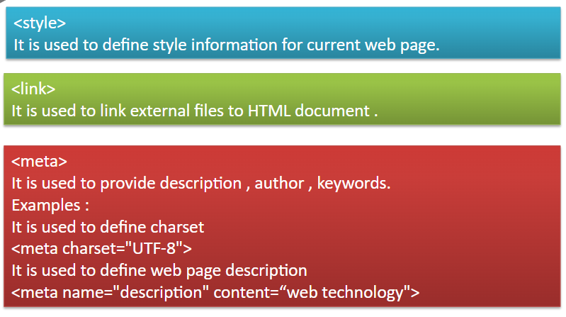

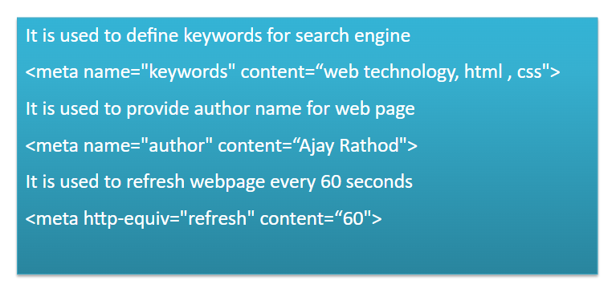

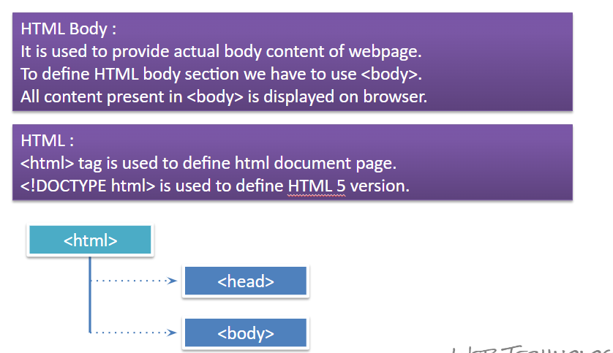

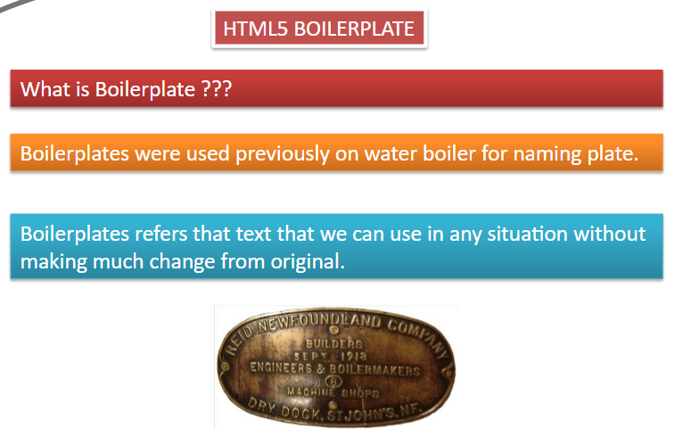

**HTML TAGS**

In HTML elements are represented by using tags.

Anything which is surrounded by ‘ <   > ‘ is known as Tag.

Tags are used to define different types of elements.

Example : <h1> <br>

There are two types of tags :

1. Pair tags / container tag
2. Unpaired tag / Self closing tags / empty tag

Pair tags :

* HTML tags which contains closing tags along with opening tags are known as Pair tags.
* Example : <h1>……</h1> ,  <div>….</div>

Self closing tags

* HTML tags which does not need closing tags are known as Self closing tags.
* Example : <br> , <hr>

**HTML TYPOGRAPHY**

Typography contains tags which can be applied on text.

Example :

**Text is appearing bold**

*But sometimes it can be in italic*

It can have underline

**AND HEADINGS**

**HTML HEADINGS**

HTML heading tags are used to provide to use headings to webpage.

Heading tags are <h1> , <h2> , <h3> , <h4> , <h5> , <h6>

Heading tags are paired type of tags.

<h1> tag displays heading in bigger font size whereas <h6> in lower font size.

Moving from <h1> to <h6> font size of heading decreases.

Example :        <h1>MySite</h1>

**Paragraph in HTML**

To provide paragraphs in web page we have to use paragraph tag.

<p>……….</p>

We can use multiple paragraph tags to provide paragraphs in web page.

Paragraph tag is paired type of tag.

Break Line Tag :

It is used to break line in web page.

<br> it is self closing tag.

**ATTRIBUTES**

Attributes are simply properties of tags.

We can change properties of tag like color , background color , size vice versa.

Attributes must be provided into opening tag.

Attributes must be in the pattern of   attribute = “value”

Example :            <  p title=“info”>

Some common Attributes :

Name , id , class , style

**Horizontal line :**

To provide horizontal line we have to use <hr> tag.

We can increase height by using height attribute.

**ELEMENT**

Opening and closing tag along with content are completely known as **HTML ELEMENT**.

We can provide elements inside another element.

Example :   <h1>My webpage </h1>

Elements which does not have content are known as empty elements.

Example : <br>

**Hyperlinks in HTML**

Hyperlinks are used to join multiple webpages.

To provide Hyperlinks in web page we have to use <a> anchor tag.

Syntax :

                <a href=“address of webpage” >link</a>

Anchor tag contains attribute href and target.

1. href attribute :  It is used to provide link of webpage which you want to join.
2. target attribute : it is used to provide behavior for opening of link. Like opening link in new tab , in current tab.

HTML TABLES

HTML Tables represent data in the form of tables.

Table consists of rows and columns.

To provide table in webpage we have to use <table> tag.

Each row of table is represented by using <tr> tag whereas each column is represented by using <td> tag.

Table contains heading which can be represented by using <th> tag.

Table title can be provided by using <caption> tag.

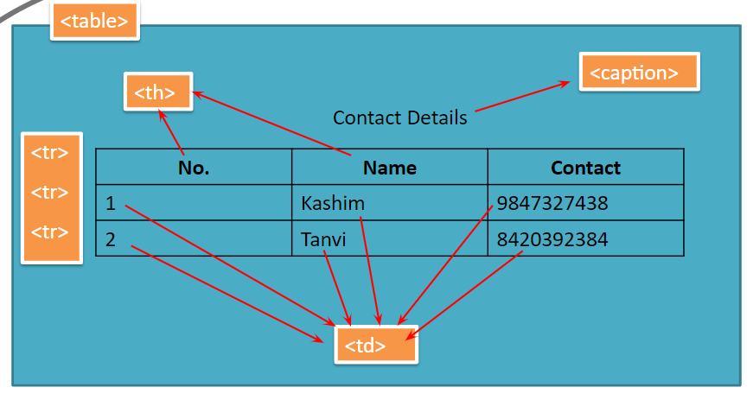

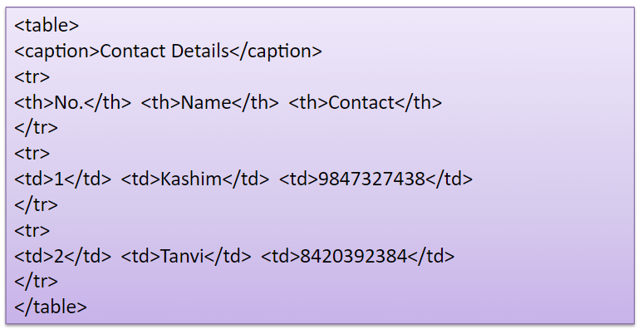

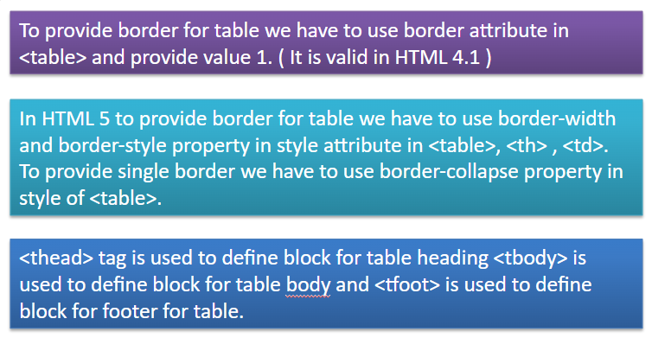

HTML Table Padding & Spacing

HTML tables can adjust the padding inside the cells, and also the space between the cells.

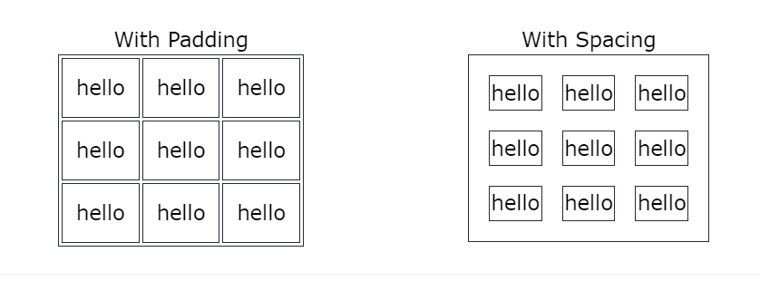

Cellspacing: this is an attribute which is used to increase the space between two cells.

Cellpadding: this is an attribute which is used to increase the surrounding area of cell.

HTML Table Colspan & Rowspan

Colspan :This is an attribute which is used to merge two or more than two colums.

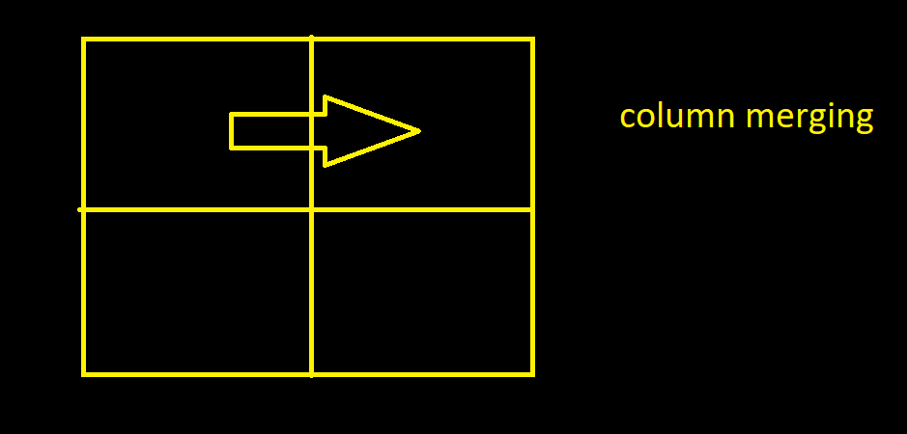

Rowspan :This is an attribute which is used to merge two or more than two rows.

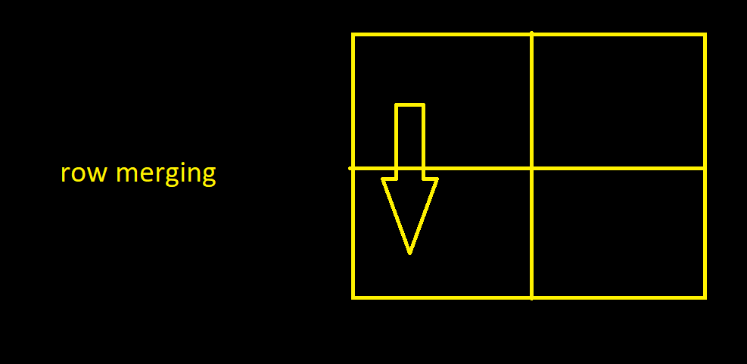

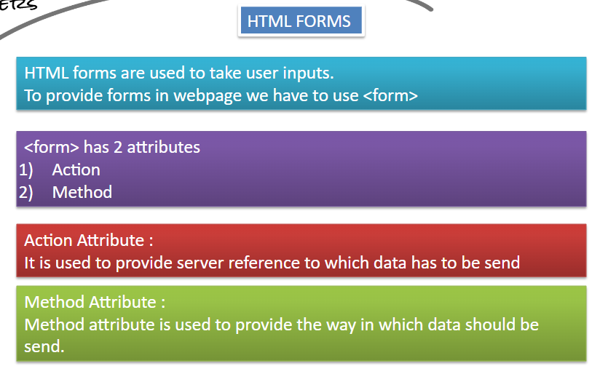

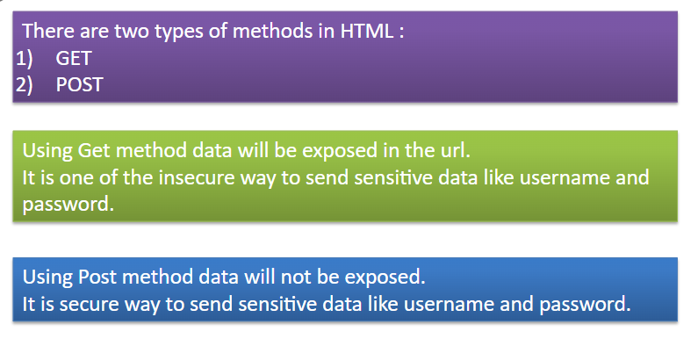

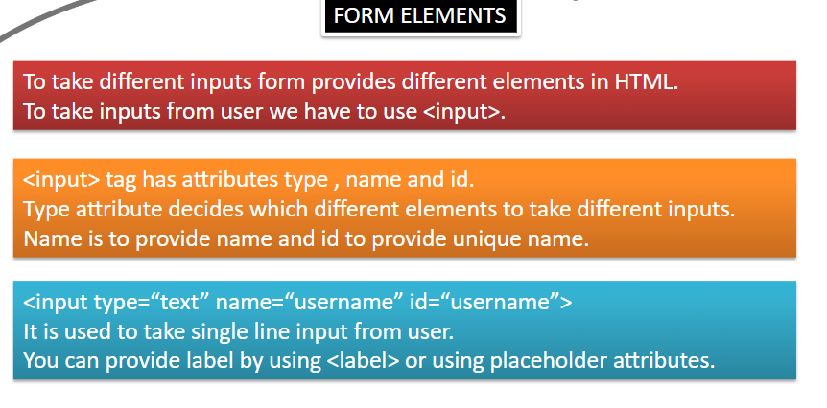

* <input>
* <label>
* <select>
* <textarea>
* <button>
* <fieldset>
* <legend>
* <datalist>
* <option>

The <input> Element

One of the most used form element is the <input> element.

The <input> element can be displayed in several ways, depending on the type attribute.

<form action="">

<label for="fname">First name:</label><br>

<input type="text" id="fname" name="fname"><br><br>

<input type="submit" value="Submit"></form>

## The <label> Element

The <label> element defines a label for several form elements.

The <label> element is useful for screen-reader users, because the screen-reader will read out loud the label when the user focus on the input element.

The <label> element also help users who have difficulty clicking on very small regions (such as radio buttons or checkboxes) - because when the user clicks the text within the <label> element, it toggles the radio button/checkbox.

The for attribute of the <label> tag should be equal to the id attribute of the <input> element to bind them together.

## The <select> Element

The <select> element defines a drop-down list:

<label for="cars">Choose a car:</label>  
<select id="cars" name="cars">  
  <option value="volvo">Volvo</option>  
  <option value="saab">Saab</option>  
  <option value="fiat">Fiat</option>  
  <option value="audi">Audi</option>  
</select>

The <option> elements defines an option that can be selected.

By default, the first item in the drop-down list is selected.

To define a pre-selected option, add the selected attribute to the option:

<select id="cars" name="cars">

<option value="volvo">Volvo</option>

<option value="saab">Saab</option>

<option value="fiat" selected>Fiat</option>

<option value="audi">Audi</option>

</select>

### **Visible Values:**

Use the size attribute to specify the number of visible values:

<label for="cars">Choose a car:</label>  
<select id="cars" name="cars" size="3">  
  <option value="volvo">Volvo</option>  
  <option value="saab">Saab</option>  
  <option value="fiat">Fiat</option>  
  <option value="audi">Audi</option>  
</select>

### **Allow Multiple Selections:**

Use the multiple attribute to allow the user to select more than one value:

<label for="cars">Choose a car:</label>  
<select id="cars" name="cars" size="4"multiple>  
  <option value="volvo">Volvo</option>  
  <option value="saab">Saab</option>  
  <option value="fiat">Fiat</option>  
  <option value="audi">Audi</option>  
</select>

## The <textarea> Element

The <textarea> element defines a multi-line input field (a text area):

<form action="">

<textarea name="message" rows="10" cols="30">The cat was playing in the garden.</textarea>

<br><br>

<input type="submit"></form>

The rows attribute specifies the visible number of lines in a text area.

The cols attribute specifies the visible width of a text area.

## The <button> Element

The <button> element defines a clickable button:

<button type="button" onclick="alert('Hello World!')">Click Me!</button>

## The <fieldset> and <legend> Elements

The <fieldset> element is used to group related data in a form.

The <legend> element defines a caption for the <fieldset> element.

<form action="">  
  <fieldset>  
    <legend>Personalia:</legend>  
    <label for="fname">First name:</label><br>  
    <input type="text" id="fname" name="fname" value="John"><br>  
    <label for="lname">Last name:</label><br>  
    <input type="text" id="lname" name="lname" value="Doe"><br><br>  
    <input type="submit" value="Submit">  
  </fieldset>  
</form>

## The <datalist> Element

The <datalist> element specifies a list of pre-defined options for an <input> element.

Users will see a drop-down list of the pre-defined options as they input data.

The list attribute of the <input> element, must refer to the id attribute of the <datalist> element.

<form action="">  
  <input list="browsers">  
  <datalist id="browsers">  
    <option value="Internet Explorer">  
    <option value="Firefox">  
    <option value="Chrome">  
    <option value="Opera">  
    <option value="Safari">  
  </datalist>  
</form>

HTML Input Types

Here are the different input types you can use in HTML:

* <input type="button">
* <input type="checkbox">
* <input type="color">
* <input type="date">
* <input type="datetime-local">
* <input type="email">
* <input type="file">
* <input type="hidden">
* <input type="image">
* <input type="month">
* <input type="number">
* <input type="password">
* <input type="radio">
* <input type="range">
* <input type="reset">
* <input type="search">
* <input type="submit">
* <input type="tel">
* <input type="text">
* <input type="time">
* <input type="url">
* <input type="week">

## Input Type Text

<input type="text"> defines a **single-line text input field**:

<form>  
  <label for="fname">First name:</label><br>  
  <input type="text" id="fname" name="fname"><br>  
    
</form>

## Input Type Password

<input type="password"> defines a **password field**:

<form>  
  <label for="username">Username:</label><br>  
  <input type="text" id="username" name="username"><br>  
  <label for="pwd">Password:</label><br>  
  <input type="password" id="pwd" name="pwd">  
</form>

## Input Type Submit

<input type="submit"> defines a button for **submitting** form data to a **form-handler**.

The form-handler is typically a server page with a script for processing input data.

The form-handler is specified in the form's action attribute:

<form action="">  
  <label for="fname">First name:</label><br>  
  <input type="text" id="fname" name="fname" value="John"><br>  
  <input type="submit" value="Submit">  
</form>

## Input Type Reset

<input type="reset"> defines a **reset button** that will reset all form values to their default values:

<form action="">  
  <label for="fname">First name:</label><br>  
  <input type="text" id="fname" name="fname" value="John"><br>  
 <input type="submit" value="Submit">  
  <input type="reset" value="RESET">  
</form>

## Input Type Radio

<input type="radio"> defines a **radio button**.

Radio buttons let a user select ONLY ONE of a limited number of choices:

<form>  
  <input type="radio" id="html" name="fav_language" value="HTML">  
  <label for="html">HTML</label><br>  
  <input type="radio" id="css" name="fav_language" value="CSS">  
  <label for="css">CSS</label><br>  
  <input type="radio" id="javascript" name="fav_language" value="JavaScript">  
  <label for="javascript">JavaScript</label>

<input type="submit" value="Submit">  
</form>

Input Type Checkbox

<input type="checkbox"> defines a **checkbox**.

Checkboxes let a user select ZERO or MORE options of a limited number of choices.

### **Example**

<form>  
  <input type="checkbox" id="vehicle1" name="vehicle1" value="Bike">  
  <label for="vehicle1"> I have a bike</label><br>  
  <input type="checkbox" id="vehicle2" name="vehicle2" value="Car">  
  <label for="vehicle2"> I have a car</label><br>  
  <input type="checkbox" id="vehicle3" name="vehicle3" value="Boat">  
  <label for="vehicle3"> I have a boat</label>  
</form>

## Input Type Color

The <input type="color"> is used for input fields that should contain a color.

Depending on browser support, a color picker can show up in the input field.

### **Example**

<form>  
  <label for="favcolor">Select your favorite color:</label>  
  <input type="color" id="favcolor" name="favcolor">  
</form>

## Input Type Date

The <input type="date"> is used for input fields that should contain a date.

Depending on browser support, a date picker can show up in the input field.

### **Example**

<form>  
  <label for="birthday">Birthday:</label>  
  <input type="date" id="birthday" name="birthday">  
</form>

You can also use the min and max attributes to add restrictions to dates:

### **Example**

<form>  
  <label for="datemax">Enter a date before 1980-01-01:</label>  
  <input type="date" id="datemax" name="datemax" max="1979-12-31"><br><br>  
  <label for="datemin">Enter a date after 2000-01-01:</label>  
  <input type="date" id="datemin" name="datemin" min="2000-01-02">  
</form>

## Input Type Datetime-local

The <input type="datetime-local"> specifies a date and time input field, with no time zone.

Depending on browser support, a date picker can show up in the input field.

### **Example**

<form>  
  <label for="birthdaytime">Birthday (date and time):</label>  
  <input type="datetime-local" id="birthdaytime" name="birthdaytime">  
</form>

## Input Type Email

The <input type="email"> is used for input fields that should contain an e-mail address.

Depending on browser support, the e-mail address can be automatically validated when submitted.

Some smartphones recognize the email type, and add ".com" to the keyboard to match email input.

### **Example**

<form>  
  <label for="email">Enter your email:</label>  
  <input type="email" id="email" name="email">  
</form>

## Input Type Image

The <input type="image"> defines an image as a submit button.

The path to the image is specified in the src attribute.

### **Example**

<form>  
<input type="image" src="img_submit.gif" alt="Submit" width="48" height="48">  
</form>

## Input Type File

The <input type="file"> defines a file-select field and a "Browse" button for file uploads.

### **Example**

<form>  
  <label for="myfile">Select a file:</label>  
  <input type="file" id="myfile" name="myfile">  
</form>

## Input Type Month

The <input type="month"> allows the user to select a month and year.

Depending on browser support, a date picker can show up in the input field.

### **Example**

<form>  
  <label for="bdaymonth">Birthday (month and year):</label>  
  <input type="month" id="bdaymonth" name="bdaymonth">  
</form>

## Input Type Number

The <input type="number"> defines a **numeric** input field.

You can also set restrictions on what numbers are accepted.

The following example displays a numeric input field, where you can enter a value from 1 to 5:

### **Example**

<form>  
  <label for="quantity">Quantity (between 1 and 5):</label>  
  <input type="number" id="quantity" name="quantity" min="1" max="5">  
</form>

## Input Type Month

The <input type="month"> allows the user to select a month and year.

Depending on browser support, a date picker can show up in the input field.

### **Example**

<form>  
  <label for="bdaymonth">Birthday (month and year):</label>  
  <input type="month" id="bdaymonth" name="bdaymonth">  
</form>

## Input Type Number

The <input type="number"> defines a **numeric** input field.

You can also set restrictions on what numbers are accepted.

The following example displays a numeric input field, where you can enter a value from 1 to 5:

|  |  |
| --- | --- |
| **Attribute** | **Description** |
| checked | Specifies that an input field should be pre-selected when the page loads (for type="checkbox" or type="radio") |
| disabled | Specifies that an input field should be disabled |
| max | Specifies the maximum value for an input field |
| maxlength | Specifies the maximum number of character for an input field |
| min | Specifies the minimum value for an input field |
| pattern | Specifies a regular expression to check the input value against |
| readonly | Specifies that an input field is read only (cannot be changed) |
| required | Specifies that an input field is required (must be filled out) |
| size | Specifies the width (in characters) of an input field |
| step | Specifies the legal number intervals for an input field |
| Value  Placeholder | Specifies the default value for an input field |

### **Example**

<form>  
  <label for="quantity">Quantity (between 1 and 5):</label>  
  <input type="number" id="quantity" name="quantity" min="1" max="5">  
</form>

## Input Type Range

The <input type="range"> defines a control for entering a number whose exact value is not important (like a slider control). Default range is 0 to 100. However, you can set restrictions on what numbers are accepted with the min, max, and step attributes:

### **Example**

<form>  
  <label for="vol">Volume (between 0 and 50):</label>  
  <input type="range" id="vol" name="vol" min="0" max="50">  
</form>

## Input Type Search

The <input type="search"> is used for search fields (a search field behaves like a regular text field).

### **Example**

<form>  
  <label for="gsearch">Search Google:</label>  
  <input type="search" id="gsearch" name="gsearch">  
</form>

## Input Type Tel

The <input type="tel"> is used for input fields that should contain a telephone number.

### **Example**

<form>  
  <label for="phone">Enter your phone number:</label>  
  <input type="tel" id="phone" name="phone" pattern="[0-9]{3}-[0-9]{2}-[0-9]{3}">  
</form>

## Input Type Time

The <input type="time"> allows the user to select a time (no time zone).

Depending on browser support, a time picker can show up in the input field.

### **Example**

<form>  
  <label for="appt">Select a time:</label>  
  <input type="time" id="appt" name="appt">  
</form>

## Input Type Url

The <input type="url"> is used for input fields that should contain a URL address.

Depending on browser support, the url field can be automatically validated when submitted.

Some smartphones recognize the url type, and adds ".com" to the keyboard to match url input.

### **Example**

<form>  
  <label for="homepage">Add your homepage:</label>  
  <input type="url" id="homepage" name="homepage">  
</form>

## Input Type Week

The <input type="week"> allows the user to select a week and year.

Depending on browser support, a date picker can show up in the input field.

### **Example**

<form>  
  <label for="week">Select a week:</label>  
  <input type="week" id="week" name="week">  
</form>

## The value Attribute

The input value attribute specifies an initial value for an input field:

## The readonly Attribute

The input readonly attribute specifies that an input field is read-only.

A read-only input field cannot be modified (however, a user can tab to it, highlight it, and copy the text from it).

## The disabled Attribute

The input disabled attribute specifies that an input field should be disabled.

A disabled input field is unusable and un-clickable.

The value of a disabled input field will not be sent when submitting the form!

## The size Attribute

The input size attribute specifies the visible width, in characters, of an input field.

The default value for size is 20.

**Note:** The size attribute works with the following input types: text, search, tel, url, email, and password.

## The maxlength Attribute

The input maxlength attribute specifies the maximum number of characters allowed in an input field.

**Note:** When a maxlength is set, the input field will not accept more than the specified number of characters.

## The min and max Attributes

The input min and max attributes specify the minimum and maximum values for an input field.

The min and max attributes work with the following input types: number, range, date, datetime-local, month, time and week.

**Tip:** Use the max and min attributes together to create a range of legal values.

## The multiple Attribute

The input multiple attribute specifies that the user is allowed to enter more than one value in an input field.

The multiple attribute works with the following input types: email, and file.

## The pattern Attribute

The input pattern attribute specifies a regular expression that the input field's value is checked against, when the form is submitted.

The pattern attribute works with the following input types: text, date, search, url, tel, email, and password.

## The placeholder Attribute

The input placeholder attribute specifies a short hint that describes the expected value of an input field (a sample value or a short description of the expected format).

The short hint is displayed in the input field before the user enters a value.

The placeholder attribute works with the following input types: text, search, url, tel, email, and password.

## The required Attribute

The input required attribute specifies that an input field must be filled out before submitting the form.

The required attribute works with the following input types: text, search, url, tel, email, password, date pickers, number, checkbox, radio, and file.

## The step Attribute

The input step attribute specifies the legal number intervals for an input field.

Example: if step="3", legal numbers could be -3, 0, 3, 6, etc.

**Tip:** This attribute can be used together with the max and min attributes to create a range of legal values.

The step attribute works with the following input types: number, range, date, datetime-local, month, time and week.

## The autofocus Attribute

The input autofocus attribute specifies that an input field should automatically get focus when the page loads.

## The list Attribute

The input list attribute refers to a <datalist> element that contains pre-defined options for an <input> element.

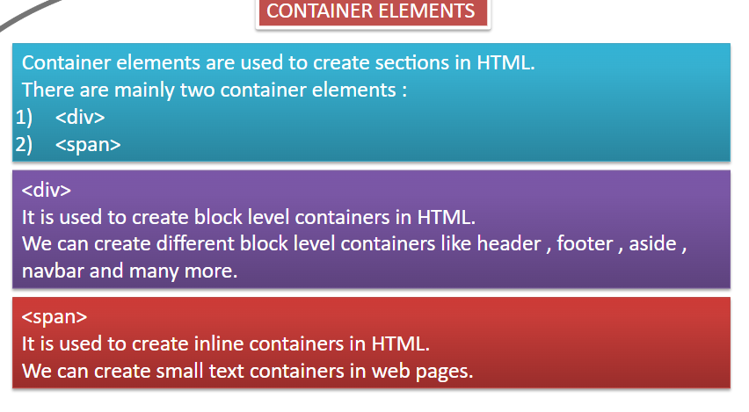

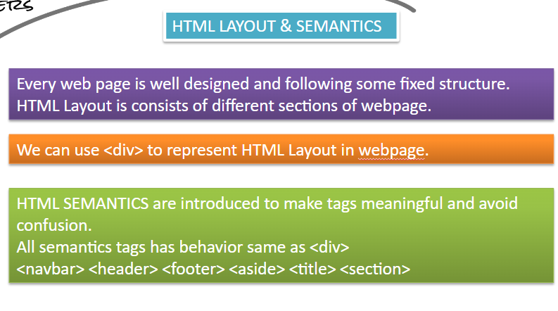

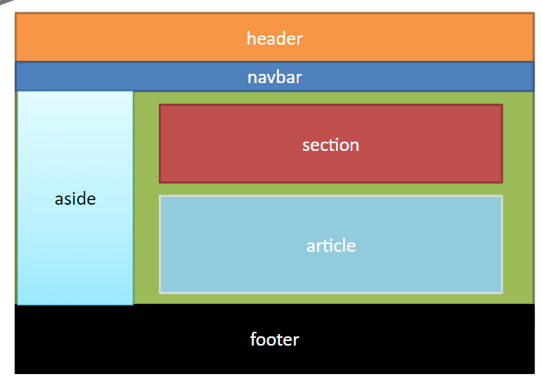

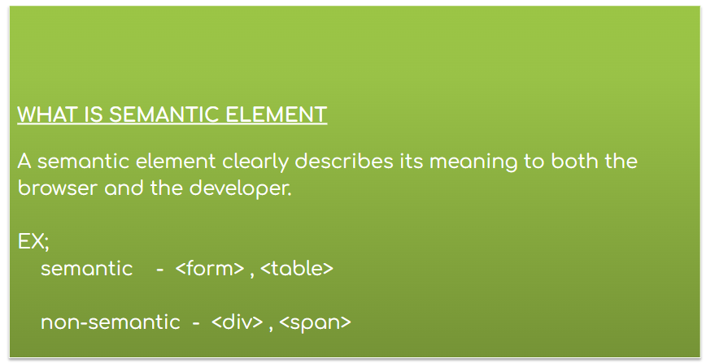

**TYPES OF ELEMENTS**

There are two types of elements in HTML :

1. BLOCK LEVEL
2. INLINE LEVEL
3. INLINE BLOCK LEVEL

**1.BLOCK LEVEL ELEMENT :**

Elements which occupy width same as browser width are known as block level elements.

Block level elements width depends on browser width.

Height and width can be changed for Block Level Elements.

Example :

      <p>  , <h3> ( all headings ),div etc

**2.INLINE ELEMENTS :**

Inline elements are elements which takes width of content.

Width of inline elements depends on content.

We can not change height and width of inline elements.

Example:

<a> , <span> etc

**3.INLINE-BLOCK**

Inline-block level elements takes exact height and width of an element and along with that we can modify an element.

Ex- <img> etc

