PROJECT REPORT: EMBEDDED SYSTEMS & IOT DEVICE DESIGN
Submitted By: Junior Embedded Engineer
Organization: Maincrafts Technology
Task Reference: Embedded Systems Task-1

1. Introduction & Theoretical Foundation

What is an Embedded System?
An embedded system is a specialized, computer-based system consisting of hardware integrated with dedicated software (firmware) designed to execute a specific, pre-defined function. Unlike general-purpose computers (e.g., personal laptops) designed to run an infinite variety of applications, an embedded system is highly optimized for efficiency, reliability, and deterministic real-time operations.

Real-World Applications
Embedded systems serve as the invisible backbone of modern infrastructure. Key industries include:
- Smart Home Automation: Smart thermostats, automated security panels, and automated environmental controllers.
- Automotive Electronics: Electronic Control Units (ECUs), Anti-lock Braking Systems (ABS), and advanced driver-assistance systems (ADAS).
- Healthcare Systems: Critical medical electronics such as implantable pacemakers, automated insulin pumps, and real-time patient vital monitors.
- Robotics & Industrial Automation: Programmable Logic Controllers (PLCs), robotic assembly arms, and automated guided warehouse vehicles.

Microcontroller (MCU) vs. Microprocessor (MPU)
Selecting the appropriate processing architecture is a fundamental step in embedded system design. The table below highlights their key functional distinctions:
Technical Feature | Microcontroller (MCU) | Microprocessor (MPU)
Architectural Design | An all-in-one chip integrating the CPU core, RAM, ROM, and I/O peripherals onto a single silicon substrate. | A standalone CPU core chip that requires external ICs for RAM, ROM, storage, and peripheral interfaces.
Production Cost | Significantly lower cost per unit, highly optimized for dedicated tasks. | Higher implementation cost due to the necessity of supporting external components.
Power Consumption | Extremely low; often designed with deep-sleep modes to run on battery power for years. | High power requirements; typically demands stable external power grids and active thermal cooling.
Core Examples | ATmega328P (Arduino UNO), ESP32, RP2040. | Intel Core series, AMD Ryzen, ARM Cortex-A series (found in smartphones).

2. Component Study
Microcontrollers Evaluated
- Arduino UNO: An entry-level 8-bit development platform utilizing the ATmega328P microcontroller. It features an open-source toolchain and a massive library ecosystem, making it the industry-standard baseline for low-complexity hardware prototyping.
- ESP32: A high-performance 32-bit dual-core microcontroller featuring native Wi-Fi and Bluetooth connectivity. This platform is the primary choice for modern Internet of Things (IoT) field deployments that demand cloud communication capability.
- Raspberry Pi Pico: A low-cost, high-efficiency board powered by the custom dual-core RP2040 chip. It offers flexible digital interfacing through unique Programmable I/O (PIO) blocks, ideal for high-speed deterministic execution.
Sensors Evaluated
- Temperature Sensors (e.g., TMP36 / DHT11): Transducers that capture environmental thermal energy and convert it into a proportional analog voltage or digital signal for computational tracking.
- Motion Sensors (e.g., PIR - Passive Infrared): Electronic modules that detect ambient infrared energy signatures emitted by moving human bodies or warm objects within their field of view.
- Light Sensors (e.g., LDR - Light Dependent Resistor): Photo-resistors that exhibit a change in electrical resistance correlated directly to the intensity of ambient light falling on their surfaces.

3. Mini Project Design: Smart Motion Detection Alarm System
System Selection
- Project Chosen: Motion Detection Alarm System
- Development Platform: Tinkercad Circuits (Digital Simulator Environment)
Working Principle
The system is engineered as an automated perimeter monitoring node.
- The PIR Sensor acts as the input node, monitoring a specific geographic zone for fluctuations in ambient infrared thermal patterns.
- When an object or person steps into the detection cone, the sensor registers an IR differential and shifts its physical output signal from LOW to HIGH.
- The Arduino UNO reads this logic shift via its digital input pin array.
- Upon evaluating the HIGH conditional state, the MCU executes its code to immediately turn on two separate output peripherals simultaneously: a high-brightness warning LED and an audible Piezo Buzzer to notify personnel of an intrusion.
Circuit Wiring Specification Table
The virtual prototype was arranged on a solderless breadboard using the following pin map configurations:
Source Component | Component Pin | Destination Component | Destination Pin / Rail | Wire Function
Arduino UNO | 5V | Breadboard | Positive (+) Rail | Primary VCC Bus
Arduino UNO | GND | Breadboard | Negative (-) Rail | System Ground
PIR Sensor | VCC / Power | Breadboard | Positive (+) Rail | Sensor Power
PIR Sensor | GND / Ground | Breadboard | Negative (-) Rail | Sensor Ground Reference
PIR Sensor | OUT / Signal | Arduino UNO | Digital Pin 2 | Digital Input Signal
Resistor (220 $\Omega$) | Terminal 1 | Arduino UNO | Digital Pin 13 | Output Control Path
Resistor (220 $\Omega$) | Terminal 2 | LED | Anode (+) | Current-Limited Power
LED | Cathode (-) | Breadboard | Negative (-) Rail | LED Ground Return
Piezo Buzzer | Positive (+) | Arduino UNO | Digital Pin 8 | Audio Output Control
Piezo Buzzer | Negative (-) | Breadboard | Negative (-) Rail | Buzzer Ground Return

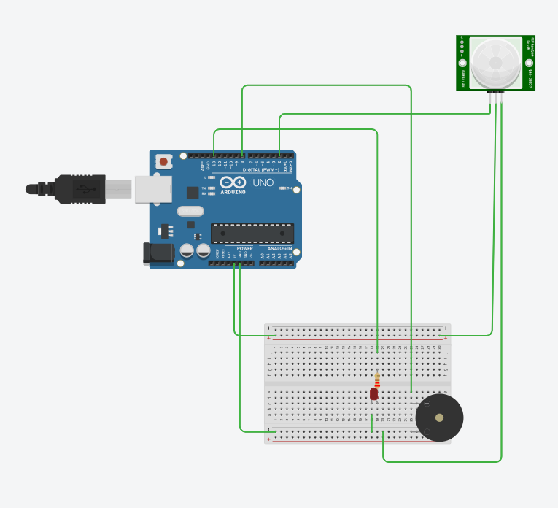

Tinkercad simulation circuit schematic for the Motion Detection Alarm System.

4. Source Code Implementation
The firmware is written in standard Arduino C++ and uploaded directly into the integrated development space of the simulator
/* * Maincrafts Technology - Embedded Systems & IoT Task 1
* Project: Motion Detection Alarm System (Simulation)
* File: main.ino
* Author: Junior Embedded Engineer
*/

// Global Constant Declarations for Pin Allocations
const int pirInputPin = 2; // Signal interface pin for the PIR Sensor
const int ledAlertPin = 13; // Drive control pin for the warning LED
const int buzzerAlertPin = 8;// Drive control pin for the warning Buzzer
// State Variable to hold real-time sensor evaluations
int motionState = 0;
void setup() {
// Establish pin modes based on I/O flow mapping
pinMode(ledAlertPin, OUTPUT); // Configure pin 13 to drive LED current
pinMode(buzzerAlertPin, OUTPUT); // Configure pin 8 to drive Audio Piezo
pinMode(pirInputPin, INPUT); // Configure pin 2 to sample PIR voltage levels

// Set up data transmission link back to host terminal for operational logging
Serial.begin(9600);
Serial.println("System Security Monitor Online. Calibrating peripherals...");
}
void loop() {
// Continually evaluate the digital state of the physical PIR pin
motionState = digitalRead(pirInputPin);
// Conditional Logic Branch: Act if sensor registers structural movement
if (motionState == HIGH)
{
// Action 1: Drive LED high to ignite the light source
digitalWrite(ledAlertPin, HIGH);
// Action 2: Drive Piezo element high to produce sound waves
digitalWrite(buzzerAlertPin, HIGH);
// Action 3: Log timestamped diagnostic telemetry string to the console
Serial.println("[ALERT] Threat Detected inside Monitored Sector!");
// Safety Delay: Prevents short stutter loops and maintains crisp alert states
delay(1000);
}
else
{
// Return to Default Safety State: Shutdown active alert pins
digitalWrite(ledAlertPin, LOW);
digitalWrite(buzzerAlertPin, LOW);
}
}

5. Industry Applications & Scalability
The simulated perimeter logic is highly scalable and directly matches several industrial market solutions:
- Commercial Security Frameworks: Can be scaled up into multi-node hardware arrays to secure facilities, linking back via wireless protocols (like ESP32 Wi-Fi) to trigger central monitoring stations.
- Smart Lighting Infrastructure: The logic can be inverted to act as an energy-conservation tool in corporate offices, automatically switching overhead lighting relays off during periods of zero motion to minimize energy footprints.
- Industrial Machine Safeguards: Can be positioned near active high-voltage automated manufacturing lines to instantly isolate or shut down heavy equipment if human operators accidentally step into hazardous operational zones

