Expiry Tracker
Expiry Tracker is a modern, high-performance web application built with Next.js 15 and MongoDB. It helps users manage the shelf life of their perishables, reducing food waste and saving money through intelligent tracking and timely notifications.

🌟 Key Features
- Dashboard Overview: Real-time tracking of all products with status indicators (Fresh, Expiring Soon, Expired).
- Smart Categorization: Organizes items into categories like Dairy, Groceries, Medicine, Cosmetics, etc.
- Email & Push Notifications: Get alerted before items expire via automated email reminders and browser push notifications.
- Recipe Integration: Discover what you can cook using your ingredients via the built-in Recipe Finder (powered by Spoonacular API).
- Image Management: Upload product images using ImageKit.io for easy identification.
- Dark Mode Support: Seamlessly switch between light and dark themes.
- Secure Authentication: User sign-up and login powered by NextAuth and JWT.

🚀 Installation setup
Prerequisites
· Node.js 18+
· npm or pnpm
· MongoDB Atlas account (free tier)
· ImageKit.io account (free tier)
· VS Code + extensions (Tailwind CSS v4, Prettier)
Setup Steps
1. Clone the repository
```bash
git clone https://github.com/your-username/expiry-tracker.git
cd expiry_tracker
```
2. Install dependencies
```bash
npm install
```
3. Set up environment variables
Create a `.env` file in the root directory and add the keys as detailed above.
```bash
cp .env.local .env
```
4. Start development server
```bash
npm run dev
```
5. Build for Production
```bash
npm run build
```

🛠️ Tech Stack
Frontend
· Next.js 15 (React 18, App Router)
· TypeScript
· Tailwind CSS 4
· Lucide React + Sonner (Toasts)
Backend
· Next.js API Routes
· RESTful endpoints for Auth, Product management, Recipe search, and Push notifications
Database
· MongoDB / MongoDB Atlas (via Mongoose)
Auth
· NextAuth.js + JWT tokens
· BcryptJS password hashing
Integrations
· ImageKit.io (Image hosting & optimization)
· Nodemailer (Email alerts)
· Web-Push (Browser notifications)
· Spoonacular API (Recipe discovery)
Validation
· Zod schema validation

□ PROJECT FLOWCHART

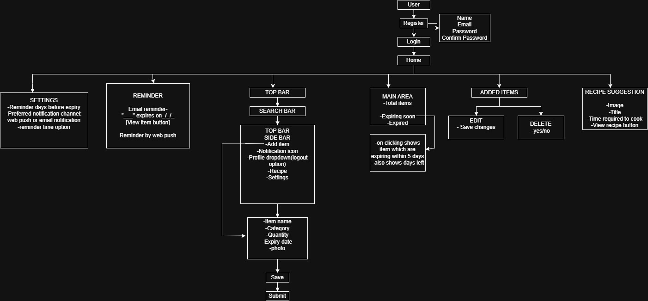
📦 Dependencies
The project utilizes several industry-standard libraries:
- @imagekit/next: Integration for ImageKit optimization.
- lucide-react: Comprehensive icon set.
- axios: Robust HTTP client for API requests.
- mongoose: Elegant MongoDB object modeling.
- sonner: Beautiful and functional toast notifications.
- react-hook-form: Performant form handling.

□ API Reference
This document provides detailed information about the API endpoints available in the Expiry Tracker application.

API Name | Method | URL | Parameters | Description | Expected Response
Registration | POST | /api/register | • name (string, required)  • email (string, required)  • password (string, required)  •confirmPassword (string, required) | Registers a new user account | • 201 Created - User successfully registered  • 400 Bad Request - Invalid input or user exists
Login | POST | /api/login | • email (string, required)  • password (string, required) | Authenticates user and returns JWT token | • 200 OK - Successfully authenticated (returns JWT)  • 400 Bad Request - Invalid credentials
Create Product | POST | /api/createProduct | • product_name (string, required)  • quantity (number, required)  •expiry_date (date, required)  •category (string, required)  • image_url (string, optional)  • Auth: Bearer Token | Adds a new item to the user's product tracker | • 201 Created - Product created  • 401 Unauthorized - Missing/invalid token  • 400 Bad Request - Invalid data
Get All Products | GET | /api/products | • Auth: Bearer Token | Fetches all products for the currently authenticated user | • 200 OK - Returns array of products  • 401 Unauthorized - Missing/invalid token
Update Product | PUT | /api/updateProduct/[id] | • product_name (string, optional)  • quantity (number, optional)  • expiry_date (date, optional)  • category (string, optional)  • image_url (string, optional)  • Auth: Bearer Token | Updates existing product details | • 200 OK - Product updated  • 404 Not Found - Product doesn't exist  • 401 Unauthorized - Missing/invalid token
Delete Product | DELETE | /api/deleteProduct/[id] | • Auth: Bearer Token | Removes a product from the database | • 200 OK - Product deleted  • 404 Not Found - Product doesn't exist  • 401 Unauthorized - Missing/invalid token
Search Recipes | GET | /api/searchRecipes | • query (string, required) - e.g., "pasta", "chicken"  • Auth: Bearer Token | Searches for recipes using the Spoonacular API | • 200 OK - Returns list of matching recipes  • 400 Bad Request - Missing query parameter
Recipe Details | GET | /api/getRecipeDetails/[id] | • Recipe ID in URL path  • Auth: Bearer Token | Fetches detailed recipe information including ingredients and cooking instructions | • 200 OK - Returns detailed recipe object  • 404 Not Found - Recipe doesn't exist
Subscribe Push | POST | /api/subscribe | •  subscription (object, required) - Browser push subscription object  • Auth: Bearer Token | Saves the browser's push notification endpoint for expiry alerts | • 201 Created - Subscription saved  • 400 Bad Request - Invalid subscription object

🎨 Frontend Guide
The Expiry Tracker frontend is built with Next.js 15 using the App Router. This guide provides an overview of the user-facing pages and their roles.
📄 Application Pages
This document provides an overview of all pages available in the Expiry Tracker application.

Path | Page Name | Description
/ | Landing Page | The first entry point for unauthenticated users. Briefly introduces the app and provides links to Log In or Register.
/login | Login Page | Allows existing users to sign in using their email and password.
/register | Registration Page | Allows new users to create an account. Includes fields for name, email, and password validation.
/products | All Products | The main dashboard. Lists all items added by the user. Includes search, category filtering, and options to edit/delete items.
/add-item | Add Item | A dedicated form page to add new items. Users can specify name, quantity, category, and expiry date.
/edit-item/[id] | Edit Item | A pre-filled form page to update details of a specific item.
/recipes | Recipe Finder | A creative tool where users can search for recipes based on ingredients they have.
/expired | Expired Items | A filtered view showing only items that have already passed their expiry date.
/expiring-soon | Critical Items | Shows items that are approaching their expiry date (based on user settings).
/settings | User Settings | Allows users to configure their notification preferences (Reminder days, Email/Push toggles).
/profile | Profile Page | Shows user information and account management options.

📄□ Page Categories

🔐 Authentication Pages
- / - Landing Page
- /login - Login Page
- /register - Registration Page

📦 Product Management
- /products - All Products
- /add-item - Add Item
- /edit-item/[id] - Edit Item

🔔 Monitoring & Alerts
- /expired - Expired Items
- /expiring-soon - Critical Items

🍳 Additional Features
- /recipes - Recipe Finder

User Management
- /settings - User Settings
- /profile - Profile Page

🧩 Key Components
- ProductCard: A reusable component used to display item details with visual status indicators.
- HamburgerMenu: The primary navigation element for mobile and desktop views.
- Providers: Wraps the app with context providers for NextAuth sessions and user data.
- ImageUpload: A custom component that interacts with ImageKit to handle product image uploads.
- Dark Mode Support: The design system includes a foundation for Dark/Light modes (via CSS variables in ‘globals.css’) and is ready for full implementation with a theme toggle.
- ImageUpload: A custom component that interacts with ImageKit to handle product image uploads.

🗝️ Environment Variables
💾 Database
- DB: Your MongoDB connection string (e.g., `mongodb+srv://...`).
🔑 Security & Auth
- SECRET_KEY: A strong, random string used for signing JWT tokens and managing sessions.
🖼️ ImageKit (Image Hosting)
- NEXT_PUBLIC_IMAGEKIT_URL_ENDPOINT: The base URL provided by your ImageKit dashboard.
- NEXT_PUBLIC_IMAGEKIT_PUBLIC_KEY: Your ImageKit public API key.
- IMAGEKIT_PRIVATE_KEY: Your ImageKit private API key.
🔔 Browser Push Notifications (VAPID)
- NEXT_PUBLIC_VAPID_PUBLIC_KEY: Public VAPID key used to identify your push server.
- VAPID_PRIVATE_KEY: Private VAPID key.
- VAPID_SUBJECT: Must be a ‘mailto:’ link or a website URL (e.g., ‘mailto:admin@example.com’).
📧 Email Reminders (SMTP)
- SMTP_HOST: The hostname of your SMTP server (e.g., `smtp.gmail.com`).
- SMTP_PORT: Port number (usually `587` for TLS).
- SMTP_USER: The email address used to send reminders.
- SMTP_PASS: The application-specific password for the email account.
- SMTP_SECURE: `true` for SSL, `false` for TLS.
🌐 App Metadata
- NEXT_PUBLIC_APP_URL: The base URL of your application (e.g., `http://localhost:3000` for local dev).

🚀 Future Scope
Next 6-12 Months
· Barcode Scanning: Use phone camera to scan product barcodes for instant name and category entry.
· Inventory Sharing: Allow families/roommates to share a single tracker and sync items.
· Smart Shopping Lists: Auto-generate lists based on expiring or low-stock items.
· In-app Recipe Editor: Save and customize favorite recipes directly in the dashboard.
Long-term
· AI Expiry Prediction: Machine learning to estimate shelf life based on storage conditions.
· Price Comparison: Integration with local grocery APIs for price drop alerts on frequent items.
· Voice Assistants: Hands-free tracking via Alexa, Siri, or Google Assistant commands.
· Multilingual Support: Complete support for Hindi and other regional languages.

