2025湖南高速检测设备提交数据格式要求
路况检测设备直接输出数据需满足以下要求：
1：提供整体文件结构目录说明。
- 提交的文件名称；
- 提交的文件含义说明；
- 提交路面图片命名与检测桩号关系说明；
- 提供真实检测数据，务必含有校桩信息，且包含上下行数据。
2：提供采集间距及图片尺寸，如有单双相机分别提供相应的格式说明。提供图像尺寸及像素关系说明。
3：要求采集设备数据格式为一套格式。
4：如果有3D检测数据，需提供相应的转换工具或直接转换为2D图片。
5：提供的数据要求为不加密的明文。各项指标需满足《JTG-T E61-2014 公路路面技术状况自动化检测规程》要求，并且如果有校桩信息，提供校桩关系说明。
6：所有数据需提供为校桩后数据。

一、文件格式要求如下：

1.路面平整度
路面平整度：原始数据格式包括桩号、断面高程及检测速度，并以文本或电子表格格式保存，断面高程输出间距应为0.1m，应根据输出的断面高程数据，以10m为单元计算IRI。平整度结果应包括检测桩号和IRI值。双轮迹检测时路面IRI应取左、右路面平整度中的大值。
附表 路面平整度自动化检测数据文件格式
桩号(km) | 左IRI(m/km) | 右IRI(m/km) | IRI(m/km)
21.01 | 0.67 | 0.88 | 0.88
21.02 | 0.81 | 1.36 | 1.36
平整度结果文件以电子表格格式保存，文件命名示例：
“路线编码”-“方向编码”-“IRI“-”起点桩号"-“日期”

路面车辙
路面车辙：应以10m为单元分别计算断面左、右车辙深度的平均值，取大值为10m平均车辙深度。输出结果应包括桩号、左侧车辙、右侧车辙和路面车辙，并以文本或电子表格格式保存。
附表 路面车辙RD标准格式
桩号(km) | 左车辙RD₁(mm) | 右车辙RD₂(mm) | 路面车辙RD(mm)
21.01 | 1.983 | 2.792 | 2.792
21.02 | 2.719 | 2.935 | 2.935
21.03 | 3.097 | 3.01 | 3.097
21.04 | 4.699 | 4.411 | 4.699
21.05 | 3.411 | 2.647 | 3.411
21.06 | 12.391 | 8.914 | 12.391
21.07 | 15.485 | 12.538 | 15.485
21.08 | 14.572 | 10.073 | 14.572
21.09 | 13.164 | 14.541 | 14.541
21.1 | 10.611 | 8.581 | 10.611
车辙文件以电子表格格式保存，文件命名示例：
“路线编码”-“方向编码”-“RD“-”起点桩号"-“日期”

3、GPS
文件命名规则：GA22A-GPS-798.568-标准格式-20200707163248.txt
文件输出间隔为5m的GPS文件；文件数据格式，第一列为桩号（单位：m），保留三位小数。第二、三、四列分别为X、Y、Z分别代表经度、纬度、海拔，保留6位小数。第五列为有效性，A代表有效，V代表无效。第六列为桩号核对，保留6位小数。第七列无字段标题，但要补位0 （如下图所示）。
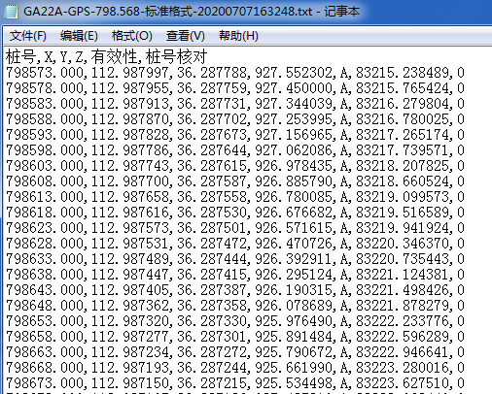
GPS格式

4、跳车
文件命名规则：S230B-PB-171.500-20231123150757.csv(逗号分隔值文件)。文件输出间隔为10m的跳车文件；文件数据格式，第一列为桩号（单位：km），保留两位小数，上行桩号递增、下行桩号递减。第二、三、四列分别为PB_L、PB_M、PB_H分别代表轻度、中度、重度，第五列为△H（如下图所示）。
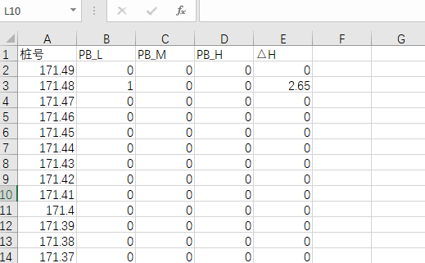

5.路面抗滑 SRI
文件命名规则：SA12-B-SFC-20231123150757.csv(逗号分隔值文件)。文件输出间隔为10m的跳车文件；文件数据格式，第一列为桩号（单位：km），保留两位小数，上行桩号递增、下行桩号递减。第二列为SFC数值，第三列为速度值，第四列为温度值。
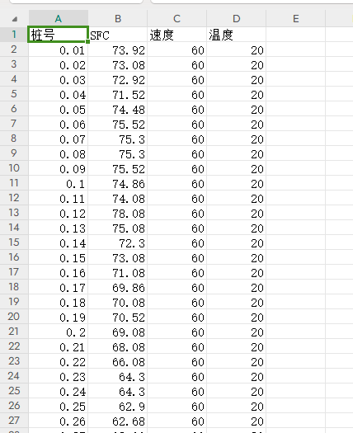

二、破损照片Images格式要求
Images目录层级要求为：Images→检测日期（如：20230601）→路线编码（按编码规则）→树形1层级文件夹（名称为数字0即可）→树形2层级文件夹（名称为数字0即可）→图片文件（图片文件名称要求附带路线编码和对应桩号，例如：G233A-1261+535505-1261+535505）
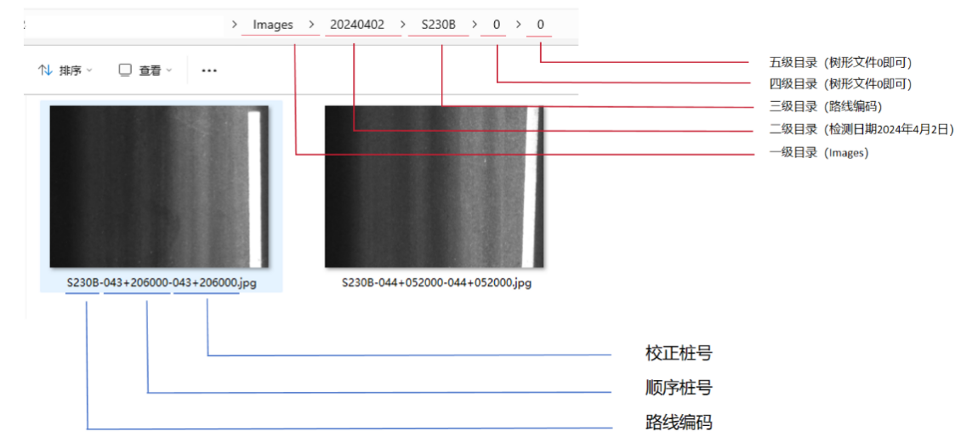
注：提供实际检测宽度，要求单张图片100像素等于0.1m，且为整百像素，例如检测宽度为2.4米×2米，单张图片要求2400*2000。
树形层级文件夹按如下方式依次建立，每个文件夹宜容纳5000张图片，到达5000张放入下一数字文件夹。
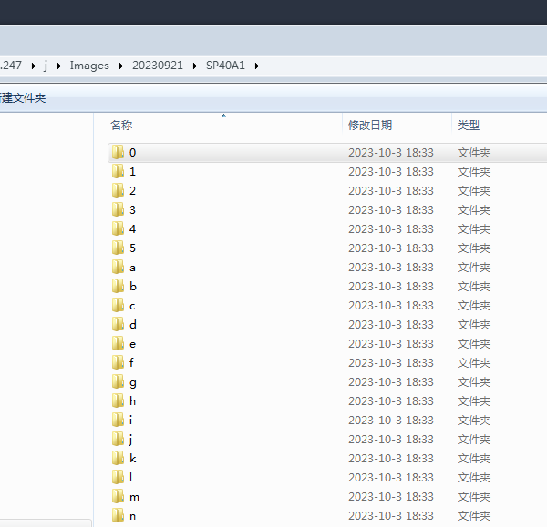

三、前方图像格式要求
前方图像目录层级要求为：前方图像→检测日期（如：20230601）→路线编码按编码规则）→前方图片文件（图片文件名称要求附带路线编码和对应桩号，例如：GX36A-024+733033-024+807806）。如图：
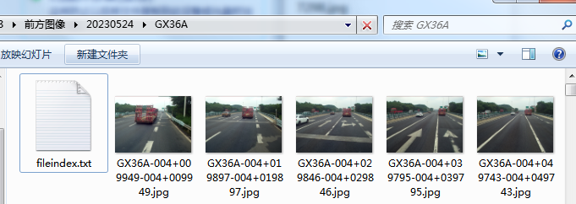
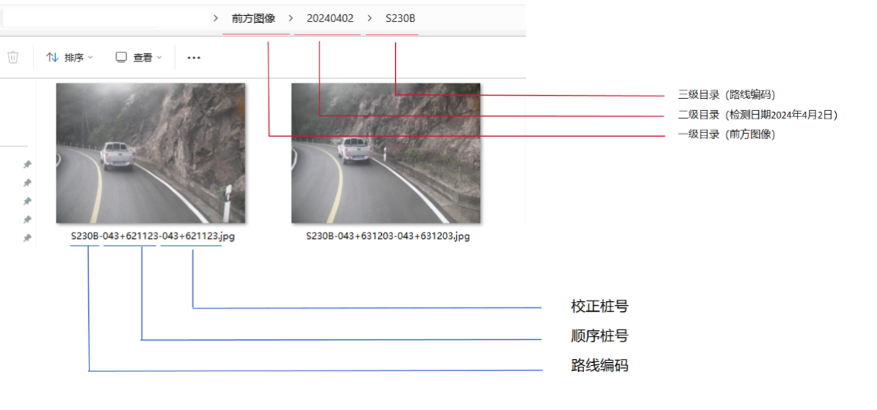

四、整体数据结构：
提供数据包含原始检测数据、转换后数据，提供整体文件结构目录并存储在根目录下，检测的所有数据信息应以检测指标建立工程名，并将同类检测指标存储在同一个工程名的文件下，不需要分级建工程信息，如下图。
文件示例路径：
F:\2024高速公路检测+G106+G106B-下行-2车道-20230927133654（工程名字）\EXPORTDATA\Images\20230927\G106B\0\0\G106B-1533+780000-1533+780000.jpg

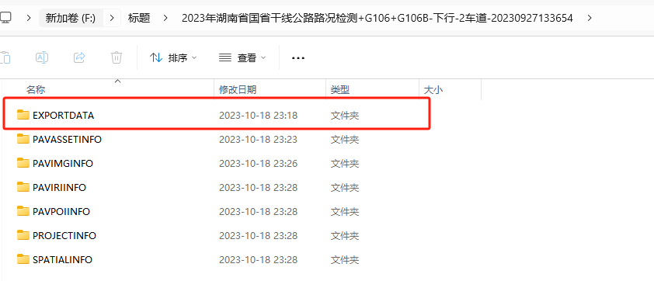
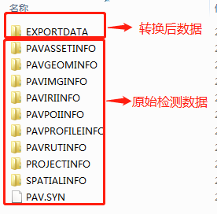
第一级目录 第二级目录 第三级目录
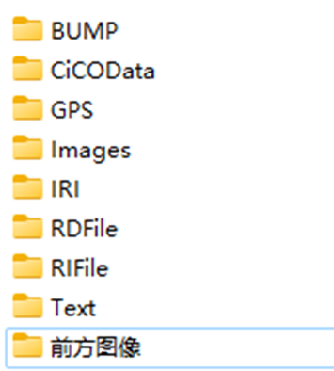
注：当日检测数据应及时校核数据完整性，确保检测数据各指标有效，没有缺失。
转换后数据第一级目录放各项检测内容，第二级目录放多个日期的检测数据，第三级目录放各路线的检测数据。
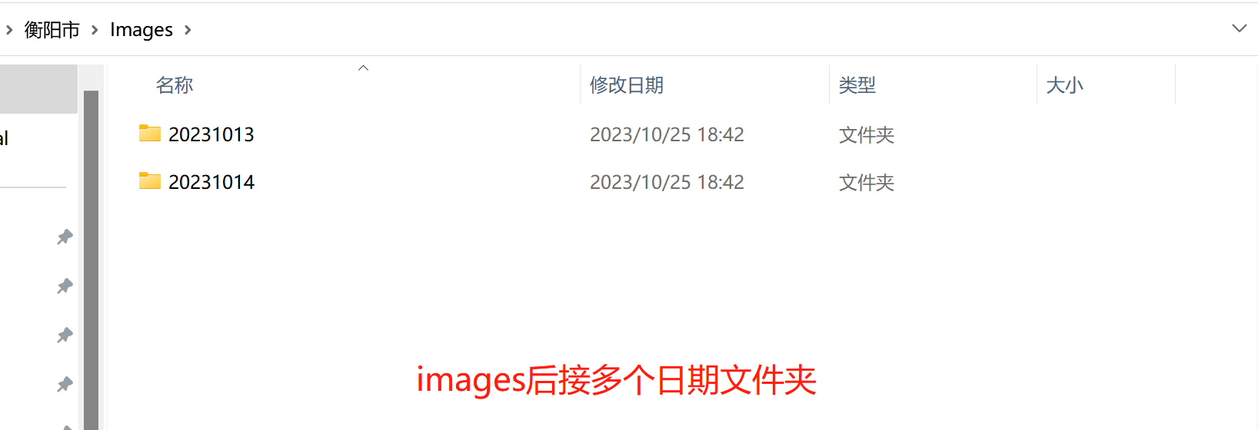
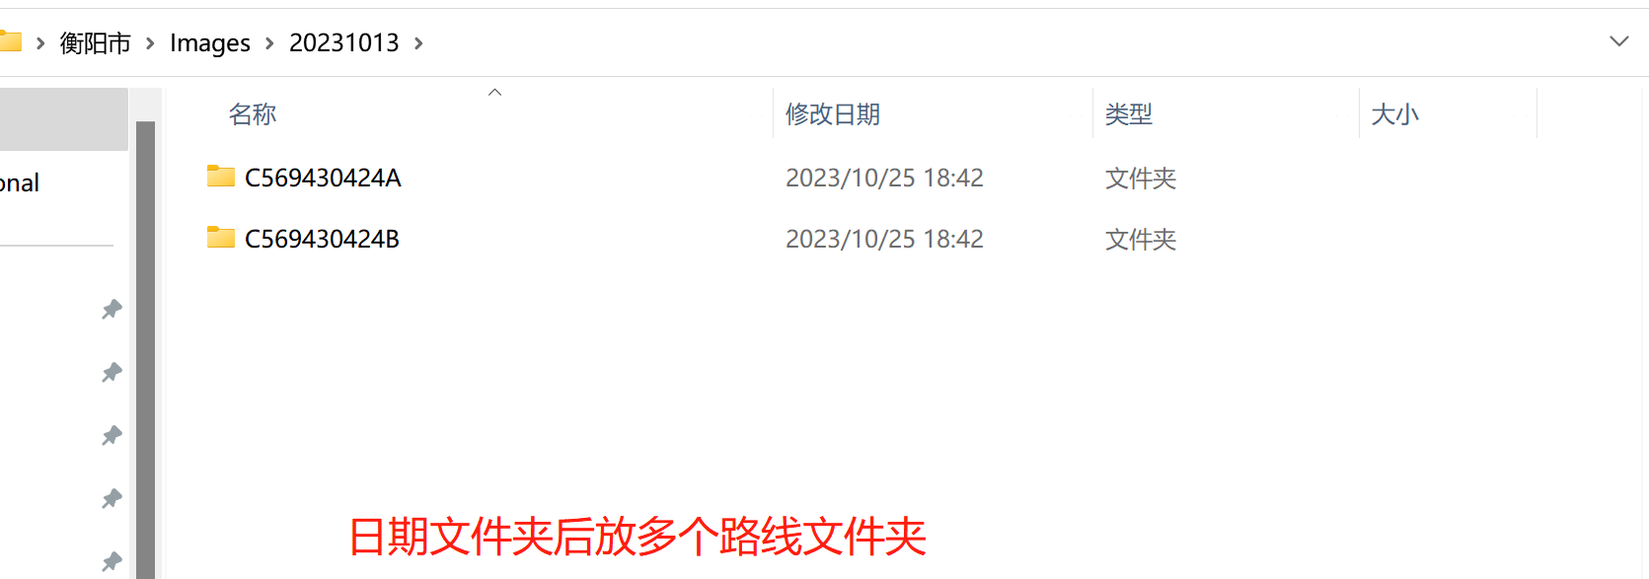

六、其它
1.以每张硬盘为单位，合并转换后数据，转换后数据包括：路面图像、前方图像、平整度、车辙、跳车、GPS等。
2.硬盘采集达到400公里时，及时封存硬盘并寄出。快递打包要严谨，需用泡沫纸将硬盘包裹后装箱，防止运输过程中磕碰。

七、编码规则
（1）干线公路编码规则： 由行政等级（大写首字母G（S））+三位路线号组成。
1、对于路线号不足三位的主线，一位时在路线号前加大写字母A和数字0补足三位（例：G1应编为GA01）
2、两位时在路线号前加大写字母A补足三位（例：G12应编为GA12）；
3、对于路线号超过四位的联络线，按下表用相应的大写字母代替其后两位数字（如G2511应编为G25H）。

后两位  数字 | 替代  字母 |  | 后两位  数字 | 替代  字母 |  | 后两位  数字 | 替代  字母
01 | C |  | 11 | H |  | 21 | N
02 | D |  | 12 | I |  | 22 | P
03 | E |  | 13 | J
05 | F |  | 14 | K |  | 31 | Q
09 | G |  | 15 | L
 |  |  | 16 | M |  | 51 | R
国高网的路线编码转换关系详见附表
（2）多车道检测编码规则：
1、路线号不足三位的，一位时加大写的车道编码和数字0补足三位（例：G7上行超车道应编为GC07）
2、两位时在路线号前加大写的车道编码补足三位（例：G45下行超车道应编为GD45）
3、三位时用大写车道码替换路线号中间数字（例:S234上行第二行车道编为S2E4）
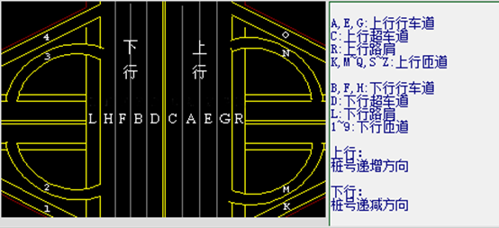
车道编码

附表：编码转换对照表
序号 |  | 原有路线编码 |  | 转换后编码 |  | 序号 | 原有路线编码 |  | 转换后编码 |  | 序号 | 原有路线编码 |  | 转换后编码
1 |  | G025 |  | G025 |  | 41 | G20 |  | GA20 |  | 81 | G36 |  | GA36
2 |  | G045 |  | G045 |  | 42 | G22 |  | GA22 |  | 82 | G301 |  | G301
3 |  | G055 |  | G055 |  | 43 | G25 |  | GA25 |  | 83 | G302 |  | G302
4 |  | G0102 |  | G01D |  | 44 | G201 |  | G201 |  | 84 | G303 |  | G303
5 |  | G0401 |  | G04C |  | 45 | G202 |  | G202 |  | 85 | G304 |  | G304
6 |  | G0601 |  | G06C |  | 46 | G203 |  | G203 |  | 86 | G305 |  | G305
7 |  | G1 |  | GA01 |  | 47 | G204 |  | G204 |  | 87 | G306 |  | G306
8 |  | G10 |  | GA10 |  | 48 | G205 |  | G205 |  | 88 | G307 |  | G307
9 |  | G11 |  | GA11 |  | 49 | G206 |  | G206 |  | 89 | G308 |  | G308
10 |  | G12 |  | GA12 |  | 50 | G207 |  | G207 |  | 90 | G309 |  | G309
11 |  | G15 |  | GA15 |  | 51 | G208 |  | G208 |  | 91 | G310 |  | G310
12 |  | G16 |  | GA16 |  | 52 | G209 |  | G209 |  | 92 | G311 |  | G311
13 |  | G18 |  | GA18 |  | 53 | G210 |  | G210 |  | 93 | G312 |  | G312
14 |  | G101 |  | G101 |  | 54 | G211 |  | G211 |  | 94 | G314 |  | G314
15 |  | G102 |  | G102 |  | 55 | G212 |  | G212 |  | 95 | G315 |  | G315
16 |  | G103 |  | G103 |  | 56 | G213 |  | G213 |  | 96 | G316 |  | G316
17 |  | G104 |  | G104 |  | 57 | G214 |  | G214 |  | 97 | G317 |  | G317
18 |  | G105 |  | G105 |  | 58 | G215 |  | G215 |  | 98 | G318 |  | G318
19 |  | G106 |  | G106 |  | 59 | G216 |  | G216 |  | 99 | G319 |  | G319
20 |  | G107 |  | G107 |  | 60 | G217 |  | G217 |  | 100 | G320 |  | G320
21 |  | G108 |  | G108 |  | 61 | G218 |  | G218 |  | 101 | G321 |  | G321
22 |  | G109 |  | G109 |  | 62 | G219 |  | G219 |  | 102 | G322 |  | G322
23 |  | G110 |  | G110 |  | 63 | G220 |  | G220 |  | 103 | G323 |  | G323
24 |  | G111 |  | G111 |  | 64 | G221 |  | G221 |  | 104 | G324 |  | G324
25 |  | G112 |  | G112 |  | 65 | G222 |  | G222 |  | 105 | G325 |  | G325
26 |  | G15W |  | G15W |  | 66 | G223 |  | G223 |  | 106 | G326 |  | G326
27 |  | G1001 |  | G10C |  | 67 | G224 |  | G224 |  | 107 | G327 |  | G327
28 |  | G1011 |  | G10H |  | 68 | G225 |  | G225 |  | 108 | G328 |  | G328
29 |  | G1111 |  | G11H |  | 69 | G227 |  | G227 |  | 109 | G329 |  | G329
30 |  | G1112 |  | G11I |  | 70 | G2001 |  | G20C |  | 110 | G330 |  | G330
31 |  | G1113 |  | G11J |  | 71 | G2011 |  | G20H |  | 111 | G3001 |  | G30C
32 |  | G1211 |  | G12H |  | 72 | G2012 |  | G20I |  | 112 | G3012 |  | G30I
33 |  | G1212 |  | G12I |  | 73 | G2201 |  | G22C |  | 113 | G3016 |  | G30M
34 |  | G1501 |  | G15C |  | 74 | G2501 |  | G25C |  | 114 | G4 |  | GA04
35 |  | G1511 |  | G15H |  | 75 | G2511 |  | G25H |  | 115 | G40 |  | GA40
36 |  | G1512 |  | G15I |  | 76 | G2512 |  | G25I |  | 116 | G42 |  | GA42
37 |  | G1513 |  | G15J |  | 77 | G2513 |  | G25J |  | 117 | G45 |  | GA45
38 |  | G1514 |  | G15K |  | 78 | G3 |  | GA03 |  | 118 | G4W |  | GA4W
39 |  | G1811 |  | G18H |  | 79 | G30 |  | GA30 |  | 119 | G42A |  | G42A
40 |  | G2 |  | GA02 |  | 80 | G35 |  | GA35 |  | 120 | G42B |  | G42B
序号 |  | 原有路线编码 |  | 转换后编码 |  | 序号 | 原有路线编码 |  | 转换后编码 |  | 序号 | 原有路线编码 |  | 转换后编码
121 |  | G4001 |  | G40C |  | 161 | G92 |  | GA92 |  | 201 | S038 |  | S038
122 |  | G4011 |  | G40H |  | 162 | G93 |  | GA93 |  | 202 | S039 |  | S039
123 |  | G4201 |  | G42C |  | 163 | G94 |  | GA94 |  | 203 | S040 |  | S040
124 |  | G4211 |  | G42H |  | 164 | G98 |  | GA98 |  | 204 | S041 |  | S041
125 |  | G4212 |  | G42I |  | 165 | G9211 |  | G92H |  | 205 | S042 |  | S042
126 |  | G4501 |  | G45C |  | 166 | G9411 |  | G94H |  | 206 | S043 |  | S043
127 |  | G4511 |  | G45H |  | 167 | GD11 |  | GD11 |  | 207 | S044 |  | S044
128 |  | G5 |  | GA05 |  | 168 | GF19 |  | GF19 |  | 208 | S045 |  | S045
129 |  | G50 |  | GA50 |  | 169 | GF21 |  | GF21 |  | 209 | S053 |  | S053
130 |  | G55 |  | GA55 |  | 170 | S01 |  | SA01 |  | 210 | S081 |  | S081
131 |  | G56 |  | GA56 |  | 171 | S04 |  | SA04 |  | 211 | S0105 |  | S01F
132 |  | G5001 |  | G50C |  | 172 | S06 |  | SA06 |  | 212 | S0311 |  | S03H
133 |  | G5011 |  | G50H |  | 173 | S001 |  | S001 |  | 213 | S0411 |  | S04H
134 |  | G5501 |  | G55C |  | 174 | S002 |  | S002 |  | 214 | S1 |  | SA01
135 |  | G5503 |  | G55E |  | 175 | S003 |  | S003 |  | 215 | S10 |  | SA10
136 |  | G5512 |  | G55I |  | 176 | S004 |  | S004 |  | 216 | S11 |  | SA11
137 |  | G5513 |  | G55J |  | 177 | S006 |  | S006 |  | 217 | S12 |  | SA12
138 |  | G5601 |  | G56C |  | 178 | S008 |  | S008 |  | 218 | S13 |  | SA13
139 |  | G6 |  | GA06 |  | 179 | S009 |  | S009 |  | 219 | S14 |  | SA14
140 |  | G60 |  | GA60 |  | 180 | S010 |  | S010 |  | 220 | S15 |  | SA15
141 |  | G65 |  | GA65 |  | 181 | S012 |  | S012 |  | 221 | S16 |  | SA16
142 |  | G65A |  | G65A |  | 182 | S013 |  | S013 |  | 222 | S17 |  | SA17
143 |  | G6001 |  | G60C |  | 183 | S014 |  | S014 |  | 223 | S18 |  | SA18
144 |  | G7 |  | GA07 |  | 184 | S020 |  | S020 |  | 224 | S19 |  | SA19
145 |  | G70 |  | GA70 |  | 185 | S021 |  | S021 |  | 225 | S100 |  | S100
146 |  | G72 |  | GA72 |  | 186 | S022 |  | S022 |  | 226 | S101 |  | S101
147 |  | G75 |  | GA75 |  | 187 | S023 |  | S023 |  | 227 | S102 |  | S102
148 |  | G76 |  | GA76 |  | 188 | S024 |  | S024 |  | 228 | S103 |  | S103
149 |  | G78 |  | GA78 |  | 189 | S026 |  | S026 |  | 229 | S104 |  | S104
150 |  | G75A |  | G75A |  | 190 | S027 |  | S027 |  | 230 | S105 |  | S105
151 |  | G75B |  | G75B |  | 191 | S028 |  | S028 |  | 231 | S106 |  | S106
152 |  | G7011 |  | G70H |  | 192 | S029 |  | S029 |  | 232 | S107 |  | S107
153 |  | G7201 |  | G72C |  | 193 | S030 |  | S030 |  | 233 | S108 |  | S108
154 |  | G7211 |  | G72H |  | 194 | S031 |  | S031 |  | 234 | S109 |  | S109
155 |  | G7511 |  | G75H |  | 195 | S032 |  | S032 |  | 235 | S110 |  | S110
156 |  | G80 |  | GA80 |  | 196 | S033 |  | S033 |  | 236 | S111 |  | S111
157 |  | G85 |  | GA85 |  | 197 | S034 |  | S034 |  | 237 | S112 |  | S112
158 |  | G8011 |  | G80H |  | 198 | S035 |  | S035 |  | 238 | S113 |  | S113
159 |  | G8511 |  | G85H |  | 199 | S036 |  | S036 |  | 239 | S114 |  | S114
160 |  | G91 |  | GA91 |  | 200 | S037 |  | S037 |  | 240 | S115 |  | S115
序号 |  | 原有路线编码 |  | 转换后编码 |  | 序号 | 原有路线编码 |  | 转换后编码 |  | 序号 | 原有路线编码 |  | 转换后编码
241 |  | S116 |  | S116 |  | 281 | S207 |  | S207 |  | 321 | S247 |  | S247
242 |  | S117 |  | S117 |  | 282 | S208 |  | S208 |  | 322 | S248 |  | S248
243 |  | S118 |  | S118 |  | 283 | S209 |  | S209 |  | 323 | S249 |  | S249
244 |  | S119 |  | S119 |  | 284 | S210 |  | S210 |  | 324 | S250 |  | S250
245 |  | S120 |  | S120 |  | 285 | S211 |  | S211 |  | 325 | S251 |  | S251
246 |  | S121 |  | S121 |  | 286 | S212 |  | S212 |  | 326 | S252 |  | S252
247 |  | S122 |  | S122 |  | 287 | S213 |  | S213 |  | 327 | S253 |  | S253
248 |  | S123 |  | S123 |  | 288 | S214 |  | S214 |  | 328 | S254 |  | S254
249 |  | S124 |  | S124 |  | 289 | S215 |  | S215 |  | 329 | S255 |  | S255
250 |  | S125 |  | S125 |  | 290 | S216 |  | S216 |  | 330 | S256 |  | S256
251 |  | S126 |  | S126 |  | 291 | S217 |  | S217 |  | 331 | S257 |  | S257
252 |  | S127 |  | S127 |  | 292 | S218 |  | S218 |  | 332 | S258 |  | S258
253 |  | S128 |  | S128 |  | 293 | S219 |  | S219 |  | 333 | S259 |  | S259
254 |  | S166 |  | S166 |  | 294 | S220 |  | S220 |  | 334 | S260 |  | S260
255 |  | S1001 |  | S10C |  | 295 | S221 |  | S221 |  | 335 | S261 |  | S261
256 |  | S1201 |  | S12C |  | 296 | S222 |  | S222 |  | 336 | S262 |  | S262
257 |  | S1202 |  | S12D |  | 297 | S223 |  | S223 |  | 337 | S263 |  | S263
258 |  | S1203 |  | S12E |  | 298 | S224 |  | S224 |  | 338 | S264 |  | S264
259 |  | S1521 |  | S15N |  | 299 | S225 |  | S225 |  | 339 | S265 |  | S265
260 |  | S1522 |  | S15P |  | 300 | S226 |  | S226 |  | 340 | S266 |  | S266
261 |  | S1531 |  | S15Q |  | 301 | S227 |  | S227 |  | 341 | S267 |  | S267
262 |  | S1551 |  | S15R |  | 302 | S228 |  | S228 |  | 342 | S268 |  | S268
263 |  | S1801 |  | S18C |  | 303 | S229 |  | S229 |  | 343 | S269 |  | S269
264 |  | S2 |  | SA02 |  | 304 | S230 |  | S230 |  | 344 | S270 |  | S270
265 |  | S20 |  | SA20 |  | 305 | S231 |  | S231 |  | 345 | S271 |  | S271
266 |  | S21 |  | SA21 |  | 306 | S232 |  | S232 |  | 346 | S272 |  | S272
267 |  | S22 |  | SA22 |  | 307 | S233 |  | S233 |  | 347 | S273 |  | S273
268 |  | S23 |  | SA23 |  | 308 | S234 |  | S234 |  | 348 | S274 |  | S274
269 |  | S24 |  | SA24 |  | 309 | S235 |  | S235 |  | 349 | S275 |  | S275
270 |  | S25 |  | SA25 |  | 310 | S236 |  | S236 |  | 350 | S276 |  | S276
271 |  | S26 |  | SA26 |  | 311 | S237 |  | S237 |  | 351 | S277 |  | S277
272 |  | S27 |  | SA27 |  | 312 | S238 |  | S238 |  | 352 | S278 |  | S278
273 |  | S28 |  | SA28 |  | 313 | S239 |  | S239 |  | 353 | S279 |  | S279
274 |  | S29 |  | SA29 |  | 314 | S240 |  | S240 |  | 354 | S280 |  | S280
275 |  | S201 |  | S201 |  | 315 | S241 |  | S241 |  | 355 | S281 |  | S281
276 |  | S202 |  | S202 |  | 316 | S242 |  | S242 |  | 356 | S282 |  | S282
277 |  | S203 |  | S203 |  | 317 | S243 |  | S243 |  | 357 | S283 |  | S283
278 |  | S204 |  | S204 |  | 318 | S244 |  | S244 |  | 358 | S284 |  | S284
279 |  | S205 |  | S205 |  | 319 | S245 |  | S245 |  | 359 | S285 |  | S285
280 |  | S206 |  | S206 |  | 320 | S246 |  | S246 |  | 360 | S286 |  | S286
序号 |  | 原有路线编码 |  | 转换后编码 |  | 序号 | 原有路线编码 |  | 转换后编码 |  | 序号 | 原有路线编码 |  | 转换后编码
361 |  | S287 |  | S287 |  | 401 | S316 |  | S316 |  | 441 | S356 |  | S356
362 |  | S288 |  | S288 |  | 402 | S317 |  | S317 |  | 442 | S357 |  | S357
363 |  | S289 |  | S289 |  | 403 | S318 |  | S318 |  | 443 | S358 |  | S358
364 |  | S290 |  | S290 |  | 404 | S319 |  | S319 |  | 444 | S359 |  | S359
365 |  | S291 |  | S291 |  | 405 | S320 |  | S320 |  | 445 | S360 |  | S360
366 |  | S292 |  | S292 |  | 406 | S321 |  | S321 |  | 446 | S361 |  | S361
367 |  | S293 |  | S293 |  | 407 | S322 |  | S322 |  | 447 | S362 |  | S362
368 |  | S294 |  | S294 |  | 408 | S323 |  | S323 |  | 448 | S363 |  | S363
369 |  | S296 |  | S296 |  | 409 | S324 |  | S324 |  | 449 | S364 |  | S364
370 |  | S297 |  | S297 |  | 410 | S325 |  | S325 |  | 450 | S365 |  | S365
371 |  | S298 |  | S298 |  | 411 | S326 |  | S326 |  | 451 | S366 |  | S366
372 |  | S299 |  | S299 |  | 412 | S327 |  | S327 |  | 452 | S367 |  | S367
373 |  | S2401 |  | S24C |  | 413 | S328 |  | S328 |  | 453 | S368 |  | S368
374 |  | S2511 |  | S25H |  | 414 | S329 |  | S329 |  | 454 | S369 |  | S369
375 |  | S2611 |  | S26H |  | 415 | S330 |  | S330 |  | 455 | S370 |  | S370
376 |  | S2612 |  | S26I |  | 416 | S331 |  | S331 |  | 456 | S371 |  | S371
377 |  | S3 |  | SA03 |  | 417 | S332 |  | S332 |  | 457 | S372 |  | S372
378 |  | S30 |  | SA30 |  | 418 | S333 |  | S333 |  | 458 | S373 |  | S373
379 |  | S31 |  | SA31 |  | 419 | S334 |  | S334 |  | 459 | S374 |  | S374
380 |  | S32 |  | SA32 |  | 420 | S335 |  | S335 |  | 460 | S375 |  | S375
381 |  | S33 |  | SA33 |  | 421 | S336 |  | S336 |  | 461 | S376 |  | S376
382 |  | S35 |  | SA35 |  | 422 | S337 |  | S337 |  | 462 | S377 |  | S377
383 |  | S36 |  | SA36 |  | 423 | S338 |  | S338 |  | 463 | S378 |  | S378
384 |  | S38 |  | SA38 |  | 424 | S339 |  | S339 |  | 464 | S379 |  | S379
385 |  | S39 |  | SA39 |  | 425 | S340 |  | S340 |  | 465 | S380 |  | S380
386 |  | S301 |  | S301 |  | 426 | S341 |  | S341 |  | 466 | S381 |  | S381
387 |  | S302 |  | S302 |  | 427 | S342 |  | S342 |  | 467 | S382 |  | S382
388 |  | S303 |  | S303 |  | 428 | S343 |  | S343 |  | 468 | S383 |  | S383
389 |  | S304 |  | S304 |  | 429 | S344 |  | S344 |  | 469 | S384 |  | S384
390 |  | S305 |  | S305 |  | 430 | S345 |  | S345 |  | 470 | S385 |  | S385
391 |  | S306 |  | S306 |  | 431 | S346 |  | S346 |  | 471 | S386 |  | S386
392 |  | S307 |  | S307 |  | 432 | S347 |  | S347 |  | 472 | S387 |  | S387
393 |  | S308 |  | S308 |  | 433 | S348 |  | S348 |  | 473 | S388 |  | S388
394 |  | S309 |  | S309 |  | 434 | S349 |  | S349 |  | 474 | S389 |  | S389
395 |  | S310 |  | S310 |  | 435 | S350 |  | S350 |  | 475 | S390 |  | S390
396 |  | S311 |  | S311 |  | 436 | S351 |  | S351 |  | 476 | S391 |  | S391
397 |  | S312 |  | S312 |  | 437 | S352 |  | S352 |  | 477 | S392 |  | S392
398 |  | S313 |  | S313 |  | 438 | S353 |  | S353 |  | 478 | S393 |  | S393
399 |  | S314 |  | S314 |  | 439 | S354 |  | S354 |  | 479 | S394 |  | S394
400 |  | S315 |  | S315 |  | 440 | S355 |  | S355 |  | 480 | S395 |  | S395
序号 |  | 原有路线编码 |  | 转换后编码 |  | 序号 | 原有路线编码 |  | 转换后编码 |  | 序号 | 原有路线编码 |  | 转换后编码
481 |  | S396 |  | S396 |  | 521 | S456 |  | S456 |  | 561 | S496 |  | S496
482 |  | S397 |  | S397 |  | 522 | S457 |  | S457 |  | 562 | S497 |  | S497
483 |  | S398 |  | S398 |  | 523 | S458 |  | S458 |  | 563 | S498 |  | S498
484 |  | S399 |  | S399 |  | 524 | S459 |  | S459 |  | 564 | S499 |  | S499
485 |  | S3011 |  | S30H |  | 525 | S460 |  | S460 |  | 565 | S4503 |  | S45E
486 |  | S3012 |  | S30I |  | 526 | S461 |  | S461 |  | 566 | S4509 |  | S45G
487 |  | S3015 |  | S30L |  | 527 | S462 |  | S462 |  | 567 | S5 |  | SA05
488 |  | S4 |  | SA04 |  | 528 | S463 |  | S463 |  | 568 | S50 |  | SA50
489 |  | S40 |  | SA40 |  | 529 | S464 |  | S464 |  | 569 | S51 |  | SA51
490 |  | S41 |  | SA41 |  | 530 | S465 |  | S465 |  | 570 | S52 |  | SA52
491 |  | S43 |  | SA43 |  | 531 | S466 |  | S466 |  | 571 | S55 |  | SA55
492 |  | S45 |  | SA45 |  | 532 | S467 |  | S467 |  | 572 | S58 |  | SA58
493 |  | S46 |  | SA46 |  | 533 | S468 |  | S468 |  | 573 | S59 |  | SA59
494 |  | S47 |  | SA47 |  | 534 | S469 |  | S469 |  | 574 | S501 |  | S501
495 |  | S48 |  | SA48 |  | 535 | S470 |  | S470 |  | 575 | S502 |  | S502
496 |  | S49 |  | SA49 |  | 536 | S471 |  | S471 |  | 576 | S504 |  | S504
497 |  | S4W |  | SA4W |  | 537 | S472 |  | S472 |  | 577 | S505 |  | S505
498 |  | S400 |  | S400 |  | 538 | S473 |  | S473 |  | 578 | S506 |  | S506
499 |  | S401 |  | S401 |  | 539 | S474 |  | S474 |  | 579 | S507 |  | S507
500 |  | S402 |  | S402 |  | 540 | S475 |  | S475 |  | 580 | S508 |  | S508
501 |  | S403 |  | S403 |  | 541 | S476 |  | S476 |  | 581 | S509 |  | S509
502 |  | S404 |  | S404 |  | 542 | S477 |  | S477 |  | 582 | S510 |  | S510
503 |  | S406 |  | S406 |  | 543 | S478 |  | S478 |  | 583 | S511 |  | S511
504 |  | S407 |  | S407 |  | 544 | S479 |  | S479 |  | 584 | S512 |  | S512
505 |  | S408 |  | S408 |  | 545 | S480 |  | S480 |  | 585 | S513 |  | S513
506 |  | S409 |  | S409 |  | 546 | S481 |  | S481 |  | 586 | S514 |  | S514
507 |  | S410 |  | S410 |  | 547 | S482 |  | S482 |  | 587 | S515 |  | S515
508 |  | S411 |  | S411 |  | 548 | S483 |  | S483 |  | 588 | S516 |  | S516
509 |  | S412 |  | S412 |  | 549 | S484 |  | S484 |  | 589 | S517 |  | S517
510 |  | S413 |  | S413 |  | 550 | S485 |  | S485 |  | 590 | S518 |  | S518
511 |  | S414 |  | S414 |  | 551 | S486 |  | S486 |  | 591 | S519 |  | S519
512 |  | S415 |  | S415 |  | 552 | S487 |  | S487 |  | 592 | S520 |  | S520
513 |  | S416 |  | S416 |  | 553 | S488 |  | S488 |  | 593 | S521 |  | S521
514 |  | S417 |  | S417 |  | 554 | S489 |  | S489 |  | 594 | S523 |  | S523
515 |  | S450 |  | S450 |  | 555 | S490 |  | S490 |  | 595 | S524 |  | S524
516 |  | S451 |  | S451 |  | 556 | S491 |  | S491 |  | 596 | S525 |  | S525
517 |  | S452 |  | S452 |  | 557 | S492 |  | S492 |  | 597 | S526 |  | S526
518 |  | S453 |  | S453 |  | 558 | S493 |  | S493 |  | 598 | S527 |  | S527
519 |  | S454 |  | S454 |  | 559 | S494 |  | S494 |  | 599 | S528 |  | S528
520 |  | S455 |  | S455 |  | 560 | S495 |  | S495 |  | 600 | S529 |  | S529
序号 |  | 原有路线编码 |  | 转换后编码 |  | 序号 | 原有路线编码 |  | 转换后编码 |  | 序号 | 原有路线编码 |  | 转换后编码
601 |  | S530 |  | S530 |  | 641 | S577 |  | S577 |  | 681 | S610 |  | S610
602 |  | S531 |  | S531 |  | 642 | S578 |  | S578 |  | 682 | S611 |  | S611
603 |  | S532 |  | S532 |  | 643 | S579 |  | S579 |  | 683 | S612 |  | S612
604 |  | S533 |  | S533 |  | 644 | S580 |  | S580 |  | 684 | S613 |  | S613
605 |  | S534 |  | S534 |  | 645 | S581 |  | S581 |  | 685 | S614 |  | S614
606 |  | S535 |  | S535 |  | 646 | S582 |  | S582 |  | 686 | S615 |  | S615
607 |  | S536 |  | S536 |  | 647 | S583 |  | S583 |  | 687 | S616 |  | S616
608 |  | S537 |  | S537 |  | 648 | S584 |  | S584 |  | 688 | S621 |  | S621
609 |  | S538 |  | S538 |  | 649 | S585 |  | S585 |  | 689 | S622 |  | S622
610 |  | S539 |  | S539 |  | 650 | S586 |  | S586 |  | 690 | S623 |  | S623
611 |  | S540 |  | S540 |  | 651 | S587 |  | S587 |  | 691 | S624 |  | S624
612 |  | S541 |  | S541 |  | 652 | S588 |  | S588 |  | 692 | S626 |  | S626
613 |  | S542 |  | S542 |  | 653 | S589 |  | S589 |  | 693 | S627 |  | S627
614 |  | S543 |  | S543 |  | 654 | S590 |  | S590 |  | 694 | S631 |  | S631
615 |  | S544 |  | S544 |  | 655 | S591 |  | S591 |  | 695 | S632 |  | S632
616 |  | S545 |  | S545 |  | 656 | S592 |  | S592 |  | 696 | S633 |  | S633
617 |  | S546 |  | S546 |  | 657 | S593 |  | S593 |  | 697 | S634 |  | S634
618 |  | S547 |  | S547 |  | 658 | S594 |  | S594 |  | 698 | S635 |  | S635
619 |  | S548 |  | S548 |  | 659 | S595 |  | S595 |  | 699 | S636 |  | S636
620 |  | S549 |  | S549 |  | 660 | S596 |  | S596 |  | 700 | S637 |  | S637
621 |  | S550 |  | S550 |  | 661 | S597 |  | S597 |  | 701 | S638 |  | S638
622 |  | S551 |  | S551 |  | 662 | S598 |  | S598 |  | 702 | S639 |  | S639
623 |  | S552 |  | S552 |  | 663 | S599 |  | S599 |  | 703 | S640 |  | S640
624 |  | S553 |  | S553 |  | 664 | S6 |  | SA06 |  | 704 | S641 |  | S641
625 |  | S554 |  | S554 |  | 665 | S60 |  | SA60 |  | 705 | S642 |  | S642
626 |  | S558 |  | S558 |  | 666 | S61 |  | SA61 |  | 706 | S643 |  | S643
627 |  | S559 |  | S559 |  | 667 | S65 |  | SA65 |  | 707 | S644 |  | S644
628 |  | S560 |  | S560 |  | 668 | S66 |  | SA66 |  | 708 | S645 |  | S645
629 |  | S561 |  | S561 |  | 669 | S68 |  | SA68 |  | 709 | S647 |  | S647
630 |  | S562 |  | S562 |  | 670 | S69 |  | SA69 |  | 710 | S648 |  | S648
631 |  | S563 |  | S563 |  | 671 | S600 |  | S600 |  | 711 | S649 |  | S649
632 |  | S564 |  | S564 |  | 672 | S601 |  | S601 |  | 712 | S650 |  | S650
633 |  | S569 |  | S569 |  | 673 | S602 |  | S602 |  | 713 | S651 |  | S651
634 |  | S570 |  | S570 |  | 674 | S603 |  | S603 |  | 714 | S652 |  | S652
635 |  | S571 |  | S571 |  | 675 | S604 |  | S604 |  | 715 | S653 |  | S653
636 |  | S572 |  | S572 |  | 676 | S605 |  | S605 |  | 716 | S655 |  | S655
637 |  | S573 |  | S573 |  | 677 | S606 |  | S606 |  | 717 | S6501 |  | S65C
638 |  | S574 |  | S574 |  | 678 | S607 |  | S607 |  | 718 | S6502 |  | S65D
639 |  | S575 |  | S575 |  | 679 | S608 |  | S608 |  | 719 | S6511 |  | S65H
640 |  | S576 |  | S576 |  | 680 | S609 |  | S609 |  | 720 | S7 |  | SA07
序号 |  | 原有路线编码 |  | 转换后编码 |  | 序号 | 原有路线编码 |  | 转换后编码 |  | 序号 | 原有路线编码 |  | 转换后编码
721 |  | S75 |  | SA75 |  | 761 | S745 |  | S745 |  | 801 | S8 |  | SA08
722 |  | S79 |  | SA79 |  | 762 | S746 |  | S746 |  | 802 | S80 |  | SA80
723 |  | S700 |  | S700 |  | 763 | S747 |  | S747 |  | 803 | S81 |  | SA81
724 |  | S701 |  | S701 |  | 764 | S749 |  | S749 |  | 804 | S82 |  | SA82
725 |  | S702 |  | S702 |  | 765 | S750 |  | S750 |  | 805 | S83 |  | SA83
726 |  | S703 |  | S703 |  | 766 | S751 |  | S751 |  | 806 | S84 |  | SA84
727 |  | S704 |  | S704 |  | 767 | S752 |  | S752 |  | 807 | S85 |  | SA85
728 |  | S705 |  | S705 |  | 768 | S753 |  | S753 |  | 808 | S86 |  | SA86
729 |  | S706 |  | S706 |  | 769 | S755 |  | S755 |  | 809 | S87 |  | SA87
730 |  | S707 |  | S707 |  | 770 | S756 |  | S756 |  | 810 | S88 |  | SA88
731 |  | S708 |  | S708 |  | 771 | S757 |  | S757 |  | 811 | S800 |  | S800
732 |  | S709 |  | S709 |  | 772 | S758 |  | S758 |  | 812 | S801 |  | S801
733 |  | S710 |  | S710 |  | 773 | S759 |  | S759 |  | 813 | S802 |  | S802
734 |  | S712 |  | S712 |  | 774 | S760 |  | S760 |  | 814 | S803 |  | S803
735 |  | S713 |  | S713 |  | 775 | S761 |  | S761 |  | 815 | S804 |  | S804
736 |  | S714 |  | S714 |  | 776 | S762 |  | S762 |  | 816 | S805 |  | S805
737 |  | S715 |  | S715 |  | 777 | S763 |  | S763 |  | 817 | S806 |  | S806
738 |  | S717 |  | S717 |  | 778 | S764 |  | S764 |  | 818 | S807 |  | S807
739 |  | S718 |  | S718 |  | 779 | S765 |  | S765 |  | 819 | S808 |  | S808
740 |  | S720 |  | S720 |  | 780 | S771 |  | S771 |  | 820 | S809 |  | S809
741 |  | S721 |  | S721 |  | 781 | S772 |  | S772 |  | 821 | S810 |  | S810
742 |  | S722 |  | S722 |  | 782 | S773 |  | S773 |  | 822 | S811 |  | S811
743 |  | S723 |  | S723 |  | 783 | S774 |  | S774 |  | 823 | S812 |  | S812
744 |  | S724 |  | S724 |  | 784 | S781 |  | S781 |  | 824 | S813 |  | S813
745 |  | S725 |  | S725 |  | 785 | S782 |  | S782 |  | 825 | S814 |  | S814
746 |  | S729 |  | S729 |  | 786 | S783 |  | S783 |  | 826 | S815 |  | S815
747 |  | S730 |  | S730 |  | 787 | S784 |  | S784 |  | 827 | S816 |  | S816
748 |  | S731 |  | S731 |  | 788 | S791 |  | S791 |  | 828 | S817 |  | S817
749 |  | S732 |  | S732 |  | 789 | S792 |  | S792 |  | 829 | S818 |  | S818
750 |  | S733 |  | S733 |  | 790 | S793 |  | S793 |  | 830 | S819 |  | S819
751 |  | S734 |  | S734 |  | 791 | S794 |  | S794 |  | 831 | S820 |  | S820
752 |  | S736 |  | S736 |  | 792 | S7201 |  | S72C |  | 832 | S821 |  | S821
753 |  | S737 |  | S737 |  | 793 | S7212 |  | S72I |  | 833 | S822 |  | S822
754 |  | S738 |  | S738 |  | 794 | S7402 |  | S74D |  | 834 | S823 |  | S823
755 |  | S739 |  | S739 |  | 795 | S7501 |  | S75C |  | 835 | S824 |  | S824
756 |  | S740 |  | S740 |  | 796 | S7512 |  | S75I |  | 836 | S825 |  | S825
757 |  | S741 |  | S741 |  | 797 | S7601 |  | S76C |  | 837 | S826 |  | S826
758 |  | S742 |  | S742 |  | 798 | S7602 |  | S76D |  | 838 | S827 |  | S827
759 |  | S743 |  | S743 |  | 799 | S7603 |  | S76E |  | 839 | S828 |  | S828
760 |  | S744 |  | S744 |  | 800 | S7801 |  | S78C |  | 840 | S829 |  | S829
序号 |  | 原有路线编码 |  | 转换后编码 |  | 序号 | 原有路线编码 |  | 转换后编码 |  | 序号 | 原有路线编码 |  | 转换后编码
841 |  | S830 |  | S830 |  | 881 | S870 |  | S870 |  | 921 | S905 |  | S905
842 |  | S831 |  | S831 |  | 882 | S871 |  | S871 |  | 922 | S906 |  | S906
843 |  | S832 |  | S832 |  | 883 | S872 |  | S872 |  | 923 | S907 |  | S907
844 |  | S833 |  | S833 |  | 884 | S873 |  | S873 |  | 924 | S908 |  | S908
845 |  | S834 |  | S834 |  | 885 | S874 |  | S874 |  | 925 | S909 |  | S909
846 |  | S835 |  | S835 |  | 886 | S875 |  | S875 |  | 926 | S910 |  | S910
847 |  | S836 |  | S836 |  | 887 | S876 |  | S876 |  | 927 | S911 |  | S911
848 |  | S837 |  | S837 |  | 888 | S877 |  | S877 |  | 928 | S912 |  | S912
849 |  | S838 |  | S838 |  | 889 | S878 |  | S878 |  | 929 | S913 |  | S913
850 |  | S839 |  | S839 |  | 890 | S879 |  | S879 |  | 930 | S914 |  | S914
851 |  | S840 |  | S840 |  | 891 | S880 |  | S880 |  | 931 | S915 |  | S915
852 |  | S841 |  | S841 |  | 892 | S881 |  | S881 |  | 932 | S916 |  | S916
853 |  | S842 |  | S842 |  | 893 | S882 |  | S882 |  | 933 | S917 |  | S917
854 |  | S843 |  | S843 |  | 894 | S883 |  | S883 |  | 934 | S918 |  | S918
855 |  | S844 |  | S844 |  | 895 | S885 |  | S885 |  | 935 | S919 |  | S919
856 |  | S845 |  | S845 |  | 896 | S886 |  | S886 |  | 936 | S920 |  | S920
857 |  | S846 |  | S846 |  | 897 | S888 |  | S888 |  | 937 | S921 |  | S921
858 |  | S847 |  | S847 |  | 898 | S890 |  | S890 |  | 938 | S922 |  | S922
859 |  | S848 |  | S848 |  | 899 | S891 |  | S891 |  | 939 | S923 |  | S923
860 |  | S849 |  | S849 |  | 900 | S892 |  | S892 |  | 940 | S924 |  | S924
861 |  | S850 |  | S850 |  | 901 | S893 |  | S893 |  | 941 | S925 |  | S925
862 |  | S851 |  | S851 |  | 902 | S894 |  | S894 |  | 942 | S926 |  | S926
863 |  | S852 |  | S852 |  | 903 | S895 |  | S895 |  | 943 | S927 |  | S927
864 |  | S853 |  | S853 |  | 904 | S896 |  | S896 |  | 944 | S928 |  | S928
865 |  | S854 |  | S854 |  | 905 | S898 |  | S898 |  | 945 | S929 |  | S929
866 |  | S855 |  | S855 |  | 906 | S899 |  | S899 |  | 946 | S930 |  | S930
867 |  | S856 |  | S856 |  | 907 | S8011 |  | S80H |  | 947 | S931 |  | S931
868 |  | S857 |  | S857 |  | 908 | S8012 |  | S80I |  | 948 | S932 |  | S932
869 |  | S858 |  | S858 |  | 909 | S8013 |  | S80J |  | 949 | S933 |  | S933
870 |  | S859 |  | S859 |  | 910 | S8211 |  | S82H |  | 950 | S934 |  | S934
871 |  | S860 |  | S860 |  | 911 | S8311 |  | S83H |  | 951 | S935 |  | S935
872 |  | S861 |  | S861 |  | 912 | S9 |  | SA09 |  | 952 | S936 |  | S936
873 |  | S862 |  | S862 |  | 913 | S91 |  | SA91 |  | 953 | S937 |  | S937
874 |  | S863 |  | S863 |  | 914 | S92 |  | SA92 |  | 954 | S938 |  | S938
875 |  | S864 |  | S864 |  | 915 | S96 |  | SA96 |  | 955 | S939 |  | S939
876 |  | S865 |  | S865 |  | 916 | S900 |  | S900 |  | 956 | S940 |  | S940
877 |  | S866 |  | S866 |  | 917 | S901 |  | S901 |  | 957 | S941 |  | S941
878 |  | S867 |  | S867 |  | 918 | S902 |  | S902 |  | 958 | S942 |  | S942
879 |  | S868 |  | S868 |  | 919 | S903 |  | S903 |  | 959 | S943 |  | S943
880 |  | S869 |  | S869 |  | 920 | S904 |  | S904 |  | 960 | S944 |  | S944
序号 | 原有路线编码 |  | 转换后编码 |  | 序号 |  |  | 原有路线编码 | 转换后编码 | 序号 |  |  | 原有路线编码 |  | 转换后编码
961 | S945 |  | S945 |  | 1000 |  |  | SL05 | SL05 | 1039 |  |  | SL53 |  | SL53
962 | S946 |  | S946 |  | 1001 |  |  | SL06 | SL06 | 1040 |  |  | SL55 |  | SL55
963 | S962 |  | S962 |  | 1002 |  |  | SL07 | SL07 | 1041 |  |  | SL56 |  | SL56
964 | S970 |  | S970 |  | 1003 |  |  | SL08 | SL08 | 1042 |  |  | SL57 |  | SL57
965 | S971 |  | S971 |  | 1004 |  |  | SL09 | SL09 | 1043 |  |  | SL58 |  | SL58
966 | S972 |  | S972 |  | 1005 |  |  | SL10 | SL10 | 1044 |  |  | SL59 |  | SL59
967 | S973 |  | S973 |  | 1006 |  |  | SL11 | SL11 | 1045 |  |  | SL60 |  | SL60
968 | S974 |  | S974 |  | 1007 |  |  | SL12 | SL12 | 1046 |  |  | SL61 |  | SL61
969 | S978 |  | S978 |  | 1008 |  |  | SL13 | SL13 | 1047 |  |  | SL62 |  | SL62
970 | S979 |  | S979 |  | 1009 |  |  | SL14 | SL14 | 1048 |  |  | SL63 |  | SL63
971 | S980 |  | S980 |  | 1010 |  |  | SL15 | SL15 | 1049 |  |  | SL64 |  | SL64
972 | S981 |  | S981 |  | 1011 |  |  | SL16 | SL16 | 1050 |  |  | SL65 |  | SL65
973 | S982 |  | S982 |  | 1012 |  |  | SL17 | SL17 | 1051 |  |  | SL66 |  | SL66
974 | S983 |  | S983 |  | 1013 |  |  | SL18 | SL18 | 1052 |  |  | SL67 |  | SL67
975 | S984 |  | S984 |  | 1014 |  |  | SL21 | SL21 | 1053 |  |  | SL68 |  | SL68
976 | S985 |  | S985 |  | 1015 |  |  | SL22 | SL22 | 1054 |  |  | SL69 |  | SL69
977 | S986 |  | S986 |  | 1016 |  |  | SL23 | SL23 | 1055 |  |  | SL70 |  | SL70
978 | S987 |  | S987 |  | 1017 |  |  | SL24 | SL24 | 1056 |  |  | SL71 |  | SL71
979 | S988 |  | S988 |  | 1018 |  |  | SL25 | SL25 | 1057 |  |  | SL72 |  | SL72
980 | S989 |  | S989 |  | 1019 |  |  | SL26 | SL26 | 1058 |  |  | SL73 |  | SL73
981 | S990 |  | S990 |  | 1020 |  |  | SL27 | SL27 | 1059 |  |  | SL74 |  | SL74
982 | S991 |  | S991 |  | 1021 |  |  | SL28 | SL28 | 1060 |  |  | SL75 |  | SL75
983 | S992 |  | S992 |  | 1022 |  |  | SL29 | SL29 | 1061 |  |  | SL76 |  | SL76
984 | S993 |  | S993 |  | 1023 |  |  | SL30 | SL30 | 1062 |  |  | SL77 |  | SL77
985 | S994 |  | S994 |  | 1024 |  |  | SL31 | SL31 | 1063 |  |  | SL78 |  | SL78
986 | S995 |  | S995 |  | 1025 |  |  | SL32 | SL32 | 1064 |  |  | SL79 |  | SL79
987 | S996 |  | S996 |  | 1026 |  |  | SL33 | SL33 | 1065 |  |  | SL80 |  | SL80
988 | S997 |  | S997 |  | 1027 |  |  | SL34 | SL34 | 1066 |  |  | SL81 |  | SL81
989 | S998 |  | S998 |  | 1028 |  |  | SL35 | SL35 | 1067 |  |  | SL82 |  | SL82
990 | SA56 |  | SA56 |  | 1029 |  |  | SL36 | SL36 | 1068 |  |  | SL83 |  | SL83
991 | SB06 |  | SB06 |  | 1030 |  |  | SL37 | SL37 | 1069 |  |  | SL84 |  | SL84
992 | SD23 |  | SD23 |  | 1031 |  |  | SL39 | SL39 | 1070 |  |  | SL85 |  | SL85
993 | SF13 |  | SF13 |  | 1032 |  |  | SL40 | SL40 | 1071 |  |  | SL86 |  | SL86
994 | SF31 |  | SF31 |  | 1033 |  |  | SL41 | SL41 | 1072 |  |  | SL87 |  | SL87
995 | SL00 |  | SL00 |  | 1034 |  |  | SL46 | SL46 | 1073 |  |  | SL88 |  | SL88
996 | SL01 |  | SL01 |  | 1035 |  |  | SL48 | SL48 | 1074 |  |  | SL89 |  | SL89
997 | SL02 |  | SL02 |  | 1036 |  |  | SL49 | SL49 | 1075 |  |  | SL90 |  | SL90
998 | SL03 |  | SL03 |  | 1037 |  |  | SL50 | SL50 | 1076 |  |  | SL91 |  | SL91
999 | SL04 |  | SL04 |  | 1038 |  |  | SL51 | SL51 | 1077 |  |  | SL92 |  | SL92

