Session 2025-2026(EVEN)

Vision: Dream of where you want. | Mission: Means to achieve Vision

Program Educational Objectives of the program (PEO): (broad statements that describe the professional and career accomplishments)
PEO1 | Preparation | P: Preparation | Pep-CL abbreviation  pronounce as Pep-si-lL easy to recall
PEO2 | Core Competence | E: Environment (Learning Environment) | Pep-CL abbreviation  pronounce as Pep-si-lL easy to recall
PEO3 | Breadth | P: Professionalism | Pep-CL abbreviation  pronounce as Pep-si-lL easy to recall
PEO4 | Professionalism | C: Core Competence | Pep-CL abbreviation  pronounce as Pep-si-lL easy to recall
PEO5 | Learning Environment | L: Breadth (Learning in diverse areas) | Pep-CL abbreviation  pronounce as Pep-si-lL easy to recall

Program Outcomes (PO): (statements that describe what a student should be able to do and know by the end of a program)
Keywords of POs:
Engineering knowledge, Problem analysis, Design/development of solutions, Conduct Investigations of Complex Problems, Engineering Tool Usage, The Engineer and The World, Ethics, Individual and Collaborative Team work, Communication, Project Management and Finance, Life-Long Learning

PSO Keywords: Cutting edge technologies, Research

“I am an engineer, and I know how to apply engineering knowledge to investigate, analyse and design solutions to complex problems using tools for entire world following all ethics in a collaborative way with proper management skills throughout my life.” to contribute to the development of cutting-edge technologies and Research.

Integrity: I will adhere to the Laboratory Code of Conduct and ethics in its entirety.

Name and Signature of Student and Date
(Signature and Date in Handwritten)

Session | 2024-25 (EVEN) |  | Course Name | Java Full Stack Development Lab
Semester | 4 |  | Course Code | 23ADS1407
Roll No | 123 |  | Name of Student | Srushtii Tadkule
Practical Number |  | 01
Course Outcome
Aim |  | WAP to demonstrate concept of Class, Object, and methods in java.
Problem Definition |  | To study and implement the basic concepts of Object-Oriented Programming in Java by creating a class, instantiating an object of that class, and using methods to perform operations on the data members of the class.
Theory  (100 words) |  | In Java, a class is a blueprint or template that defines the attributes (data members) and behaviors (methods) of an object. An object is an instance of a class that represents a real-world entity and can access the properties and methods defined in the class. Methods are blocks of code inside a class that perform specific tasks or operations, allowing objects to exhibit certain behaviors. By using classes, objects, and methods together, Java programs can be organized, reusable, and easier to maintain, forming the foundation of object-oriented programming.
Procedure and Execution  (100 Words) |  | Step for Implementation:  - Start the program.  - Define a class to represent an entity and declare the required data members inside the class.  - Create methods within the class to perform operations such as assigning values and displaying data.  - Define the main() method in another class or the same class as required.  - Create an object of the defined class using the new keyword.  - Call the methods of the class using the created object.  - Compile the program to check for syntax errors.  - Execute the program and observe the output.  - Stop the program.
Code:
class Addition {
int a, b;
void getData(int x, int y) {
a = x;
b = y;
}
void add() {
System.out.println("Addition = " + (a + b));
}
void subtract() {
System.out.println("Subtraction = " + (a - b));
}
void multiply() {
System.out.println("Multiplication = " + (a * b));
}
void divide() {
System.out.println("Division = " + (a / b));
}
}
public class Main {
public static void main(String[] args) {
Addition obj = new Addition();
obj.getData(14, 2);
obj.add();
obj.subtract();
obj.multiply();
obj.divide();
}
}

Output:
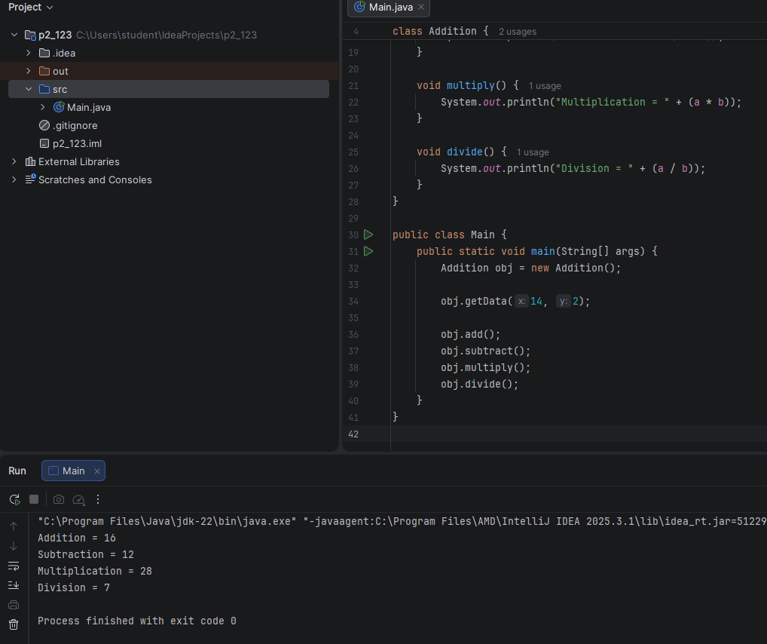
Output Analysis |  | - When the program is executed, the Java runtime first looks for the main() method as the starting point of execution.  - Inside main(), an object of the class is created using the new keyword. This object occupies memory and can access the data members and methods of the class.  - The program then calls a method (e.g., setData()) using the object to assign values to the data members of the class.  - Another method (e.g., displayData()) is called to print the values of the data members to the console.  - The output shows the actual data stored in the object, demonstrating that the object correctly encapsulates data and behavior defined in the class.  - This confirms the concepts of Class (blueprint), Object (instance), and Methods (behavior) in Java, as the object can manipulate and display its own data through methods.
Link of student Github profile where lab assignment has been uploaded
Conclusion |  | The practical demonstrates the basic concepts of class, object, and methods in Java. By defining a class, creating its object, and invoking methods, the program shows how data and behavior are combined in object-oriented programming. Understanding these concepts helps in developing structured, reusable, and efficient Java applications and forms the foundation for advanced OOP features such as inheritance, polymorphism, and abstraction.
Plag Report (Similarity index < 12%)
Date

Observation copy screenshot

