
Nagar Yuwak Shikshan Sanstha’s

Yeshwantrao Chavan College of Engineering (An Autonomous Institution affiliated to Rashtrasant Tukadoji Maharaj Nagpur University) Hingna Road, Wanadongri, Nagpur - 441 110
NAAC A++
Ph.: 07104-237919, 234623, 329249, 329250 Fax: 07104-232376, Website: www.ycce.edu Department of Computer Technology
Vision of the Department
To be a well-known centre for pursuing computer education through innovative pedagogy, value-based education and industry collaboration.
Mission of the Department
To establish learning ambience for ushering in computer engineering professionals in core and multidisciplinary area by developing Problem solving skills through emerging technologies.
Session 2025-2026
Vision: Dream of where you want. Mission: Means to achieve Vision
Program Educational Objectives of the program (PEO): (broad statements that describe the professional and career accomplishments)
PEO1 | Preparation | P: Preparation | Pep-CL abbreviationpronounce as Pep-si-lL  easy to recall  in
PEO2 | Core Competence | E: Environment  (Learning Environment)
PEO3 | Breadth | P: Professionalism
PEO4 | Professionalism | C: Core Competence
PEO5 | LearningEnvironment | L: Breadth (Learningdiverse areas)

Program Outcomes (PO): (statements that describe what a student should be able to do and knowby the end of a program)
Keywords of POs:
Engineering knowledge, Problem analysis, Design/development of solutions, Conduct Investigations of Complex Problems, Engineering Tool Usage, The Engineer and The World, Ethics, Individual and Collaborative Team work, Communication, Project Management and Finance, Life-Long Learning
PSO Keywords: Cutting edge technologies, Research
“I am an engineer, and I know how to apply engineering knowledge to investigate, analyse and design solutions to complex problems using tools for entire world following all ethics in a collaborative way with proper management skills throughout my life.” to contribute to the development of cutting-edge technologies and Research.
Integrity: I will adhere to the Laboratory Code of Conduct and ethics in its entirety.
Name and Signature of Student and Date
(Signature and Date in Handwritten)

Nagar Yuwak Shikshan Sanstha’s

Yeshwantrao Chavan College of Engineering (An Autonomous Institution affiliated to Rashtrasant Tukadoji Maharaj Nagpur University) Hingna Road, Wanadongri, Nagpur - 441 110
NAAC A++
Ph.: 07104-237919, 234623, 329249, 329250 Fax: 07104-232376, Website: www.ycce.edu Department of Computer Technology
Vision of the Department
To be a well-known centre for pursuing computer education through innovative pedagogy, value-based education and industry collaboration.
Mission of the Department
To establish learning ambience for ushering in computer engineering professionals in core and multidisciplinary area by developing Problem solving skills through emerging technologies.
Session | 2024-25 (ODD) | Course Name | Lab - Advanced Data Structures
Semester | 4 | Course Code | 23ADS1404
Roll No | 138 | Name of Student | Devang Mankar

Practical Number | 2
Course Outcome | 1. Understand the fundamental concepts of non -linear data structures  2. Implement the real-life application using nonlinear data structures.  3. Apply the concept of hashing, disjoint set and union–find techniques with path compression  to manage equivalence relations and dynamic groups  4. Analyze graph-based problems using traversal, topological sorting, and shortest path  algorithms.  5. Evaluate the problem requirements and implement an optimal solution using relevant data  structures.
Aim | Apply the concept of max/min heap
Problem Definition | Construct a max/min heap and apply heap sort to arrange  elements in ascending or descending order.
Theory  (100 words) | A heap is a complete binary tree that satisfies the heap property. In a max heap, every parent node is greater than or equal to its children, while in a min heap, every parent node is smaller than or equal to its children. Heaps are commonly implemented using arrays for efficient storage and indexing. Heap Sort is a comparison-based sorting technique that first builds a heap from the given elements and then repeatedly removes the root element to arrange data in sorted order. Using a max heap produces ascending order, whereas a min heap results in descending order. Heap Sort runs in O(n log n) time.
Procedure and Execution  (100 Words) | Algorithm:  Algorithm to Build Max Heap  - Input array A of size n.  - Start from the last non-leaf node: index = ⌊n/2⌋ − 1.  - For each index i from ⌊n/2⌋ − 1 down to 0:  - Apply Max-Heapify(A, n, i).  - After completion, array satisfies max heap property.  2️⃣ Max-Heapify Procedure  - Set largest = i.  - Left child = 2i + 1.  - Right child = 2i + 2.  - If left child exists and A[left] > A[largest], update largest.  - If right child exists and A[right] > A[largest], update largest.  - If largest ≠ i:  - Swap A[i] and A[largest].  - Recursively call Max-Heapify on largest.  3️⃣ Heap Sort Using Max Heap (Ascending Order)  - Build Max Heap from array.  - For i from n − 1 down to 1:  - Swap A[0] with A[i].  - Reduce heap size by 1.  - Apply Max-Heapify on root (index 0).  - Array becomes sorted in ascending order.  4️⃣ Heap Sort Using Min Heap (Descending Order)  - Build Min Heap from array.  - For i from n − 1 down to 1:  - Swap A[0] with A[i].  - Reduce heap size by 1.  - Apply Min-Heapify on root.  - Array becomes sorted in descending order.
Code:
#include <stdio.h>

void heapify(int arr[], int n, int i) {
int largest = i;
int left = 2 * i + 1;
int right = 2 * i + 2;

if (left < n && arr[left] > arr[largest])
largest = left;

if (right < n && arr[right] > arr[largest])
largest = right;

if (largest != i) {
int temp = arr[i];
arr[i] = arr[largest];
arr[largest] = temp;
heapify(arr, n, largest);
}
}

void heapSort(int arr[], int n) {
for (int i = n / 2 - 1; i >= 0; i--)
heapify(arr, n, i);

for (int i = n - 1; i > 0; i--) {
int temp = arr[0];
arr[0] = arr[i];
arr[i] = temp;
heapify(arr, i, 0);
}
}

int main() {
int arr[] = {12, 11, 13, 5, 6, 7};
int n = sizeof(arr) / sizeof(arr[0]);

heapSort(arr, n);

for (int i = 0; i < n; i++)
printf("%d ", arr[i]);

return 0;
}

Output:
For the input array:
12 11 13 5 6 7

✅ Ascending Order (Using Max Heap)
5 6 7 11 12 13

✅ Descending Order (Using Min Heap)
13 12 11 7 6 5

Output Analysis | - Ascending Order (Max Heap):  After building a max heap and repeatedly placing the largest element at the end, the array becomes:  5 6 7 11 12 13  This shows elements are arranged from smallest to largest.  - Descending Order (Min Heap):  After building a min heap and repeatedly placing the smallest element at the end, the array becomes:  13 12 11 7 6 5  This shows elements are arranged from largest to smallest.  Heap Sort maintains O(n log n) time complexity in both cases.
Link of student
Github profilelab
Where
assignment has


Nagar Yuwak Shikshan Sanstha’s

Yeshwantrao Chavan College of Engineering (An Autonomous Institution affiliated to Rashtrasant Tukadoji Maharaj Nagpur University) Hingna Road, Wanadongri, Nagpur - 441 110
NAAC A++
Ph.: 07104-237919, 234623, 329249, 329250 Fax: 07104-232376, Website: www.ycce.edu Department of Computer Technology
Vision of the Department
To be a well-known centre for pursuing computer education through innovative pedagogy, value-based education and industry collaboration.
Mission of the Department
To establish learning ambience for ushering in computer engineering professionals in core and multidisciplinary area by developing Problem solving skills through emerging technologies.
been uploaded
Conclusion | Heap Sort is an efficient comparison-based sorting technique that uses a binary heap structure. By constructing a max heap, elements can be arranged in ascending order, and by constructing a min heap, elements can be arranged in descending order. The algorithm works by repeatedly extracting the root element and maintaining the heap property. Heap Sort has a time complexity of O(n log n) in all cases and does not require additional memory for sorting, making it suitable for large datasets. Thus, heap construction combined with heap sort provides a reliable and efficient sorting method.
Plag Report  (Similarity index12%) | 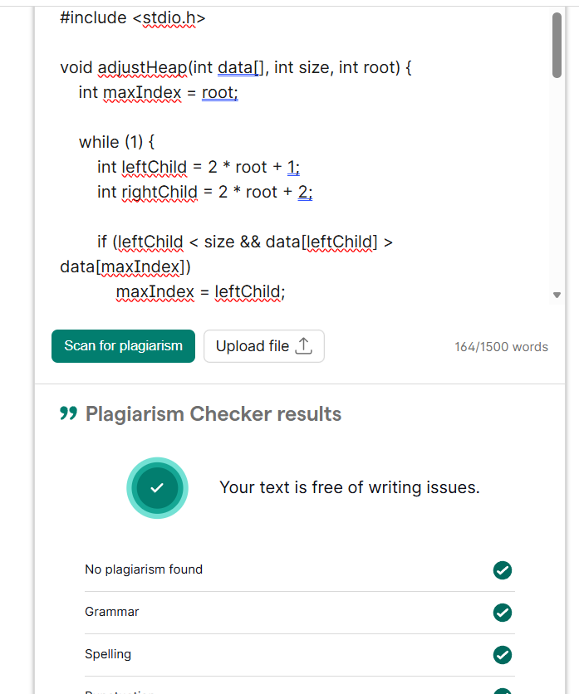
Date | 22/02/2026

