CampusTrack
Project Proposal Document
Week 1 — Requirements Engineering

Course / Team: Northrise University, BIT (Web and Software Development), Group 1
Team members: Athens Gandize, Atupele Beza, Benjamin Lungu (2206920)
Deliverable: Project Proposal Document — 10 pages
Date: Delivered 2026-09-08, revised 2026-09-09
Repository: github.com/2206920-benjamin/campustrack-attendance-tracker (private)

Note on this reissue
This file is regenerated from the project's own saved continuity notes for Week 1, not a re-export of the exact original .docx delivered on 2026-09-08/09 (that file is not retained in this working environment). Content — problem statement, requirements, stakeholders, diagrams — matches what was recorded as delivered; exact pagination and minor wording may differ from the original.

1. Introduction & Problem Statement
Attendance at Northrise University is currently tracked on paper registers in most classes. This approach is fragmented across courses, easy to falsify or lose, time-consuming for lecturers to tally, and gives students no self-service way to check their own standing until it becomes a problem. Administration has no real-time or aggregate view of attendance across departments, and there is no mechanism to flag a student who is falling below the attendance threshold required to sit an exam until it is too late to act.
We propose CampusTrack, an Android mobile Student Attendance & Academic Tracker. The app supports three roles — Student, Lecturer, and Administrator — and offers manual and QR-code attendance recording, an offline-first local cache that syncs to a remote REST API and database once connectivity returns, dashboards and analytics for each role, search and filtering, and automatic low-attendance notifications.

2. Stakeholder Analysis
Stakeholder | Interest in the System
Students | Primary end users; need visibility into their own attendance record and an easy, fast way to check in to class.
Lecturers | Record attendance (manually or via QR), view live class statistics, and identify students at risk.
University Administration / Registrar | Oversight across courses and departments; system-wide attendance reporting for academic decisions.
IT Support | Deployment, server maintenance, and account/data recovery.
Development Team (Group 1) | Design, build, test, document, and deploy the system to meet the module brief.
Course Lecturer / Assessor | Evaluates the finished project against the module's stated requirements and marking rubric.

3. Functional Requirements
Requirements are prioritised using the MoSCoW method (Must have, Should have, Could have, Won't have this iteration).
ID | Requirement | Priority
FR1 | User authentication and role-based access control for Student, Lecturer, and Admin accounts. | Must
FR2 | Course management — lecturers create and edit their own courses; admins have oversight of all courses. | Must
FR3 | Attendance recording — manual marking by a lecturer, and QR-code check-in initiated by the student's device. | Must
FR4 | Student attendance view — running attendance percentage, per-course breakdown, and session history. | Must
FR5 | Lecturer dashboard — live session count, class roster, and quick actions (start session, mark attendance). | Must
FR6 | Search and filter — courses, students, and users by name, course code, or attendance status. | Should
FR7 | Reporting and analytics — attendance trends and present/late/absent breakdowns, per course and system-wide. | Should
FR8 | Offline attendance recording, with changes queued locally and synchronised automatically once connectivity returns. | Must
FR9 | Low-attendance notifications pushed to the affected student and their lecturer. | Should
FR10 | Input validation and error handling across all forms, QR scans, and network calls. | Must
Out of scope for this iteration (Won't have): biometric attendance capture, a native iOS client, and SMS-based notifications. These are noted as candidates for future work.

4. Non-Functional Requirements
ID | Requirement
NFR1 | Performance — primary screens render within ~2 seconds on mid-range Android hardware.
NFR2 | Security — passwords are hashed, authentication is token-based (JWT), and session tokens are stored encrypted on-device.
NFR3 | Offline reliability — core recording operations (attendance marking, QR check-in) must work with no network connection.
NFR4 | Usability — consistent Material Design components and role-appropriate navigation for non-technical users.
NFR5 | Scalability — the backend is layered (Controller → Service → Repository/DAO) so it can grow beyond a single course or department.
NFR6 | Maintainability — the Android client follows a modular MVVM architecture; the API is documented.
NFR7 | Android compatibility — minimum SDK 26 (Android 8.0) and above.
NFR8 | Data privacy — attendance and user data access is restricted by role; a student can only see their own records.

5. Use-Case Diagrams
Each actor's primary interactions with CampusTrack are shown below. All three include relationships to the QR Module, the Notification Service, and the Remote API/Database.
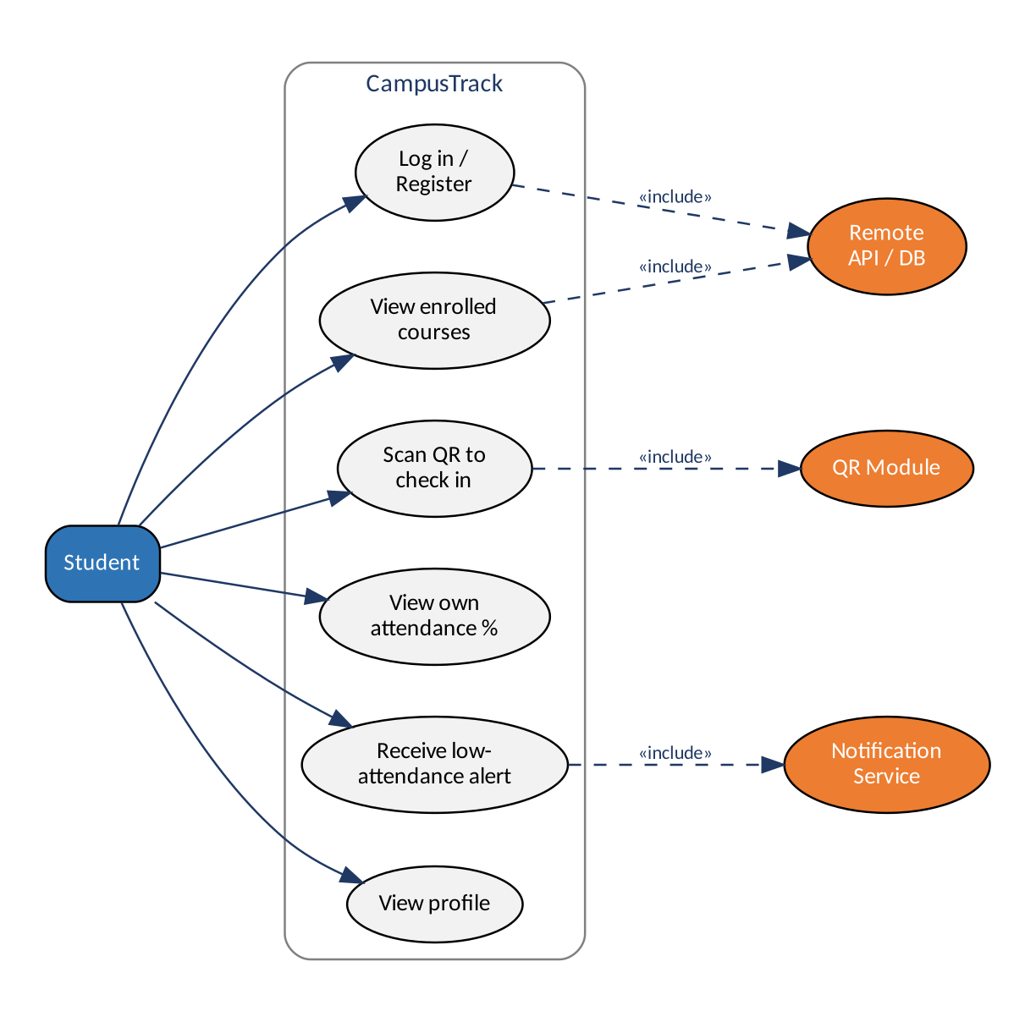
Figure 1 — Student use-case diagram
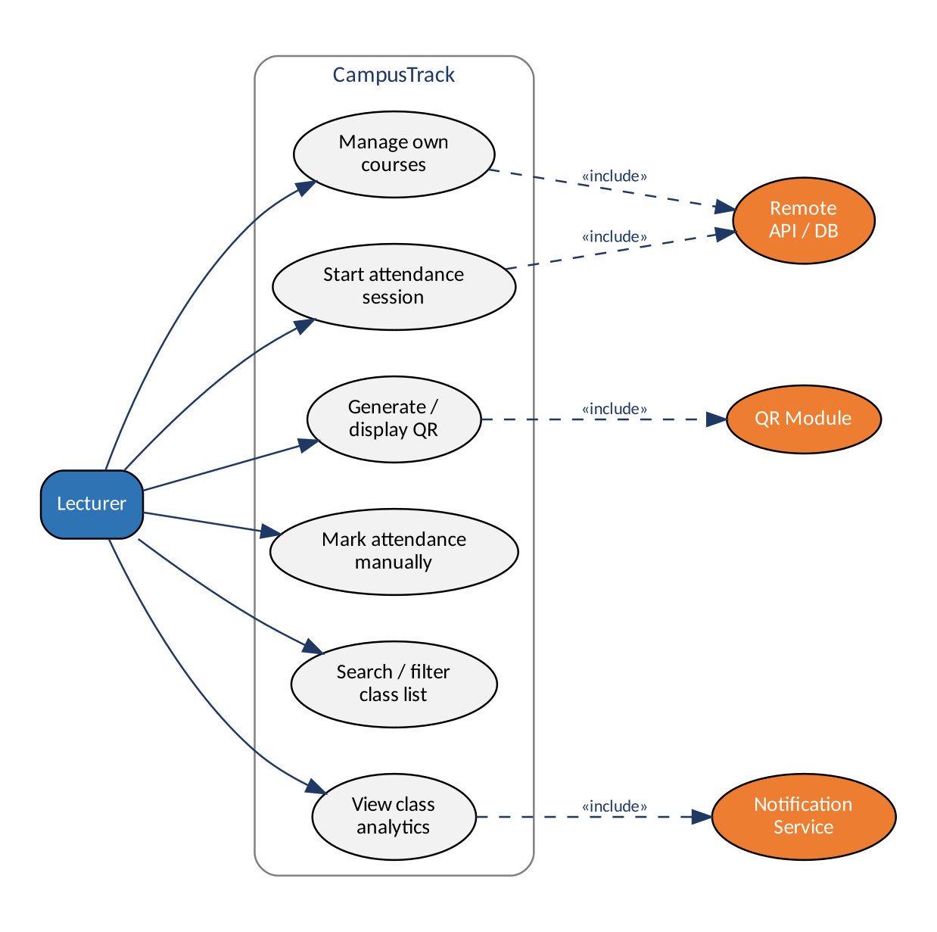
Figure 2 — Lecturer use-case diagram
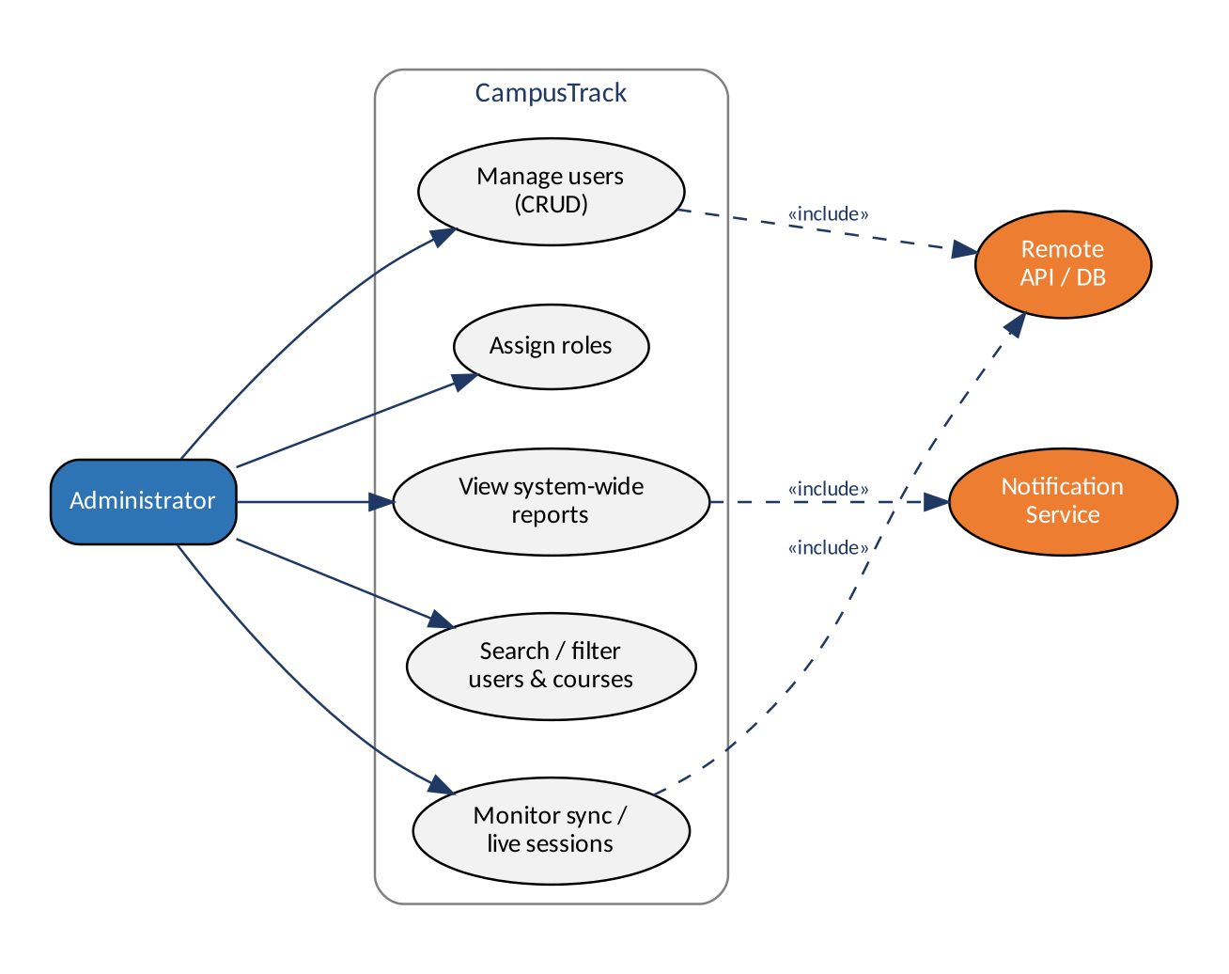
Figure 3 — Administrator use-case diagram

6. System Context Diagram
At a high level, each actor interacts with the mobile app, which reads and writes a local Room cache for offline use, uses the device camera for QR scanning/display, and talks to the REST API over HTTPS. The API is the single source of truth, backed by the remote database, and triggers the notification service for low-attendance alerts.
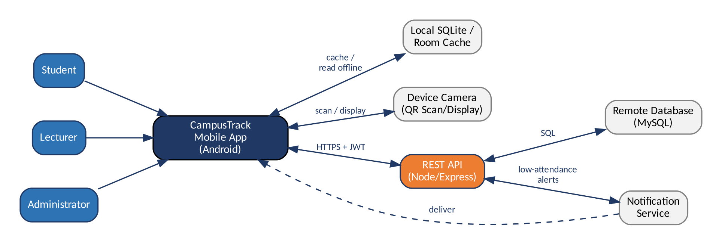
Figure 4 — System context diagram

7. Team Roles & Responsibilities
Three role slots were drafted for the three-person team; names were not yet finalised at the end of Week 1 — confirmed at the team's next meeting (see Week 2).
Role | Responsibilities | Assigned to
Project Lead & Backend/API Developer | Database design, REST API, authentication, deployment. | To be confirmed
Mobile Frontend Developer — UI & QR/Attendance Module | Android UI, navigation, QR scanning/check-in flow. | To be confirmed
QA, Documentation & Analytics Lead | Testing, documentation, analytics/reporting. | To be confirmed

8. Repository & Next Steps
- GitHub repository created (private): github.com/2206920-benjamin/campustrack-attendance-tracker — initial commit, README.md, and .gitignore in place.
- Add Athens Gandize and Atupele Beza as collaborators.
- Finalise which of the three roles each teammate takes.
- Week 2 (per the module brief): system design — ER/database design for local and remote stores, API endpoint specification, and UI wireframes for the student/lecturer/admin roles.

