CampusTrack
System Design Document
Week 2 — System & Database Design

Course / Team: Northrise University, BIT (Web and Software Development), Group 1
Team members: Benjamin Lungu (2206920, Project Lead & Backend/API), Athens Gandize (Mobile Frontend & QR module), Atupele Beza (QA, Documentation & Analytics)
Deliverable: System Design Document — 10 pages
Date: Delivered 2026-09-22
Repository: github.com/2206920-benjamin/campustrack-attendance-tracker (private)

Note on this reissue
This file is regenerated from the project's own saved continuity notes for Week 2, not a re-export of the exact original .docx delivered on 2026-09-22 (that file is not retained in this working environment). Content — architecture, ER schema, API design, sequence flows — matches what was recorded as delivered; exact pagination and minor wording may differ from the original.

1. Application Architecture
The Android client follows an MVVM architecture: View (Activities/Fragments) observes a ViewModel, which calls into Domain/use-case logic, which in turn calls a Repository layer backed by Room (local cache) and Retrofit (remote API). The client talks to a layered REST backend over HTTPS/JSON, authenticated with a JWT bearer token: Controller → Service → Repository/DAO → remote database. An Auth middleware on the server verifies the JWT and enforces role-based access control (RBAC) before a request reaches its controller.

2. Entity-Relationship Diagram & Schema
The schema is normalised to third normal form (3NF) and has six entities: User, Course, Enrollment (the junction table resolving the student–course many-to-many relationship), AttendanceSession, AttendanceRecord, and Notification.
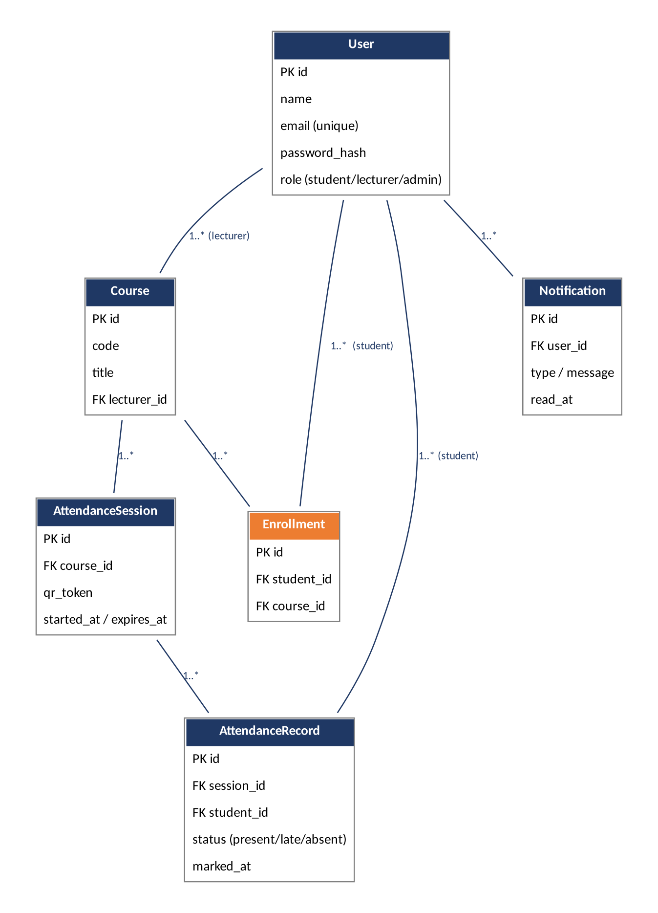
Figure 1 — Entity-relationship diagram
Entity | Key fields | Normalisation note
User | id (PK), name, email (unique), password_hash, role | Single role column avoids a separate roles table for only 3 fixed roles.
Course | id (PK), code, title, lecturer_id (FK → User) | One lecturer per course; many-to-many with students resolved via Enrollment.
Enrollment | id (PK), student_id (FK), course_id (FK) | Junction table — resolves the student ↔ course many-to-many relationship.
AttendanceSession | id (PK), course_id (FK), qr_token, started_at, expires_at | One session per class meeting; qr_token is single-use and time-bound.
AttendanceRecord | id (PK), session_id (FK), student_id (FK), status, marked_at | One row per student per session; status is present/late/absent.
Notification | id (PK), user_id (FK), type, message, read_at | Added this week — was design-only until Week 2.

3. REST API Endpoint Design
Thirteen endpoints were designed across six resource groups, each gated by role.
Method | Path | Description | Roles
POST | /auth/register | Create a new account. | Public
POST | /auth/login | Authenticate and issue a JWT. | Public
GET | /auth/me | Return the current authenticated user. | All
GET | /courses | List courses (own courses for lecturer, enrolled for student, all for admin). | All
POST | /courses | Create a course. | Lecturer, Admin
POST | /courses/:id/enroll | Enrol a student in a course. | Lecturer, Admin
GET | /courses/:id/students | List students enrolled in a course. | Lecturer, Admin
POST | /sessions | Start an attendance session and issue a QR token. | Lecturer
POST | /attendance/checkin | Mark attendance manually or via scanned QR token. | Lecturer, Student
GET | /attendance/course/:id/summary | Class attendance summary/analytics for a course. | Lecturer, Admin
GET | /attendance/student/:id/history | A student's attendance history. | Student, Lecturer, Admin
POST | /sync/batch | Submit a batch of records created while offline for reconciliation. | All
GET | /notifications | List notifications for the current user. | All
Sample payload — POST /auth/login request/response:
Request: { "email": "student1@nu.ac.zm", "password": "••••••••" }
Response: { "token": "<jwt>", "user": { "id": 12, "name": "…", "role": "student" } }
Sample payload — POST /attendance/checkin (QR check-in):
Request: { "sessionId": 44, "qrToken": "a1b2c3…" }
Response: { "status": "present", "markedAt": "2026-09-22T09:03:11Z" }

4. Authentication & Role Model
Authentication is stateless, using a JWT access token with a 2-hour expiry. Passwords are hashed server-side with bcrypt before storage. Each User row carries a single role column (student / lecturer / admin), checked by the Auth middleware against the permission matrix below.
Capability | Student | Lecturer | Admin
Register / log in | ✓ | ✓ | ✓
View own attendance | ✓ | — | ✓
Create / edit own courses | — | ✓ | ✓ (all)
Start attendance session | — | ✓ | —
Scan QR to check in | ✓ | — | —
Mark attendance manually | — | ✓ | ✓
View class analytics | — | ✓ (own) | ✓ (all)
Manage user accounts | — | — | ✓
Receive low-attendance alerts | ✓ | ✓ (own class) | ✓

5. Sequence Diagrams

Login Flow
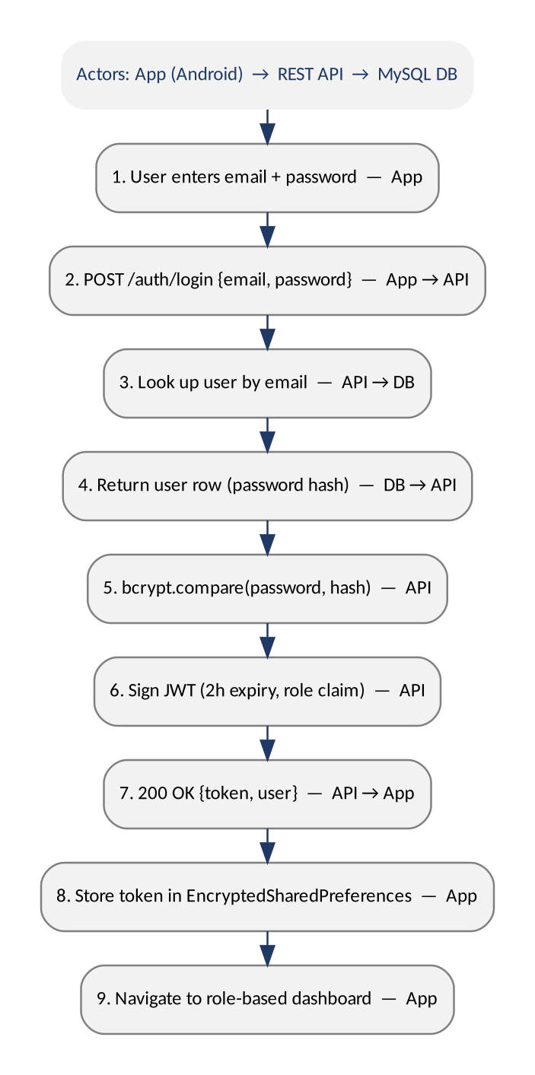
Figure 2 — Login sequence

QR Attendance Check-in (primary transaction)
The lecturer starts a session, which generates a time-bound QR token. The student scans it; if the device is online, the check-in is verified and recorded immediately. If offline, the check-in is queued locally in Room and reconciled through the batch sync endpoint once connectivity returns, after which class statistics are recomputed.
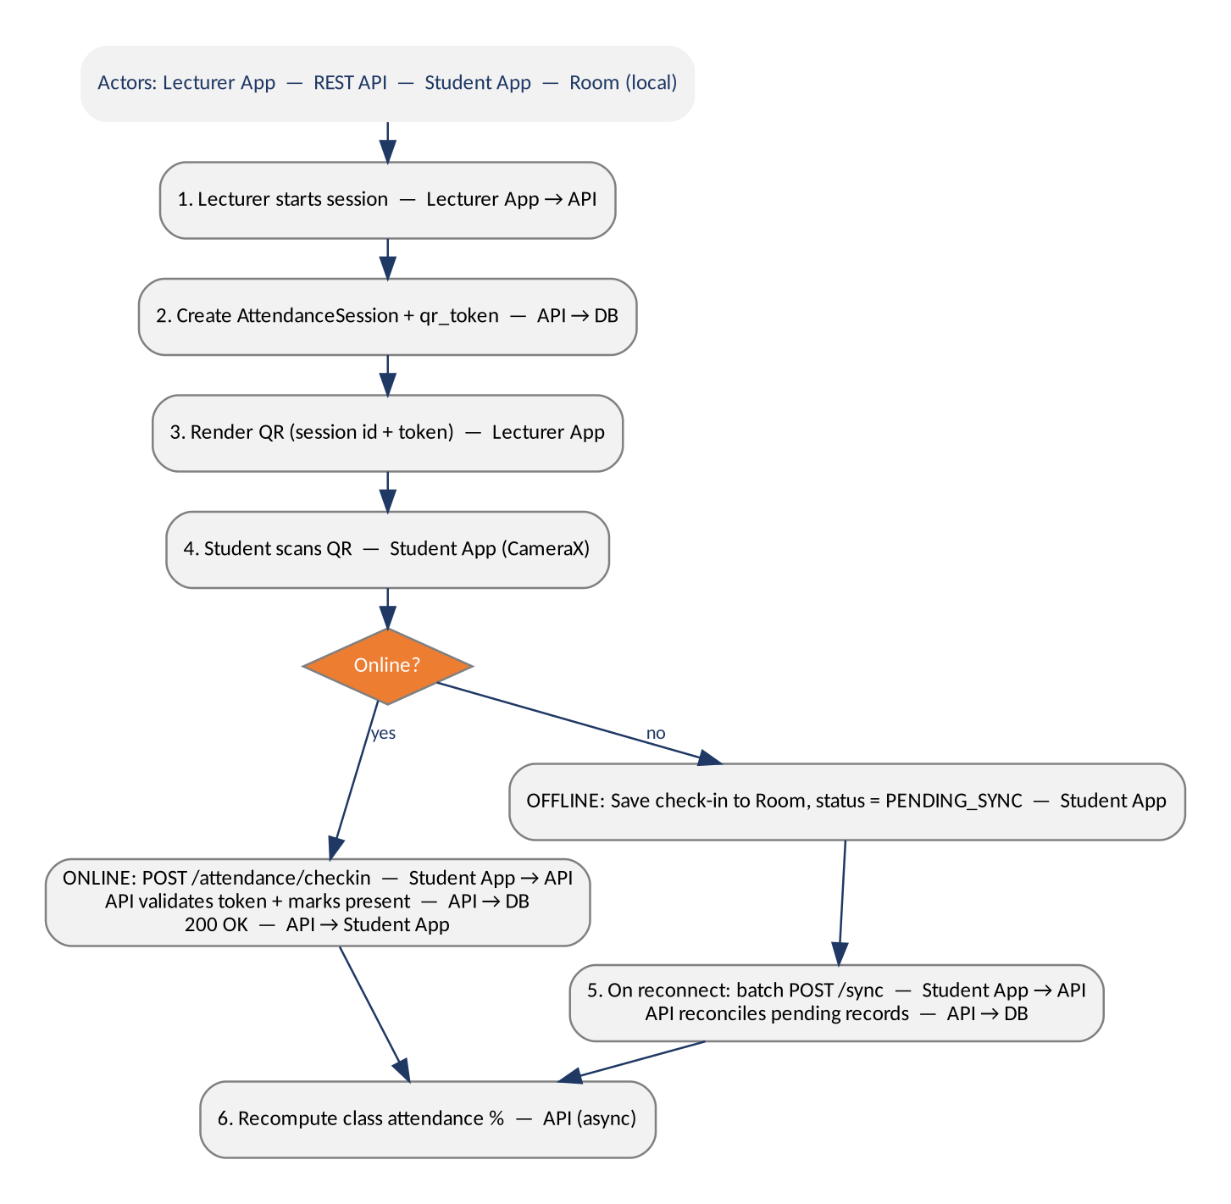
Figure 3 — QR check-in sequence (online/offline branch)

6. Team Role Tie-in & Next Steps
- Benjamin: stand up the database and first endpoints (auth, courses, sessions).
- Athens: Android project scaffold and Room entities mirroring this week's schema.
- Atupele: turn the endpoint table into test cases; keep the weekly log going.
- Carried over from Week 1: add Athens Gandize and Atupele Beza as GitHub collaborators.
- Week 3 (per the module outline): UI wireframes and Android implementation kickoff.

