CampusTrack
UI/UX & Android Foundation
Week 3 — Screen Design, Navigation & Project Structure

Course / Team: Northrise University, BIT (Web and Software Development), Group 1
Team members: Athens Gandize (lead), Atupele Beza, Benjamin Lungu (2206920)
Deliverable: UI/UX Package + working Android shell (no backend yet) — 7 pages
Date: Delivered 2026-09-22
Repository: github.com/2206920-benjamin/campustrack-attendance-tracker (private)

Note on this reissue
This file is regenerated from the project's own saved continuity notes for Week 3, not a re-export of the exact original CampusTrack_Week3_UIUX_Package.docx (that file is not retained in this working environment). The wireframes below are simplified low-fidelity recreations in the same brand, not the original high-fidelity phone mockups — the layout and screen content they describe matches what was recorded as delivered. The accompanying Android project source is covered separately by the Week 3 code zip.

1. Introduction
This week's brief called for wireframes/mockups of all major screens, a navigation flow diagram, Material Design XML layouts, working Activities/Fragments with basic navigation, and a functional splash/login/register/dashboard shell against mocked data — no backend yet. The deliverable is a UI/UX package (this document) plus a real Android Studio project implementing it.

2. Navigation Flow
Splash leads to Login, which can branch to Register or, after authenticating, to one of three role-specific dashboards, each with its own bottom navigation.
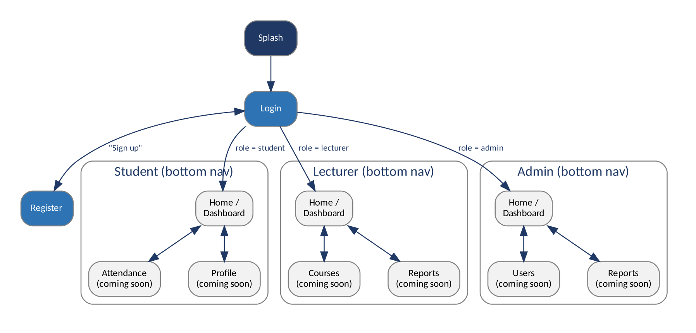
Figure 1 — Navigation flow diagram

3. Screen Design — Onboarding & Authentication
Splash shows the CampusTrack wordmark while the app initialises. Login takes an email and password; Register additionally lets the user pick a role via pill-style selectors (Student / Lecturer / Admin) for the demo build.
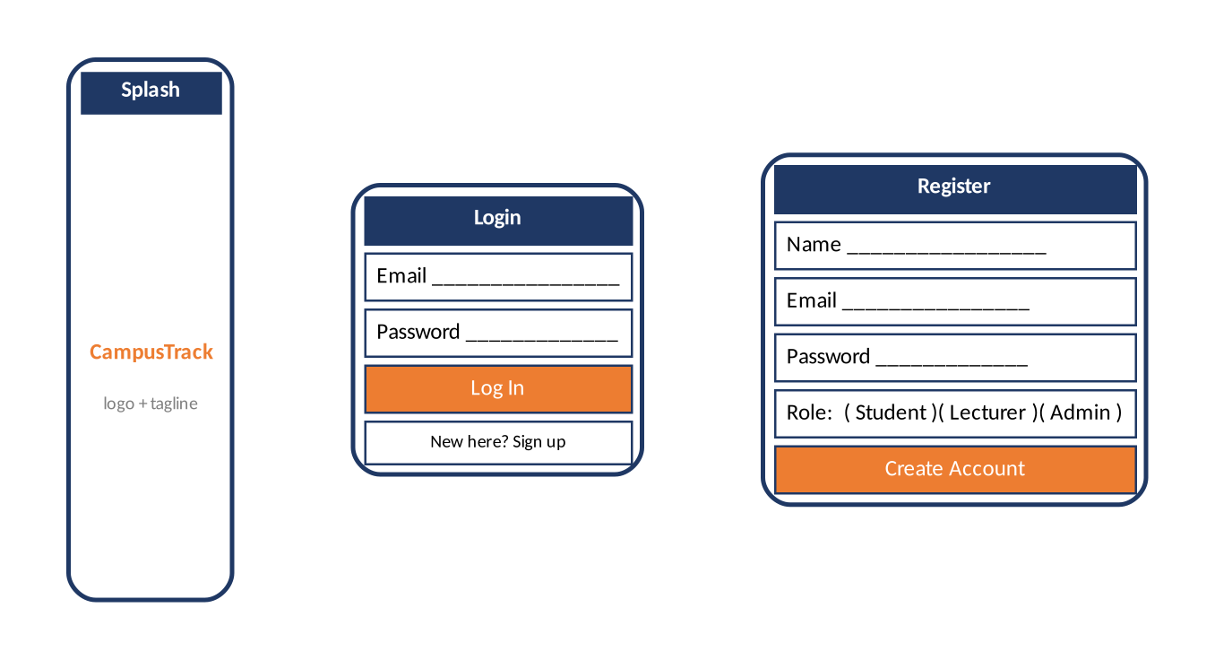
Figure 2 — Onboarding & authentication wireframes

4. Screen Design — Role-Based Dashboards
Each role lands on a dashboard tailored to it: the student sees their own attendance percentage and course list with a Scan QR action; the lecturer sees today's session count and their courses with a Start Session action; the admin sees system totals and recent users. Mocked/static data stands in for the real API this week.
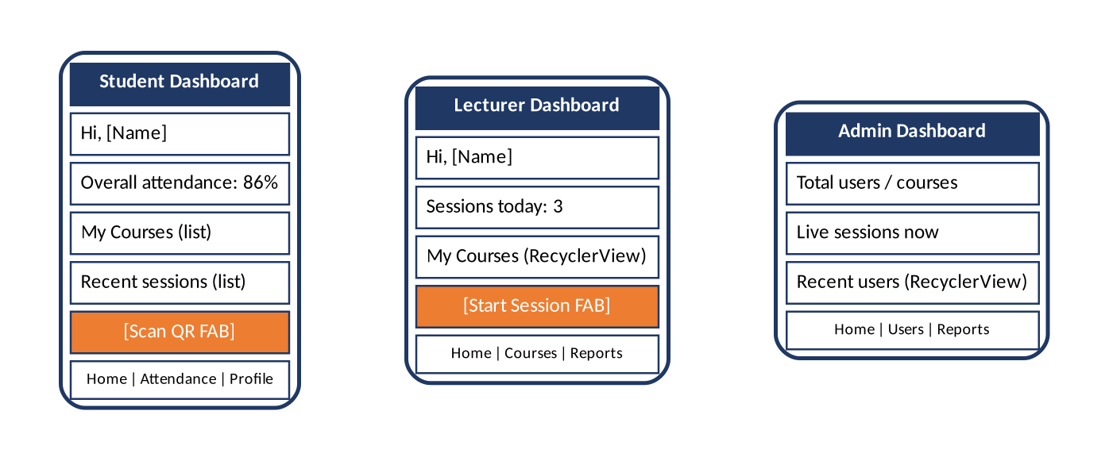
Figure 3 — Student, Lecturer, and Admin dashboard wireframes

5. Android Project Structure

5.1 Architecture
Single-Activity app (com.northrise.campustrack) using the Jetpack Navigation Component: SplashActivity hands off to MainActivity, which hosts a NavHostFragment driven by nav_graph.xml and a role-specific bottom navigation bar. This lays the groundwork for the MVVM architecture formalised in Week 2's design and built out fully from Week 4 onward.

5.2 XML Layouts & Material Design
All screens are implemented as Material Design XML layouts: LoginFragment and RegisterFragment (with the role-pill selector), and StudentDashboardFragment / LecturerDashboardFragment / AdminDashboardFragment, each built around a RecyclerView and adapter over static mock data. The data/model/ package mirrors the Week 2 ER schema (User, Course, AttendanceSession, AttendanceRecord, Role), and a MockData/MockAuthRepository pair stands in for the real API until Week 5's backend lands. Brand colours (navy/blue/orange) and Material Components are applied throughout, matching the mockups above.

6. Implementation Status

6.1 Working in code
- Splash → Login/Register → role-based dashboard navigation (Jetpack Navigation Component).
- Login and Register screens, including the demo role-pill selector.
- Student, Lecturer, and Admin dashboards rendering a RecyclerView over static mock data.
- Home tab wired to a real destination on the bottom navigation for all three roles.

6.2 Still mocked / not yet implemented
- Attendance/Courses/Users/Reports/Profile tabs show a “coming soon” message — only Home is wired up this week.
- QR scanning and offline sync are not implemented; the dashboard QR action opens a placeholder screen.
- No backend yet — all data is static mock data in the app.

7. Next Steps
- Week 4: Room local database implementing the Week 2 schema, replacing mock data with real local persistence.
- Week 5: Retrofit networking layer replacing MockAuthRepository once the backend (designed in Week 2) is implemented.
- Week 6+: QR scanning module, offline sync, analytics, and security hardening.

