Analysing the Relationship Between Age and Monthly Income

Subtitle: A Statistical Correlation Study Using the Kaggle Employee Dataset
Course : 7COM1079 – Data Analytics
Group Number: B136
Group Members:
- Jeevith Vijayakumar Gowda
- Dheekshith Annamaneni
- Dheeraj Kandukuri
- Nabeel Ayub Bhatti
- Pushpalatha Angothu

Presented by : Dheeraj Kandukuri
Date : 08-12-2025

Table of Contents
1. Introduction 3
1.1 Problem Statement and Research Motivation 3
1.2 The Dataset 3
1.3 Research Question 3
1.4 Null Hypothesis and Alternative Hypothesis 4
2. Background Research 4
2.1 Research Papers 4
2.2 Why the Research Question Is of Interest 5
3. Visualisation 5
3.1 Scatter Plot Output 5
3.2 Histogram Output 6
3.3 Useful Insights 7
4. Analysis 7
4.1 Statistical Test Used 7
4.2 Hypothesis Decision and Interpretation 7
5. Evaluation – Group Experience 7
5.1 What Went Well 7
5.2 Points for Improvement 7
5.3 Group Time Management 8
5.4 Project’s Overall Judgement 8
5.5 GitHub Log Output 8
6. Conclusions 8
6.1 Results Explained 8
6.2 Interpretation of Results 8
6.3 Limitations and Future Work 8
References 9
Appendices 10
Appendix A : - R Code Used for Analysis and Visualisation 10
Appendix B : - GitHub Log Output 15

1. Introduction

1.1 Problem Statement and Research Motivation
The factors affecting the salary of the employees is a significant feature of workforce analytics particularly concerning equity, career growth and salary forms. Age is often thought to have a relationship with income since people tend to assume that there is the correlation with experience, career growth and high position. But this assumption must be statistically proved and not by the perception. Assessing the age and salary correlation can assist organisations in determining whether the trends in compensation are founded on systematic career growth or some other extraneous variables. According to the previous studies, demographic factors might affect incomes (Guzzo, Nalbantian and Anderson, 2021), which is why this issue becomes relevant to human resource and data-oriented decision-making.

1.2 The Dataset
The dataset employed in this project is the Kaggle Employee Attrition Dataset that has 1,470 records of employees with demographic characteristics, salary rates, and work-related variables. Following the elimination of the missing values on the two selected variables, there was a left over of 1058 complete entries. The analysed variables include Age (interval numeric) and Monthly Income (interval numeric). This data will be applicable in statistical correlation since both the chosen variables are continuous and a corresponding Pearson correlation test can be conducted.

1.3 Research Question
The research question guiding this study is:
➡ Is there a statistically significant correlation between an employee’s Age and their Monthly Income?
The purpose of this question is to identify whether the salary trends are increasing with age or not or whether there is an increase or decrease with age in the dataset of income.

1.4 Null Hypothesis and Alternative Hypothesis
- Null Hypothesis (H₀): Monthly Income and Age have no statistically significant correlation.
- Alternative Hypothesis (H₁): Monthly Income and Age have a statistically significant correlation.
By testing the hypotheses, the analysis can be used to find out whether any relationship that has been observed between the variables is significant or a mere chance. The level of significance used is α= 0.05 to test the hypothesis. The p-value of the Pearson correlation test will be used to decide on the final decision.

2. Background Research

2.1 Research Papers
There are a number of studies that have been conducted to determine the impact of demographic variables on the compensation trends in different organisations. Guzzo, Nalbantian and Anderson (2021) showed that senior positions are characterized by age and job experience as strong predictors of increased compensation and better performance. Their study contributes to the fact that the salary is expected to grow with age because of the gained experience and promotion career.
Using statistical regression and machine learning, Gao (2024) examined the trend of salaries and established a positive relationship, which was measurable, between salary and age. Similarly, Krishna and Sidharth (2024), in their HR analytics and attrition modelling study, found age to affect the retention and compensation results.
Rockey and Ava (2022) performed exploratory data analysis on HR data and determined that there is a positive pattern in income depending on the age. They highlighted that visual and inferential approaches should be applied in the analysis of employee datasets. Lastly, Sims (2025) focused on the role of age and experience in the contemporary organisations, which still determine the patterns of income distribution.
All the literature together supports the assumption age can have an effect on incomes, but also suggests further statistical confirmation of such a hypothesis with independently acquired data, such as the one utilized in this research.

2.2 Why the Research Question Is of Interest
The importance of this research question is that the phenomenon of salary equity, role development and employee compensation policies is among the critical fields of study in workforce data science and HR management. Although age might be connected with the trends of income, it is not always true that such a relationship is strong and significant within organisations. The available literature suggests contradictory findings based on industry, workforce organization and work roles. Thus, the analysis of this data will contribute to the conclusion about the predictability of age on income in this particular situation. The results can be used in future predictive modelling or making equity based human resource decisions.

3. Visualisation

3.1 Scatter Plot Output
Scatter plot was created to provide a graphic representation of correlation between Age and Monthly Income. To show the direction and the strength of the relationship, a regression trend line was included. This is an appropriate plot in that both the variables are continuous and thus linear patterns can be assessed visually.
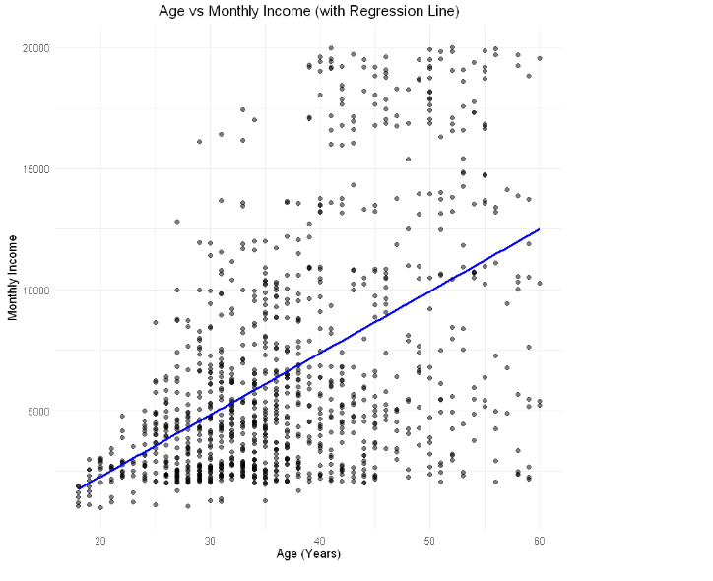
Figure 1: Scatter Plot of Age vs Monthly Income (with Regression Line)

3.2 Histogram Output
To determine the distribution of each variable, two histograms were created. The Age histogram indicates the equal distribution with the centre placed at 30 to 40 range, whereas the salary histogram indicates a right-skewed picture with more employees earning salaries at the lower to middle-range.
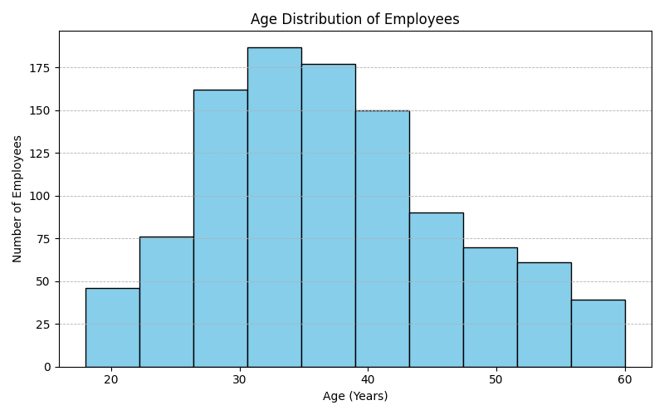
Figure 2: Age Distribution Histogram
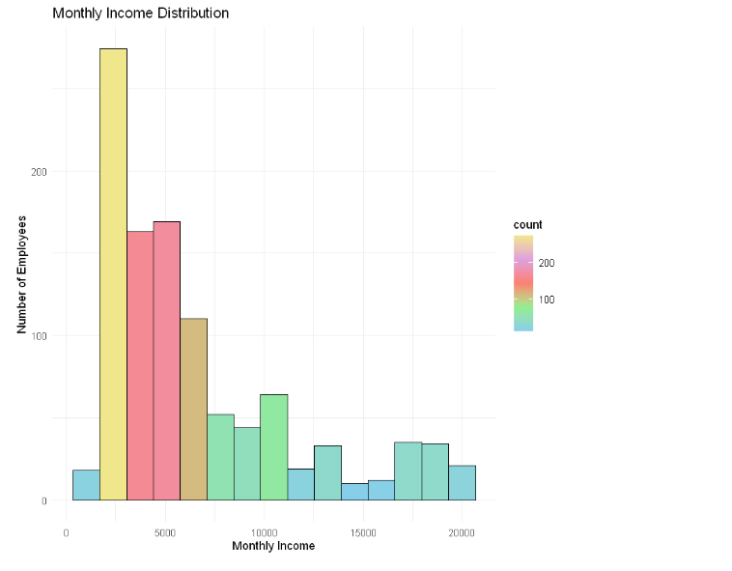
Figure 3: Monthly Income Distribution Histogram

3.3 Useful Insights
The scatter plot shows that there is an average increase, where the older employees are more likely to earn more. The increasing data dispersion with the increase in income implies the possibility of role or seniority differences. The patterns of the histograms validate the visual trend as majority of the employees are in mid-career and mid-income brackets.

4. Analysis

4.1 Statistical Test Used
Pearson correlation test was the test of choice due to the characteristics of the two variables used in the evaluation, Age, and Monthly Income, as continuous numeric variables, measured on an interval scale. It is the right test to use in establishing the existence of a linear relationship between the two variables. The result of the analysis gave a correlation (r = 0.4974) as well as a p-value (3.298 x 10-67). The moderate positive r-value implies that there is a moderate positive correlation whereas the p-value is incredibly small meaning that the observed association cannot have taken place by chance.

4.2 Hypothesis Decision and Interpretation
The p-value based on Pearson correlation test was considerably lower than the significance level of α = 0.05. Thus, the null hypothesis is rejected and the alternative hypothesis is accepted and Age and Monthly Income have statistically significant correlation. According to the results, the monthly income is more likely to increase with age in the dataset. Although, the correlation is not high, but the results indicate that age is probably indicator of seniority, experience, promotion levels or role maturity in the workforce.

5. Evaluation – Group Experience

5.1 What Went Well
The team worked very well as all members were involved in the review of datasets, analysis, and writing of reports. Communication was obvious and roles were shared based on strengths and this was beneficial in making sure there was accuracy and efficiency. The stages of the statistical analysis and visualisation went on well after the research question was established.

5.2 Points for Improvement
The team started by deliberating on irrelevant modelling possibilities then they settled down to the assignment specifications. Preliminary preparation and consideration of the reviewing criteria could have decreased the confusion. Also, time would have been utilized efficiently on editing and formatting in order to prevent last minute changes.

5.3 Group Time Management
There was an improvement in the time management during the project. Frequent progress talks were used to monitor work and define the areas where a greater emphasis should be given. Even though the initial stages were slower, the team was more organized at the final phase of the project.

5.4 Project’s Overall Judgement
The group thinks that the project achieved its aims, and there is a definite statistically appropriate answer to the research question. The analysis is consistent with the characteristics of the dataset, and it shows the effective application of statistical methods.

5.5 GitHub Log Output
The logs available on GitHub show that the team members made regular contributions and meaningful commits related to cleaning the data, statistical analysis, visualisation, and documentation. In Appendix B, we have a screenshot of the log output and three major commit messages which serve as supporting evidence.

6. Conclusions

6.1 Results Explained
The statistical analysis showed that there is moderate positive correlation between Age and Monthly Income. The results show that the older workers tend to have a higher salary which is expected to be seen in the scatter plot and the expanding dispersion in the income histogram. The test hypothesis affirmed that the relationship is significant.

6.2 Interpretation of Results
The findings indicate that salary increment can be affected by age-related issues, including work experience, tenure, and career development. The relationship is however not to be understood as causal since there are other pertinent variables like job role, education and performance which can equally be determinants of income.

6.3 Limitations and Future Work
Only one independent variable was analyzed, which restricted the general interpretation. The further application in the work is that multiple regression or machine learning scenarios might be implemented in the future that include other variables like job level, years of experience, and qualifications to explain the salary patterns more accurately.

References
Gao, H. and Natural Science University College London (2024) Research on the Effect of Age and Experience on Salary based on Linear Regression and Tree-Based Train, Highlights in Business, Economics and Management EMFRM, pp. 1401–1402.
Guzzo, R.A., Nalbantian, H.R. and Anderson, N.L. (2021) 'Age, Experience, and Business Performance: A Meta-Analysis of Work Unit-Level Effects,' Work Aging and Retirement, 8(2), pp. 208–223. https://doi.org/10.1093/workar/waab039.
How to explore the relationship between age and income using EDA – the Palos Publishing Company (2025). https://palospublishing.com/how-to-explore-the-relationship-between-age-and-income-using-eda/.
Krishna, S. and Sidharth, S. (2024) 'HR Analytics: Analysis of Employee Attrition Using Perspectives from Machine Learning,' in Flexible systems management, pp. 267–286. https://doi.org/10.1007/978-981-99-9550-9_15.
Rockey, J.C.E.M., and Ava (2022) Age vs. Salary. https://rstudio-pubs-static.s3.amazonaws.com/949360_5bc97ad2e1864260b6258fe03fc8f5f6.html.
Sims, R. (2025) Why Age and Experience Matter: Insights from HR Attrition Data. https://www.linkedin.com/pulse/why-age-experience-matter-insights-from-hr-attrition-data-ronald-sims-zj1ze/.

Appendices

Appendix A : - R Code Used for Analysis and Visualisation
Code for:
- Data cleaning
- Pearson correlation test
- Scatter plot with regression line
- Histograms
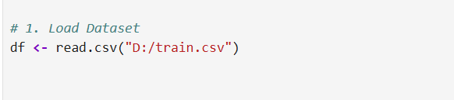
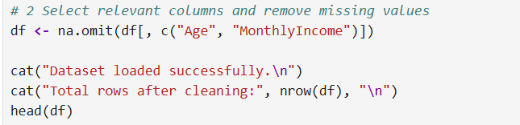
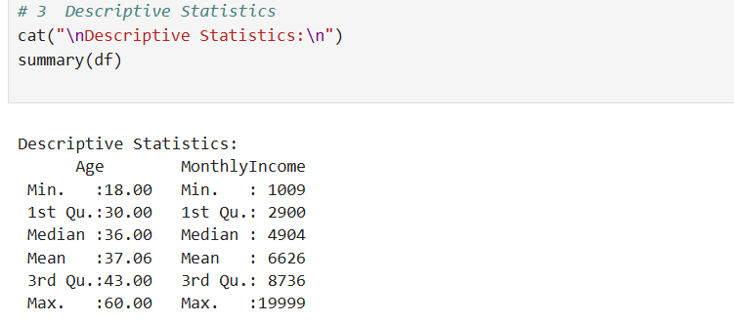
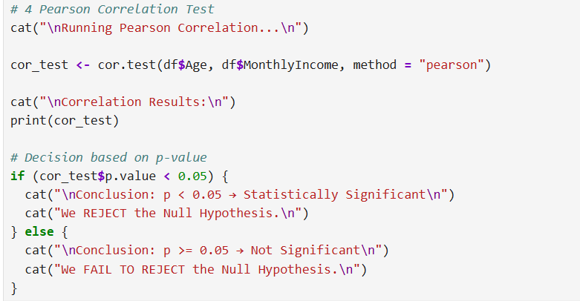
Output :
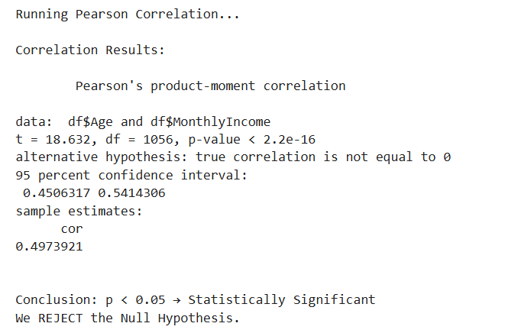
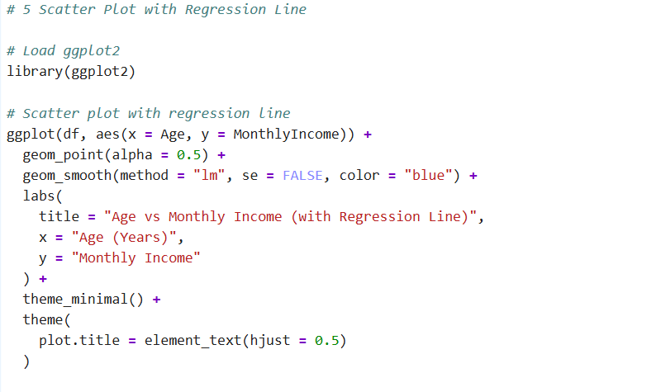
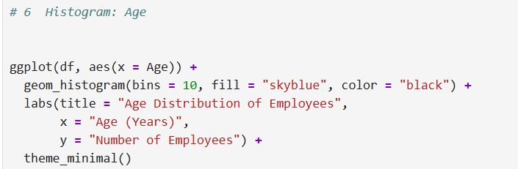
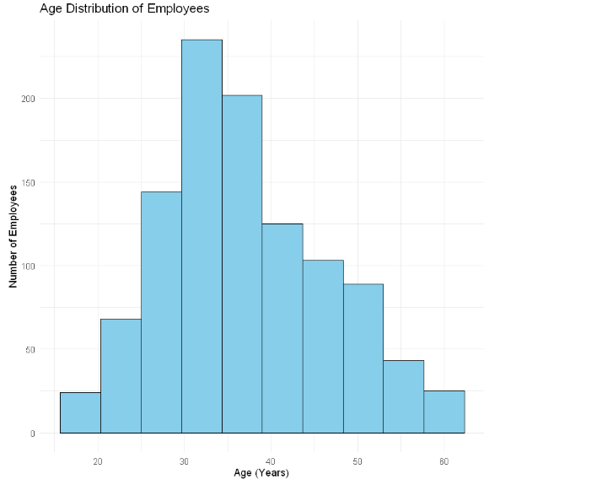
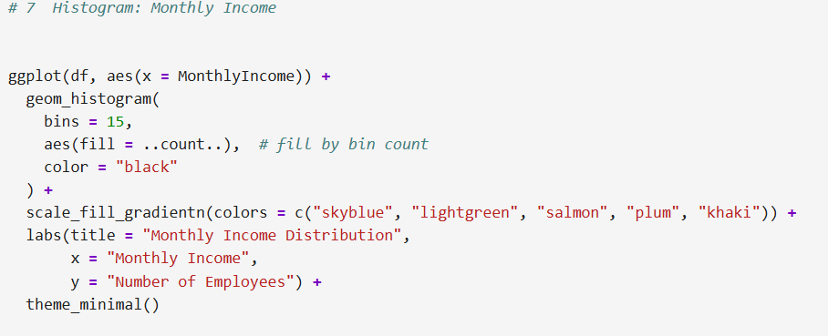

Appendix B : - GitHub Log Output
- Screenshot(s) of GitHub commit history
Commit 1
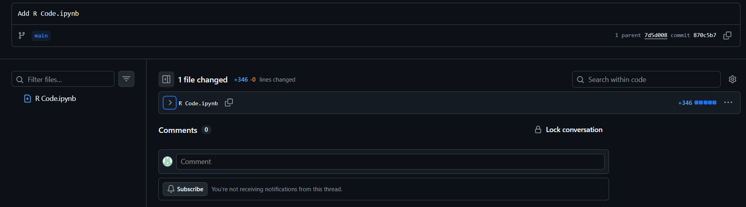
Commit 2
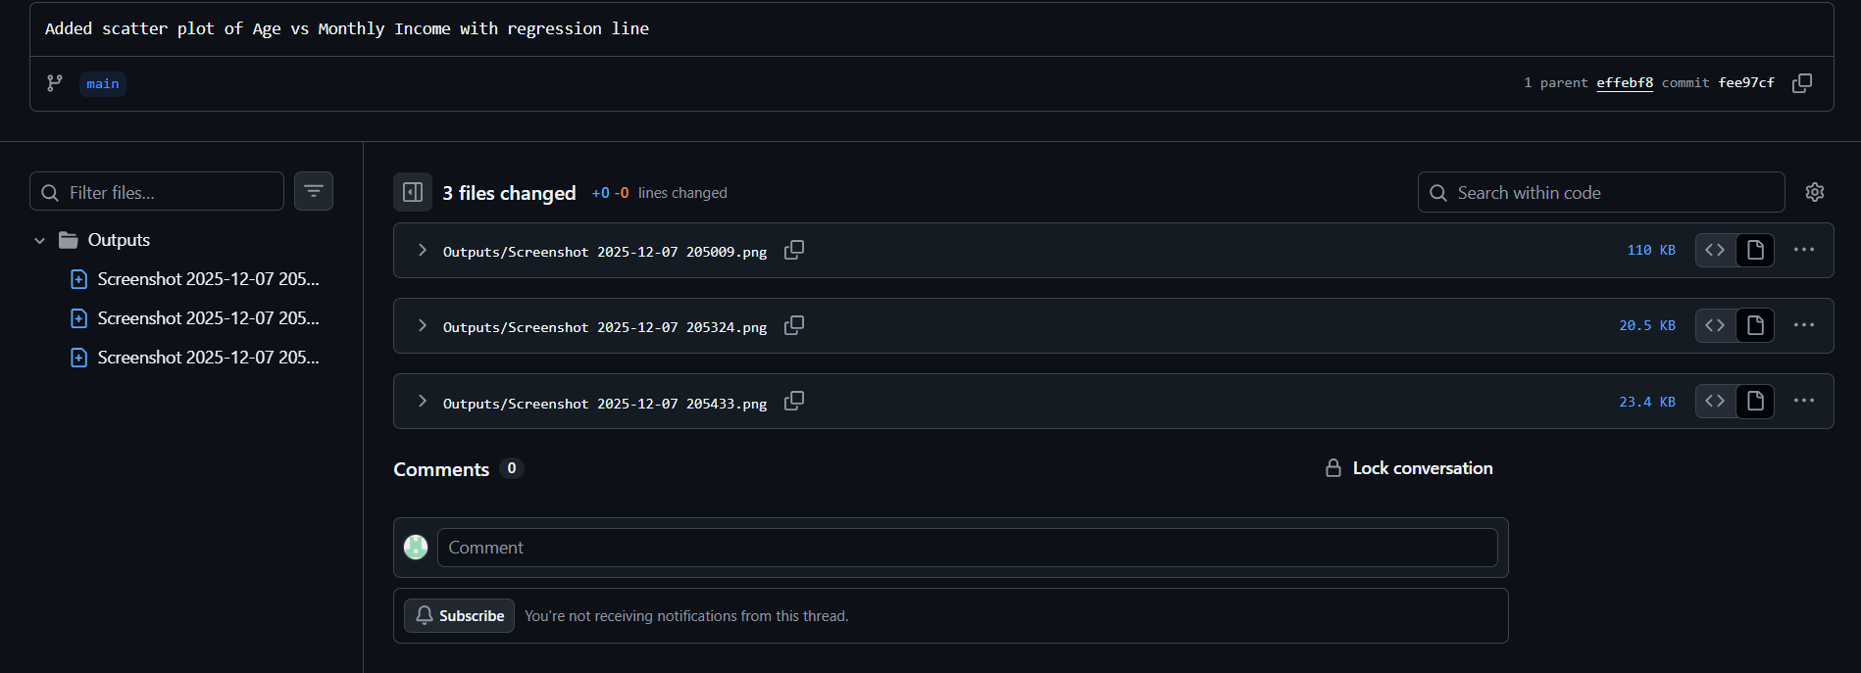
Commit 3
