PHENIKAA UNIVERSITY
SCHOOL OF ENGINEERING AND TECHNOLOGY
FALCULTY OF ELECTRICAL AND ELECTRONIC ENGINEERING


COURSE PROJECT REPORT
REINFORCEMENT LEARNING
Title of the project :
Reinforcement Learning on a Windy Grid World with Random Wind and Anchor Cells: Algorithm Comparison
Student: | Trần Ngọc Như Nghĩa | Student ID: | 24107677
Supervisor: | Msc.Vu Hoang Dieu | Major: | Electrical and Electronic Engineering
Score

Lecture 1 | Lecture 2
MSc. Vu Hoang Dieu

Hà Nội,November 2026
1.Introduction
For this project I chose Windy Grid World, which is Example 6.5 in the Sutton and Barto book. The idea is simple: the agent starts at S and needs to get to G. But some columns have wind that pushes the agent up, so if it just walks straight to G it will miss.
The topic has 4 settings that I had to do:
- Each column has a fixed wind.
- A bigger map, wind from 0 to 2 cells.
- Random wind, the wind can be 1 more or 1 less than normal.
- Anchor cells. If the agent picks one up, it can ignore the wind one time.
For the anchor, the state also has to say if the agent still has it or already used it.
I tried the 5 algorithms we learned in class: Policy Iteration, Value Iteration, Monte Carlo, SARSA and Q-learning. They all use a table, I did not use any neural network.
2.Background
2.1 Markov Decision Process
The problem is a Markov Devision Process (MDP) with:
- A set of states S and a set of action A
- Transition probabilities p(s’ | s, a)
- A reward r for each step
- A discount factor γ
The agent follow the policy π(a | s).The return is G_t = r_{t+1} + γ r_{t+2} + γ² r_{t+3} + … and the goal is to find a policy with the highest expected return.
2.2 Value functions and Bellman equations
- V^π(s): the expected return when starting from s and following π.
- Q^π(s, a): the expected return when taking a in s, then following π.
The best value function satisfies the Bellman optimality equation:
V*(s) = max_a Σ_{s’} p(s’ | s, a) [ r + γ V*(s’) ]
If we know V* or Q*, the best policy is just to pick the action with the highest value.
2.3 Model-based vs model-free
- Model-based (Dynamic Programming): we know p(s’ | s, a), so we can solve the Bellman equation directly. Policy Iteration and Value Iteration are in this group.
- Model-free: the agent does not know p and has to learn from playing. Monte Carlo, SARSA and Q-learning are in this group.

3.Environment

3.1 Maps
I made 3 maps. Map 1 is the easy one from the book, and the other two get harder.
Map | Size | Wind | Anchor
Map 1 (easy) | 7×10, no walls | fixed 0–2 | no
Map 2 (medium) | 10×14, 2 walls | 0–2, random ±1 | no
Map 3 (hard) |  | 0–2, random ±1 | 2 cells
  12×16, 2 walls
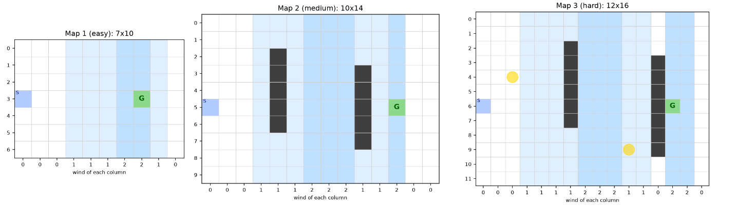
For Map 3 I put G in a column with strong wind and right next to a wall on purpose. That way it is really hard to stop on G without using the anchor.
Picture 1: The 3 maps

3.2 State, actions and reward
- State: s = (row, col, k). k = 0 means the agent has no anchor yet, k = 1 means it is holding one, k = 2 means it already used it.
- Actions: up, down, left, right. On Map 3 I added 4 more actions, “move and use the anchor”, so there are 8 actions there.
- Reward: −1 each step and γ = 1. So the return is just minus the number of steps, a shorter path is better.
- End: the episode ends when the agent stops on G. I also stop it after 2000 steps (3000 on Map 3) so it does not run forever.
The number of states is 70 for Map 1, 140 for Map 2 and 12×16×3 = 576 for Map 3 (some of them are walls so the agent can never be there).

3.3 What happens in one step
- The agent moves one cell. If there is a wall or the edge, it stays where it is.
- Then I look at the wind of the column it just moved into. If the wind is random , w = max(0, w̄ + δ) with δ ∈ {−1, 0, 1}.
- If the agent has the anchor, chose to use it and w > 0, the wind does nothing and k becomes 2.
- If not, the wind pushes it up w cells, one cell at a time, and stops if there is a wall.
- If the agent lands on an anchor cell and k = 0, it picks the anchor up (k = 1).
I think the state is Markov because the wind only depends on the column, and k says everything about the anchor. If I did not put k in the state, the same cell could give different results depending on whether the anchor was used, so it would not be Markov anymore.
3.4 Why the state is Markov
The wind only depends on the column, and the random part δ is drawn fresh each step, so the next state only depends on (row, col, k) and the action. If I left k out, the same cell could behave differently depending on whether the anchor was used before, so the state would not be Markov.
I also wrote a function transition_distribution(s, a) that returns all possible next states with their probabilities. Policy Iteration and Value Iteration use it

4. Algorithms
4.1 Policy Iteration
Policy Iteration repreats 2 step:
- Policy evaluation: compute V^π for the current policy by repeating
V(s) ← Σ_{s’} p(s’ | s, π(s)) [ r + γ V(s’) ]
- Policy improvement: make the policy greedy with respect to V:
π(s) ← argmax_a Σ_{s’} p(s’ | s, a) [ r + γ V(s’) ]
It stops when the policy does not change anymore. The good thing is that it needs only a few improvement steps. The bad thing is that each evaluation step needs many sweeps over all states, so it can be slow.
One problem I had: with γ = 1, a bad policy that never reaches G (for example walking into a wall forever) has an infinite value. So I start from a policy that can reach G and limit the number of sweeps in evaluation.
4.2 Value Iteration
Value Iteration combines the two steps into one update:
V(s) ← max_a Σ_{s’} p(s’ | s, a) [ r + γ V(s’) ]
It repeats this until the biggest change in one sweep is smaller than a small θ, then takes the greedy policy. I update V in place (using new values right away in the same sweep), which makes it converge faster. Each sweep is cheap, so it was much faster than Policy Iteration in my case.

4.3 Monte Carlo control
Monte Carlo does not need the model. It plays one whole episode with ε-greedy, then goes back from the end to compute the return G for each step. For the first time each (s, a) appears in the episode (first-visit), it updates:
N(s, a) ← N(s, a) + 1
Q(s, a) ← Q(s, a) + (1 / N(s, a)) [ G − Q(s, a) ]
So Q(s, a) is the average of all returns seen after (s, a). It is simple and does not bootstrap, but it can only learn when the episode ends. In Windy Grid World the early episodes can be thousands of steps, so it learns very slowly. I used ε = 0.2 for Monte Carlo because it needs more exploring.

4.4 SARSA
SARSA is a TD method, it learns after every step. After taking a in s, getting r and s’, it chooses the next action a’ with ε-greedy and updates:
Q(s, a) ← Q(s, a) + α [ r + γ Q(s’, a’) − Q(s, a) ]
The name comes from (S, A, R, S’, A’). It is on-policy: it learns the value of the ε-greedy policy it is really following, including the random moves. So it tends to stay away from places where a random move is costly.

4.5 Q-learning
Q-learning is almost the same as SARSA, but uses the best next action instead of the one actually taken:
Q(s, a) ← Q(s, a) + α [ r + γ max_{a’} Q(s’, a’) − Q(s, a) ]
It is off-policy: it explores with ε-greedy but learns the value of the greedy policy. So it learns the best path directly, even if that path is risky while exploring.

4.6 Summary
Algorithm | Needs model? | When it update | Target
Policy Iteration | Yes | Evaluate,then improve | Full expectation
Value Iteration | Yes | Every sweep | Max over actions
Monte Carlo | No | End of episode | Real return G
SARSA | No | Every step | r + γQ(s’, a’)
Q-learning | No | Every step | r + γ max Q(s’, ·)

5. Experimental setup
- Q starts at 0. ε = 0.1 (0.2 for Monte Carlo)
- α = 0.5 for Map 1, 0.1 for Map 2, 0.2 for Map 3. I tried a few values and picked these
- Training episodes: 300 / 3000 / 8000 for Map 1 / 2 / 3. Monte Carlo got 3000 / 5000 / 3000
- Each setting was run with 10 seeds (3 seeds for Monte Carlo on Map 3 because it is very slow).
- After training I run the greedy policy (no exploring) and count the steps to G. “Seeds that always reach G” means the greedy policy reached G in every test episode.
- Policy Iteration and Value Iteration do not need training, they use the model directly.

4.1 All 5 algorithms
Table 2 shows how many steps the final greedy policy takes. The number in brackets is how many seeds always got to the goal.
Algorithm | Map 1 | Map 2 | Map 3
Policy Iteration | 17 | 26.1 | 30.5
Value Iteration | 17 | 26.1 | 30.5
Q-learning | 17 (10/10) | 28.0 (10/10) | 31.7 (10/10)
SARSA | 17.8 (9/10) | 29.2 (9/10) | 37.8 (6/10)
Monte Carlo | 20.7 (6/10) | 39.0 (9/10) | failed (0/3)
Some things I noticed:
- Policy Iteration and Value Iteration always got the same answer, which makes sense since both use the real model.
- Q-learning was the best of the 3 learning methods, it got very close to the best answer on every map.
- SARSA took a bit longer paths. I think it is because SARSA learns with the random ε moves included, so it stays away from risky places.
- Monte Carlo was the worst. It only learns at the end of an episode, and at the start an episode can take thousands of steps. On Map 3 it did not learn at all, and it was also very slow to run.
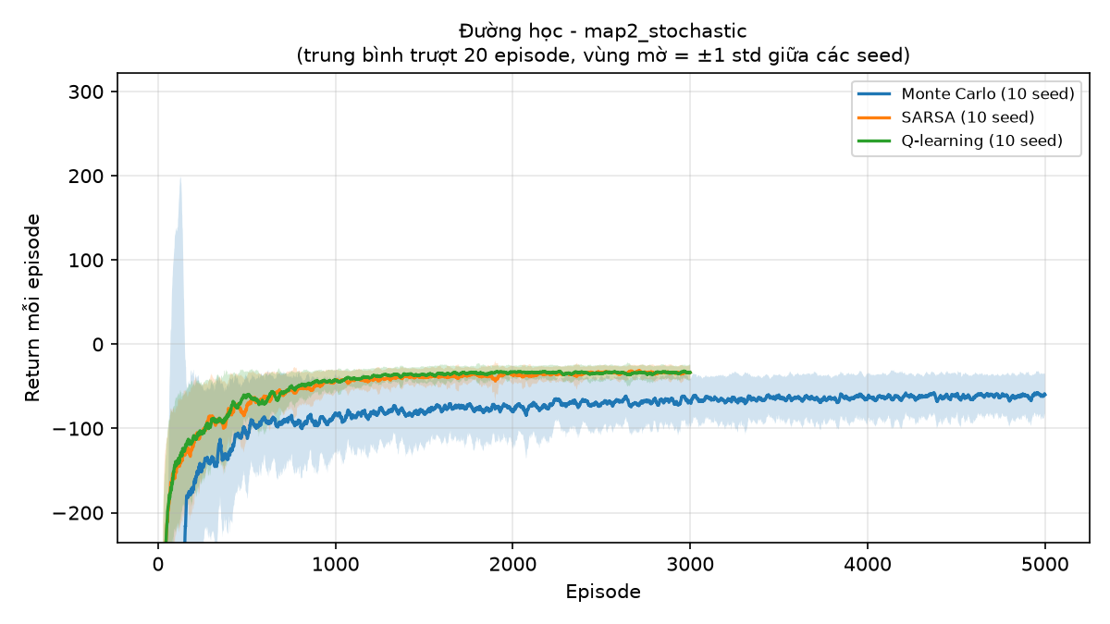

Picture 2 : Learning curves on Map 2
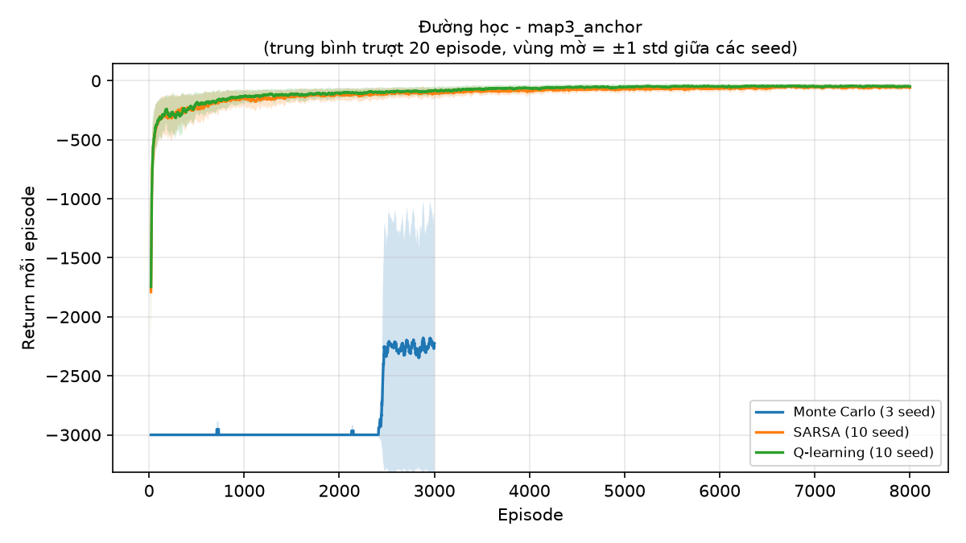

Picture 3: Q-learning policy on Map 3. Red arrows mean “move and use the anchor”.
On Map 3 the agent learned to go and get the anchor first, then walk around the walls, and use the anchor only at the very last step so the wind does not push it off G. I did not tell it to do this, so I was happy it found it by itself.

4.2 Policy Iteration vs Value Iteration
Map | Value Interation | Policy Interation
Map 1 | 18 sweeps,0.01s | 17 improvements,1.6 s
Map 2 | 99 sweeps, 0.07 s | 20 improvements, 3.0 s
Map 3 | 200 sweeps, 1.5 s | 27 improvements, 17 s

4.3 Changing the reward (Map 2, Q-learning)
Setting | Steps | Bumps | % time on top row
−1 per step (normal) | 28.0 | 5.35 | 28.5
−5 extra per bump | 48.3 | 2.49 | 13.7
+10 at G only, γ = 0.95 | 30.6 | 7.07 | 33.8
No random wind | 22.0 | 7.00 | 39.1
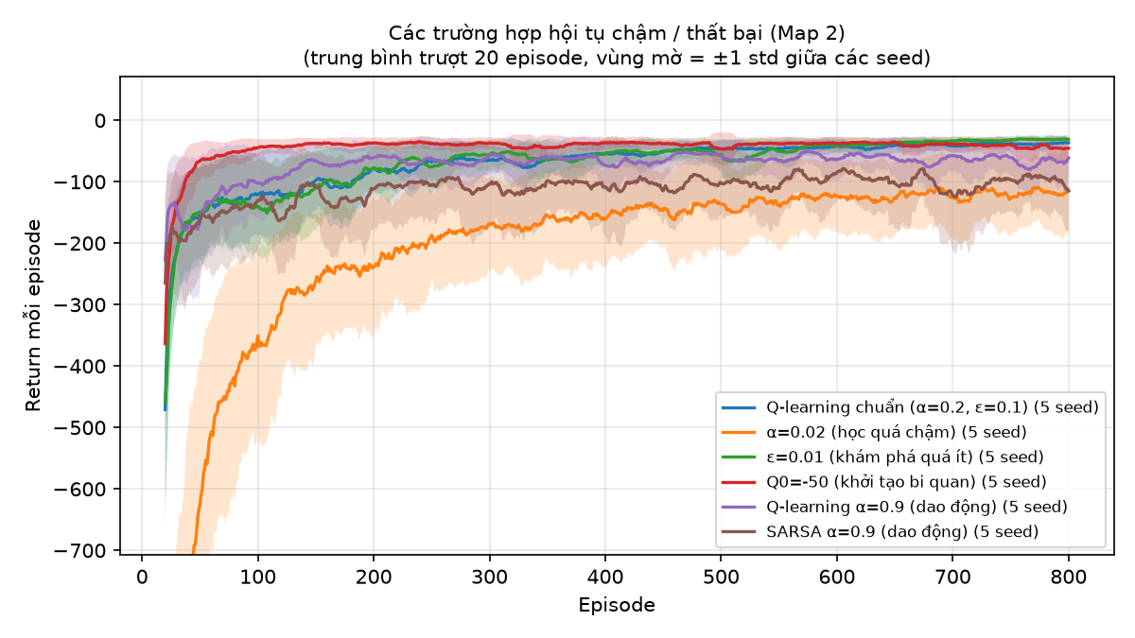
When I added −5 for hitting the edge, the agent stopped going along the top row so much and bumped less, but the path got almost twice as long. So the reward really changes what the agent does. Also the random wind makes the path longer than the fixed wind (28 vs 22 steps).
Figure 5. Learning curves of the failure cases

