Lab Experiment – 1
Golu Sah(241210040)

Aim: To design, simulate, and verify the functionality of Half Adder, Full Adder, and 4-bit Adder circuits using fundamental logic gates, and to implement Half Adder and Full Adder circuits exclusively with NAND gates.

Theory:

- Half Adder (Using Basic Logic Gates)

A Half Adder is a digital combinational circuit designed to perform the addition of two one-bit binary inputs, A and B. It generates two outputs:
  - Sum (S): Represents the least significant bit of the addition
  - Carry (C): Represents the overflow bit
    - Boolean Expressions: Sum: S = A ⊕ B. And Carry: C = A · B

The XOR gate is used to produce the Sum output because it gives a logic HIGH when the two inputs differ. The AND gate generates the Carry output only when both inputs are HIGH.

- Half Adder (Using NAND Gates Only)

Since NAND gates are universal gates, any digital logic function can be implemented using only NAND gates.

  - The XOR operation required for Sum is constructed by combining multiple NAND gates
  - The AND operation for Carry is also derived from NAND gate configurations

Thus, a complete Half Adder circuit can be designed without using XOR or AND gates directly.

- Full Adder (Using Basic Logic Gates)
A Full Adder is a combinational circuit that adds three binary inputs:
  - A , B , Carry-in (cin) It produces:
  - Sum (S)
  - Carry-out (Cout)

Boolean Expressions:
  - Sum: S = A ⊕ B ⊕ Cin
  - Carry: Cout = AB + Cin(A ⊕ B)

The Full Adder can be realized by connecting two Half Adders in sequence and combining their carry outputs through an OR gate.

- 4-bit Adder (Using Basic Logic Gates)

A 4-bit Adder is used for adding two 4-bit binary numbers. It is formed by cascading four Full Adders in series.

Working Principle:
  - Each Full Adder handles one bit position
  - The carry generated from each stage is forwarded to the next stage
  - The first Full Adder receives Cin = 0
  - The final output consists of:
- A 4-bit Sum
- A final Carry-out

This arrangement is commonly referred to as a Ripple Carry Adder due to sequential carry propagation.

Logisim Implementation:

Circuit diagrams for Half Adder, Full Adder, and 4-bit Adder were designed and tested in Logisim to verify correct logical operation.
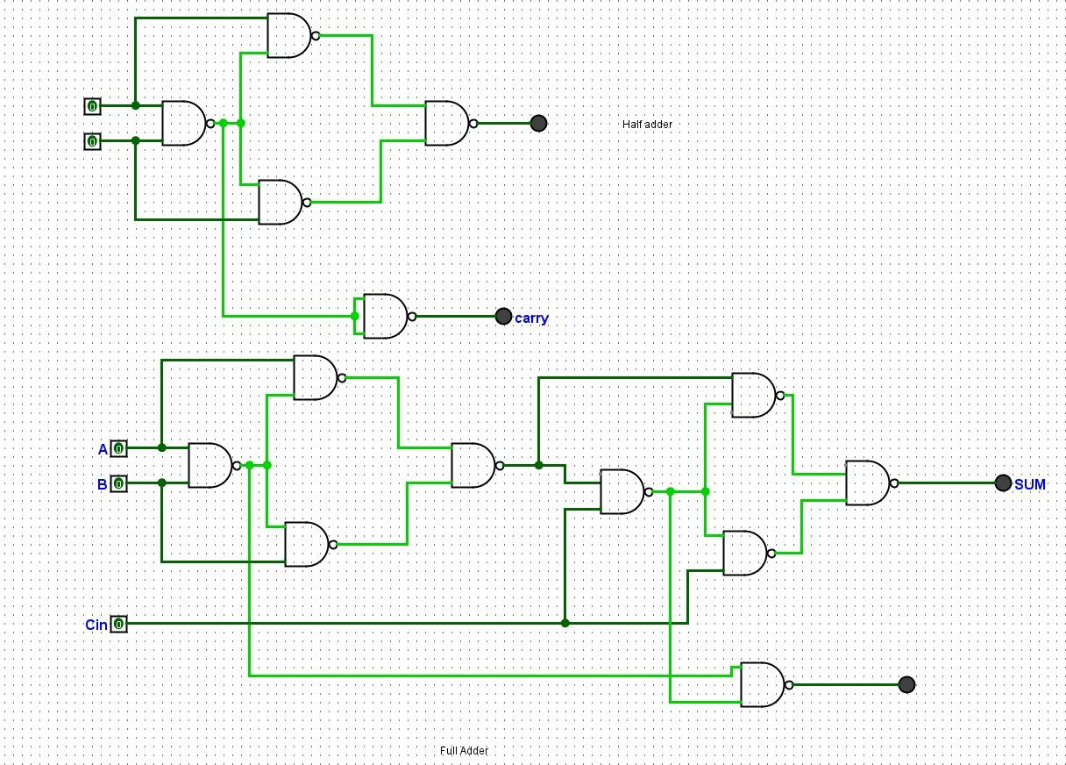

Full adder and half adder

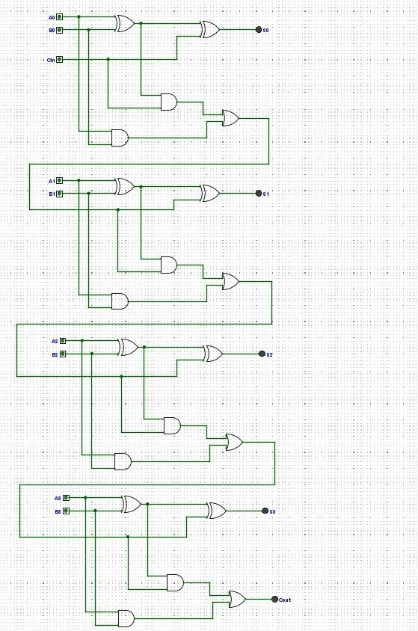
4 bit full adder

