Lab Experiment - 2

Golu Sah(241210040)

Aim:
To design and verify the operation of an 8:3 Encoder and an 8:1 Multiplexer using basic logic gates and simulation tools such as Logisim.

8:3 Encoder
An 8:3 Encoder is a combinational logic circuit that converts eight input lines into a 3-bit binary output. At any given time, only one input is assumed to be active.

Inputs:
  - D0, D1, D2, D3, D4, D5, D6, D7

Outputs:
  - Y2, Y1, Y0

Working Principle:
The encoder generates the binary equivalent of the active input line.

Boolean Expressions:
  - Y2 = D4 + D5 + D6 + D7
  - Y1 = D2 + D3 + D6 + D7
  - Y0 = D1 + D3 + D5 + D7

For example:

  - If D3 is HIGH, output will be 011
  - If D6 is HIGH, output will be 110

The encoder reduces multiple input lines into fewer output bits, making it useful in data compression and digital communication systems.

8:1 Multiplexer (MUX)

An 8:1 Multiplexer is a combinational circuit that selects one of eight input lines and forwards it to a single output line based on the selection inputs.

Inputs:
  - I0, I1, I2, I3, I4, I5, I6, I7

Selection Lines:
  - S2, S1, S0

Output:
  - Y

Working Principle:
The selection lines determine which input is connected to the output.

Output Expression:
Y = I0S2'S1'S0' + I1S2'S1'S0 + I2S2'S1S0' + I3S2'S1S0 + I4S2S1'S0' + I5S2S1'S0 + I6S2S1S0'
+ I7S2S1S0

Depending on the binary value of selection lines:

  - 000 selects I0
  - 001 selects I1
  - 010 selects I2
  - ...
  - 111 selects I7

The Multiplexer acts as a digital data selector and is widely used in communication systems, arithmetic circuits, and control units.

Logisim Implementation:
Both the 8:3 Encoder and 8:1 Multiplexer circuits were implemented and tested in Logisim software to verify their truth tables and operational correctness.

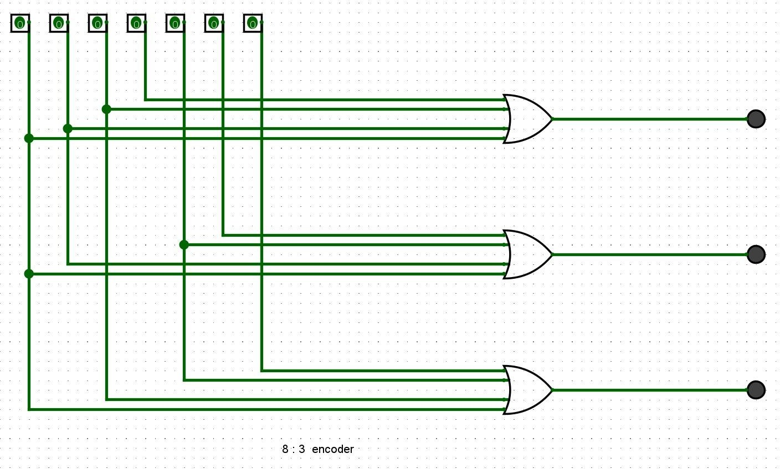
8 : 3 encoder
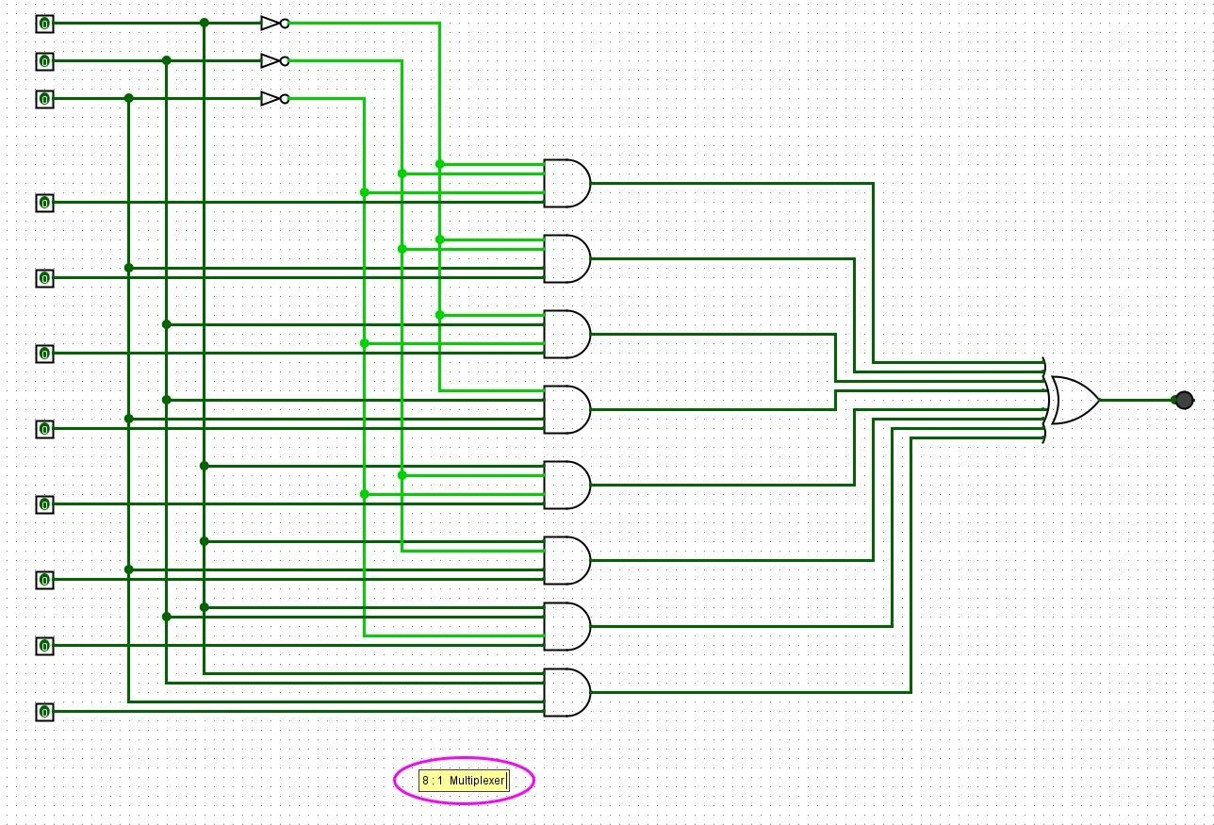
8 : 1 Mutliplexer

