Lab Experiment - 3

Golu Sah(241210040)

Aim: To design, implement, and verify the operation of a 4-bit Ripple Carry Adder using Full Adder circuits and basic logic gates in Logisim.

Theory:
A Ripple Carry Adder is a combinational digital circuit used for the addition of two binary numbers of multiple bits. It is formed by connecting several Full Adders in cascade, where the carry output of one stage becomes the carry input of the next stage.
In this experiment, four Full Adders are connected to perform the addition of two 4-bit binary numbers:
- A = A3 A2 A1 A0
- B = B3 B2 B1 B0

Inputs:
- A0, A1, A2, A3
- B0, B1, B2, B3
- Cin (Initial Carry Input)

Outputs:
- S0, S1, S2, S3 (Sum Bits)
- Cout (Final Carry Output)

Working Principle:

First Stage:
- Inputs: A0, B0, Cin
- Outputs: S0 and Carry C1

Second Stage:
- Inputs: A1, B1, C1

- Outputs: S1 and Carry C2

Third Stage:
- Inputs: A2, B2, C2
- Outputs: S2 and Carry C3

Fourth Stage:
- Inputs: A3, B3, C3
- Outputs: S3 and Final Carry Cout

The carry generated at each stage propagates through all subsequent stages, which is why it is called a “Ripple Carry Adder.”

Boolean Expressions for Each Full Adder:
- Sum = A ⊕ B ⊕ Cin
- Carry = AB + Cin(A ⊕ B)

Advantages:
- Simple design
- Easy to implement
- Suitable for small binary additions

Limitations:
- Carry propagation delay increases with the number of bits
- Slower performance for large bit operations

Logisim Implementation:
The circuit was implemented using NAND, AND, OR, and XOR gate combinations to construct Full Adders, which were then cascaded to form the complete 4-bit Ripple Carry Adder.

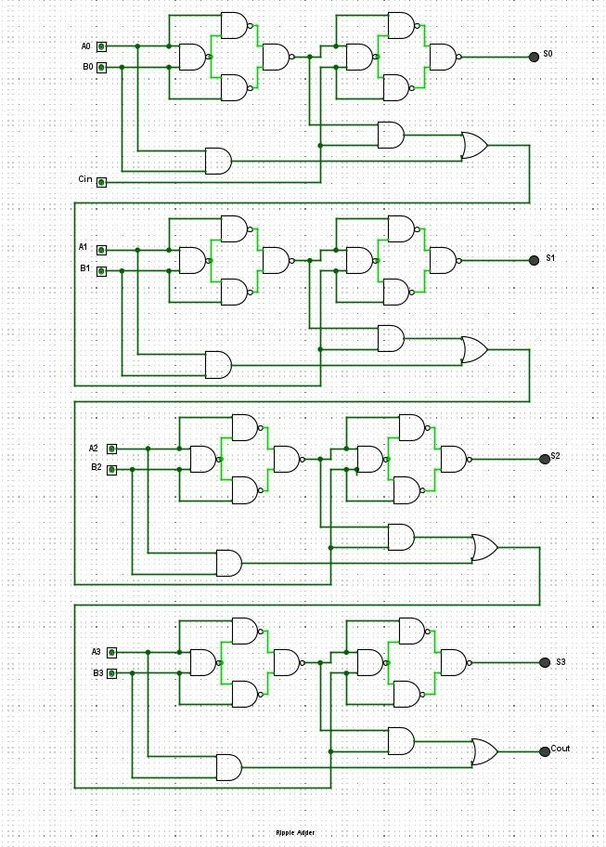
4 bit ripple adder

