Lab Experiment – 4

Golu Sah(241210040)

Aim:
To study the compilation and debugging process of a C/C++ program using the GNU Debugger (GDB), and to understand program execution through breakpoints, step-by-step tracing, and runtime analysis.

Theory:

Introduction to GNU Debugger (GDB)
GNU Debugger (GDB) is a powerful debugging tool used to monitor, control, and analyze the execution of programs. It helps programmers identify logical errors, execution flow, and variable changes during runtime.
Programs are compiled using the -g option to include debugging symbols:

g++ -g program.cpp -o output

Program Used in the Experiment
In this experiment, a multiplication table program was compiled and executed using GDB. The program accepts a number from the user and displays its multiplication table.
  - User enters a number
  - Program processes input
  - Loop executes repeatedly
  - Multiplication results are displayed

GDB Commands Used

Breakpoint:
break main

This command pauses execution at the main function.

Run:

run

Starts the program inside GDB.

Step:
step

Executes one statement at a time.

Continue:
continue

Resumes execution until the next breakpoint or program termination.

List:
list

Displays source code around the current execution point.

Code used :-

Using “list” command
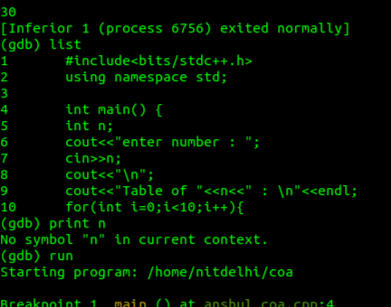

Execution Analysis
  - Program was compiled successfully with debugging symbols
  - Breakpoint was placed at main()

  - Execution paused before user input
  - Step command was used to monitor:
    - Variable declaration
    - User input
    - Loop execution
    - Output generation

Code output :-

Command used - “step” , “ run” , “breakpoint main” , “continue”
