Lab Experiment – 5

Golu Sah(241210040)

Aim:
To study various instruction addressing modes by executing and analyzing a C program through GNU Debugger (GDB), and to observe assembly instructions, memory references, and register operations.

Theory:

Introduction to Addressing Modes
Addressing modes define the method by which an instruction accesses its operands. Different addressing techniques allow processors to efficiently retrieve data from registers, constants, memory locations, or stack frames.

Using GDB commands such as info registers and disassemble, we can inspect machine-level execution and understand how high-level C code is translated into assembly instructions.

Immediate Addressing Mode
In Immediate Addressing Mode, constant values are directly embedded within the instruction.

Examples:

  - mov $0xa, ... → loads value 10 directly
  - mov $0x14, ... → loads value 20 directly
  - movl $0x1, ... → stores constant value

Observation:
This mode is mainly used for initializing variables or assigning fixed values.

Register Addressing Mode
In this mode, operands are stored in CPU registers, enabling faster execution.

Examples:

  - mov %rsp, %rbp
  - mov %eax, %esi
  - add %edx, %eax
  - xor %eax, %eax

Observation:
Register operations are fast because data is processed directly inside CPU registers.

Direct (Absolute) Addressing Mode
This mode directly references specific memory addresses or function locations.

Examples:

  - callq printf@plt
  - callq stack_chk_fail@plt

Observation:
Used for function calls and accessing predefined memory locations.

Register Indirect Addressing Mode
In this mode, a register contains the memory address of the operand.

Examples:

  - mov (%rax), %eax
  - mov %rax, ...
  - lea -0x34(%rbp), %rax

Observation:
Frequently used in pointer operations and array handling.

Indexed/Base Addressing Mode

The effective memory address is calculated using a base register and an offset.

Examples:

  - mov -0x34(%rbp), %edx
  - mov -0x30(%rbp), %eax
  - lea -0x34(%rbp), %rax

Observation:
Useful for local variables, arrays, and structured data storage.

Relative Addressing Mode
Relative addressing determines target addresses relative to the current instruction pointer.

Examples:

  - je (jump if equal)
  - jmp (unconditional jump)

Observation:
Primarily used for loops, branching, and conditional statements.

Stack Addressing Mode
Stack operations manage function calls, local variables, and return addresses.

Examples:

  - push %rbp
  - mov %rsp, %rbp
  - sub $0x40, %rsp
  - leaveq

Observation:
This mode manages stack frames during program execution.

Program Used:

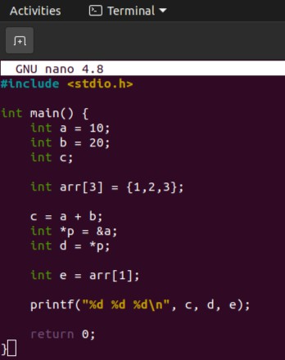

GDB Commands Used:
  - break main → Set breakpoint
  - run → Start execution
  - step → Execute line-by-line
  - continue → Resume execution
  - info registers → Display register contents
  - disassemble main → View assembly instructions

Code output :-

