Lab Experiment – 6
Golu Sah(241210040)

Aim:
To design and verify the operation of a 4-bit Common Bus System using multiplexers/basic logic gates for transferring binary data between multiple registers.

Theory:
A Common Bus System is a digital communication pathway that allows data transfer among various registers or components through a shared set of lines. In a 4-bit Common Bus System, four parallel lines are used to transfer 4-bit data from one selected register to another.
The bus reduces the need for multiple direct connections between registers, simplifying circuit design and improving hardware efficiency.

Components Used:
- Multiple 4-bit registers (e.g., Register A, B, C, D)
- Multiplexers or tri-state buffers
- Selection lines
- Control signals

Working Principle:
- Each register contains 4 bits of binary data
- Selection lines determine which register’s data is placed on the common bus
- Only one register can transfer data onto the bus at a time
- The selected data is then available for transfer to another destination register

Example:
If Register B is selected:

- Bus Output = B3 B2 B1 B0 If Register D is selected:
- Bus Output = D3 D2 D1 D0

Bus Structure:
For each bus line:

One multiplexer selects one bit from corresponding bits of all registers Thus:
- Bus line 0 selects from A0, B0, C0, D0
- Bus line 1 selects from A1, B1, C1, D1
- Bus line 2 selects from A2, B2, C2, D2
- Bus line 3 selects from A3, B3, C3, D3

Logisim Implementation:
The 4-bit Common Bus System was designed using multiplexers and logic gates in Logisim, where different registers were selected using control lines to observe correct data transfer on the shared bus.
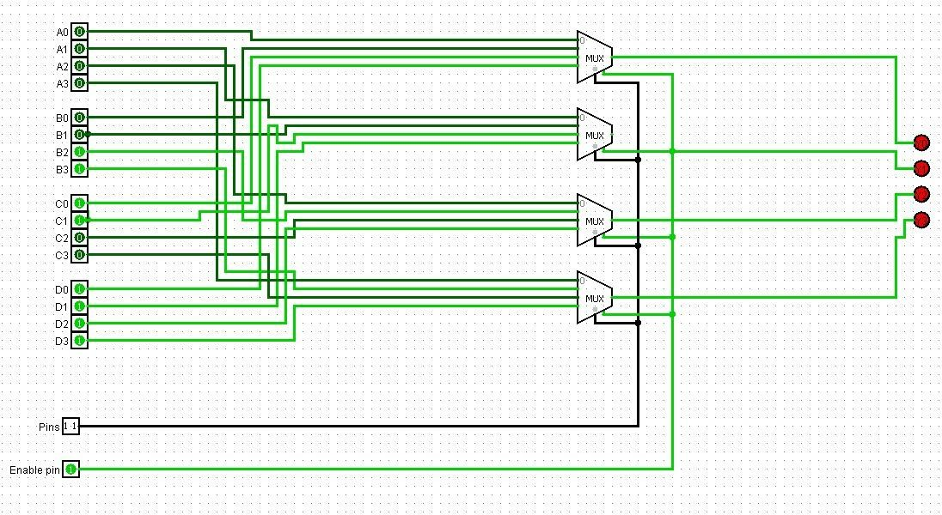

4- bit Common Bus Architecture

