**1. Introduction**

**Project Title:** CookBook – Your Virtual Kitchen Assistant

**Team ID:** NM2025TMID40468

**Team Leader:** Pooja S (Email: lavanyasuresh198305@gmail.com) **Team Members:**

1. Sivasankari M (Email: msivasankari237@gmail.com)
2. Manjupriya M (Email: manju20priya06@gmail.com)
3. Yuvasri B (Email: [mnagarajnagaraj43@gmail.com](mailto:mnagarajnagaraj43@gmail.com))
4. Yuvasri G (Email: yuvasrig2006@gmail.com)

# Project Overview

Purpose: CookBook is a recipe discovery platform that allows users to explore dishes across different categories, view trending recipes, and search based on their preferences.

Features:

* Recipe browsing by categories (Vegetarian, Chicken, Dessert, etc.)
* Trending dishes section
* Popular categories section
* Search functionality
* User-friendly UI with images and recipe cards

# Architecture

* Frontend: React.js with Bootstrap and Material UI
* Backend: Node.js and Express.js (optional, if extended)
* Database: MongoDB (for storing recipes, categories, and users)

# Setup Instructions

Prerequisites:

* Node.js
* MongoDB
* Git
* React.js
* Express.js- Visual Studio Code

Installation Steps:

1. Clone the repository: git clone
2. Install client dependencies: cd client && npm install
3. Install server dependencies: cd ../server && npm install

# Folder Structure

CookBook/

|-- client/ # React frontend

| |-- components/

| |-- pages/

|-- server/ # Node.js backend (optional)

| |-- routes/

| |-- models/

| |-- controllers/

# Running the Application

Frontend: cd client npm start

Backend: cd server npm start

Access at: http://localhost:3000

# API Documentation

User:

* /api/user/register- /api/user/login

Recipes:

* /api/recipes/:category- /api/recipes/trending

Search:

* /api/recipes/search?q=

# Authentication

* JWT-based authentication for secure login
* Middleware protects private routes (if backend is enabled)

# User Interface

* Landing Page
* Popular Categories Page
* Trending Dishes Page
* Category-specific Pages (e.g., Vegetarian, Dessert, Chicken) - Search functionality

# Testing

* Manual testing during milestones
* Tools: Postman, Chrome Dev Tools, Browser testing

# Screenshots or Demo

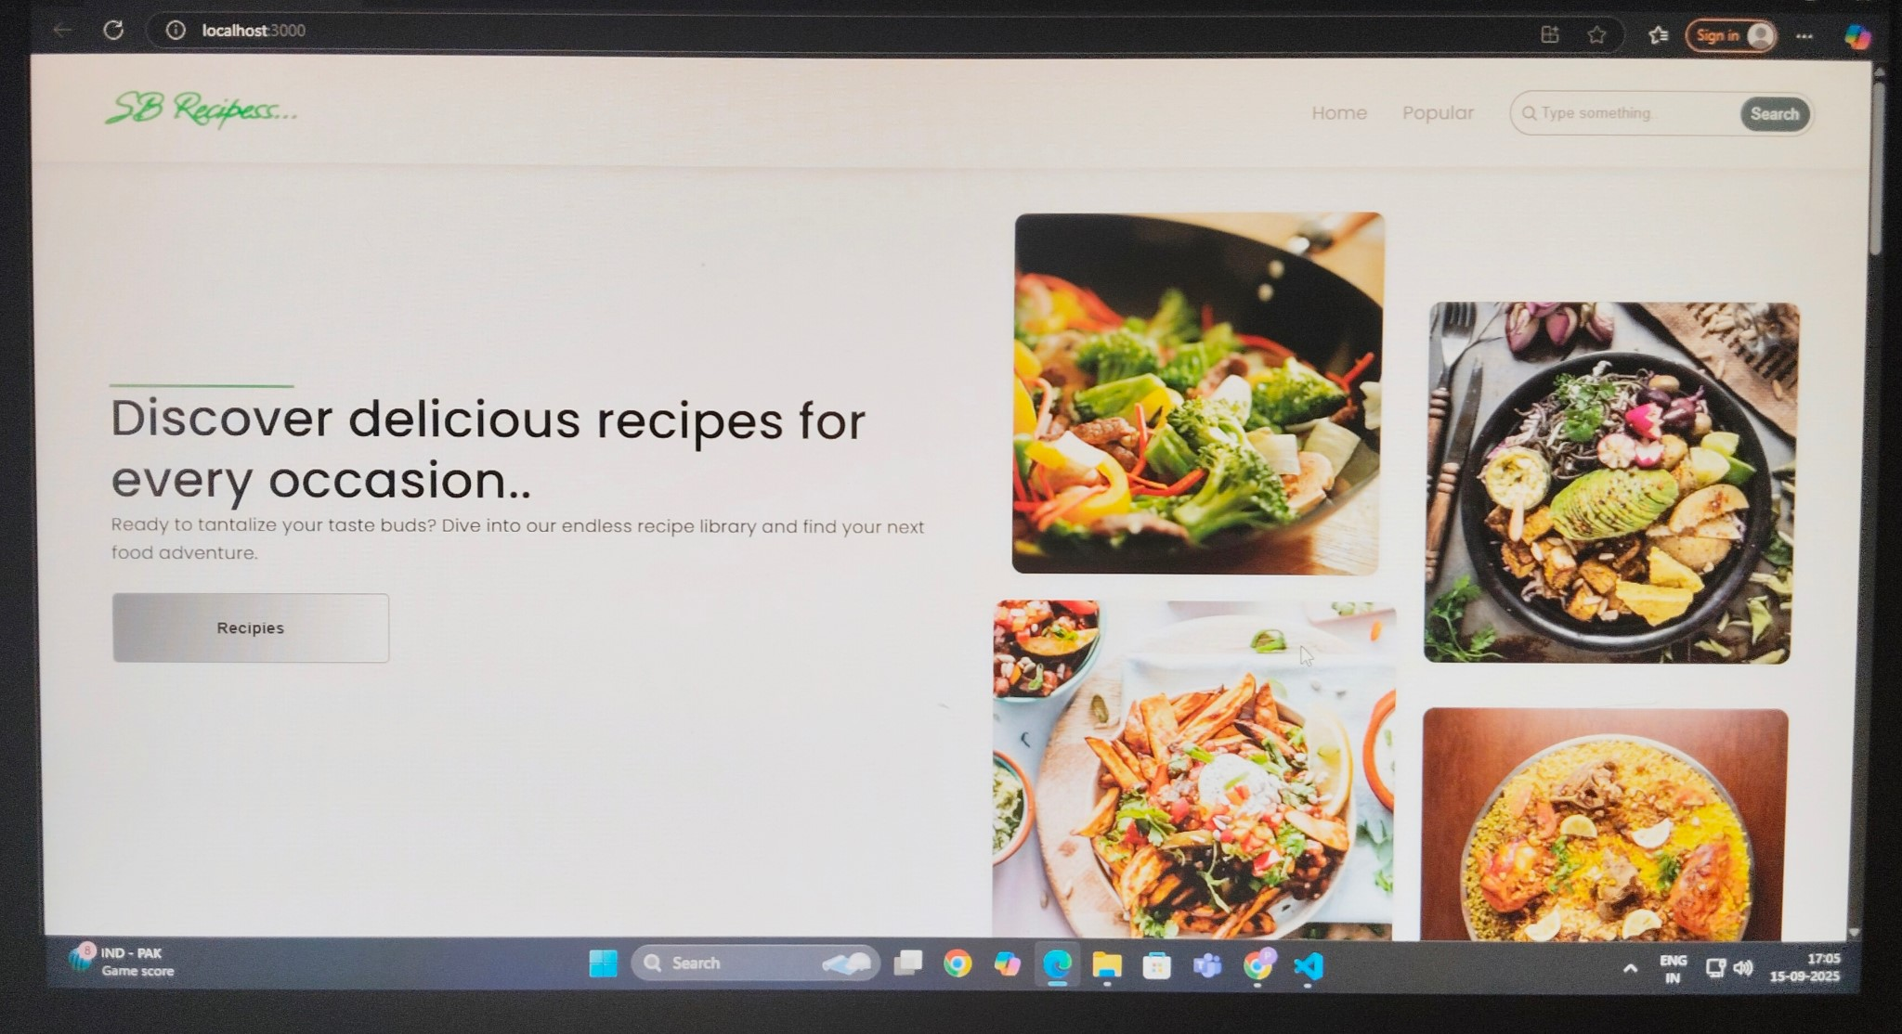

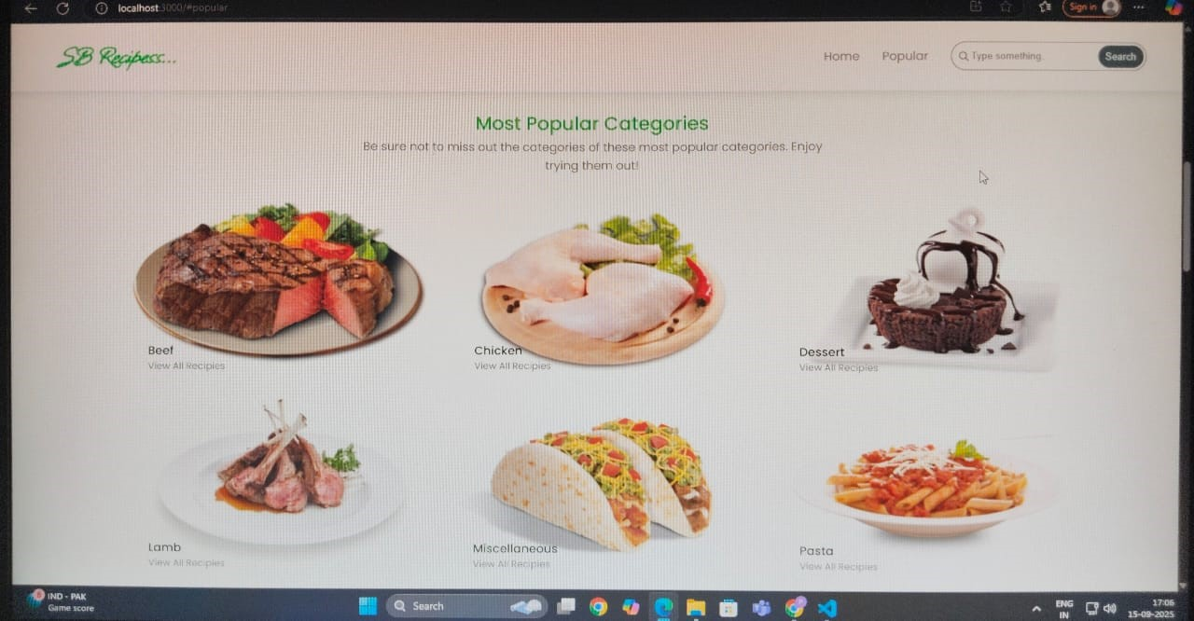

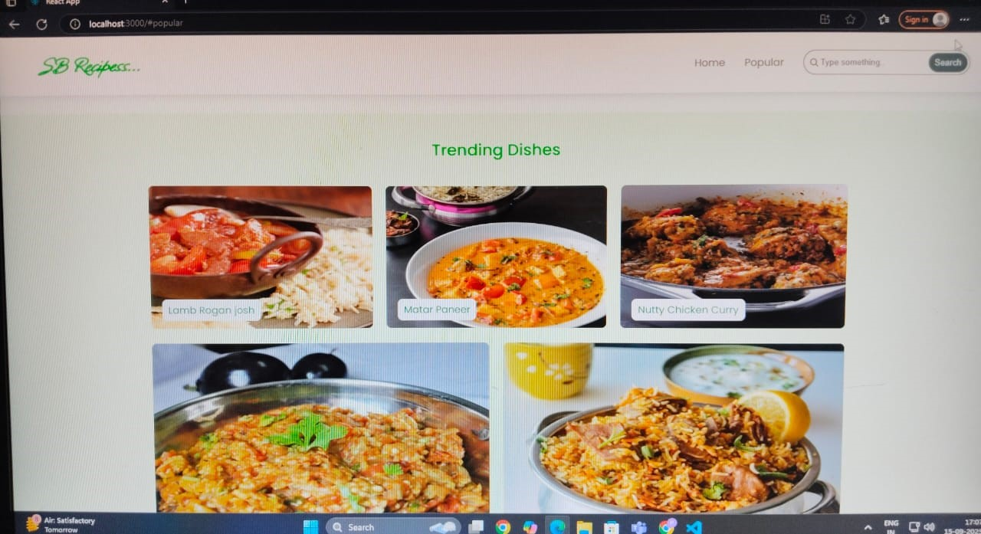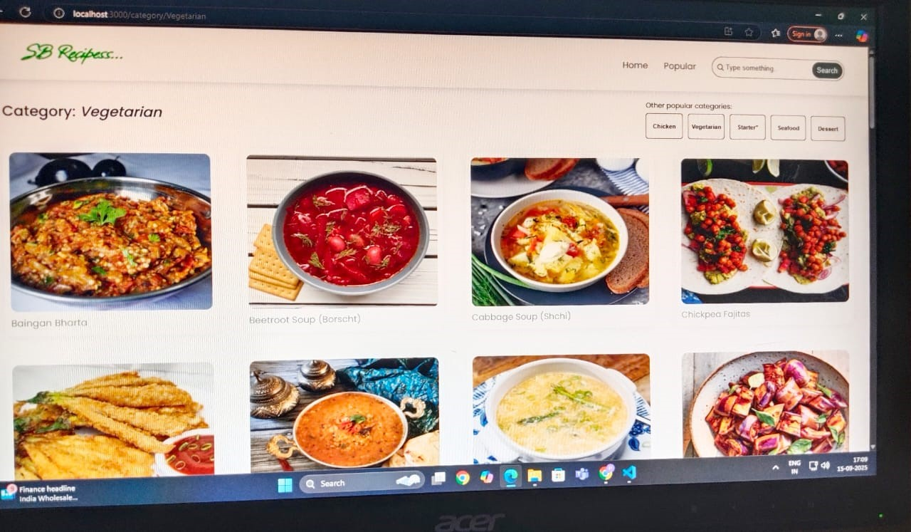

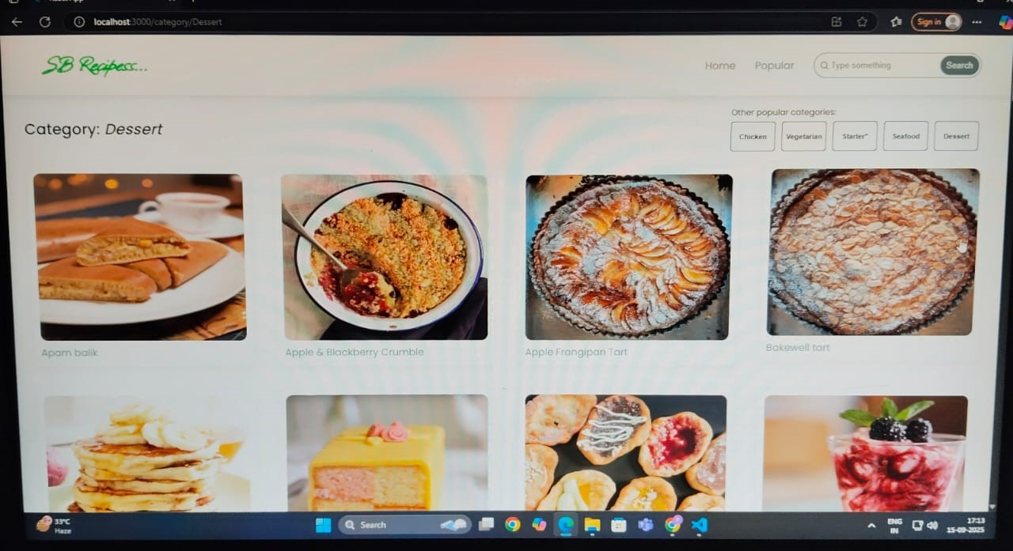

# Known Issues

* Limited backend functionality (currently focused on frontend UI)
* No user authentication fully implemented
* Recipe data is static (needs dynamic API integration)

# Future Enhancements

* Implement full backend with user accounts and authentication
* Enable users to add their own recipes
* Rating and review system for recipes
* Advanced search and filtering options
* Mobile responsive design improvements