7. Write a Servlet program to store a user's preferences (like theme or language) using cookies. Retrieve and display these preferences on
subsequent visits.

AIM
To develop a Java Servlet-based web application that stores user preferences (such as theme and language) using cookies and retrieves them on subsequent visits to personalize the weather information webpage.

ALGORITHM
- Create a Dynamic Web Project in Eclipse or any IDE.
- Add Servlet API library (Apache Tomcat server).
- Create an HTML form to accept user preferences: Theme (Light/Dark)
Language (English/Tamil/etc.)
- Develop a Servlet (PreferenceServlet): Read user inputs from the form.
Store preferences using cookies.
- Develop another Servlet (DisplayServlet): Retrieve cookies.
Display saved preferences along with weather info.
- Configure web.xml (if not using annotations).
- Run the project on server (Tomcat).

Test in browser:
First visit → set preferences.
Next visit → preferences auto-loaded.

SOURCE CODE

HTML Page (index.html)
<!DOCTYPE html>
<html>
<head>
<title>LuxStay | Preferences</title>

<style>
body {
font-family: Arial;
background: linear-gradient(135deg, #1c1c2b, #2c2c54);
color: white;
display: flex;
justify-content: center;
align-items: center;
height: 100vh;
}

.box {
background: rgba(255,255,255,0.1);
padding: 30px;
border-radius: 10px;
width: 300px;
}

h2 { text-align: center; }

select, input {
width: 100%;
padding: 10px;
margin-top: 10px;
}

.btn {
background: orange;
border: none;
cursor: pointer;
}
</style>
</head>

<body>
<div class="box">
<h2>Hotel Preferences</h2>

<form action="PreferenceServlet" method="post">
Theme:
<select name="theme">
<option value="Light">Light</option>
<option value="Dark">Dark</option>
</select>

Language:
<select name="language">
<option value="English">English</option>
<option value="Tamil">Tamil</option>
</select>

Room Type:
<select name="roomtype">
<option value="Deluxe">Deluxe</option>
<option value="Suite">Suite</option>
</select>

Meal:
<select name="meal">
<option value="Breakfast">Breakfast</option>
<option value="Full Board">Full Board</option>
</select>

<input type="submit" value="Save" class="btn">
</form>

<br>
<a href="DisplayServlet" style="color:white;">View Booking</a>
</div>
</body>
</html>

PreferenceServlet.java
package com.example;

import java.io.*;
import javax.servlet.*;
import javax.servlet.http.*;
import javax.servlet.annotation.WebServlet;

@WebServlet("/PreferenceServlet")
public class PreferenceServlet extends HttpServlet {

private static final long serialVersionUID = 1L;

protected void doPost(HttpServletRequest request, HttpServletResponse response)
throws ServletException, IOException {

String theme = request.getParameter("theme");
String language = request.getParameter("language");
String roomtype = request.getParameter("roomtype");
String meal = request.getParameter("meal");

Cookie c1 = new Cookie("theme", theme);
Cookie c2 = new Cookie("language", language);
Cookie c3 = new Cookie("roomtype", roomtype);
Cookie c4 = new Cookie("meal", meal);

int oneDay = 24 * 60 * 60;
c1.setMaxAge(oneDay);
c2.setMaxAge(oneDay);
c3.setMaxAge(oneDay);
c4.setMaxAge(oneDay);

response.addCookie(c1);
response.addCookie(c2);
response.addCookie(c3);
response.addCookie(c4);

response.setContentType("text/html");
PrintWriter out = response.getWriter();

out.println("<html><head><title>Saved</title>");
out.println("<style>");
out.println("body { font-family: Arial; background: linear-gradient(135deg,#1c1c2b,#2c2c54); color:white; display:flex; justify-content:center; align-items:center; height:100vh; }");
out.println(".card { background: rgba(255,255,255,0.1); padding:40px; border-radius:10px; text-align:center; }");
out.println("a { display:inline-block; margin-top:20px; padding:10px 20px; background:orange; color:black; text-decoration:none; border-radius:5px; }");
out.println("a:hover { background:#ffcc70; }");
out.println("</style></head>");

out.println("<body>");
out.println("<div class='card'>");
out.println("<h2>Preferences Saved ✅</h2>");
out.println("<p>Your hotel preferences are stored successfully.</p>");
out.println("<a href='DisplayServlet'>View Booking</a>");
out.println("</div>");
out.println("</body></html>");
}
}

DisplayServlet.java
package com.example;

import java.io.*;
import javax.servlet.*;
import javax.servlet.http.*;
import javax.servlet.annotation.WebServlet;

@WebServlet("/DisplayServlet")
public class DisplayServlet extends HttpServlet {

private static final long serialVersionUID = 1L;

protected void doGet(HttpServletRequest request, HttpServletResponse response)
throws ServletException, IOException {

Cookie[] cookies = request.getCookies();

String theme="Light", language="English", roomtype="Deluxe", meal="Breakfast";

if (cookies != null) {
for (Cookie c : cookies) {
if (c.getName().equals("theme")) theme = c.getValue();
if (c.getName().equals("language")) language = c.getValue();
if (c.getName().equals("roomtype")) roomtype = c.getValue();
if (c.getName().equals("meal")) meal = c.getValue();
}
}

response.setContentType("text/html");
PrintWriter out = response.getWriter();

out.println("<html><head><title>Booking</title>");
out.println("<style>");
out.println("body { font-family: Arial; background: linear-gradient(135deg,#1c1c2b,#2c2c54); color:white; display:flex; justify-content:center; align-items:center; height:100vh; }");
out.println(".card { background: rgba(255,255,255,0.1); padding:30px; border-radius:10px; width:350px; }");
out.println("h2 { text-align:center; }");
out.println("p { font-size:14px; margin:8px 0; }");
out.println(".btn { display:block; margin-top:20px; text-align:center; padding:10px; background:orange; color:black; text-decoration:none; border-radius:5px; }");
out.println(".btn:hover { background:#ffcc70; }");
out.println("</style></head>");

out.println("<body>");
out.println("<div class='card'>");

out.println("<h2>Hotel Booking Details</h2>");
out.println("<p><b>Theme:</b> " + theme + "</p>");
out.println("<p><b>Language:</b> " + language + "</p>");
out.println("<p><b>Room Type:</b> " + roomtype + "</p>");
out.println("<p><b>Meal Plan:</b> " + meal + "</p>");

out.println("<h3>Booking Info</h3>");
out.println("<p>Check-in: 17 April 2026</p>");
out.println("<p>Check-out: 20 April 2026</p>");
out.println("<p>Status: Confirmed</p>");

out.println("<a href='index.html' class='btn'>Back</a>");

out.println("</div>");
out.println("</body></html>");
}
}

OUTPUT :

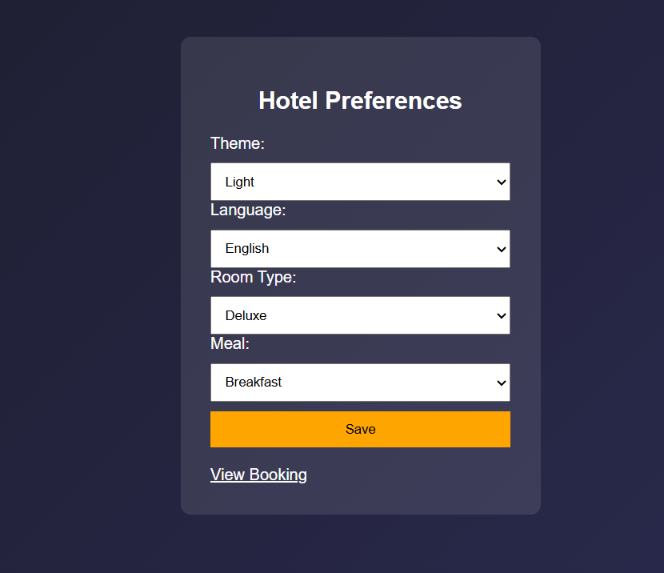

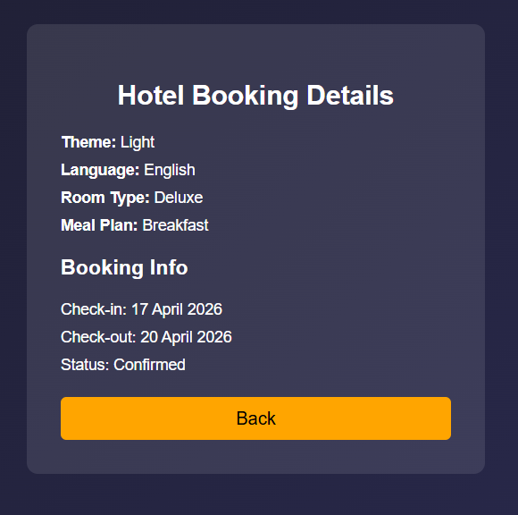



Result:
The experiment was successfully completed.User preferences (theme and language) were stored using cookies and retrieved on subsequent visits, allowing the weather webpage to provide a personalized user experience.

