EXP.NO: 6 | Write a Servlet to demonstrate session tracking  using HttpSession.
DATE:24/02/2025

AIM:
To demonstrate session tracking using HttpSession in a Servlet-based web
application. The exercise involves implementing a simple login system where a user can log
in with their username and password, and their session will be tracked throughout their
interaction with the web application.
ALGORITHM:
1. Input:
- The user will enter their username and password in a login form.
- Provide a submit button to send the data to the servlet for authentication.
2. Create the Login Servlet:
  - Write a Java servlet class to handle login requests.
  - Retrieve the username and password from the form.
3.Validate User Credentials:
  - In the servlet, check if the username and password match the expected values.
  - The servlet will have two methods:
    - doGet() to handle the GET requests.
    - doPost() to handle the POST requests.
  - If valid, create a session and store the username in the session.
  - If invalid, redirect the user back to the login page with an error message.
4. Create and Track User Session:
  - Upon successful login, use the HttpSession object to store the session data.
  - Use the session.setAttribute(&quot;username&quot;, username) method to save the username.
. Optionally, set session timeout usingsession.setMaxInactiveInterval(time_in_seconds) to manage session expiration.
5.Deploy and Test the Servlet:
  - After a successful login, the user will be redirected to a protected page (e.g., a
dashboard or home page).
  - The protected page should check if the user is authenticated by checking the
session attribute.
6.Logout and Session Invalidation:
  - Provide a logout feature that invalidates the session using session.invalidate()
when the user logs out.
  - After logout, redirect the user back to the login page.
Code:
index.html
<!DOCTYPE html>
<html>
<head>
<title>Hotel Booking Portal | Login</title>
<style>
@import url('https://fonts.googleapis.com/css2?family=Playfair+Display:wght@500;700&family=Lato:wght@300;400&display=swap');

* { box-sizing: border-box; margin: 0; padding: 0; }

body {
font-family: 'Lato', sans-serif;
background: linear-gradient(135deg, #1a1a2e 0%, #16213e 50%, #0f3460 100%);
display: flex;
justify-content: center;
align-items: center;
height: 100vh;
}

.login-card {
background: rgba(255,255,255,0.05);
backdrop-filter: blur(16px);
border: 1px solid rgba(255,255,255,0.12);
padding: 40px 36px;
border-radius: 16px;
width: 340px;
text-align: center;
box-shadow: 0 20px 60px rgba(0,0,0,0.4);
}

.hotel-icon {
font-size: 2.5rem;
margin-bottom: 8px;
}

h2 {
font-family: 'Playfair Display', serif;
color: #f0c674;
font-size: 1.6rem;
margin-bottom: 6px;
}

.subtitle {
color: rgba(255,255,255,0.45);
font-size: 0.82rem;
letter-spacing: 1.5px;
text-transform: uppercase;
margin-bottom: 28px;
}

input[type="text"],
input[type="password"] {
width: 100%;
padding: 11px 14px;
margin: 8px 0;
background: rgba(255,255,255,0.08);
border: 1px solid rgba(255,255,255,0.15);
border-radius: 8px;
color: #fff;
font-family: 'Lato', sans-serif;
font-size: 0.92rem;
outline: none;
transition: border 0.2s;
}

input[type="text"]::placeholder,
input[type="password"]::placeholder {
color: rgba(255,255,255,0.35);
}

input[type="text"]:focus,
input[type="password"]:focus {
border-color: #f0c674;
}

.btn {
width: 100%;
padding: 12px;
margin-top: 16px;
background: linear-gradient(135deg, #f0c674, #d4a843);
color: #1a1a2e;
border: none;
border-radius: 8px;
font-family: 'Playfair Display', serif;
font-size: 1rem;
font-weight: 700;
letter-spacing: 0.5px;
cursor: pointer;
transition: opacity 0.2s, transform 0.1s;
}

.btn:hover { opacity: 0.9; transform: translateY(-1px); }
.btn:active { transform: translateY(0); }

.footer-note {
color: rgba(255,255,255,0.25);
font-size: 0.72rem;
margin-top: 20px;
}
</style>
</head>
<body>
<div class="login-card">
<div class="hotel-icon"></div>
<h2>Grand Portal</h2>
<p class="subtitle">Hotel Booking System</p>

<form action="HotelSessionServlet" method="POST">
<input type="text" name="name" placeholder="Username" required>
<input type="password" name="password" placeholder="Password" required>
<input type="submit" class="btn" value="Sign In">
</form>

<p class="footer-note">Use password: <strong style="color:#f0c674">hotel123</strong> to login</p>
</div>
</body>
</html>

hotelsessionsevlet.java
package com.example;

import java.io.*;
import javax.servlet.*;
import javax.servlet.http.*;
import javax.servlet.annotation.WebServlet;

@WebServlet("/HotelSessionServlet")
public class HotelSessionServlet extends HttpServlet {

protected void doPost(HttpServletRequest request, HttpServletResponse response)
throws ServletException, IOException {

response.setContentType("text/html");
PrintWriter out = response.getWriter();

String name = request.getParameter("name");
String pass = request.getParameter("password");

if (pass.equals("hotel123")) {
// Create session and store guest name
HttpSession session = request.getSession();
session.setAttribute("guest", name);

// Redirect to booking dashboard
response.sendRedirect("HotelDashboardServlet");
} else {
out.println("<!DOCTYPE html><html><head>");
out.println("<title>Login Failed</title>");
out.println("<style>body{font-family:sans-serif;background:#1a1a2e;color:#fff;text-align:center;padding-top:60px;}</style>");
out.println("</head><body>");
out.println("<p style='color:#e74c3c;font-size:1.1rem;'>❌ Invalid Password! Please try again.</p>");
out.println("<a href='index.html' style='color:#f0c674;'>← Back to Login</a>");
out.println("</body></html>");
}
}
}

hoteldashboardservlet.java
package com.example;

import java.io.*;
import javax.servlet.*;
import javax.servlet.http.*;
import javax.servlet.annotation.WebServlet;

@WebServlet("/HotelDashboardServlet")
public class HotelDashboardServlet extends HttpServlet {

protected void doGet(HttpServletRequest request, HttpServletResponse response)
throws ServletException, IOException {

response.setContentType("text/html");
PrintWriter out = response.getWriter();

// Validate session
HttpSession session = request.getSession(false);

if (session != null && session.getAttribute("guest") != null) {
String guest = (String) session.getAttribute("guest");

out.println("<!DOCTYPE html><html><head>");
out.println("<title>Hotel Booking Dashboard</title>");
out.println("<style>");
out.println(" @import url('https://fonts.googleapis.com/css2?family=Playfair+Display:wght@500;700&family=Lato:wght@300;400&display=swap');");
out.println(" * { box-sizing: border-box; margin: 0; padding: 0; }");
out.println(" body { font-family: 'Lato', sans-serif; background: linear-gradient(135deg, #1a1a2e, #16213e, #0f3460); min-height: 100vh; color: #fff; padding: 40px 20px; }");
out.println(" .container { max-width: 800px; margin: 0 auto; }");
out.println(" .header { text-align: center; margin-bottom: 40px; }");
out.println(" .header h1 { font-family: 'Playfair Display', serif; color: #f0c674; font-size: 2rem; margin-bottom: 6px; }");
out.println(" .header p { color: rgba(255,255,255,0.5); font-size: 0.9rem; letter-spacing: 1px; text-transform: uppercase; }");
out.println(" .cards { display: grid; grid-template-columns: repeat(auto-fit, minmax(220px, 1fr)); gap: 20px; margin-bottom: 30px; }");
out.println(" .card { background: rgba(255,255,255,0.07); border: 1px solid rgba(255,255,255,0.12); border-radius: 14px; padding: 24px; text-align: center; }");
out.println(" .card .icon { font-size: 2rem; margin-bottom: 10px; }");
out.println(" .card h3 { font-family: 'Playfair Display', serif; color: #f0c674; font-size: 1.1rem; margin-bottom: 6px; }");
out.println(" .card p { color: rgba(255,255,255,0.6); font-size: 0.85rem; line-height: 1.5; }");
out.println(" .booking-form { background: rgba(255,255,255,0.06); border: 1px solid rgba(255,255,255,0.12); border-radius: 14px; padding: 30px; }");
out.println(" .booking-form h2 { font-family: 'Playfair Display', serif; color: #f0c674; margin-bottom: 20px; }");
out.println(" .form-row { display: flex; gap: 16px; margin-bottom: 14px; flex-wrap: wrap; }");
out.println(" .form-row input, .form-row select { flex: 1; min-width: 140px; padding: 10px 14px; background: rgba(255,255,255,0.08); border: 1px solid rgba(255,255,255,0.15); border-radius: 8px; color: #fff; font-family: 'Lato'; font-size: 0.9rem; outline: none; }");
out.println(" .book-btn { display: inline-block; margin-top: 10px; padding: 12px 32px; background: linear-gradient(135deg, #f0c674, #d4a843); color: #1a1a2e; border: none; border-radius: 8px; font-family: 'Playfair Display', serif; font-weight: 700; font-size: 1rem; cursor: pointer; }");
out.println(" .logout { display: block; text-align: center; margin-top: 30px; color: rgba(255,255,255,0.4); text-decoration: none; font-size: 0.85rem; letter-spacing: 0.5px; }");
out.println(" .logout:hover { color: #f0c674; }");
out.println("</style></head><body>");

out.println("<div class='container'>");
out.println(" <div class='header'>");
out.println(" <h1>🏨 Welcome, " + guest + "!</h1>");
out.println(" <p>Grand Portal — Hotel Booking Dashboard</p>");
out.println(" </div>");

out.println(" <div class='cards'>");
out.println(" <div class='card'><div class='icon'>🛏</div><h3>Deluxe Room</h3><p>King bed, sea view, complimentary breakfast. ₹4,500/night</p></div>");
out.println(" <div class='card'><div class='icon'>🌿</div><h3>Garden Suite</h3><p>Private balcony, garden view, spa access. ₹7,200/night</p></div>");
out.println(" <div class='card'><div class='icon'>👑</div><h3>Presidential Suite</h3><p>Full floor, butler service, panoramic view. ₹18,000/night</p></div>");
out.println(" </div>");

out.println(" <div class='booking-form'>");
out.println(" <h2>📋 Book a Room</h2>");
out.println(" <div class='form-row'>");
out.println(" <input type='text' placeholder='Full Name' value='" + guest + "'>");
out.println(" <select><option>Deluxe Room</option><option>Garden Suite</option><option>Presidential Suite</option></select>");
out.println(" </div>");
out.println(" <div class='form-row'>");
out.println(" <input type='date' placeholder='Check-in'>");
out.println(" <input type='date' placeholder='Check-out'>");
out.println(" </div>");
out.println(" <button class='book-btn'>Confirm Booking</button>");
out.println(" </div>");

out.println(" <a class='logout' href='HotelLogoutServlet'>🚪 Logout</a>");
out.println("</div></body></html>");

} else {
out.println("<p style='color:red;text-align:center;padding-top:60px;'>⚠ Session expired. Please login first!</p>");
request.getRequestDispatcher("index.html").include(request, response);
}
}
}

hotelLogoutServlet.java:
package com.example;

import java.io.*;
import javax.servlet.*;
import javax.servlet.http.*;
import javax.servlet.annotation.WebServlet;

@WebServlet("/HotelLogoutServlet")
public class HotelLogoutServlet extends HttpServlet {

protected void doGet(HttpServletRequest request, HttpServletResponse response)
throws ServletException, IOException {

// Invalidate the session
HttpSession session = request.getSession(false);
if (session != null) {
session.invalidate();
}

// Redirect back to login page
response.sendRedirect("index.html");
}
}

Output:
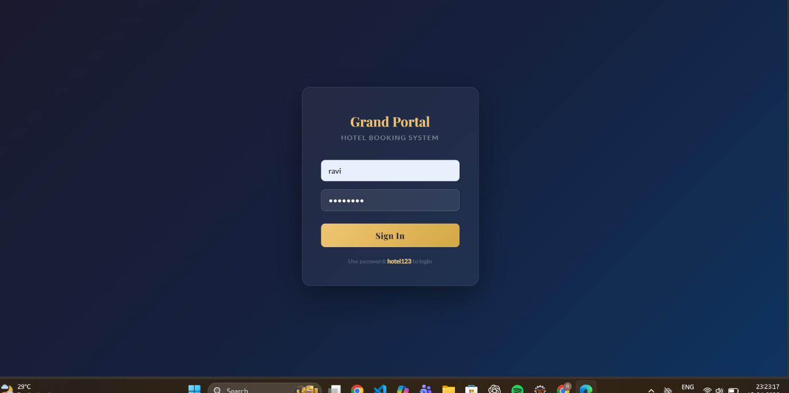
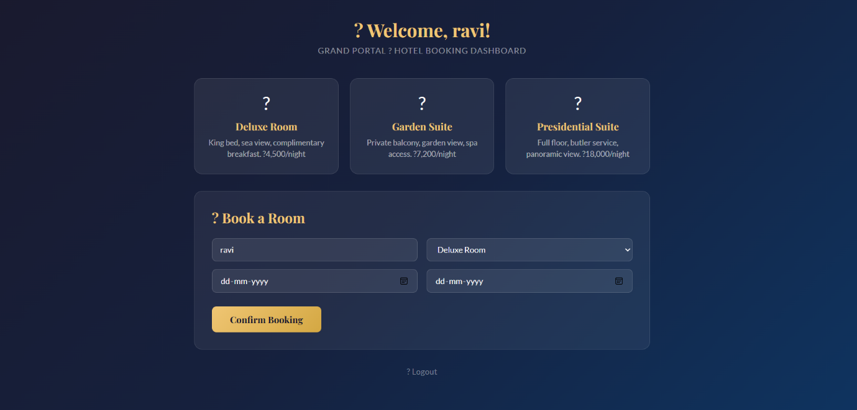

RESULT:
A simple login system is created where the user&#39;s session is tracked by a servlet to
demonstrate session tracking using HttpSession.

