CUSTOMER CHURN PREDICTION
An End-to-End Data Science & Machine Learning Project’s Report

Prepared by
Umair
BS Data Science Student
Dataset Source
Customer Churn Dataset — Kaggle (Muhammad Shahid Azeem)
kaggle.com/datasets/muhammadshahidazeem/customer-churn-dataset
September 2026

1. Introduction
Customer churn, the point at which a paying customer decides to walk away, is one of the most expensive problems a subscription business can face. It is almost always cheaper to keep an existing customer than to win a new one, so being able to flag a customer who is likely to leave before they actually leave has real commercial value. This report documents a complete churn-prediction workflow: understanding the raw data, cleaning and preparing it, exploring the patterns inside it, training a classification model on it, evaluating that model honestly, and finally wrapping it in a small interactive app so that a prediction can be generated for any customer without writing a line of code.
The work was carried out end to end in a single Jupyter notebook using pandas, seaborn, matplotlib and scikit-learn, with the final trained model deployed through a Gradio interface. Every figure, table and result quoted in this report was read directly out of that notebook's own outputs, not estimated after the fact, so the numbers below match what the notebook actually produced.

2. Dataset Source
The dataset used for this project is the Customer Churn Dataset, published on Kaggle by Muhammad Shahid Azeem, and specifically the training file customer_churn_dataset-training-master.csv. It can be found at:
https://www.kaggle.com/datasets/muhammadshahidazeem/customer-churn-dataset?select=customer_churn_dataset-training-master.csv
As loaded into the notebook, the dataset contains 440,833 rows and 12 columns, covering demographic details, usage behaviour, billing history, and a binary Churn label for each customer. It is large enough to give a tree-based model plenty of examples to learn from, while still being small enough to explore comfortably on a personal laptop.

3. Data Dictionary
The table below lists every column exactly as it appears in the raw CSV, along with its data type and what it represents. This is the reference point for every decision made later in the preprocessing and modeling stages.
Column | Type | Description
CustomerID | Numeric (ID) | Unique identifier for each customer. Dropped before modeling — an ID carries no predictive signal and only risks overfitting.
Age | Numeric (years) | Customer's age, ranging from 18 to 65 in this dataset.
Gender | Categorical | Male or Female. Label-encoded to 0/1 for modeling.
Tenure | Numeric (months) | How long the customer has held their subscription, from 1 to 60 months.
Usage Frequency | Numeric (count) | How often the customer used the service in a given period (1–30).
Support Calls | Numeric (count) | Number of support calls the customer placed (0–10). Turned out to be the single strongest churn signal.
Payment Delay | Numeric (days) | Average number of days the customer's payment was delayed (0–30).
Subscription Type | Categorical | Basic, Standard, or Premium. One-hot encoded for modeling.
Contract Length | Categorical | Monthly, Quarterly, or Annual. One-hot encoded for modeling.
Total Spend | Numeric (currency) | Total amount the customer has spent, from $100 to $1,000.
Last Interaction | Numeric (days) | Days since the customer's last interaction with the service (1–30).
Churn | Binary target | 1 = the customer churned, 0 = the customer was retained. This is the label the model predicts.

4. Full Analysis

4.1 Data Quality Check
Before any exploration, the dataset was checked for structure and completeness. data.info() confirmed 12 columns with the types listed in the data dictionary above, and data.isnull().sum() showed exactly one missing value in every single column. Cross-checking with data[data.isnull().any(axis=1)] revealed that all of these missing values belonged to the same single row (index 199295), meaning one entire customer record was blank rather than the missingness being spread across many rows. Because this affected only 1 record out of 440,833 (roughly 0.0002% of the data), it was dropped outright with data.dropna() rather than imputed — imputing a single row would have added complexity for no real benefit.

4.2 Gender and Churn
The customer base is 250,252 male (56.8%) and 190,580 female (43.2%). Despite men outnumbering women, the churn counts came out close — 122,941 male churners versus 127,058 female churners — which, once divided by each group's size, exposes a real gap: women churned at 66.7% while men churned at 49.1%. That roughly 17-point difference is why Gender was kept in the model instead of being dropped as "just a demographic" — the pattern in the data does not support treating it as noise.
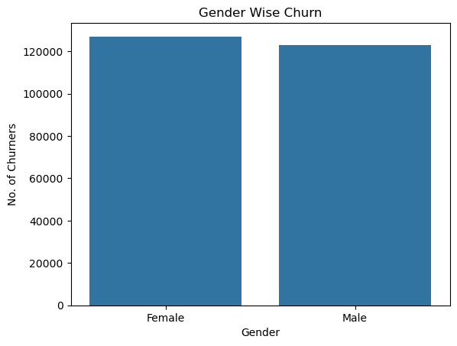
Figure 1 — Total churners by gender.

4.3 Age Distribution and Age Groups
Customer age ranges from 18 to 65 and is fairly evenly spread across that range, with a slight thinning out among older customers, as shown in Figure 2. To make the age pattern easier to read, customers were bucketed into three groups — Young (18–29), Mature (30–49), and Old (50–65) — using a simple helper function. The churn rate climbs sharply across these groups: 54.8% for Young, 43.4% for Mature, and 88.8% for Old, with each group still backed by a substantial sample (103,807, 233,625 and 103,400 customers respectively). The Old segment churning at nearly 89% is one of the clearest signals in the whole dataset, which is also reflected in Age's 0.22 correlation with Churn — the strongest of any raw numeric feature besides Support Calls.
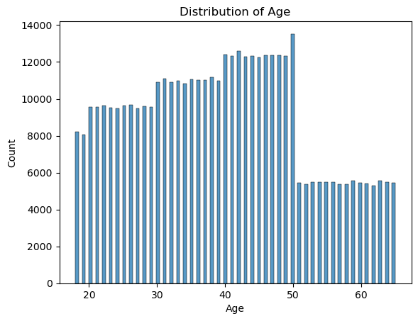
Figure 2 — Distribution of customer age.

4.4 Subscription Type
The three subscription tiers — Basic (143,026 customers), Standard (149,128) and Premium (148,678) — are almost evenly sized, and their churn rates sit close together too, at 58.2%, 56.1% and 55.9% respectively. Total spending tells a similar story: summed spend naturally scales with each tier's customer count (Figure 3), but the mean spend per customer is essentially flat across Basic, Standard and Premium (Figure 4). In other words, the subscription tier a customer picks says very little about whether they will churn or how much they will spend on average — it behaves more like a label than a driver.
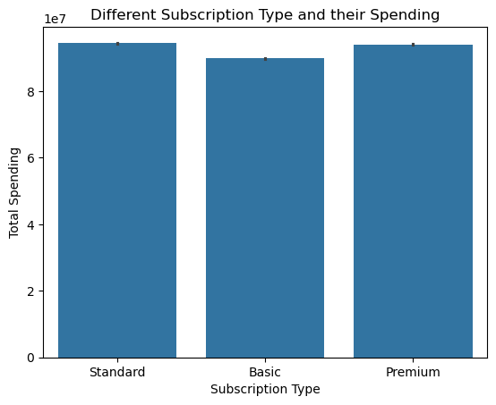
Figure 3 — Total spend by subscription type (summed).
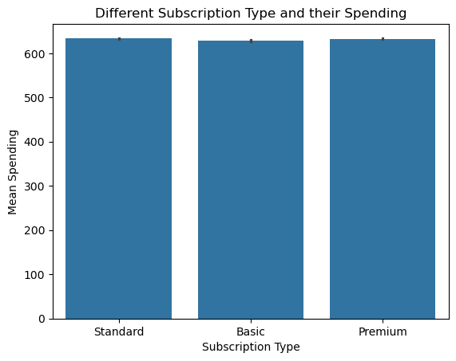
Figure 4 — Mean spend by subscription type.

4.5 Tenure
Tenure — how many months a customer has held their subscription — turned out to be a mild surprise. A bar chart of tenure against churn status (Figure 5) and a stacked histogram of tenure split by churn (Figure 6) both show churners and retained customers distributed across tenure in roughly the same proportions. Tenure's correlation with Churn is a weak -0.05, meaning that simply being a long-standing customer does not meaningfully protect someone from churning in this dataset — churn happens at a fairly constant rate regardless of how long the relationship has lasted.
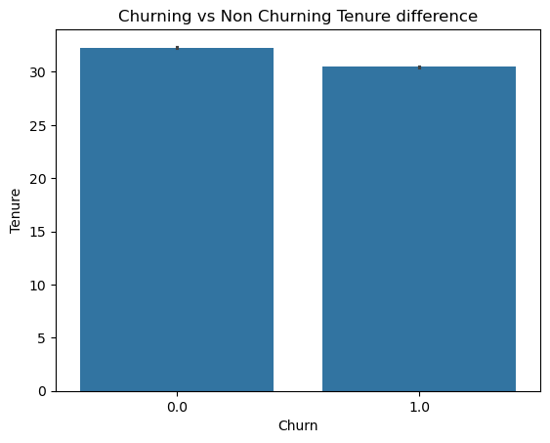
Figure 5 — Tenure compared across churned vs retained customers.
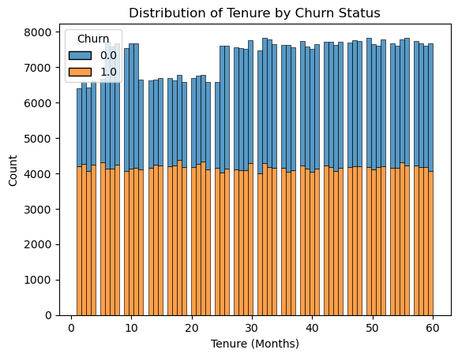
Figure 6 — Tenure distribution stacked by churn status.

4.6 Spending by Age
Plotting mean total spend against age (Figure 7) shows spend holding fairly steady through most of the age range before tapering off noticeably after around age 50 — consistent with the Old age group's much higher churn rate noted earlier. Customers who are both older and spending less appear to be the segment most at risk.
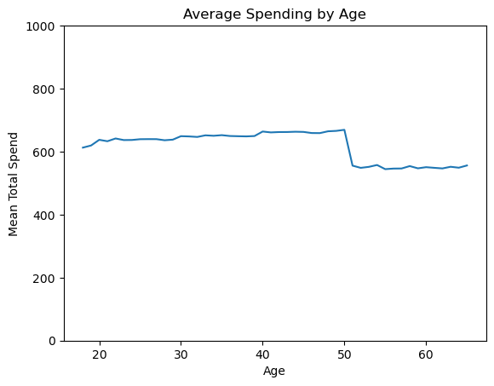
Figure 7 — Average spend by age.

4.7 Correlation Analysis
A correlation matrix was computed over the numeric features against the Churn label. Two features stood out clearly above the rest: Support Calls (+0.57) and Payment Delay (+0.31) both push churn up, while Total Spend (-0.43) pulls it down — customers who spend more tend to stick around. Age (+0.22) and Last Interaction (+0.15) showed weaker but still meaningful positive relationships with churn, while Tenure and Usage Frequency were both close to zero. This pattern — that how a customer is being served (support calls, payment friction) matters more than how long they've been around — carried straight through into what the trained model later learned to rely on.

5. Data Preprocessing, Justifications and Decisions
Every transformation applied to the raw data was a deliberate choice made after looking at what the exploratory analysis showed, not a default pipeline applied blindly. The reasoning behind each step is laid out below.

5.1 Dropping CustomerID
CustomerID is an arbitrary identifier with no relationship to churn behaviour. Feeding it into a model risks the model latching onto ID ranges as a spurious pattern (a form of overfitting), so it was removed immediately after loading the data.

5.2 Dropping the Engineered AgeGroup Column
AgeGroup was created purely to make the exploratory charts easier to read (Section 4.3). It was deliberately excluded from the modeling dataset because it is a direct, coarser re-statement of Age — keeping both would let age influence the model twice, effectively over-weighting it relative to every other feature.

5.3 Handling the Missing Row
As covered in Section 4.1, only one row out of 440,833 contained any missing data, and it was missing in every column simultaneously. With a loss this small (0.0002% of the dataset) and no realistic way to impute an entire blank record, dropping the row was the correct call — imputation techniques exist to rescue data that is otherwise useful, and this single row was not.

5.4 Outlier Handling
The summary statistics from describe() were reviewed for every numeric column, and the minimum, maximum and quartile values all fell within sensible, realistic ranges for a subscription business (for example, spend between $100 and $1,000, support calls between 0 and 10). No values looked fabricated or extreme, so no outlier removal or capping was applied — doing so would have discarded genuine variation for no real quality benefit.

5.5 Encoding Categorical Variables
Subscription Type and Contract Length are both unordered categories (there's no natural ranking between Basic and Premium, or between Monthly and Annual), so they were one-hot encoded with pd.get_dummies(), producing separate binary columns for each category. Gender, being a simple two-value category, was label-encoded into 0/1 with scikit-learn's LabelEncoder rather than one-hot encoded, since a single binary column captures it fully without adding an unnecessary extra dimension.

5.6 Class Balance
The target variable splits into 249,999 churned customers (56.7%) and 190,833 retained customers (43.3%). This is a mild imbalance, not a severe one, and with close to 191,000 examples in the minority class there was more than enough data for the model to learn the retained-customer pattern properly. This is why no resampling technique (such as SMOTE or class-weight adjustment) was applied — it was judged unnecessary given how much data both classes have.

5.7 Train/Test Split
The cleaned, encoded dataset was split 80/20 into training and testing sets using train_test_split(test_size=0.2, random_state=42, stratify=y). The stratify=y argument matters here: it guarantees that the same 56.7%/43.3% churn ratio present in the full dataset is preserved in both the training set and the held-out test set, so the model's evaluation numbers are not distorted by an accidental imbalance between the two splits. A fixed random_state was used so the split — and therefore the results in this report — is exactly reproducible.

6. Model Training and Results

6.1 Model Choice
A Decision Tree Classifier (max_depth=10, random_state=42) from scikit-learn was chosen as the model. Decision trees are a natural fit here for two reasons: the features are a mix of numeric and one-hot encoded categorical columns with no need for scaling, and the resulting tree remains interpretable — feature importances can be read directly off it, which matters for a churn problem where a business will want to know why a customer is flagged, not just that they are. Capping the depth at 10 keeps the tree expressive enough to capture the real patterns in the data without growing so deep that it starts memorising noise from individual training rows.

6.2 Train/Test Split Summary
Split | Rows | Proportion
Training set | 352,666 | 80%
Test set | 88,167 | 20%
Total (after cleaning) | 440,833 | 100%

6.3 Test Set Performance
Evaluated on the held-out 88,167-row test set, the model achieved an accuracy of 99.73%. The full classification report is reproduced below exactly as the notebook printed it.
Class | Precision | Recall | F1-score | Support
0 (Retained) | 0.99 | 1.00 | 1.00 | 38,167
1 (Churn) | 1.00 | 1.00 | 1.00 | 50,000
Accuracy |  |  | 1.00 | 88,167
Macro avg | 1.00 | 1.00 | 1.00 | 88,167
Weighted avg | 1.00 | 1.00 | 1.00 | 88,167

Both classes are predicted with essentially equal, near-perfect precision and recall, which is what the stratified split was designed to make possible — the model isn't just good at spotting the majority class, it's equally reliable on the minority one too.

6.4 Feature Importance
Reading feature_importances_ off the trained tree confirms exactly what the correlation analysis in Section 4.7 hinted at: Support Calls dominates, accounting for roughly 37% of the tree's total decision-making, followed at a distance by Total Spend, whether the contract is Monthly, Age, Payment Delay and Last Interaction. Subscription Type and the Annual/Quarterly contract flags contributed only marginal predictive power. Practically, this means a customer calling support frequently is the single loudest warning sign in this dataset — well ahead of how much they've spent or how old they are.
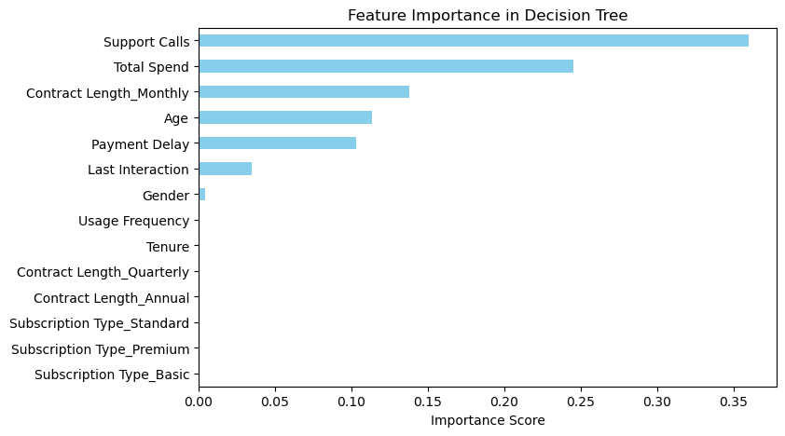
Figure 8 — Feature importance scores from the trained Decision Tree.

6.5 Confusion Matrix
The confusion matrix on the test set shows the model getting only 239 predictions wrong out of 88,167 — roughly 87,928 correct predictions, split almost entirely correctly between the Retained and Churn classes. This lines up with the 99.73% accuracy figure and confirms the errors are rare and not concentrated in one class.
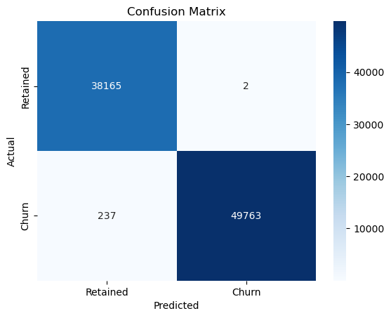
Figure 9 — Confusion matrix on the test set (Retained vs Churn).
It's worth being upfront about one thing: accuracy this high on a real-world churn problem is unusually clean, and it is almost certainly because Support Calls and Payment Delay are strong, near-deterministic proxies for churn within this particular dataset, rather than because churn is genuinely this easy to predict in the real world. That doesn't make the exercise less valid as a demonstration of the full workflow — data understanding, cleaning, encoding, splitting, training and evaluating — but it's the honest caveat to attach to a 99.73% figure before treating it as a benchmark for a live production system.

6.6 Model Export
The trained model was serialized with joblib.dump(model, 'churn_model.pkl') so it could be reloaded without retraining — this is the exact file the Gradio app below loads at startup.

7. Key Insights
- Support Calls is the dominant churn driver, both by correlation (+0.57) and by feature importance (~37% of the trained tree) — customers who call support often are the clearest at-risk group.
- Payment Delay (+0.31 correlation) is the second strongest positive signal — billing friction and churn go hand in hand.
- Total Spend is protective: it correlates -0.43 with churn, meaning higher-spending customers are meaningfully less likely to leave.
- Older customers churn far more: the 50–65 age group churns at 88.8%, versus 43.4% for the 30–49 group — age is a real risk factor, not a neutral demographic.
- Women in this dataset churn noticeably more than men (66.7% vs 49.1%), despite men making up the larger share of the customer base.
- Tenure barely matters: long-standing customers churn at almost the same rate as new ones (correlation -0.05), so loyalty tenure alone is not a retention signal here.
- Subscription Type (Basic/Standard/Premium) has almost no effect on churn rate or average spend — customers behave similarly across tiers.
- Average spend drops off noticeably after age 50, reinforcing that older customers are both spending less and churning more.

8. Gradio Application
To make the model usable without touching code, the trained churn_model.pkl was wrapped in a small Gradio interface. A predict_churn() function takes in a customer's Age, Tenure, Usage Frequency, Support Calls, Payment Delay, Total Spend, Last Interaction, Contract Type and Gender, rebuilds them into the exact one-hot / label-encoded column layout the model was trained on (matching X_train.columns), and returns a plain-English verdict: "Customer Will Churn" or "Customer Will Stay".
The interface itself uses sliders for every numeric input (e.g. Age from 18–65, Support Calls from 0–10, Total Spend from $100–$1,000) and radio buttons for Contract Type (Monthly / Quarterly / Annual) and Gender, titled "Customer Churn Prediction App". Running gui.launch() starts a local server (the notebook shows it launching at http://127.0.0.1:7864) and serves the interface as an embedded, interactive form — anyone on the team can move the sliders, pick a contract type, and get an instant churn prediction back without writing or running any code themselves.

8.1 Gradio Interface — Inputs
Input | Widget | Range / Options
Age | Slider | 18 – 65
Tenure (Months) | Slider | 1 – 60
Usage Frequency | Slider | 1 – 30
Support Calls | Slider | 0 – 10
Payment Delay (Days) | Slider | 0 – 30
Total Spend ($) | Slider | 100 – 1,000
Last Interaction (Days ago) | Slider | 1 – 30
Contract Type | Radio buttons | Monthly / Annual / Quarterly
Gender | Radio buttons | Male / Female

9. Conclusion
This project walked the customer churn dataset through the full data science lifecycle: inspecting and cleaning raw data, exploring it to build genuine intuition about what drives churn, encoding it correctly for a tree-based learner, training and honestly evaluating a Decision Tree Classifier, and finally packaging the result into a Gradio app that turns nine simple inputs into an instant, human-readable prediction. The exploratory work and the model agree with each other on what matters: support-call frequency, payment delays, spend level and age are the real drivers of churn in this dataset, while tenure and subscription tier are largely incidental. That agreement between the exploratory analysis and the model's learned feature importances is, in a way, a stronger validation of the workflow than the 99.73% accuracy figure on its own.

Digitally signed,
Umair
BS Data Science Student

