ERP Case Study
KL University ERP — Adaptive Software Engineering
Name | Roll Number | Selected System
K. Sai vardhan | 2420030095 | KL University ERP System
Overview
Subject: Adaptive Software Engineering
Selected System: KL University ERP System
The KL University ERP (Enterprise Resource Planning) System is an online portal used by students, faculty, and administrators to manage academic and administrative activities. It provides all important services in one place, making the work easier and faster.
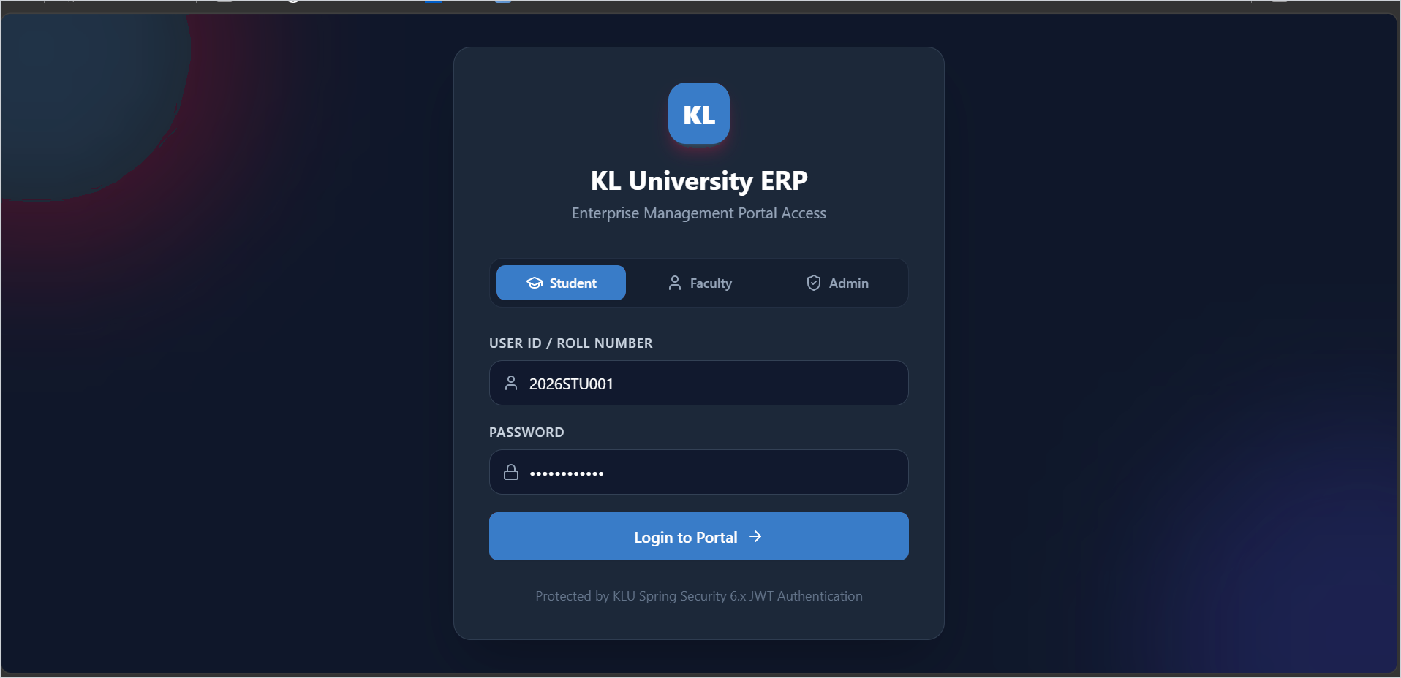
Figure 1. KL University ERP login page
1. Understanding the System
The KL University ERP System helps manage different university activities such as:
- Student Login
- Attendance Management
- Course Registration
- Timetable
- Examination Results
- Fee Payment
- Assignment Submission
- Notifications
- Student Profile Management
It reduces paperwork and allows users to access information anytime.
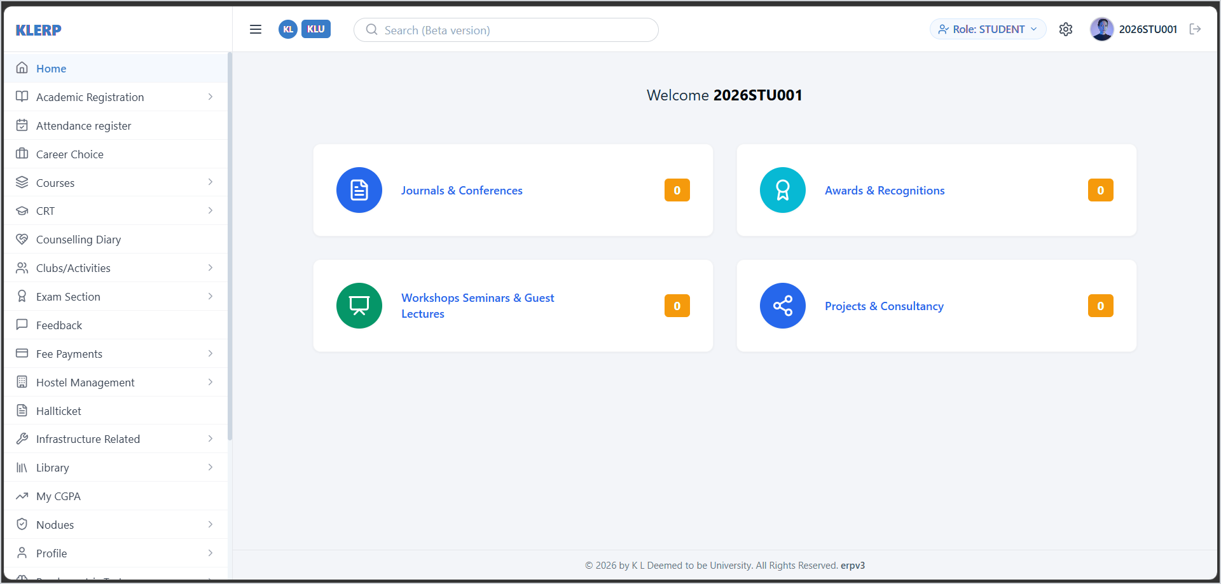
Figure 2. Student home page after login
2. User Stories
Student
- As a student, I want to log in securely to access my academic details.
- As a student, I want to view my attendance.
- As a student, I want to check my examination results.
- As a student, I want to view my timetable.
- As a student, I want to pay my fees online.
- As a student, I want to update my profile information.
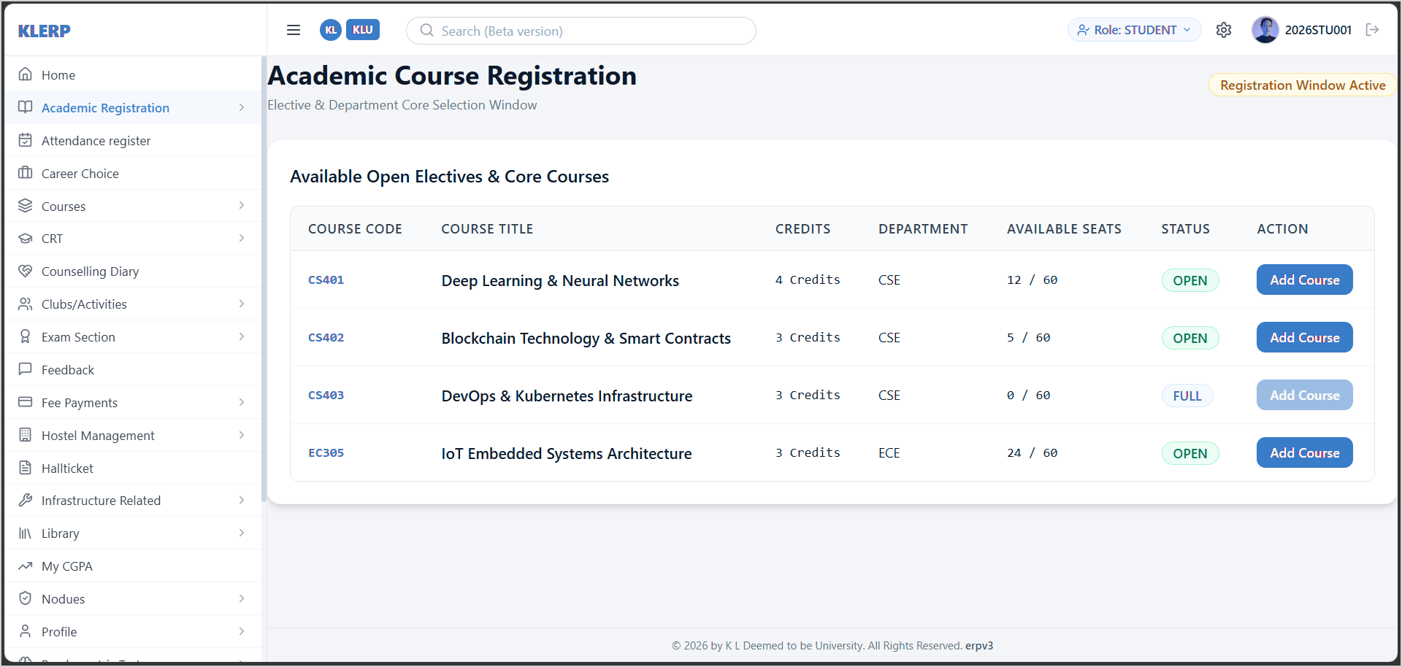
Figure 3. Course registration page
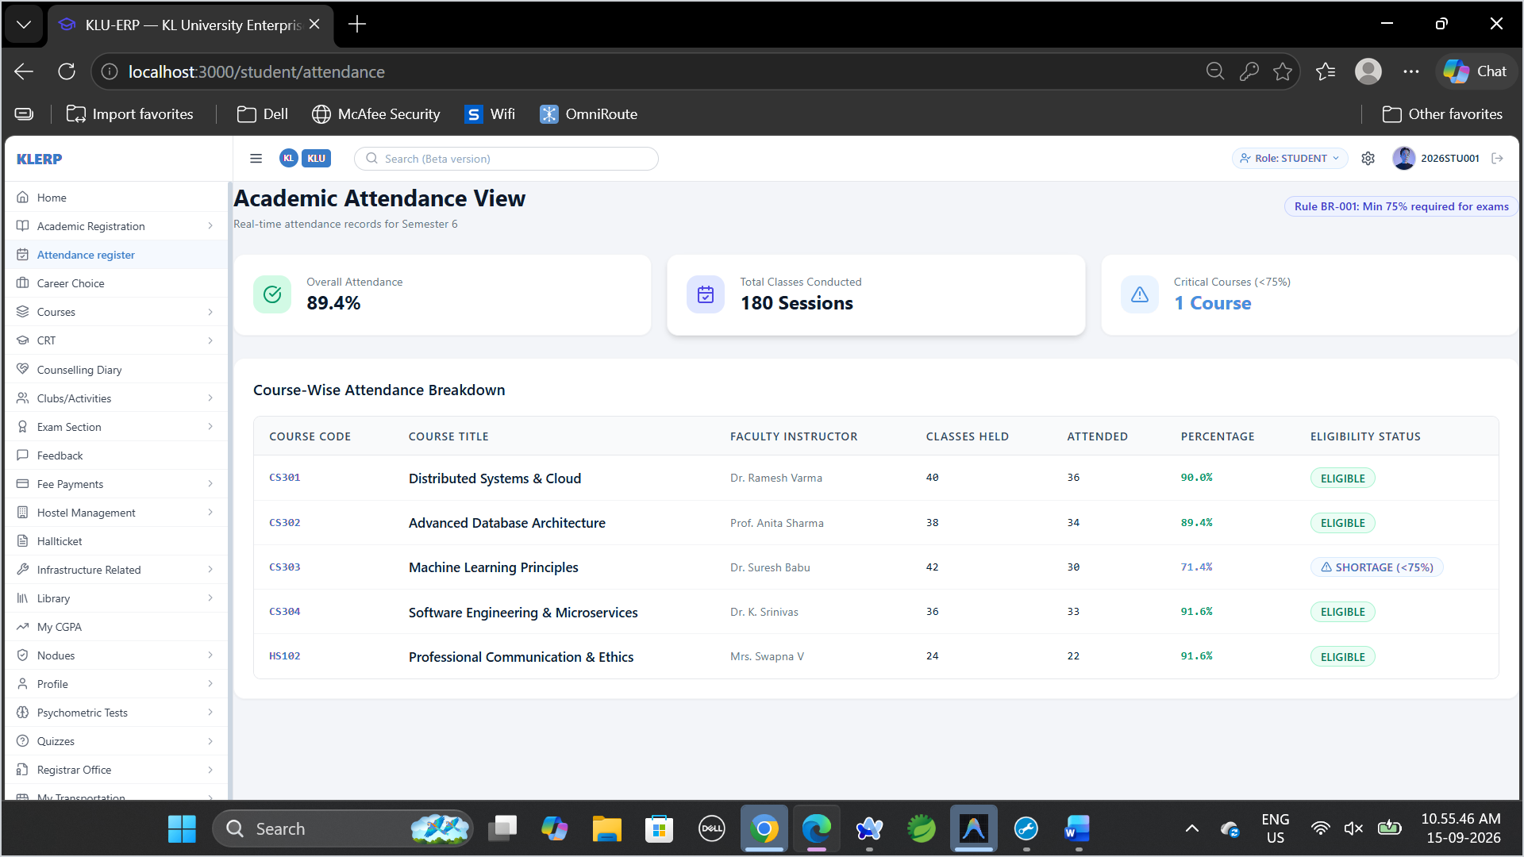
Figure 4. Attendance view with course-wise breakdown
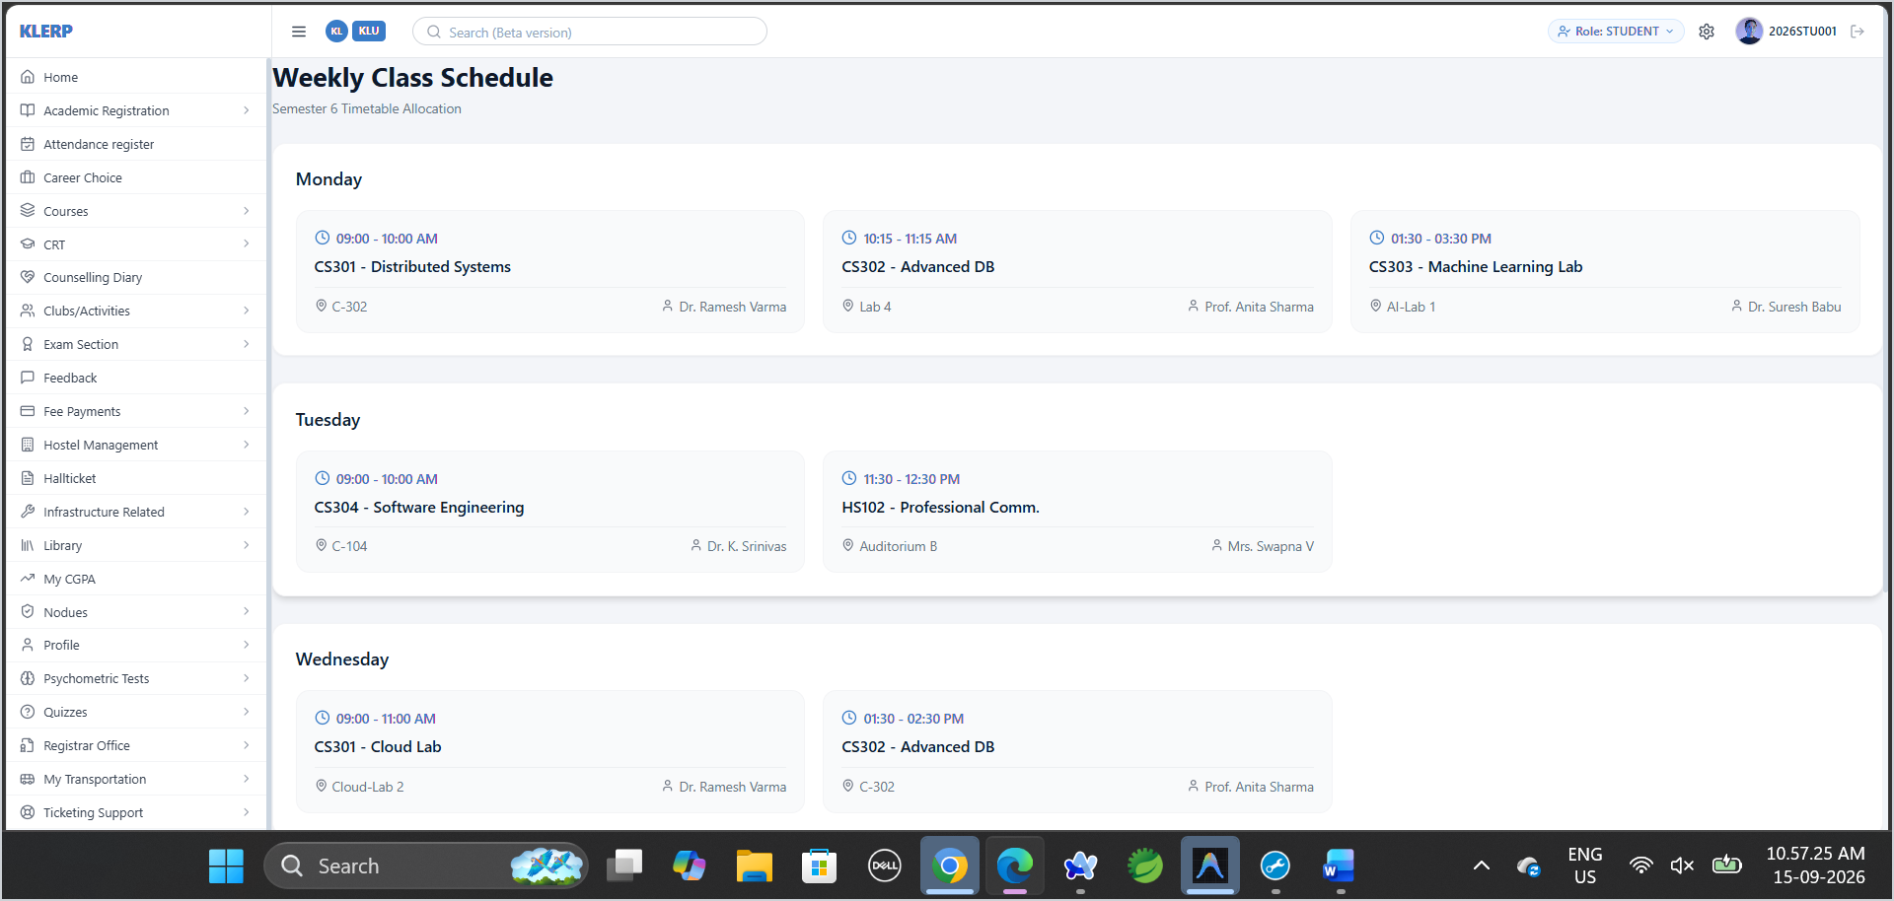
Figure 5. Weekly class schedule
Faculty
- As a faculty member, I want to upload attendance.
- As a faculty member, I want to upload student marks.
- As a faculty member, I want to manage course information.
- As a faculty member, I want to view student performance.
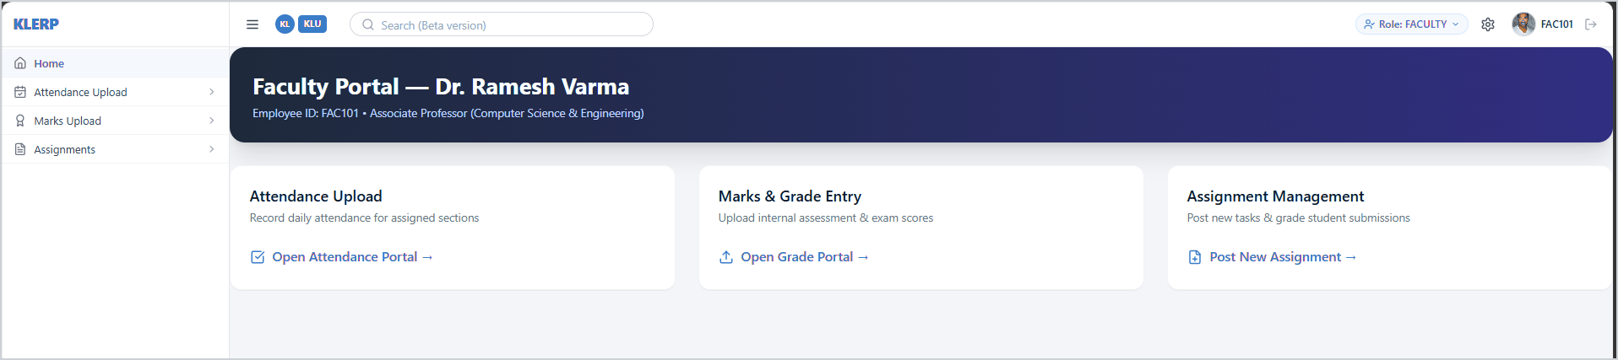
Figure 6. Faculty portal home page
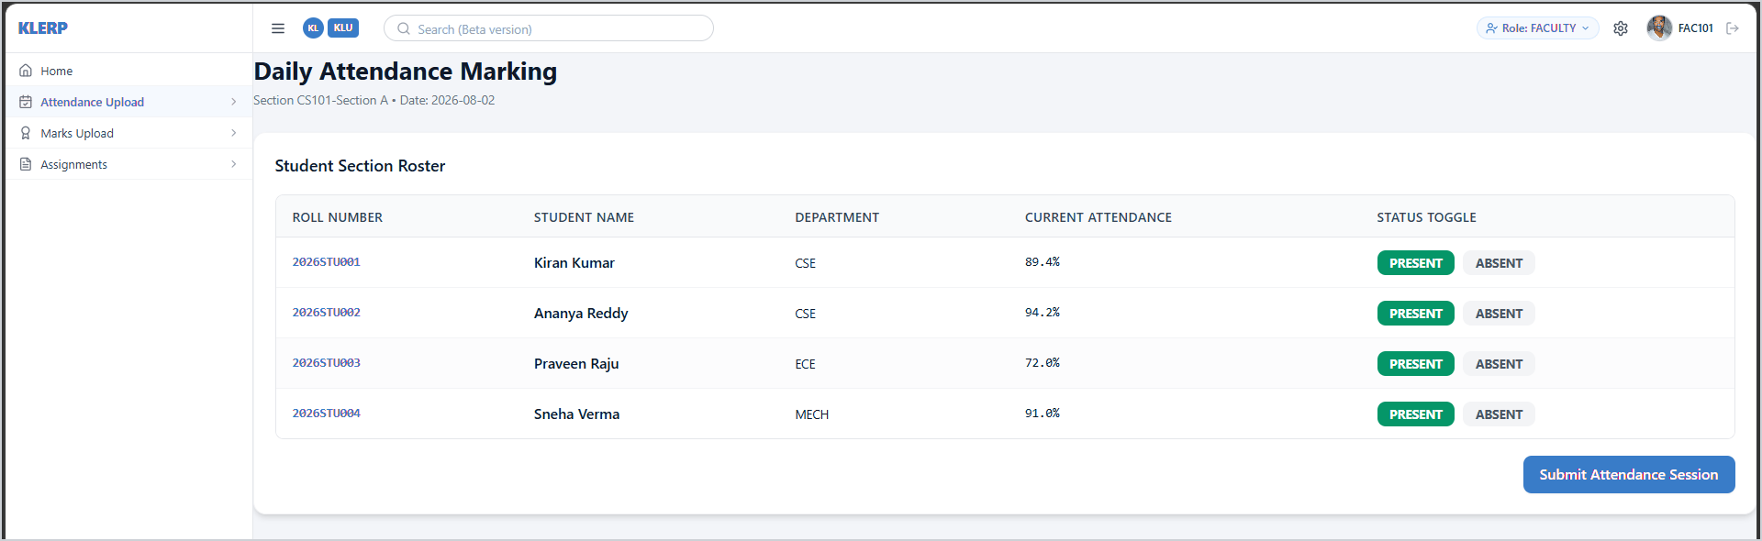
Figure 7. Daily attendance marking
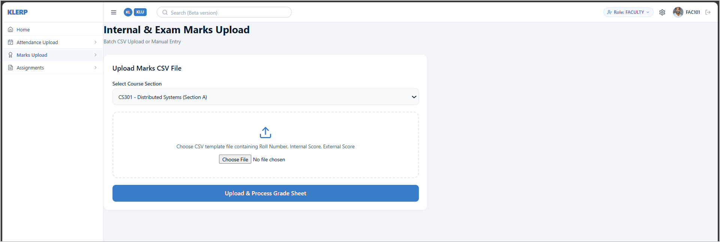
Figure 8. Internal and exam marks upload
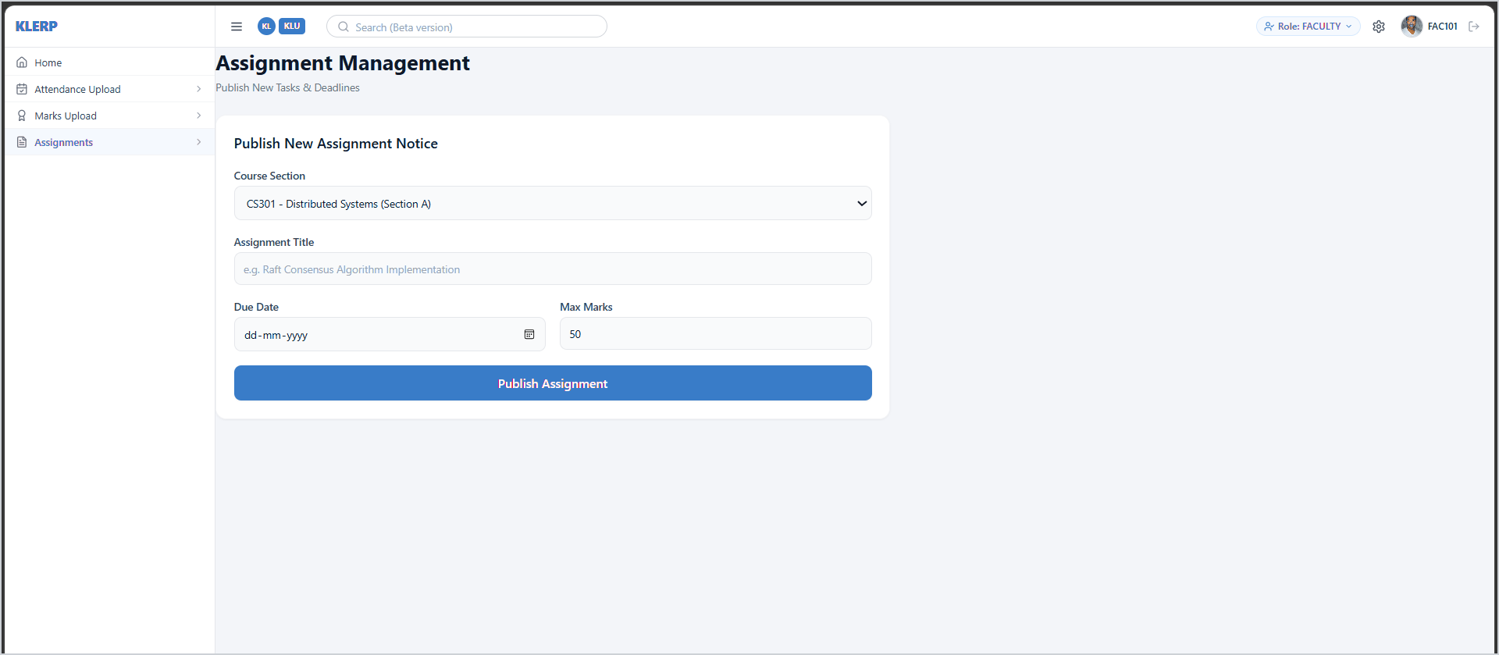
Figure 9. Assignment management
Admin
- As an admin, I want to manage student records.
- As an admin, I want to manage faculty details.
- As an admin, I want to manage courses and departments.
- As an admin, I want to generate university reports.
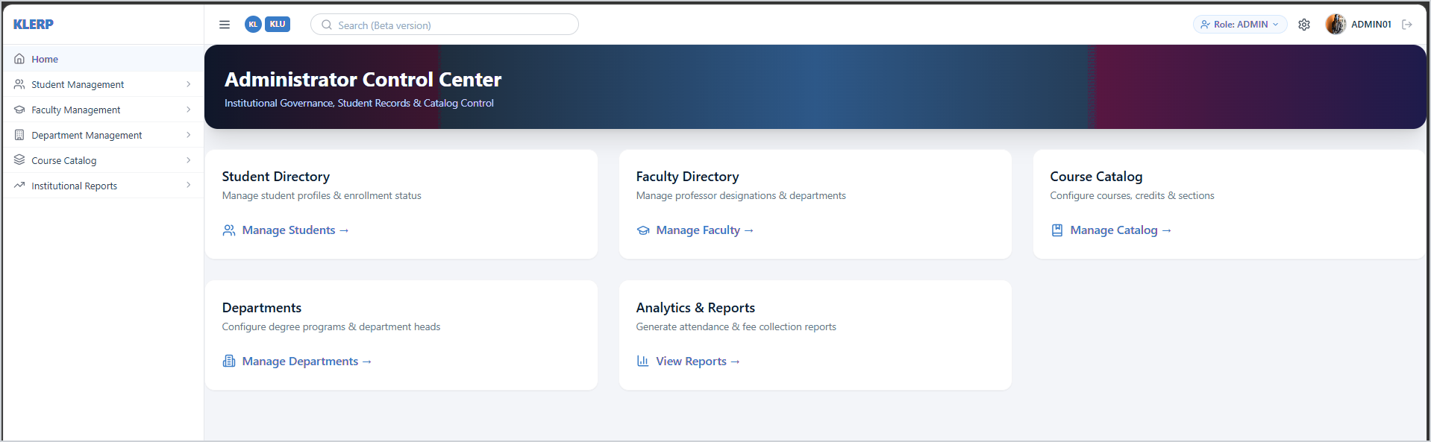
Figure 10. Administrator control center
3. Software Development Process Model
Selected Model: Agile Model
Reason
- Easy to add new features.
- Changes can be made quickly.
- Regular testing improves the software.
- User feedback can be added in every update.
- Suitable for ERP systems because requirements may change over time.
4. Programming Language
Layer | Technology
Frontend | HTML, CSS, JavaScript, React
Backend | Java (Spring Boot)
Database | MySQL
These technologies help build a secure, fast, and user-friendly ERP system.
5. Implementation Strategy
- Gather requirements from students, faculty, and administrators.
- Design the database and user interface.
- Develop modules such as Login, Attendance, Results, Timetable, and Fee Payment.
- Connect the frontend with the backend.
- Test every module.
- Deploy the application.
- Improve the system based on user feedback.
6. Evaluation Strategy
The ERP system will be evaluated by checking:
- Login works correctly.
- Attendance information is accurate.
- Results are displayed correctly.
- Fee payment works properly.
- The website loads quickly.
- User information is secure.
- The system is easy to use.
7. Expected Outcomes
- Secure ERP System
- Easy access to academic information
- Accurate attendance management
- Reliable examination results
- Secure online fee payment
- Improved communication between students and faculty
- Better management of university activities
- Scalable system for future improvements
Conclusion
The KL University ERP System helps students, faculty, and administrators manage university activities in one place. It provides secure access to academic information, reduces manual work, and improves communication. Using the Agile Software Development Model makes it easier to add new features, fix bugs, and improve the system based on user feedback.

