E-Commerce Case Study
Alibaba — Adaptive Software Engineering
Name | Roll Number | Selected Website
K. Sai vardhan | 2420030095 | Alibaba (international e-commerce platform)
Overview
Selected website: Alibaba
Alibaba is among the largest international e-commerce platforms in the world, linking buyers and sellers across many countries. Customers can look up products, place orders, pay securely, and follow their deliveries, while businesses can sell their products to customers anywhere in the world.
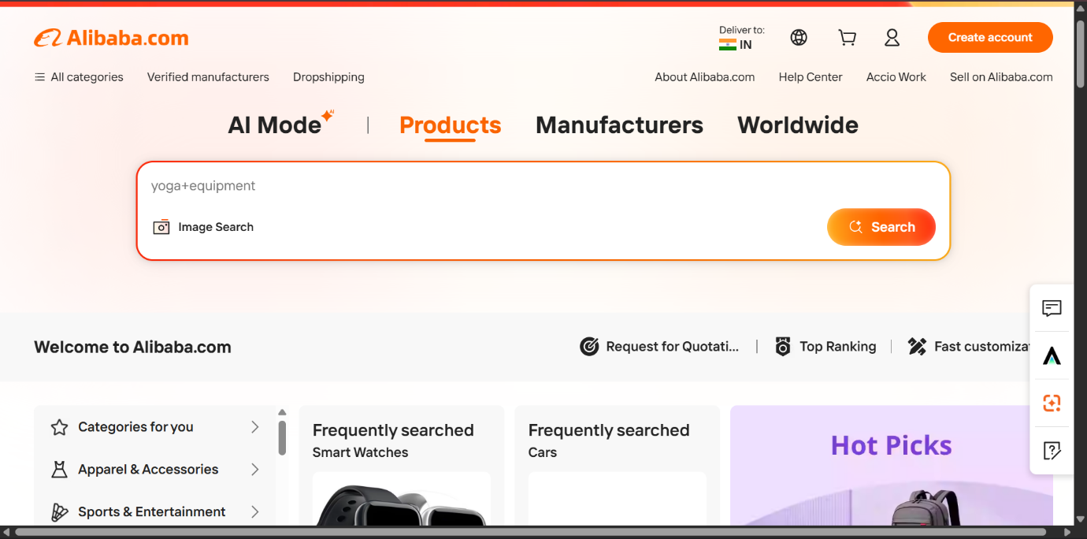
Figure 1. Alibaba home page with the product search box
1. Understanding the System
Alibaba is an online marketplace where buyers and sellers carry out business over the internet. The system offers the following features:
- User registration and login
- Product search
- Product categories
- Shopping cart
- Online payment
- Order tracking
- Product reviews and ratings
- Seller dashboard
- Customer support
Together, these features make online shopping simple, fast, and secure.
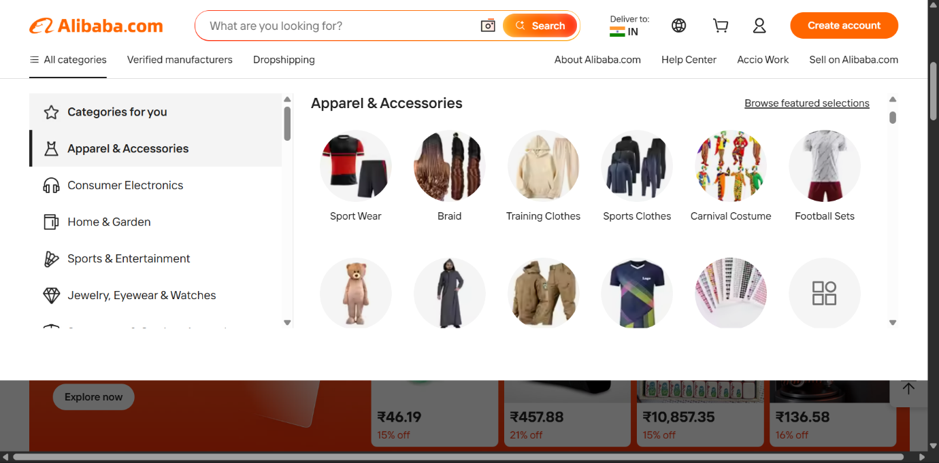
Figure 2. Browsing products by category
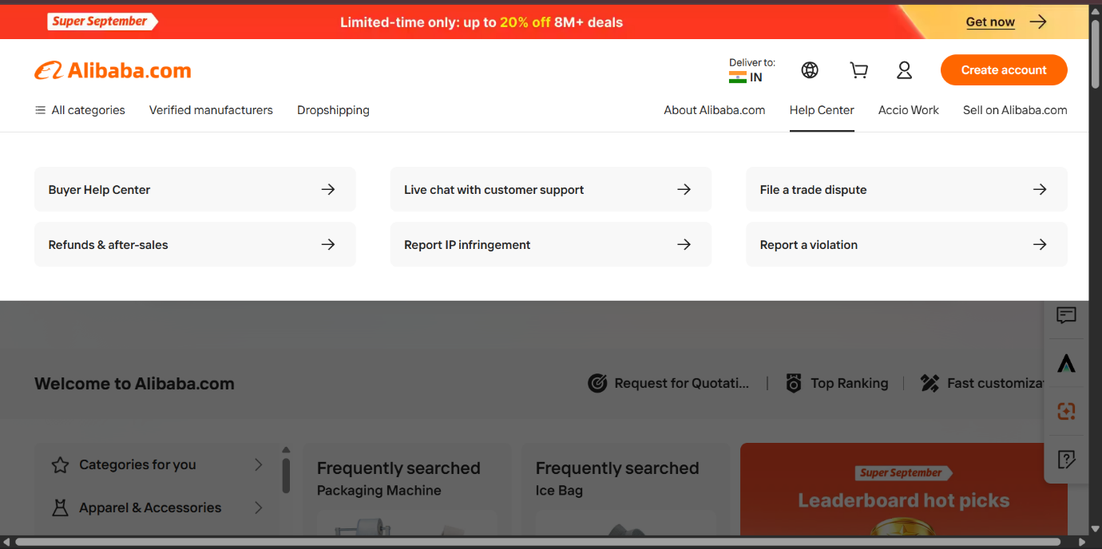
Figure 3. Help Center with customer support options
2. User Stories
Customer
- As a customer, I want to register and log in securely.
- As a customer, I want to search for the products I need.
- As a customer, I want to put products into my shopping cart.
- As a customer, I want to pay online in a secure way.
- As a customer, I want to follow the status of my orders.
- As a customer, I want to rate and review products.
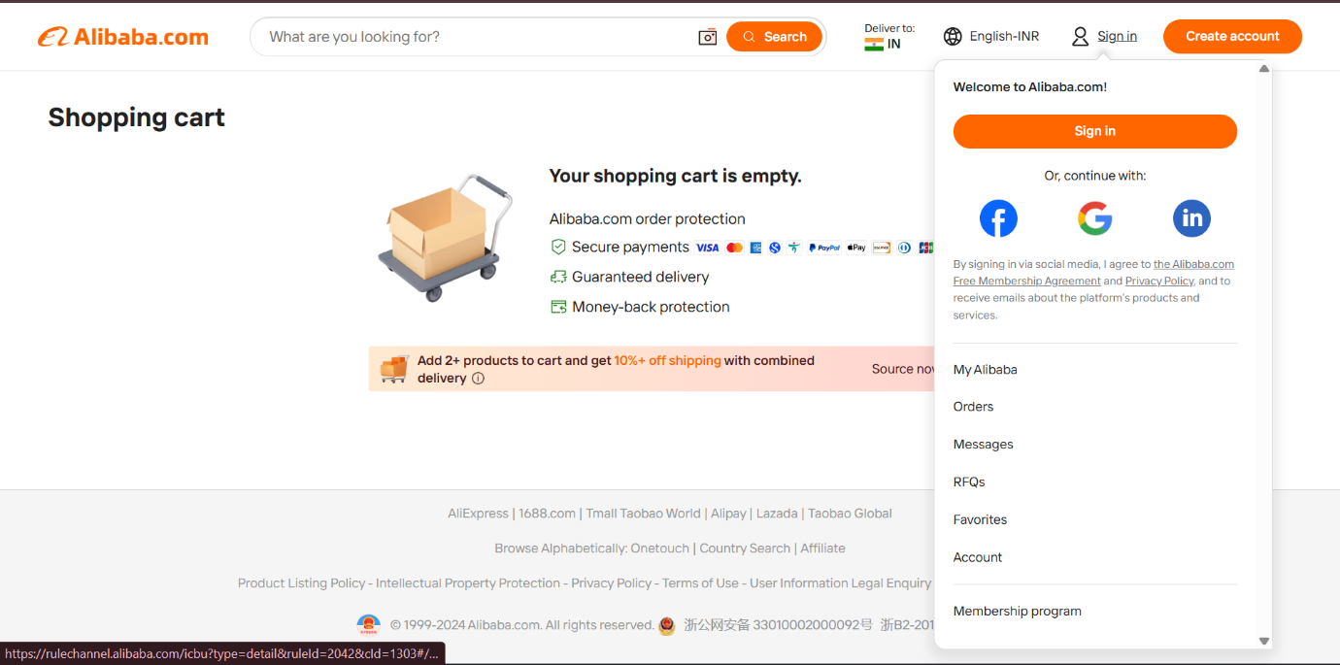
Figure 4. Shopping cart page with the sign-in menu
Seller
- As a seller, I want to list new products.
- As a seller, I want to edit the details of my products.
- As a seller, I want to manage my inventory.
- As a seller, I want to see the orders placed by customers.
Admin
- As an admin, I want to manage customer accounts.
- As an admin, I want to manage seller accounts.
- As an admin, I want to monitor orders.
- As an admin, I want to generate sales reports.
3. Software Development Process Model
Selected model: Agile
Reasons
- New features can be added easily.
- Changes can be made quickly.
- Testing at regular intervals improves the quality of the software.
- Customer feedback can be included in every update.
- It suits e-commerce websites, where customer requirements change often.
4. Programming Language and Technology Stack
Layer | Technology
Frontend | HTML, CSS, JavaScript, React
Backend | Java (Spring Boot)
Database | MySQL
This combination of technologies supports a fast, secure, and user-friendly e-commerce application.
5. Implementation Strategy
- Collect the requirements of customers and sellers.
- Design the database and the user interface.
- Build the modules: Login, Product Management, Shopping Cart, Payment, and Order Tracking.
- Connect the frontend to the backend.
- Test every module.
- Deploy the application.
- Keep improving the system using feedback from users.
6. Evaluation Strategy
The e-commerce system will be evaluated by checking that:
- registration and login work correctly;
- product search returns accurate results;
- the shopping cart behaves properly;
- online payments are secure;
- orders can be tracked successfully;
- the website loads quickly;
- user information stays protected;
- customers find the website easy to use.
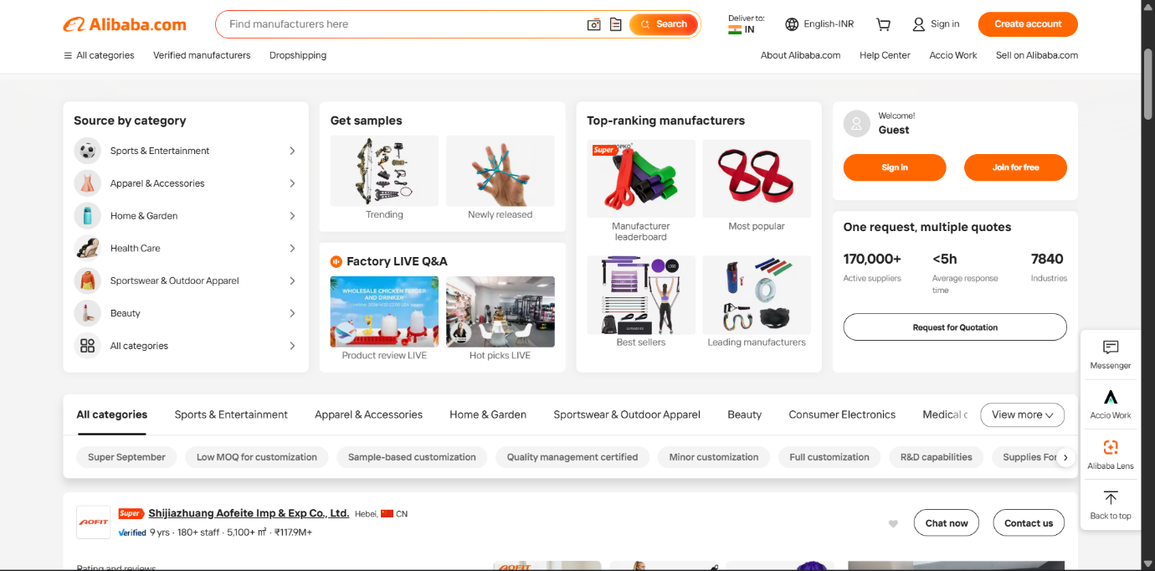
Figure 5. Alibaba manufacturer sourcing page
7. Expected Outcomes
- A secure online shopping platform
- Fast product search
- Reliable order management
- Secure online payments
- Simple product management for sellers
- Higher customer satisfaction
- A scalable system that can grow with future improvements
Conclusion
Alibaba is a successful international e-commerce platform that offers secure online shopping, quick order processing, and dependable product management. Following the Agile development model helps the system improve steadily, as new features are added and problems are fixed based on customer feedback.

