Trello
Project Planning and Task Management
Name | Roll Number | Objective
K. Sai vardhan | 2420030095 | Plan a project and track its tasks using a Trello board.
Part A — Signing Up for Trello
- Open a web browser.
- Search for Trello.
- Select the Trello (Atlassian) result.
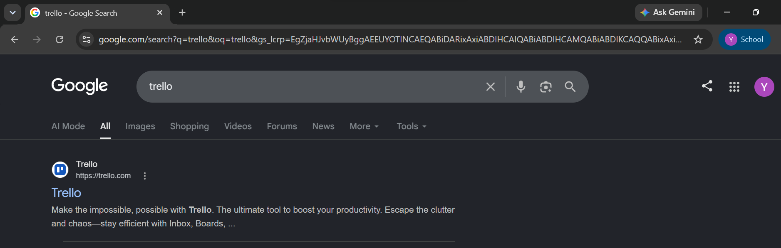
Figure 1. Searching for Trello in the browser
- Sign up, or log in with your Atlassian account.

Figure 2. Trello home page with the sign-up option
Part B — Building the Board
- Create a new Workspace.
- Create a new Board.
- Type a name for the board and create it.
- Add lists such as To Do, Doing, and Done.
Part C — Organising the Tasks
- Add task cards to the To Do list.
- Assign members to the cards.
- Set a due date for each task.
- Add labels to keep the tasks organised.
- Attach files or documents wherever they are needed.
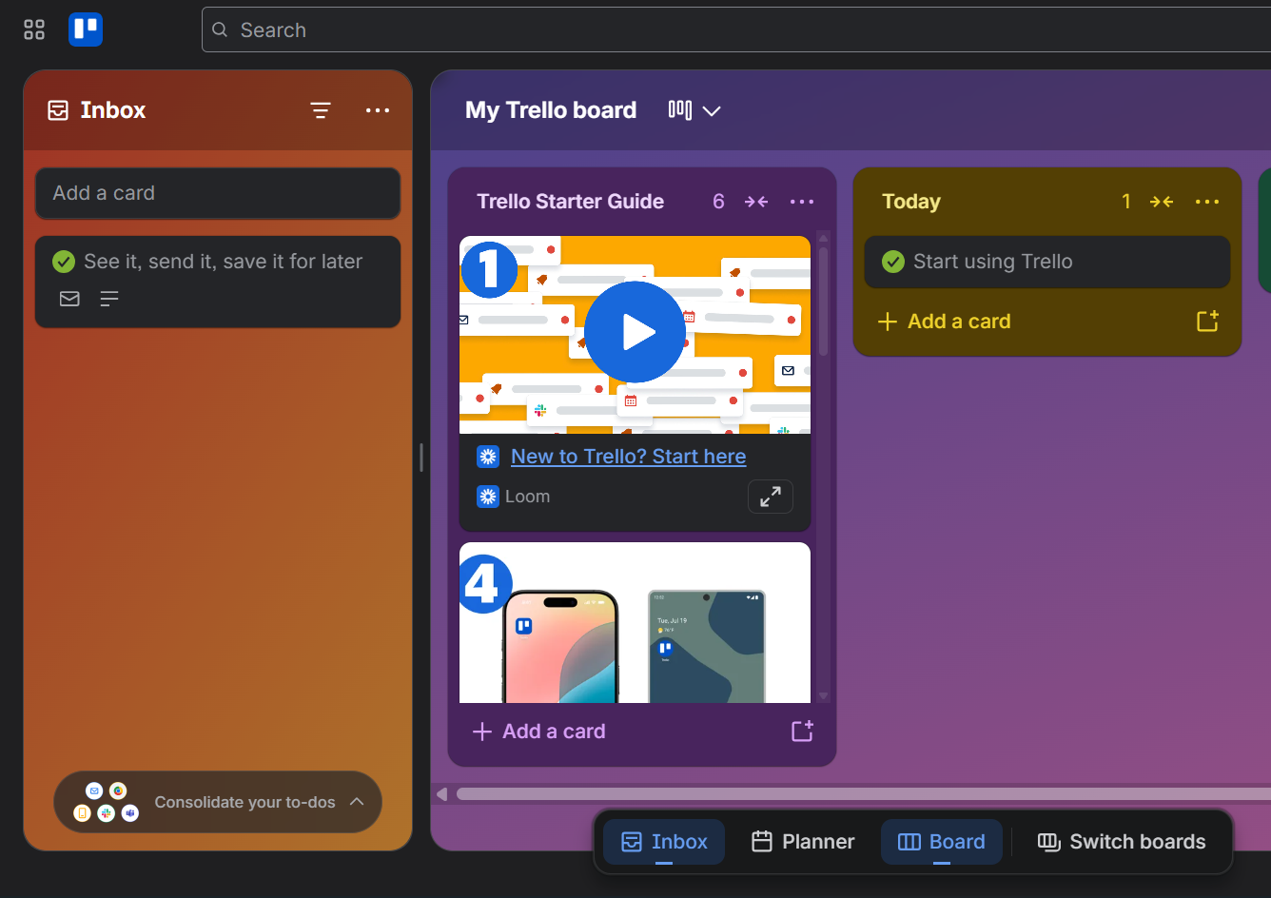
Figure 3. The Trello board with its lists and cards
Part D — Tracking Progress
- Move each card from To Do to Doing to Done as the work moves along.
- Follow the progress of the project on the board.
- Finish all the tasks and review the board.
Outcome
Successfully learned how to use Trello for project planning, task management, team collaboration, and project tracking.

