Docker
Working with Images and Containers (Windows)
Name | Roll Number | Objective
K. Sai vardhan | 2420030095 | Install Docker, pull and run images, and manage containers.
Part A — Getting Started
- Install Docker Desktop.
- Open Command Prompt.
- Check that Docker is available by typing:
docker
- Launch Docker Desktop and look at the Images tab.
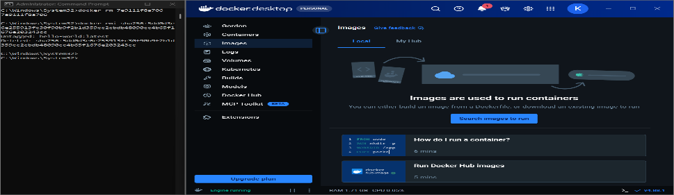
Figure 1. Docker Desktop open on the Images tab
Part B — Finding and Pulling an Image
- Open Docker Hub and search for an image such as Hello World or Ubuntu.
- Download the image you need with the pull command:
docker pull hello-world
docker pull ubuntu
Part C — Running and Removing a Container
- Run the image as a container:
docker run hello-world
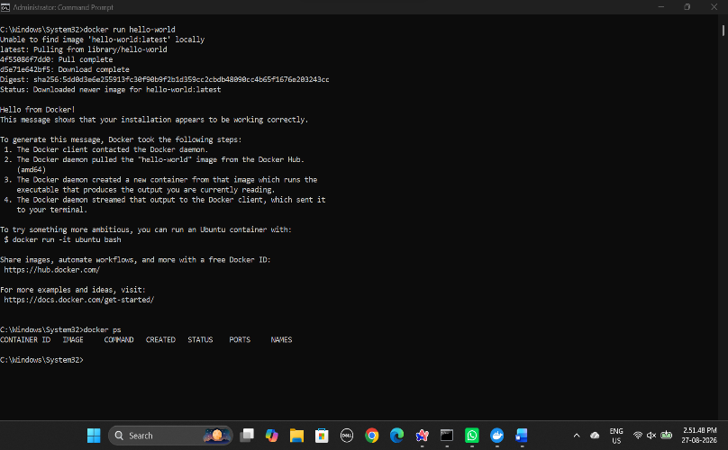
Figure 2. Running the hello-world image from Command Prompt
- Stop the container, using its container ID:
docker stop <container-id>
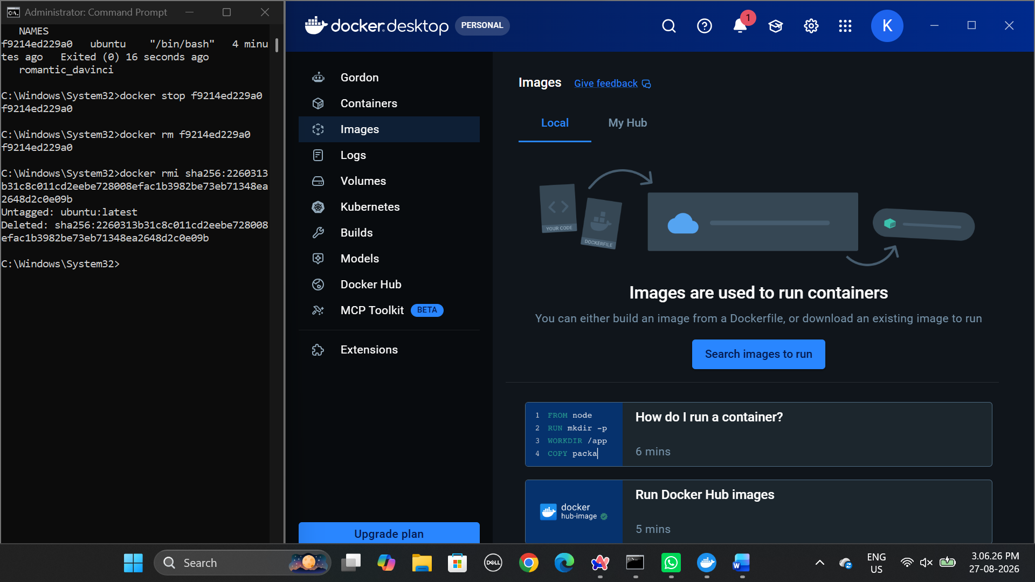
Figure 3. Stopping and removing a container, and removing its image
- Delete the container, using its container ID:
docker rm <container-id>
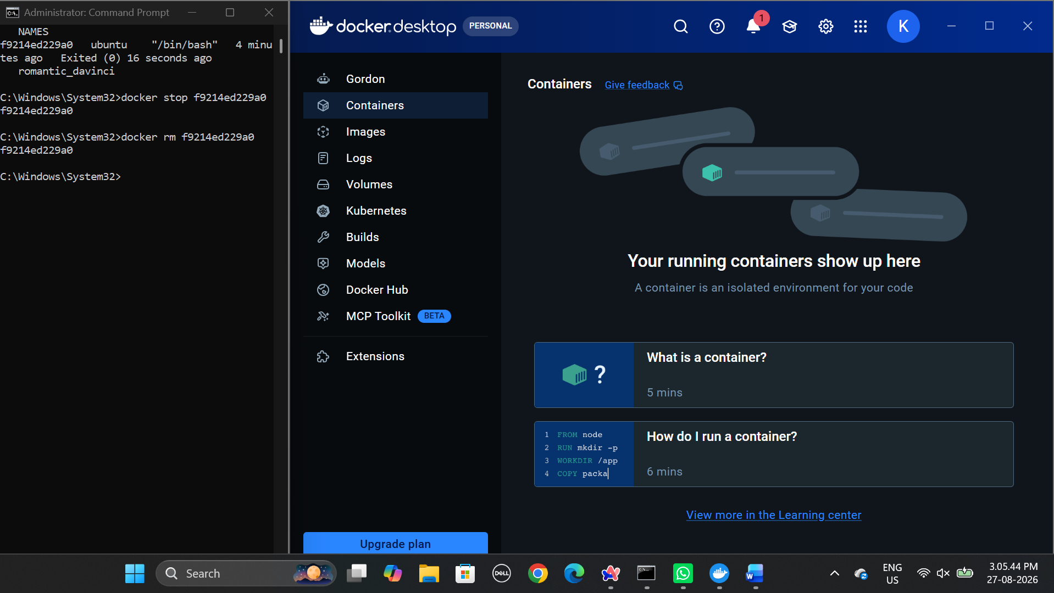
Figure 4. Docker Desktop showing no running containers after removal
Part D — Ubuntu in Interactive Mode
- Start an Ubuntu container with an interactive terminal:
docker run -it ubuntu
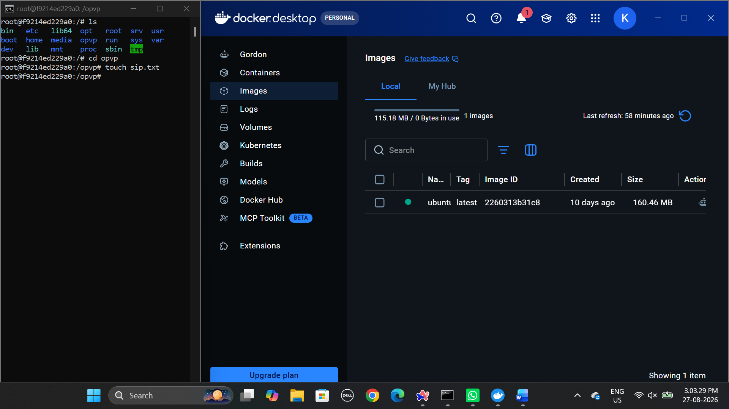
Figure 5. Working inside the Ubuntu container, with the image listed in Docker Desktop

