Kubernetes
Running an Nginx Pod on Minikube (Windows)
Name | Roll Number | Objective
K. Sai vardhan | 2420030095 | Set up Minikube and kubectl, deploy an Nginx Pod, and open it in the browser.
Part A — Installing the Tools
- Install Docker Desktop and confirm that it is up and running.
- Launch PowerShell as Administrator.
- Install Minikube with the following command:
winget install Kubernetes.minikube
- Confirm the Minikube installation:
minikube version
- Install kubectl with this command:
winget install -e --id Kubernetes.kubectl
- Confirm the kubectl installation:
kubectl version --client
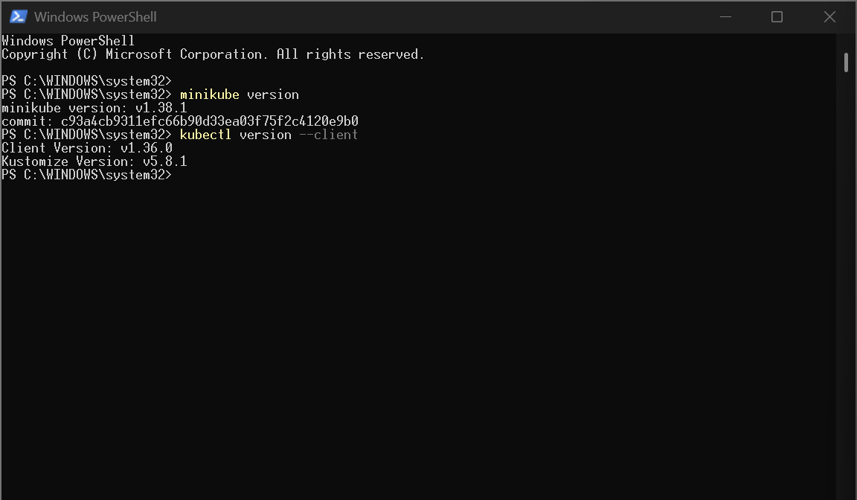
Figure 1. Minikube and kubectl versions displayed in PowerShell
Part B — Starting the Cluster
- Start Minikube using the Docker driver:
minikube start --driver=docker
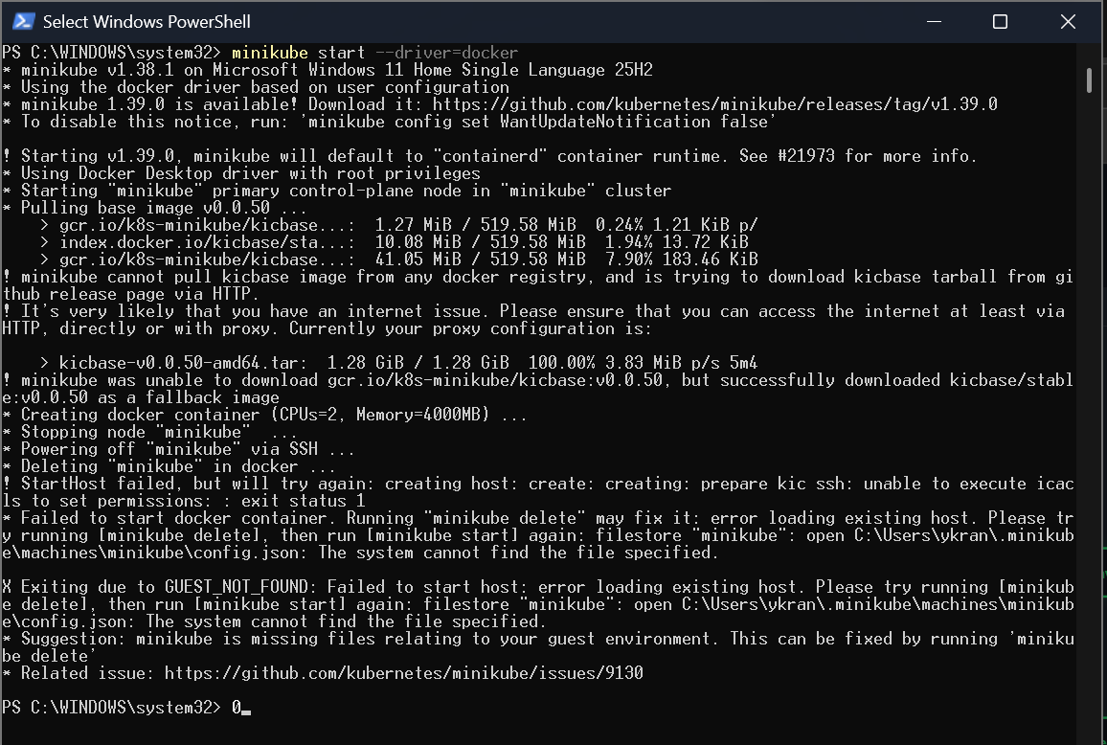
Figure 2. Output of the minikube start command
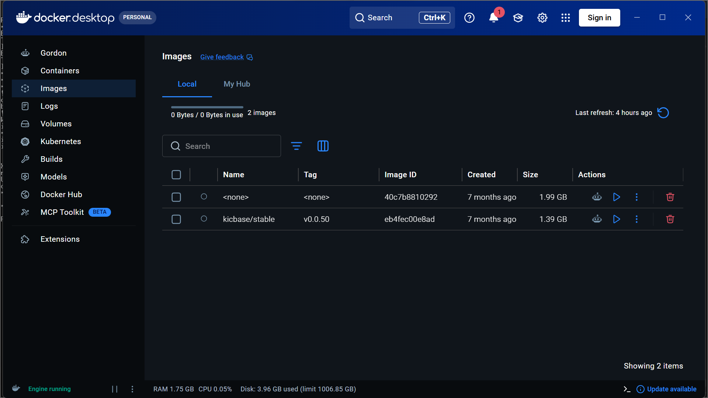
Figure 3. Docker Desktop — Images tab
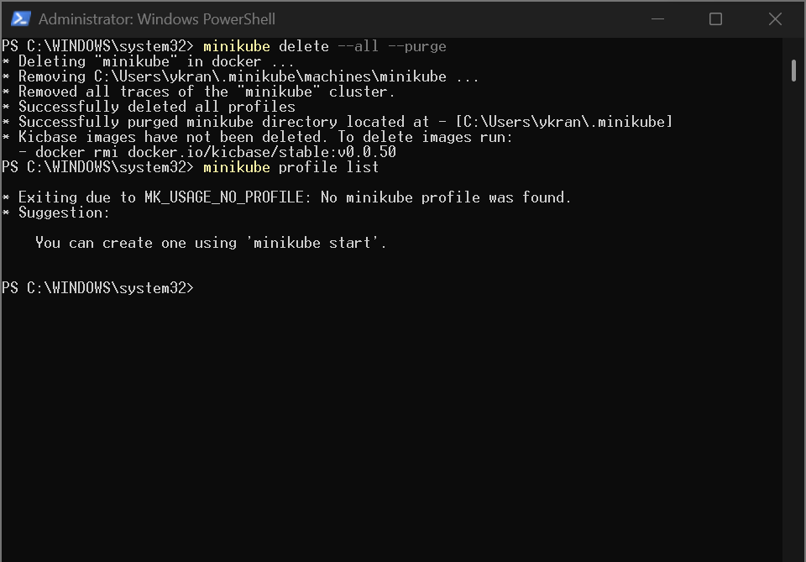
Figure 4. Clearing the existing Minikube profile with minikube delete --all --purge
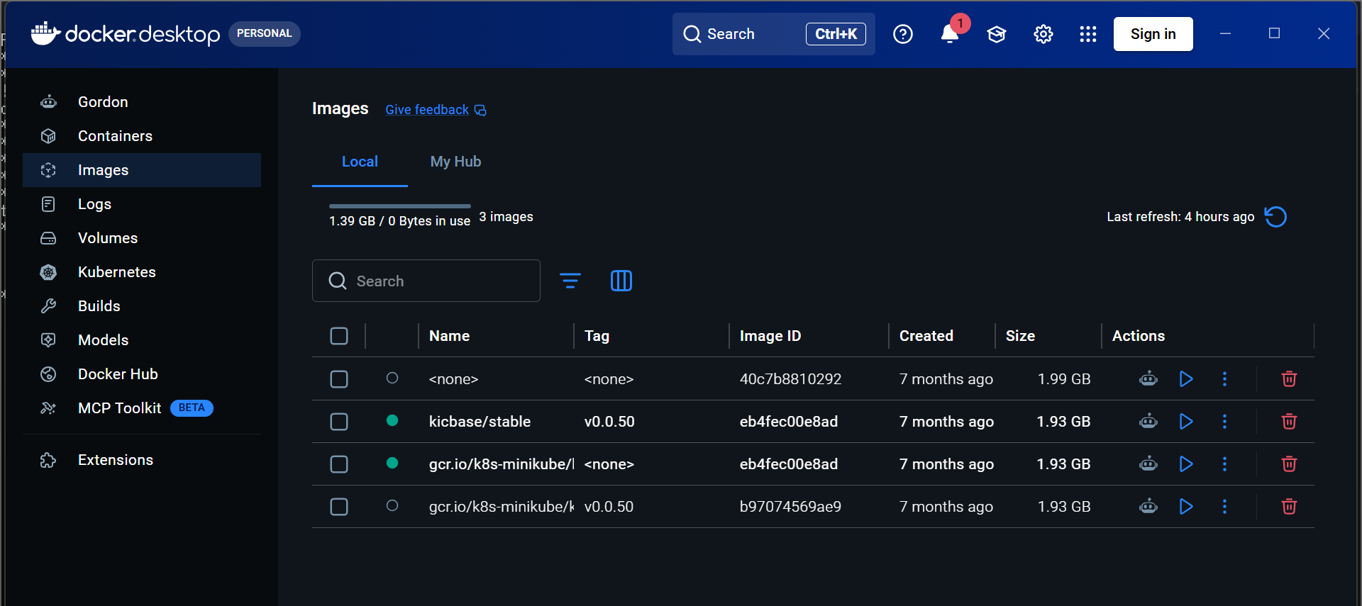
Figure 5. Docker Desktop — Images tab after the cleanup
- Check the status of the cluster:
minikube status
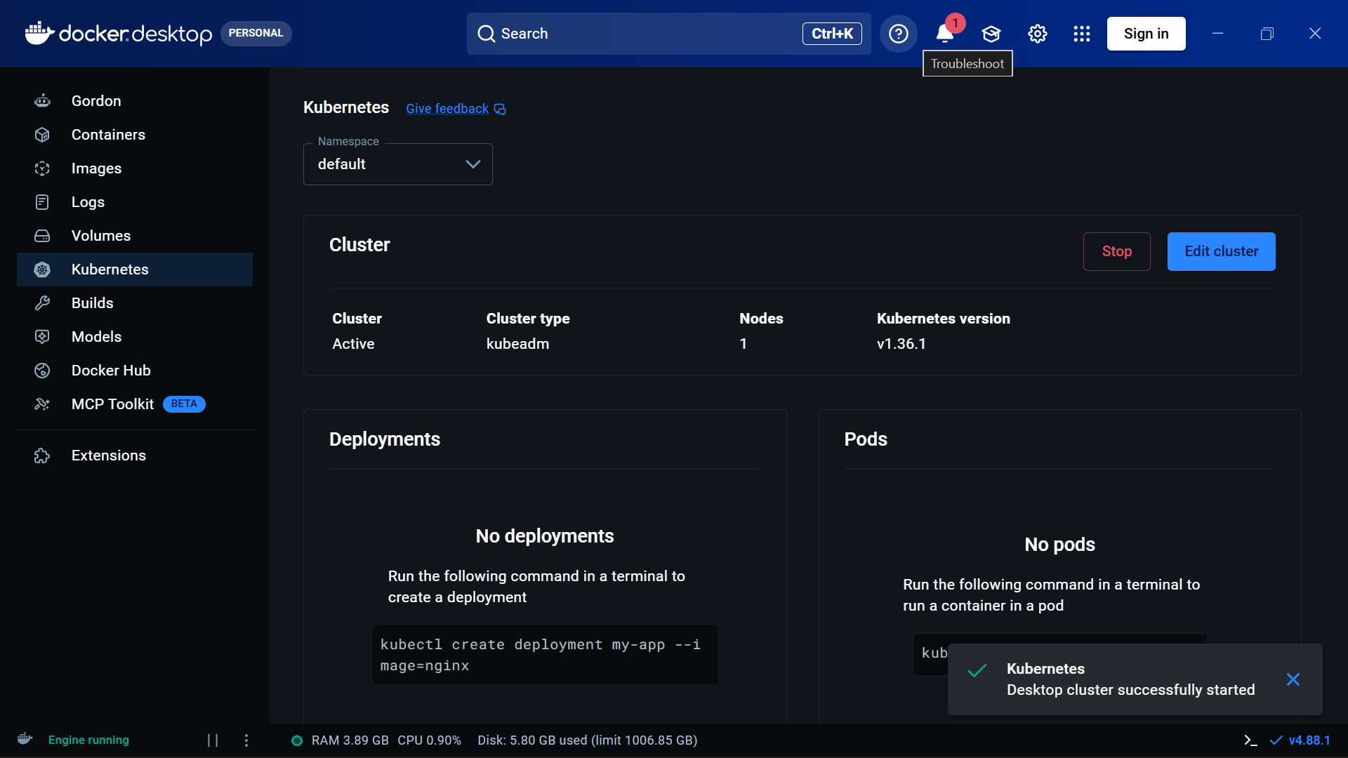
Figure 6. Kubernetes cluster shown as active in Docker Desktop
- List the Kubernetes nodes:
kubectl get nodes
Part C — Deploying the Nginx Pod
- Create a file named nginx-pod.yaml and add the Nginx Pod configuration shown below.
apiVersion: v1
kind: Pod
metadata:
name: nginx-pod
labels:
app: nginx
spec:
containers:
- name: nginx
image: nginx:latest
ports:
- containerPort: 80
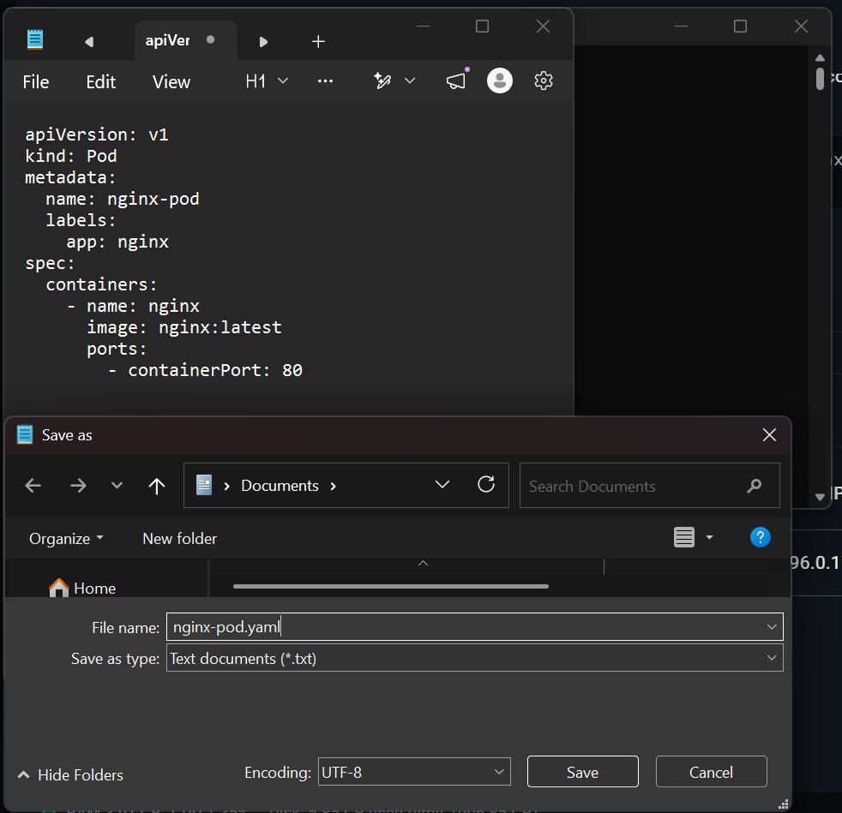
Figure 7. Saving the Pod configuration as nginx-pod.yaml
- Deploy the Pod by applying the file:
kubectl apply -f nginx-pod.yaml
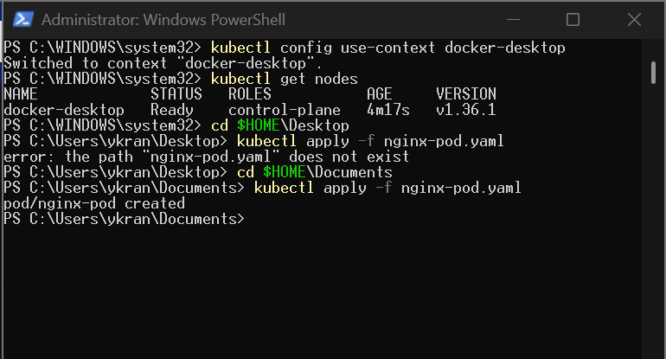
Figure 8. Pod created successfully with kubectl apply
- Check that the Pod is running:
kubectl get pods
- Look at the detailed Pod information:
kubectl describe pod nginx-pod
Part D — Accessing Nginx and Cleaning Up
- Forward local port 8080 to port 80 of the Pod:
kubectl port-forward pod/nginx-pod 8080:80
- Open http://localhost:8080 in your web browser.
- Verify that the Welcome to nginx! page appears.
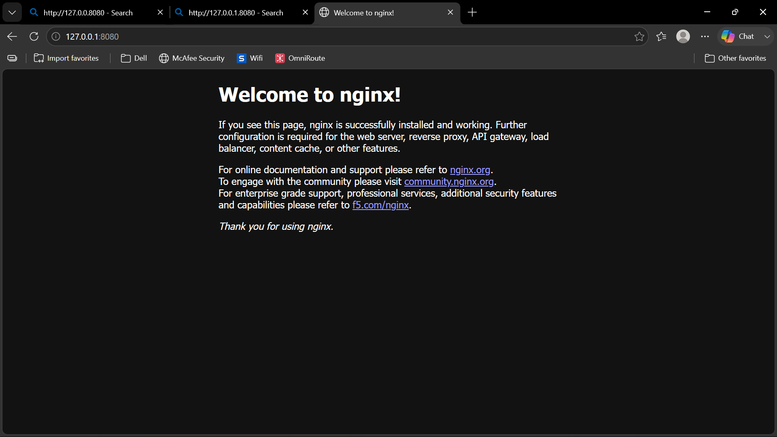
Figure 9. Nginx welcome page served from the Pod at localhost:8080
- Read the Nginx container logs:
kubectl logs nginx-pod
- Remove the Pod:
kubectl delete -f nginx-pod.yaml
- Shut down Minikube:
minikube stop

